Data rate control in Distributed systems using feedback.

First Checkpoint: Measuring data rate between server and client at the client side.

For the 1st checkpoint, the data rate between the client and server is measured by transferring text of 32KB in size between the server and client.

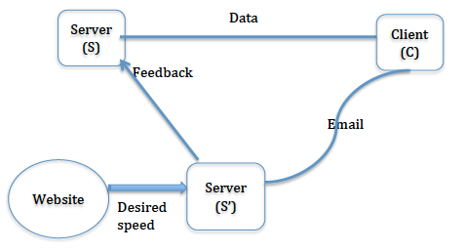

The client sends a text of 32KB to the server. The time at which data is sent to the server is recorded at the client. T1

The server receives the text, reads, and sends the text of 32KB back to the client.

The client receives the data sent by the server and records the time at which it received. T2

The time elapsed for this two data transfers, from client to server and then from server to client, is calculated at client side by finding the difference between the two recorded times.

Time_elapsed = T1 – T2

The time difference is then divided by 2 as we only want the data transfer time in one direction.

Data_transfer_time = Time_elapsed / 2

The amount of data, i.e., 32KB in this case is then divided by the data transfer time to get the data rate between the server and client.

Data_rate(i) = 32KB/Data_transfer_time

For accuracy, the above procedure is repeated for 200 times and then the average of the 200 measurements is taken to get the final data rate between the server and client.

Data_Rate = Data_rate(1 to 200) / 200

The measured data rate is written into a file called “measurements.txt” in the same folder.