**HW3 – Analysis**

First my virtual Ubuntu instance with apache2 server is started on the Amazon AWS cloud. Then the inbound traffic rules of my server are edited to allow the traffic from the client machine over ports 80 and 443 by giving the IP address of the client.

The following requests are made on the wireless interface.

Following is the command used for making a HTTP request using wget:-

wget http://52.1.43.112/killer-whale-825-1920x1200.jpg

Following is the command used for making a HTTPS request using wget:-

wget --ca-certificate /System/Library/OpenSSL/certs/52.1.43.112.crt https://52.1.43.112/killer-whale-825-1920x1200.jpg

This is the location of the self signed certificate on my local machine:-

/System/Library/OpenSSL/certs/52.1.43.112.crt

The above location of the certificate on the client machine is given to the "wget" with "--ca-certicate" flag as follows "--ca-certificate = path/to/certificate.." to verify the self signed certificate sent by my server.

A simple shell script "./scr.sh" is written to execute the above commands concurrently 20 times to launch 20 concurrent clients to my server to download a ".jpg" image of 630KB in size.

For HTTP request:

With wget, the average **download time is 0.8s** and the average data rate is **795KB/s**

For HTTPs request:

With wget, the average **download time is 0.865s** and the average data rate is **763KB/s**

The average download time for https request is slightly more than that of http request. This level of overdue is because of overhead due to encryption i.e., checking the server certificate for authentication. When monitored the CPU utilization, there was no significant difference in utilization between http and https requests. It only increased by 2% for https request when compared to http. So, I don’t think the performance was higly effected by that.

The download time for https request from the Google chrome browser is considerably high compared to http request. This is shown in the screen shots below.

The load time for https request is 1.06s while that of http request is 562ms.

Following is the screen shot containing the statistics about the connections made for HTTP request.

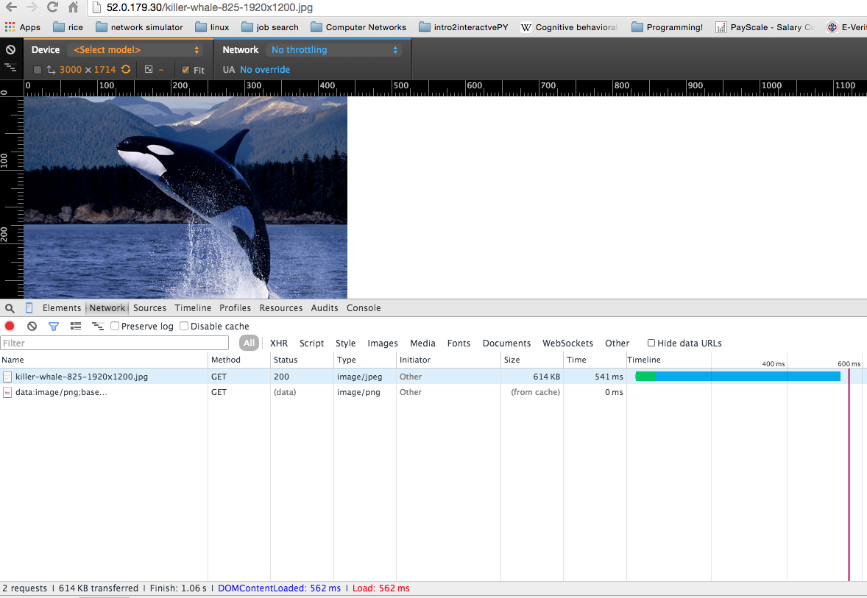

Following is the screen shot containing the statistics about the connections made for HTTPS request.

