Login Page with update Meta Tags from database=>

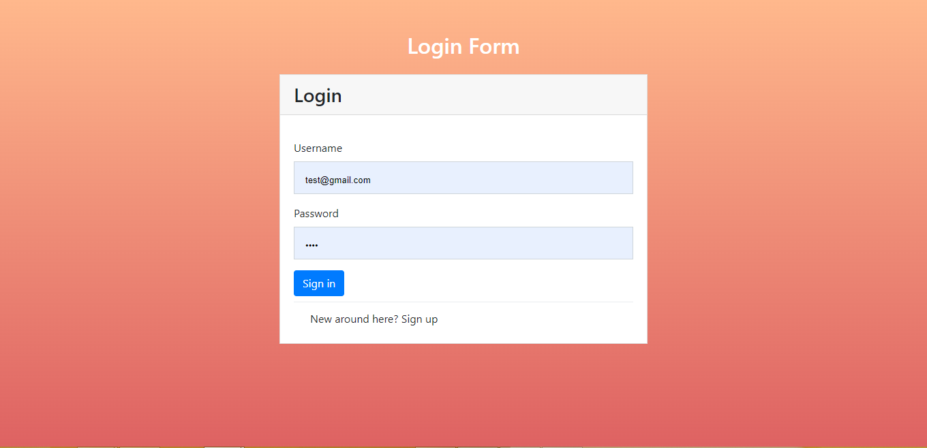

Register Page with update Meta Tags from database=>



Register Page display Register Users=>



Home Page with update Meta Tags from database=>

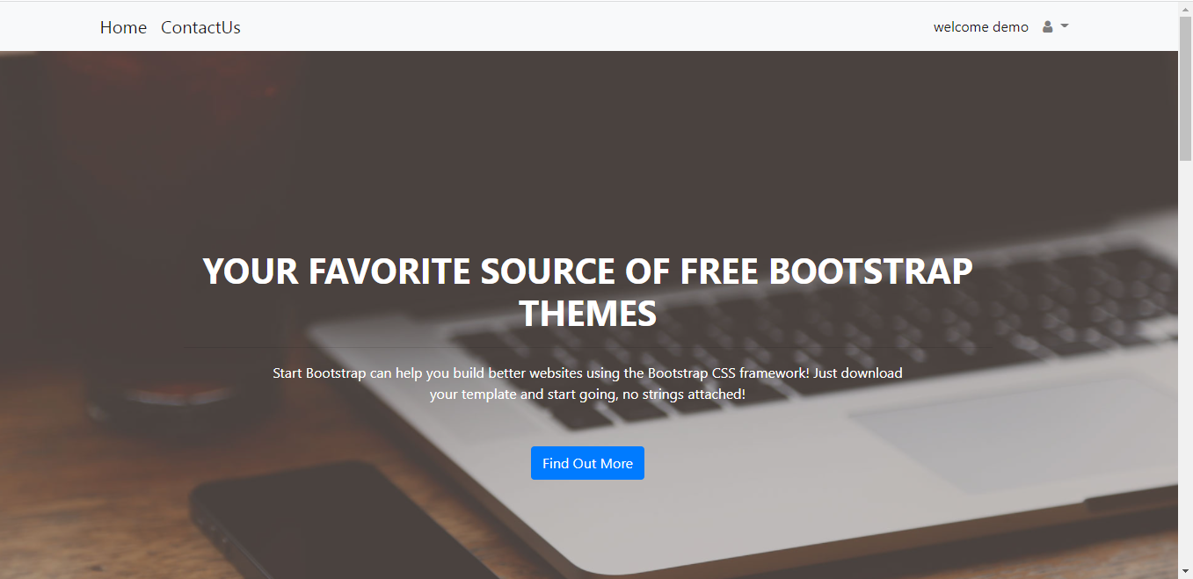

Ad rotator randomly select ads from database=>



Meta Tags=>

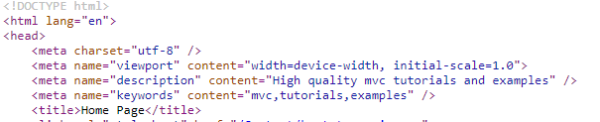

Contact Us Page with update Meta Tags from database=>

