**AGRITECH**

***Submitted by***

**Bandaru Bhaskar Sai Madhava Krishna ( RA2011003010109 )**

**Jagadeesh S - ( RA2011003010125 )**

**Praveen S - ( RA2011003010116 )**

***Under the Guidance of***

**Dr.T.K.Sivakumar**

**Assoc Prof., CTECH**

***In partial satisfaction of the requirements for the degree of***

**BACHELOR OF TECHNOLOGY**

**in**

**COMPUTER SCIENCE ENGINEERING**



**SCHOOL OF COMPUTING**

**COLLEGE OF ENGINEERING AND TECHNOLOGY**

**SRM INSTITUTE OF SCIENCE AND TECHNOLOGY**

**KATTANKULATHUR - 603203**

**JUNE 2022**



# SRM INSTITUTION OF SCIENCE AND TECHNOLOGY KATTANKULATHUR-603203

**BONAFIDE CERTIFICATE**

Certified that this lab report titled “**Agritech Application**” is the Bonafede work done by **Bandaru Bhaskar Sai Madhava Krishna (RA2011003010109)** who carried out the lab exercises under my supervision. Certified further, that to the best of my knowledge the work reported herein does not form part of any other work

| **Staff-in-charge**  **Dr.T.K.SIVAKUMAR**  **Asst.Prof.(Sr.Grade) / Computing Technologies** | **HEAD OF THE DEPARTMENT**  **Dr. M. Pushpalatha, Professor Dept. of Computing Technologies** |
| --- | --- |

University Examination held on …………..………….

**INTERNAL EXAMINAR – 1 INTERNAL EXAMINAR -2**

**ABSTRACT**

**Creates a portal between farmers, Agricultural labourers and also with big farmers or merchants willing to rent agricultural equipment. It solves the problem of finding agricultural labourers for farmers and also vice-versa for labourers in that surrounding region. Farmers can use agricultural machinery on rental basis without spending heavy amount on machinery. Also it will create an extra income for the other set of farmers or merchants by renting their equipment when not in use. A chart forum will help in discussing the doubts, opinions among the farmers from various regions.**

|  |  |  |  |
| --- | --- | --- | --- |
| **TABLE OF CONTENTS** | | | |
| **CHAPTER NO** | **TITLE** | **DATE** | **PAGE No** |
|  | **ABSTRACT** |  |  |
|  | **LIST OF FIGURES** |  |  |
|  | **LIST OF ABBREVIATIONS** |  |  |
| **1** | **PROBLEM STATEMENT** | **15.03.2022** | **7** |
| **2** | **STAKEHOLDERS & PROCESS MODELS** | **22.03.2022** | **11** |
| **3** | **IDENTIFYING REQUIREMENTS** | **29.03.2022** | **14** |
| **4** | **PROJECT PLAN & EFFORT** | **05.04.2022** | **16** |
| **5** | **WORK BREAKDOWN STRUCTURE & RISK ANALYSIS** | **12.04.2022** | **20** |
| **6** | **SYSTEM ARCHITECTURE, USE CASE & CLASS DIAGRAM** | **21.04.2022** | **25** |
| **7** | **ENTITY RELATIONSHIP DIAGRAM** | **06.05.2022** | **30** |
| **8** | **DATA FLOW DIAGRAM** | **13.05.2022** | **33** |
| **9** | **SEQUENCE & COLLABORATION DIAGRAM** | **20.05.2022** | **35** |
| **10** | **DEVELOPMENT OF TESTING FRAMEWORK/USER INTERFACE** | **27.05.2022** | **38** |
| **11** | **TEST CASES & REPORTING** | **11.06.2022** | **40** |
| **12** | **ARCHITECTURE/DESIGN/FRAMEWORK/IMPLE-MENTATION** | **17.06.2022** | **43** |
|  | **CONCLUSION** |  |  |
|  | **REFERENCES** |  |  |
|  | **APPENDIX (CODE)** |  |  |

## 

## 

|  |  |  |
| --- | --- | --- |
| **FIGURE NO** | **TITLE** | **PAGE NO** |
| **5.1** | **Work Breakdown Structure** | **20** |
| **6.1** | **System Architecture** | **27** |
| **6.2** | **Use Case Diagram** | **28** |
| **6.3** | **Class Diagram** | **29** |
| **7.1** | **Entity Relationship Diagram** | **32** |
| **8.1** | **Data Flow Diagram Level 0** | **34** |
| **8.2** | **Data Flow Diagram Level 1** | **34** |
| **9.1** | **Sequence Diagram** | **36** |
| **9.2** | **Collaboration Diagram** | **37** |
| **13.1** | **System Architecture (Modified)** | **27** |

**LIST OF ABBREVIATIONS**

| **ERT** - Entity Relationship Diagram |
| --- |
| **DFD** – Data Flow Diagram |

## **CHAPTER 1**

## Course Code: 18CSC206J Course Name: Software Engineering and Project Management

|  |  |
| --- | --- |
| **Experiment No** | 1 |
| **Title of Experiment** | To identify the Software Project, Create Business Case, Arrive at a Problem Statement |
| **Name of the candidate** | B.B.S.M.Krishna |
| **Team Members** | S.Jagadeesh, S.Praveen |
| **Register Number** | RA2011003010109 |
| **Date of Experiment** | 14-03-22 |

**Mark Split Up**

|  |  |  |  |  |  |
| --- | --- | --- | --- | --- | --- |
| **S.No** | **Description** |  |  | **Maximum Mark** | **Mark Obtained** |
| 1 | Exercise |  |  | 5 |  |
| 2 | Viva |  |  | 5 |  |
|  |  |  | **Total** | **10** |  |

## Staff Signature with date

**Aim**

To Frame a project team, analyze and identify a Software project. To create a business case and Arrive at a

Problem

Statement for the <title of the project>

**Project Title: AGRITECH – Digital Solution for providing farmers with workers and equipment**

**Team Members:**

|  |  |  |  |
| --- | --- | --- | --- |
| **S. No** | **Register No** | **Name** | **Role** |
| **1** | **RA2011003010109** | **B.B.S.M. Krishna** | **Leader and developer** |
| **2** | **RA2011003010125** | **S. Jagadeesh** | **Developer** |
| **3** | **RA2011003010116** | **S. Praveen** | **Developer** |

**Project Description: Creates a portal between farmers, Agricultural labourers and also with big farmers or merchants willing to rent agricultural equipment. It solves the problem of finding agricultural labourers for farmers and also vice-versa for labourers in that surrounding region. Farmers can use agricultural machinery on rental basis without spending heavy amount on machinery. Also it will create an extra income for the other set of farmers or merchants by renting their equipment when not in use. A chart forum will help in discussing the doubts, opinions among the farmers from various regions.**

**Business Case:**

|  |  |
| --- | --- |
| **DATE** | 14-03-2022 |
| **SUBMITTED BY** | B.B.S.M.Krishna, S. Jagadeesh, S. Praveeen |



**AGRITECH**

### THE PROJECT

In bullet points, describe the problem this project aims to solve or the opportunity it aims to develop.

|  |  |  |
| --- | --- | --- |
| 1) Connects Farmers and Agricultural labourers in the nearby villages | | |
| 2) Provides Agricultural equipment on rent | |  |
| 3) Farmers Forum |  |

### THE HISTORY

In bullet points, describe the current situation.

|  |  |  |
| --- | --- | --- |
| 1) Lack of communication between agricultural labourers and farmers | |  |
| 2) Small farmers can’t afford expensive machinery. |  |
| 3) There is no platform for farmers to share their doubts, opinions with other farmers | | |

### LIMITATIONS

List what could prevent the success of the project, such as the need for expensive equipment, bad weather, lack of special training, etc.

1. Unavailability of stable internet connection in remote areas
2. Unavailability of smartphones with some farmers and agricultural labourers 1) Difficulty in using the app to farmers

### APPROACH

List what is needed to complete the project.

|  |  |  |  |
| --- | --- | --- | --- |
| 1) Admin app |  | | |
| 2) App for farmers | |  | |
| 3) App for Agricultural labourers | | |  |
| 4) App for Customers Renting the equipment | | | |

### BENEFITS

In bullet points, list the benefits that this project will bring to the organization.

|  |  |  |
| --- | --- | --- |
| 1) Organization takes 10% of the transaction amount as their commission | | |
| 2) Membership fees paid by Customers |  | |
| 3) Promotions and Advertisement Commissions | |  |

Result:

Thus, the project team formed, the project is described, the business case was prepared and the problem statement was arrived.

### **CHAPTER 2**

### Course Code: 18CSC206J Course Name: Software Engineering and Project Management

|  |  |
| --- | --- |
| **Experiment No** | 2 |
| **Title of Experiment** | To Prepare STAKEHOLDER Register |
| **Name of the candidate** | B.B.S.M.Krishna |
| **Team Members** | S.Jagadeesh, S.Praveen |
| **Register NumberS** | RA2011003010109, RA2011003010125, RA2011003010116 |
| **Date of Experiment** | 14-03-22 |

### Mark Split Up

|  |  |  |  |  |
| --- | --- | --- | --- | --- |
| **S.No** | **Description** | | **Maximum Mark** | **Mark Obtained** |
| 1 | Exercise |  | 5 |  |
| 2 | Viva |  | 5 |  |
|  |  | **Total** | **10** |  |

|  |  |  |  |  |  |  |  |  |  |
| --- | --- | --- | --- | --- | --- | --- | --- | --- | --- |
| **PROJETCT NAME : AGRITECH** | | | | | | | | | |
| **PROJECT BY : B.B.S.M.KRISHNA,JAGADEESH S,PRAVEEN S** | | | | | | | | | |
| **DATE : 22/03/2022** | | | | | | | | | |
| **S.N**  **O** | **STAKEHOLD**  **ERS**  **NAME** | **ROLE** | **EXPERTISE** | **CATEGORY** | **COMMUNICATION** | | | **IMPACT** | **EXPECTATIONS** |
| **EMAIL** | **MOBILE**  **NUMBER** | **TYPES AND**  **FREQUENCY OF**  **COMMUNICATION** |
| 1 | B.B.S.M.KRISHNA | 1. Project leader 2. Developer | 1. Project   Management   1. Software   Development And  Programming languages and Environment | INTERNAL | bb2360@srmist  .edu.in | 8445566 149 | ANY KIND | HIGH | 1. PROJECT   DELIVERY ON  TIME (CRM  Function, Client,  Tasks, Documents)     1. Stable Software |
| 2 | JAGADEESH S | 1. Developer 2. Tester | 1) Software  Development  2)  Programming languages and Environment | INTERNAL | Js9441@srmist.  edu.in | 7397391  381 | PHONE | HIGH | Error free code |
| 3 | PRAVEEN S | 1. Developer 2. Marketing   assistant | 1) Marketing Strategies 2) Program  Language | INTERNAL | Ps6782@srmist  .edu.in | 9840389  507 | EMAIL | HIGH | Full compliance to current marketing strategies and technologies |

**CHAPTER-3**

# **AGRITECH**

**TEAM MEMBERS:**



1. **B.B.S.M.krishna (RA2011003010109)**
2. **Jagadeesh S (RA2011003010125)**
3. **Praveen S (RA2011003010116)**

**STAKEHOLDER REQUIRMENTS:**

1. **Description of project**
2. **Return on investment**
3. **Manage customer databases**

**SYSTEM REQUIRMENTS:**

* 1. **Server to keep the website up and running 24*7**
  2. **A workspace setup**
  3. **A stable functional network**

|  |  |
| --- | --- |
| **Operating system** | **Windows 10 or later** |
| **Processor** | **I5or later** |
| **Memory** | **4GB minimum , 8GB recommended** |
| **Screen resolution** | **1280 X 720 or larger** |
| **Application window size** | **1280 X 720 or larger** |
| **Internet connection** | **Required** |

**Functional Requirements:**

* 1. **Displaying assignment in the worker’s section once created by the farmer**
  2. **Providing details of the equipment lenders to farmers after clicking on a particular equipment**
  3. **Displaying the status of assignment acceptance to the farmers**

**NON-FUNCTIONAL REQUIRMENTS:**

* 1. **Communications between workers and farmer**
  2. **Interaction between farmers in their own language**
  3. **User friendly**

**Result: Therefore Requirements have been specified.**

# **CHAPTER-4**

Team Members:

1. B.B.S.M.Krishna (RA2011003010109)
2. S.Jagadeesh (RA2011003010125)
3. S.Praveen (RA2011003010116

Project Plan:

Agritech is a digital startup focussing primarily on providing services in the agricultural sector

The Aim of the project is to make an android based application that connects farmers, agricultural workers and lenders.

* 1. To help farmers in finding workers within their proximity quickly and easily
  2. To provide work to agricultural workers by connecting them to farmers
  3. To provide farming equipment on rent to the farmers from lenders

Kilo lines of code = 500

## Basic COCOMO

|  |  |  |  |
| --- | --- | --- | --- |
| Software Projects A | B | C | D |
| Organic 2.4 | 1.05 | 2.5 | 0.38 |
| Semi Detached 3.0 | 1.12 | 2.5 | 0.35 |

Embedded 3.6 1.20 2.5 0.32

## Organic

Effort = 1637.30 Person-Months

Development Time 41.61 Months

Average staff required = Effort/Time= 39.34 Persons

## Semi Detached

Effort = 3162.04 Person Months

Development Time = 41.96 Months

Average Staff Required = 75.35 Persons

|  |  |  |
| --- | --- | --- |
| Project Attributes |  |  |
| RSR | High | 1.15 |
| SAD | High | 1.08 |
| COP    Hardware Attributes | Very High | 1.36 |
| RPC | High | 1.11 |
| Memory Cost | High | 1.06 |
| Volume | Ver High | 1.30 |
| RTT    Personal Attributes | High | 1.07 |
| AC | N | 1.00 |
| AE | N | 1.00 |
| SEC | N | 1.00 |
| VMF | L | 1.10 |
| PLE    Project Attributes | N | 1.00 |
| App SEM | N | 1.00 |
| Use of Software | L | 1.10 |
| RDS | N | 1.00 |
| Intermediate COCOMO |

Effort = 16229.9865 persons- month

1. PROJECT SPONSOR : Vijay

1. SUBJECT MATTER EXPERTS (SME): T. Sivakumar

1. PRODUCT OWNER: S. Jagadeesh

1. PROJECT MANAGER (PM): Krishna Bandaru

1. TECHNICAL LEAD: Krishna Bandaru

1. SOFTWARE DEVELOPERS: Krishna Bandaru, S. Jagadeesh

1. SOFTWARE TESTER: S. Jagadeesh

1. USER ACCEPTANCE TESTER: S. Praveen

**CHAPTER 5**

WBS, Timeline, Risk Analysis

NAME : KRISHNA BBSM(RA2011003010109)(REP)

JAGADEESH S(RA2011003010125)

PRAVEEN S(RA2011003010116)

CLASS : CSE B1

|  |  |  |
| --- | --- | --- |
| Sl No | Register No | Role |
| 1 | RA20110030109 (B.B.S.M.Krishna) | Rep |
| 2 | RA2011003010125 (Jagadeesh.S) | Member |
| 3 | RA2011003010116 (Praveen.S) | Member |

|  |
| --- |
| 0.0 |

WORK BREAKDOWN STRUCTURE

4.1

Project

Management

Requirements

Gathering

Design and

Analysis

Application

Development

Testing and

Production

Application Design

and Implementation

Backend Software

User

Interface

Transaction

Database

Implementation

Middleware

Development

Cloud Server

Software

-

as

-

a

-

service

Content Creation

Android Application

1

,

0

2.0

3.0

4.0

5.0

4.1

4.2

4.3

4.4

4.2.1

4.2.2

4.2.3

4.2.4

4.2.5

0.0 Retail Web Site

1.0 Project Management

2.0 Requirements Gathering

3.0 Analysis &amp; Design

4.0 Site Software Development

◦ 4.1 HTML Design and Creation

◦ 4.2 Backend Software

* 4.2.1 Database Implementation
* 4.2.2 Middleware Development
* 4.2.3 Security Subsystems
* 4.2.4 Catalog Engine
* 4.2.5 Transaction Processing

◦ 4.3 Graphics and Interface

◦ 4.4 Content Creation

5.0 Testing and Production

### TIMELINE – GANTT CHART

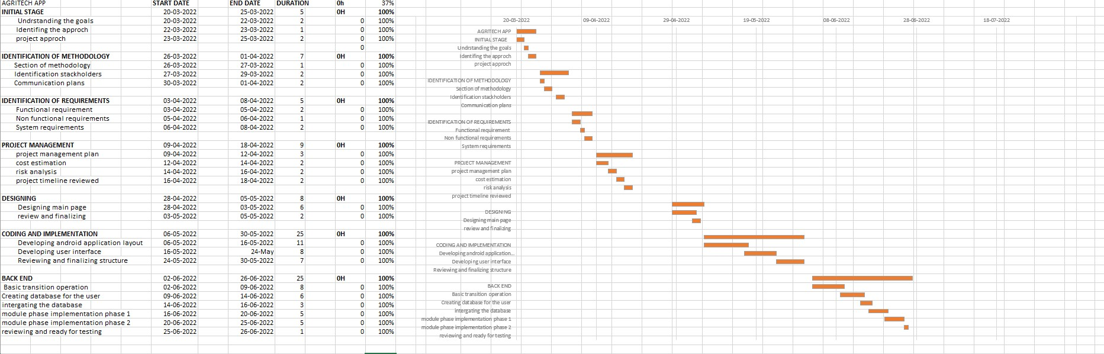

### RISK ANALYSIS – SWOT &amp; RMMM

STRENGTHS STRENGTHS

* Good Content WEAKNESS
* User friendly design • Poor mobile optimization
* Quick sign up • Poor server maintPoor images enance
* Server reliability

### 

### SWOT

OPPORTUNITIES THREATS

* New Market • Difficulty in Gathering
* Internet on data

Mobile phones • New Competitors

* New • Complex User Interface

Technology

### RISK MANAGEMENT FRAMEWORK-RISK AND MITIGATION

|  |  |  |
| --- | --- | --- |
| RESPONSE | STRATEGY | EXAMPLES |
| AVOID | Risk avoidance is a strategy where the project team takes action to remove the threat of the risk or protect from the impact | * Extending the schedule * Reducing/removing scope * Change the execution strategy |
| Transfer | Risk transference involves shifting or transferring the risk threat and impact to a third party. Rather transfer the responsibility and ownership | * Purchasing insurance * Performance bonds * Warranties * Contract issuance(lumpsum) |
| Mitigate | Risk mitigation is a strategy were by the project team takes a action to reduce the probability of the risk occurring .This dose not risk or potential impact ,but rather reduces the likelihood of it becoming real | * Increasing testing * Changing suppliers to a more stable one * Reducing process complexity |
| Accept | Risk acceptance means the team acknowledges the risk and its potential impact, but decides not to take any pre-emptive action to prevent it . it is deal with only if it occurs | * Contingency reserve budgets * Management schedule   float   * Event contingency |

Result:

Thus, the work breakdown structure with timeline chart and risk table were formulated successfully.

**CHAPTER 6**

System Architecture, Use Case and Class Diagram

### Course Code: 18CSC206J Course Name: Software Engineering and Project Management

|  |  |
| --- | --- |
| Experiment No | 6 |
| Title of Experiment | System Architecture, Use Case and Class Diagram |
| Name of the candidate | PRAVEEN S |
| Team Members | Jagadeesh S,B.B.S.M.Krishna |
| Register Number | RA2011003010116 |
| Date of Experiment | 12/06/2022 |

**Aim:**

To create System Architecture, Use Case and Class Diagram

**Team Members:**

|  |  |  |  |
| --- | --- | --- | --- |
| **S No** | **Register No** | **Name** | **Role** |
| 1 | RA2011003010109 | B.B.S.M. Krishna | Rep |
| 2 | RA2011003010125 | Jagadeesh S | Member |
| 3 | RA2011003010116 | Praveen S | Member |

### SYSTEM ARCHITECTURE

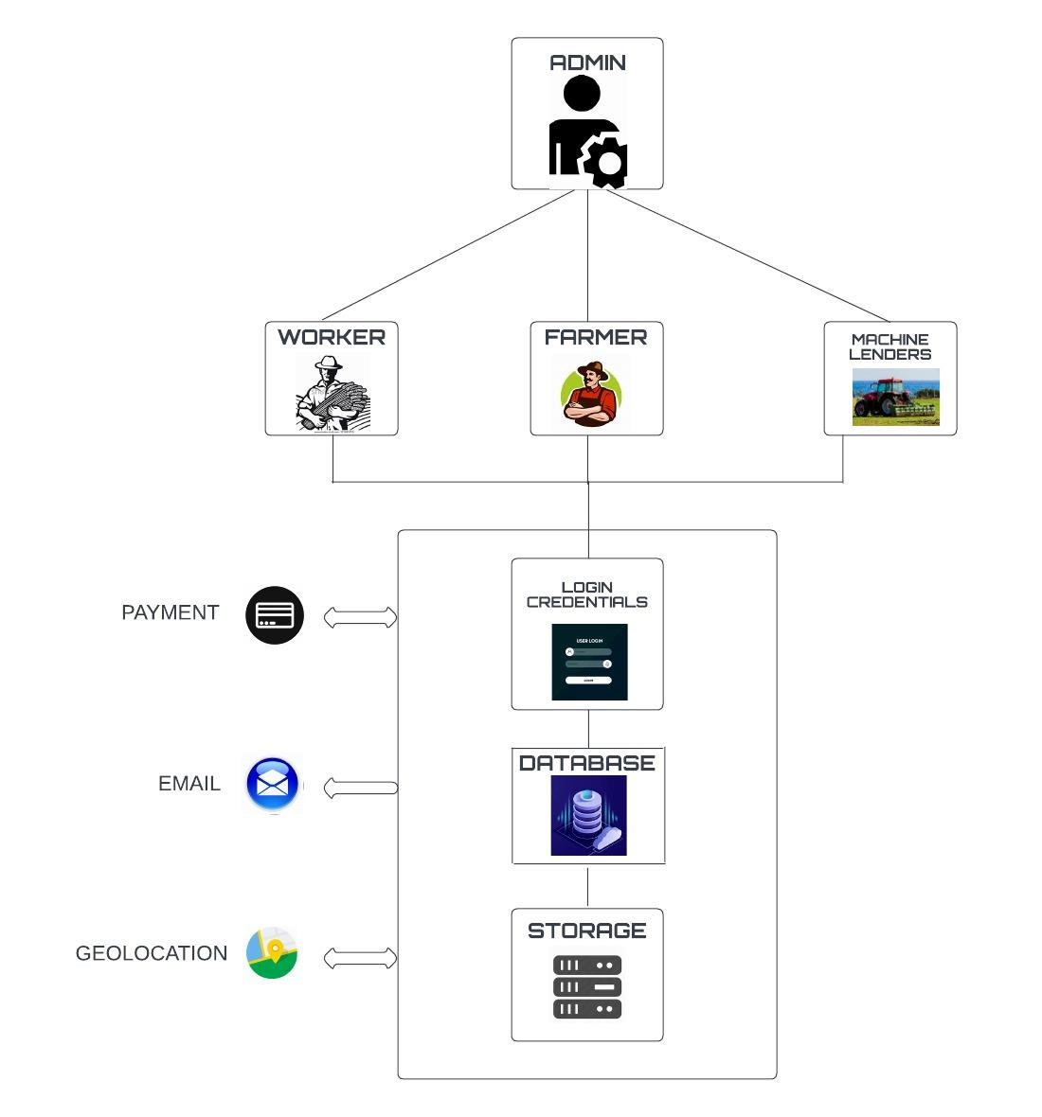

### USE CASE DIAGRAM

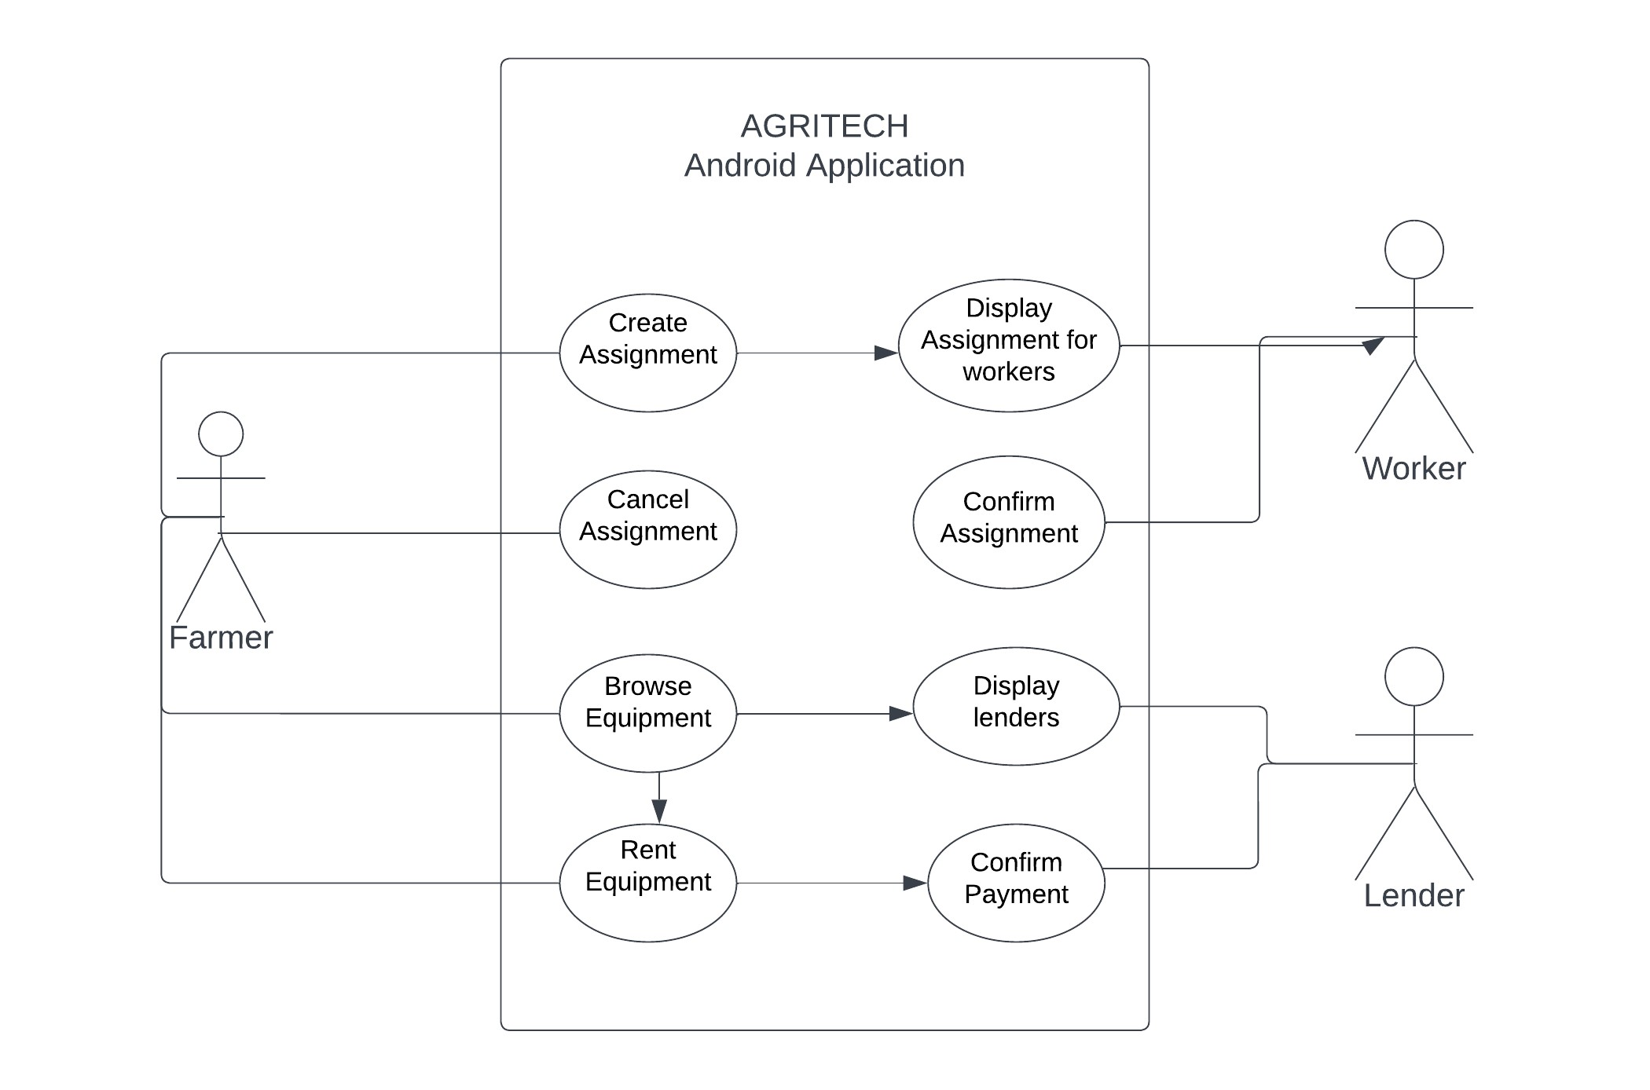

### CLASS DIAGRAM

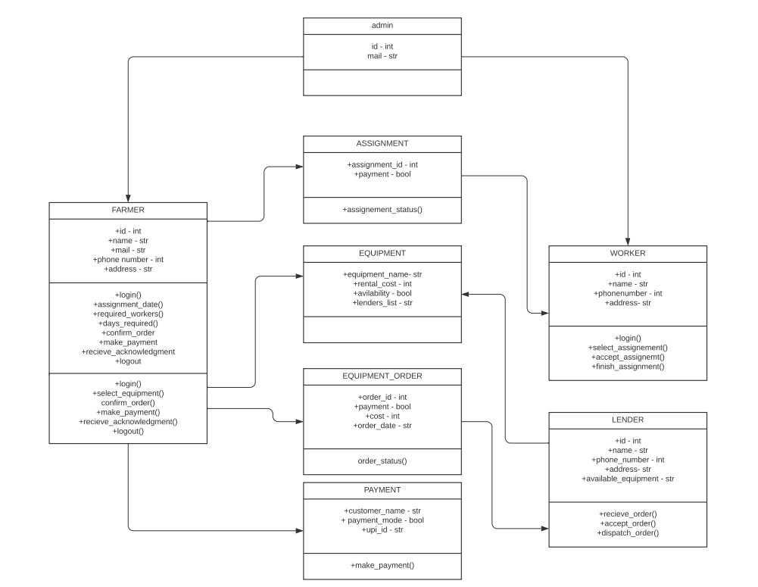

**Result:**

Thus, System Architecture, Use Case and Class Diagram is created.

**CHAPTER 7**

**Course Code: 18CSC206J**

|  |  |  |  |
| --- | --- | --- | --- |
| **S. No** | **Description** | **Maximum Mark** | **Mark Obtained** |
| 1 | Exercise | 5 |  |

#### Course Name: Software Engineering and Project Management

|  |  |
| --- | --- |
| **Experiment No** | 7 |
| **Title of Experiment** | Design a Entity relationship diagram |
| **Name of the candidate** | B.B.S.M.Krishna |
| **Team Members** | B.B.S.M KRISHNA  S JAGADEESH  PRAVEEN S |
| **Register Number** | RA2011003010109 |
| **Date of Experiment** | 23/5/22 |

**Mark Split Up**

|  |  |  |  |  |
| --- | --- | --- | --- | --- |
| 2 | Viva |  | 5 |  |
|  |  | **Total** | **10** |  |

### Staff Signature with date

**Aim**

To create the Entity Relationship Diagram

**Team Members:**

|  |  |  |  |
| --- | --- | --- | --- |
| **S No** | **Register No** | **Name** | **Role** |
| **1** | **RA2011003010109** | **BBSM KRISHNA** | **Rep** |
| **2** | **RA2011003010125** | **JAGADEESH S** | **Member** |
| **3** | **RA2011003010116** | **PRAVEEN S** | **Member** |

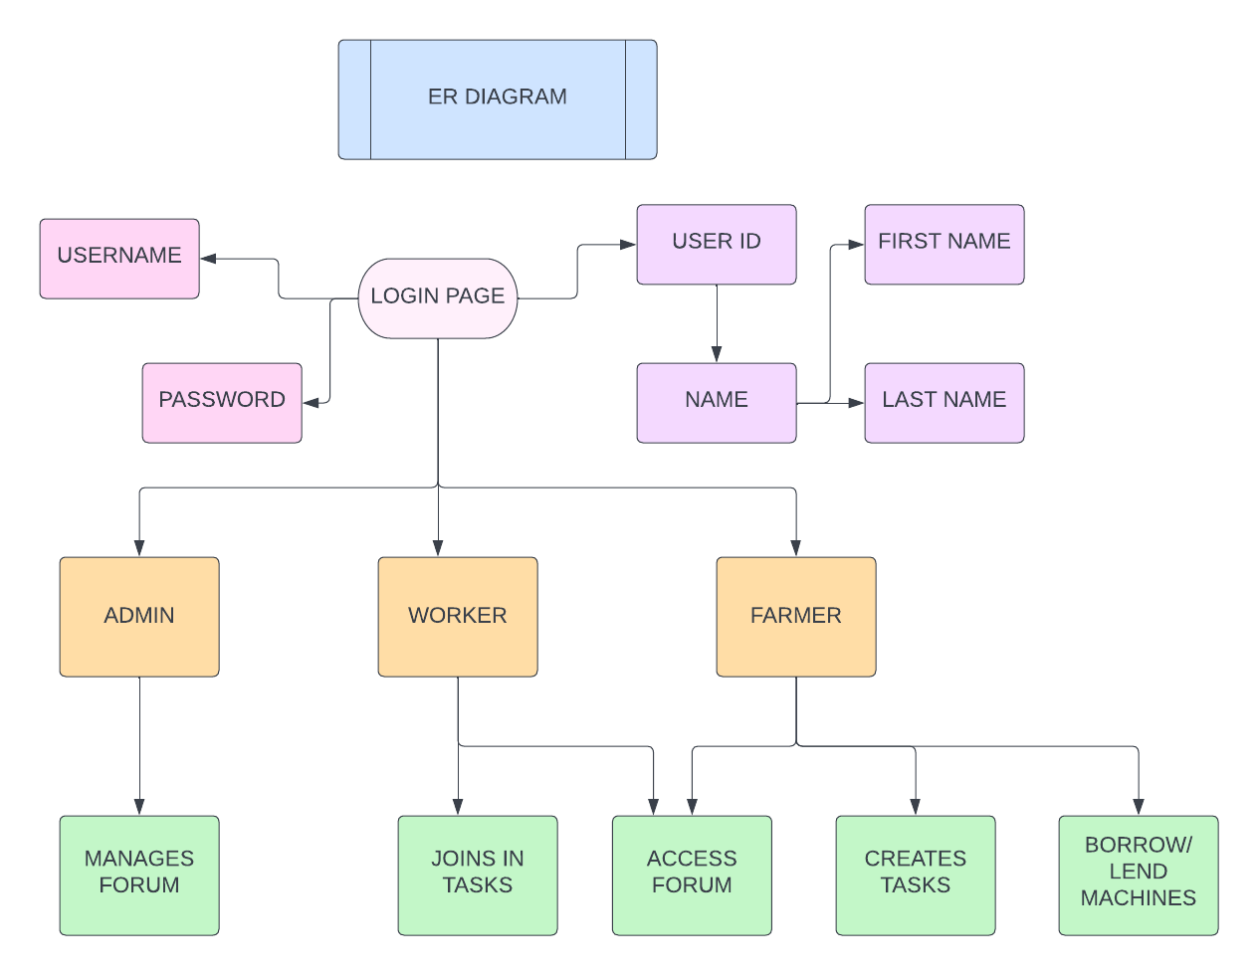

Result:

Thus, the entity relationship diagram was created successfully.

**CHAPTER 8**

**Course Code: 18CSC206J**

**Course Name: Software Engineering and Project Management**

|  |  |
| --- | --- |
| **Experiment No** | 8 |
| **Title of Experiment** | Develop a Data Flow Diagram (Process-Up to Level 1) |
| **Name of the Candidate** | B.B.S.M. Krishna |
| **Team Members** | Jagadeesh S, Praveen S |
| **Register Number** | RA2011003010109 |
| **Date of Experiment** | 25-05-2022 |

**Aim:** To develop the data flow diagram up to level 1 for the Agritech Application

**Team Members:**

|  |  |  |  |
| --- | --- | --- | --- |
| **S No** | **Register No** | **Name** | **Role** |
| 1 | RA2011003010109 | B.B.S.M. Krishna | Rep |
| 2 | RA2011003010125 | Jagadeesh S | Member |
| 3 | RA2011003010116 | Praveen S | Member |

**DFD Diagram:**

**Level 1:**

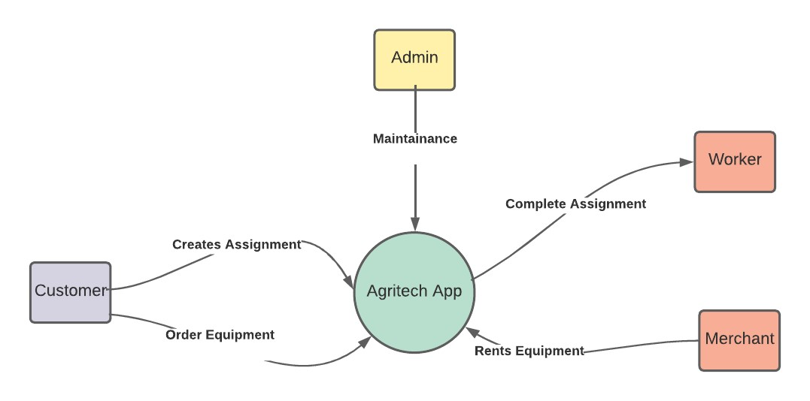

**Level 2:**

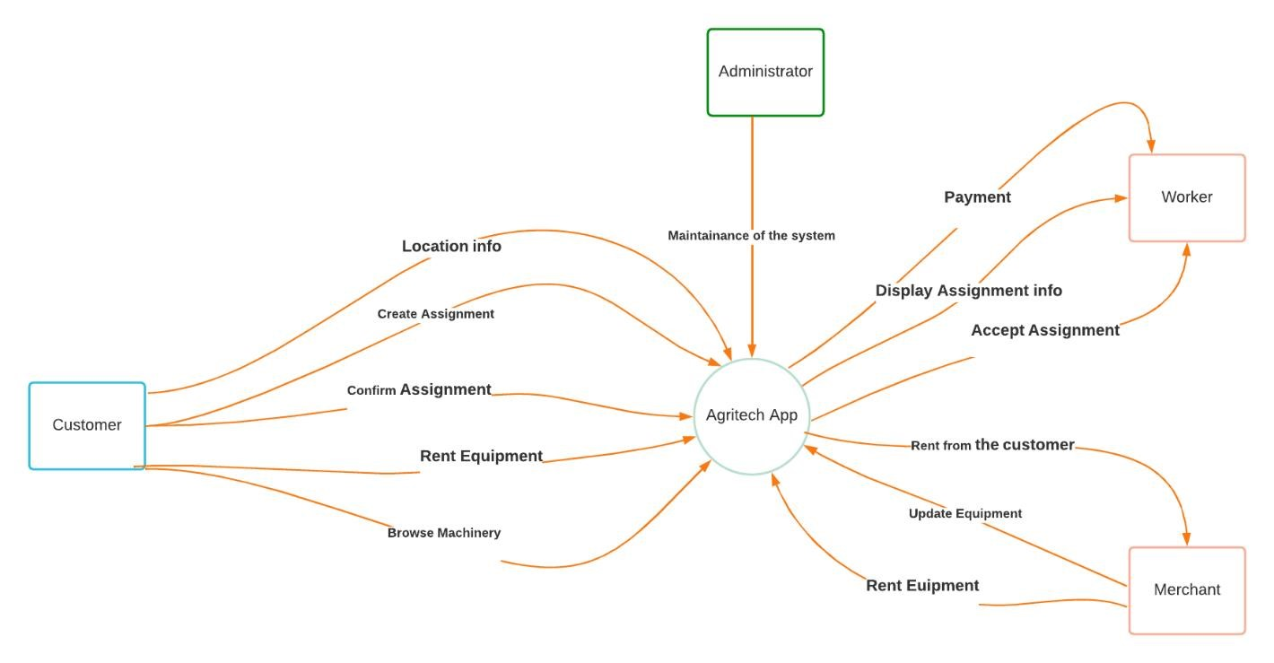

**Result:** Thus, the data flow diagrams have been created for the Agritech Application

**CHAPTER 9**

|  |  |
| --- | --- |
|  | 9 |
|  | Design a Sequence and Collaboration Diagram |
|  | B.B.S.M. Krishna |
|  | Jagadeesh S, Praveen S |
|  | RA2011003010109, RA2011003010116, RA2011003010125 |
|  | 09-06-2022 |

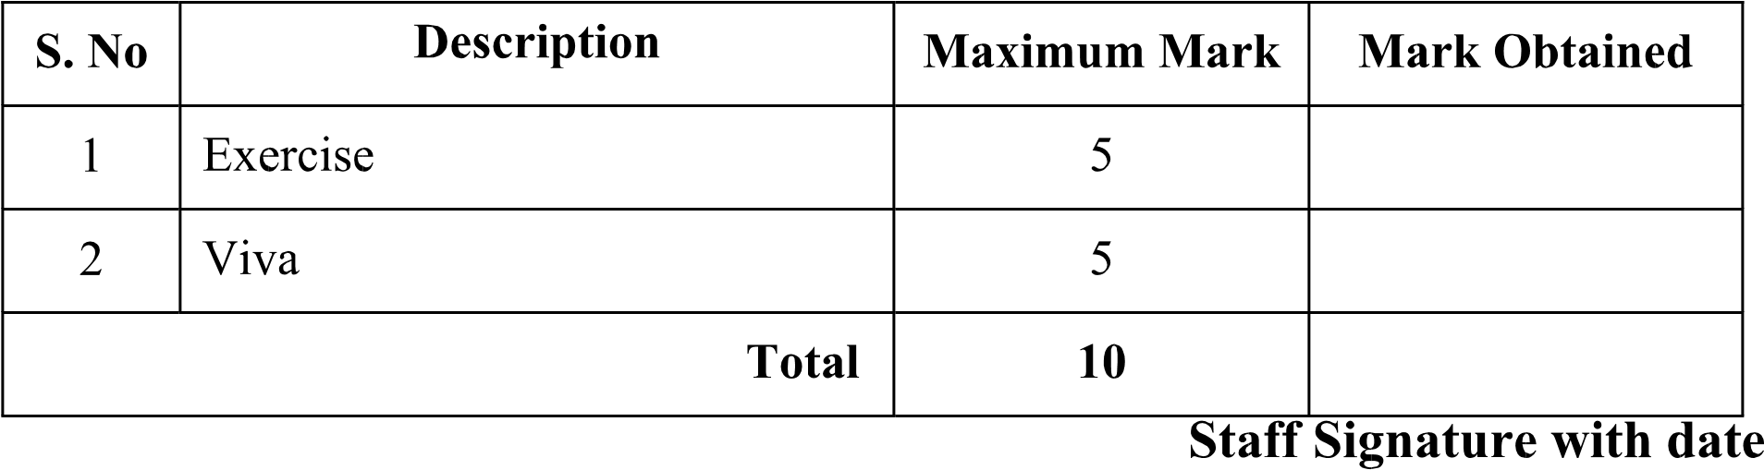

Aim: To create the sequence and collaboration diagram for the Agritech Application

|  |  |  |  |
| --- | --- | --- | --- |
|  |  |  |  |
|  | RA2011003010109 | B.B.S.M. Krishna |  |
|  | RA2011003010125 | Jagadeesh S |  |
|  | RA2011003010116 | Praveen S |  |

Sequence Diagram:

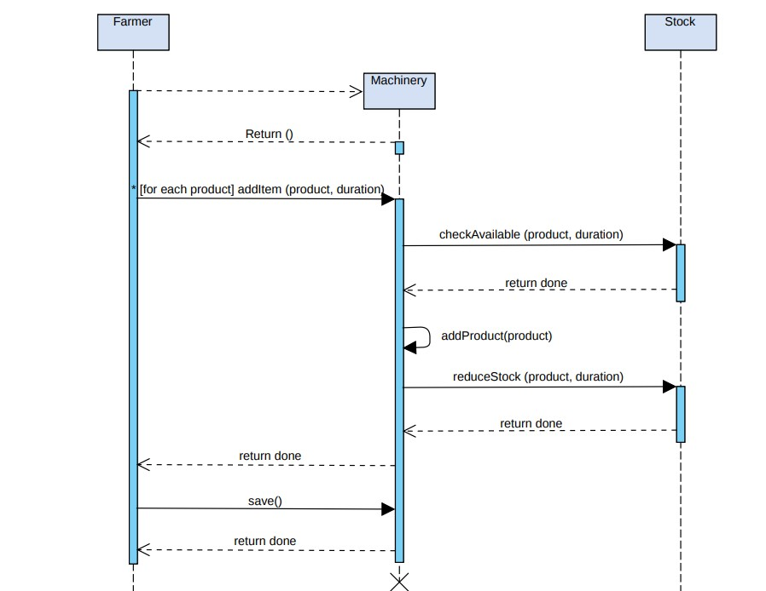

Collaboration Diagram:

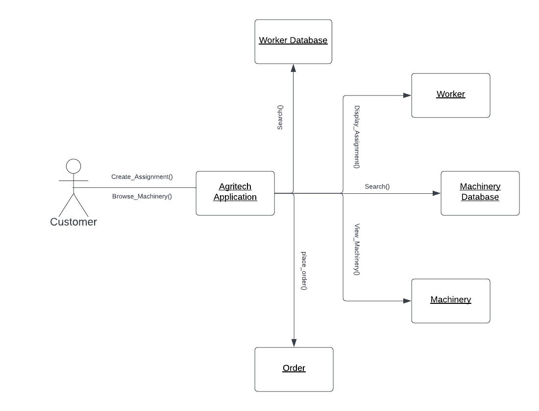

Result: Thus, the sequence and collaboration diagrams were created for the Agritech Application

**CHAPTER 10**

**Course Code: 18CSC206J**

#### Course Name: Software Engineering and Project Management

|  |  |
| --- | --- |
| **Experiment No** | 10 |
| **Title of Experiment** | Develop a Testing Framework/User Interface |
| **Name of the candidate** | B.B.S.M. Krishna |
| **Team Members** | Jagadeesh S, Praveen S |
| **Register Number** | RA2011003010109 |
| **Date of Experiment** | 08-06-22 |

**Mark Split Up**

|  |  |  |  |  |
| --- | --- | --- | --- | --- |
| **S. No** | **Description** |  | **Maximum Mark** | **Mark Obtained** |
| 1 | Exercise |  | 5 |  |
| 2 | Viva |  | 5 |  |
|  | | **Total** | **10** |  |

### Staff Signature with date

**Aim**: To develop the testing framework and/or user interface framework for the Agritech Application

**Team Members:**

|  |  |  |  |
| --- | --- | --- | --- |
| **S No** | **Register No** | **Name** | **Role** |
| **1** | RA2011003010109 | B.B.S.M. Krishna | **Rep/Member** |
| **2** | RA2011003010116 | Praveen S | **Member** |
| **3** | RA2011003010125 | Jagadeesh S | **Member** |

|  |  |  |  |
| --- | --- | --- | --- |
| Category |  | Methodology | Tools Required |
| Functional  Requirements |  | Manual | Word Template |
| • | Test | the installation and Uninstallation | of the App |
| • | Test the login and log out of the account | | |
| • | Test the equipment display | | |
| • | Test the signup for new user | | |
| • | Test the assignment process | | |
| • | Test | whether equipment update is in s | ync with merchant and customer |
| Category |  | Methodology | Tools Required |
| Non- Functional Requirements | | Manual | Word Template |

* Test whether UI is understandable
* Test whether Application is reliable
* Test whether application is working when internet is slow

Summary:

Most of the Functional Modules and Non-Functional are modules are covered. Further testing will be done when modules are added in the future.

Result:

Thus, the testing framework/user interface framework has been created for the Agritech Application

**CHAPTER 11**

**Course Code: 18CSC206J**

#### Course Name: Software Engineering and Project Management

|  |  |
| --- | --- |
| **Experiment No** | 11 |
| **Title of Experiment** | Test Cases |
| **Name of the candidate** | B.B.S.M. Krishna |
| **Team Members** | Jagadeesh S, Praveen S |
| **Register Number** | RA2011003010109 |
| **Date of Experiment** | 20/06/2022 |

**Mark Split Up**

|  |  |  |  |  |
| --- | --- | --- | --- | --- |
| **S. No** | **Description** |  | **Maximum Mark** | **Mark Obtained** |
| 1 | Exercise |  | 5 |  |
| 2 | Viva |  | 5 |  |
|  |  | **Total** | **10** |  |

### Staff Signature with date

**Aim** : To develop the test cases manual for the Agritech Application

**Team Members:**

|  |  |  |  |
| --- | --- | --- | --- |
| **S No** | **Register No** | **Name** | **Role** |
| **1** | RA2011003010109 | B.B.S.M. Krishna | **Rep** |
| **2** | RA2011003010125 | Jagadeesh S | **Member** |
| **3** | RA2011003010116 | Praveen S | **Member** |

**Test Case**

**Functional Test Cases**

|  |  |  |  |  |  |  |  |  |  |  |  |  |  |  |
| --- | --- | --- | --- | --- | --- | --- | --- | --- | --- | --- | --- | --- | --- | --- |
| **Test**  **ID**  **(#)** | **Test**  **Scenario** | **Test Case** | | **Execution Steps** | | | **Expected Outcome** | | **Actual Outcome** | **Status** | | | **Remarks** | |
| 1. | Verify User Registration from India | Accept Valid  India Mobile Number on the Page#1 | | 1.1  User clicks on User Registration link  2.2  Enter the mobile Number in the text box  3.3 Click  Register button | | | User should be taken to the next page for entering  more user details | | A form will pop for registration and ask for the details. | Pass | | | success | |
| 2. | Summary pick from database |  | | 2.1 User open the application 2.2 Summary pickup is fetched from the data base | | | Summary pickup is fetched and displayed | | Summary pickup is displayed | Pass | | | Success | |
| 3 | Live location | |  | | App ask for the live location of the user | It accesses the location | | Uses the user location for tracking | | | pass | Success | |

**Non-Functional Test Cases**

|  |  |  |  |  |  |  |  |
| --- | --- | --- | --- | --- | --- | --- | --- |
| **Test ID (#)** | **Test**  **Scenario** | **Test Case** | **Execution Steps** | **Expected Outcome** | **Actual Outcome** | **Status** | **Remarks** |
| 1. | Feature Testing | All the operations are  working | 1. Each operation in the software  is  executed at least once  The features are tested for proper execution | Operations are able to execute  properly | Operations executed  properly | Pass | Success |
| 2 | Load Testing | Performan  ce of the application under maximum  load | Functionalities of the application are  run over a long  period of time under maximum load to check degradation | Functionalitie s continue to run at  optimum  levels | Functionalitie s kept running at the optimum level | pass | success |
| 3 | Usability Testing | Ease of use of the application (User Friendlines  s) | 5 testers are chosen at random and are  assigned to  complete tasks on the application infront of the developing team, which monitors the testers behaviors and expressions and evaluates the outcome according | The application is user friendly and easy to use. The controls and jargons are selfexplanatory | The application is user friendly, aesthetically pleasing and easy to use. | Pass | Success |

**Result:** Thus, the test case manual has been created for the Agritech Application

**CHAPTER 12**

**Course Code: 18CSC206J**

#### Course Name: Software Engineering and Project Management

|  |  |
| --- | --- |
| **Experiment No** | 12 |
| **Title of Experiment** | Manual Test Case Reporting |
| **Name of the candidate** | B.B.S.M.Krishna |
| **Team Members** | Jagadeesh S, Praveen S |
| **Register Number** | RA2011003010125 , RA2011003010116 , RA2011003010109 |
| **Date of Experiment** | 17-06-2022 |

**Mark Split Up**

|  |  |  |  |  |
| --- | --- | --- | --- | --- |
| **S. No** | **Description** |  | **Maximum Mark** | **Mark Obtained** |
| 1 | Exercise |  | 5 |  |
| 2 | Viva |  | 5 |  |
|  | | **Total** | **10** |  |

### Staff Signature with date

**Aim**

To prepare the manual test case report for Agritech Application

**Team Members:**

|  |  |  |  |
| --- | --- | --- | --- |
| **S No** | **Register No** | **Name** | **Role** |
| **1** | RA2011003010109 | B.B.S.M. KRISHNA | **Rep/Member** |
| **2** | RA2011003010125 | JAGADEESH S | **Member** |
| **3** | RA2011003010116 | PRAVEEN S | **Member** |

**Testing:**

This section consists of the test plans and test suites carried out on some of the features in the application. The features tested were the home page, contact page and the about page.

**Test Traceability Matrix (for Unit Testing, Integration Testing, and System Testing):**

During the implementation of this application, some errors came up and they were corrected. Below are the error reports encountered and their respective corrections.

|  |  |  |
| --- | --- | --- |
| **Category** | **Progress Against Plan** | **Status** |
| Verify User Registration (1) | Green | Completed |
| Verify Valid mail id (2) | Green | Completed |
| Verify User Type (3) | Green | Completed |
| Verify History of  Assignments and orders (4) | Green | Completed |
| Responsiveness (5) | Green | Completed |
| Checking the working of payment page (6) | Amber | In progress |
| Checking Time for retrieving  Database data  (7) | Green | Completed |
| Checking the Working of forum (8) | Amber | In progress |

|  |  |  |
| --- | --- | --- |
| **Functional** | **Test Case Coverage (%)** | **Status** |
| 1 | 90% | Completed |
| 2 | 70% | Completed |
| 3 | 100% | Completed |
| 4 | 100% | Completed |
| 5 | 60% | Completed |
| 6 | 30% | In-Progress |
| 7 | 100% | Completed |
| 8 | 40% | In-Progress |

**Test Report Summary (for Unit Testing, Integration Testing, and System Testing)**:

All the test cases and suite carried out for this application were successful. No error was encountered during the testing phase

Result:

Thus, the test case report has been created for Agritech Application.



**School of Computing**

**SRM IST, Kattankulathur – 603 203**

**Course Code: 18CSC206J**

#### Course Name: Software Engineering and Project Management

|  |  |  |  |
| --- | --- | --- | --- |
| **Experiment No** | 13 |  |  |
| **Title of Experiment** | Provide the details  Design/Framework/Implementation | of | Architecture |
| **Name of the candidate** | B.B.S.M.Krishna |  |  |
| **Team Members** | Jagadeesh S, Praveen S |  |  |
| **Register Numbers** | RA2011003010109 |  |  |
| **Date of Experiment** | 08-06-22 |  |  |

**Mark Split Up**

|  |  |  |  |  |
| --- | --- | --- | --- | --- |
| **S. No** | **Description** |  | **Maximum Mark** | **Mark Obtained** |
| 1 | Exercise |  | 5 |  |
| 2 | Viva |  | 5 |  |
|  | | **Total** | **10** |  |

### Staff Signature with date

**Aim**: To provide the details of architectural design/framework/implementation **Team Members:**

|  |  |  |  |
| --- | --- | --- | --- |
| **S No** | **Register No** | **Name** | **Role** |
| **1** | RA2011003010109 | B.B.S.M.Krishna | **Rep/Member** |
| **2** | RA2011003010125 | Jagadeesh S | **Member** |
| **3** | RA2011003010116 | Praveen S | **Member** |

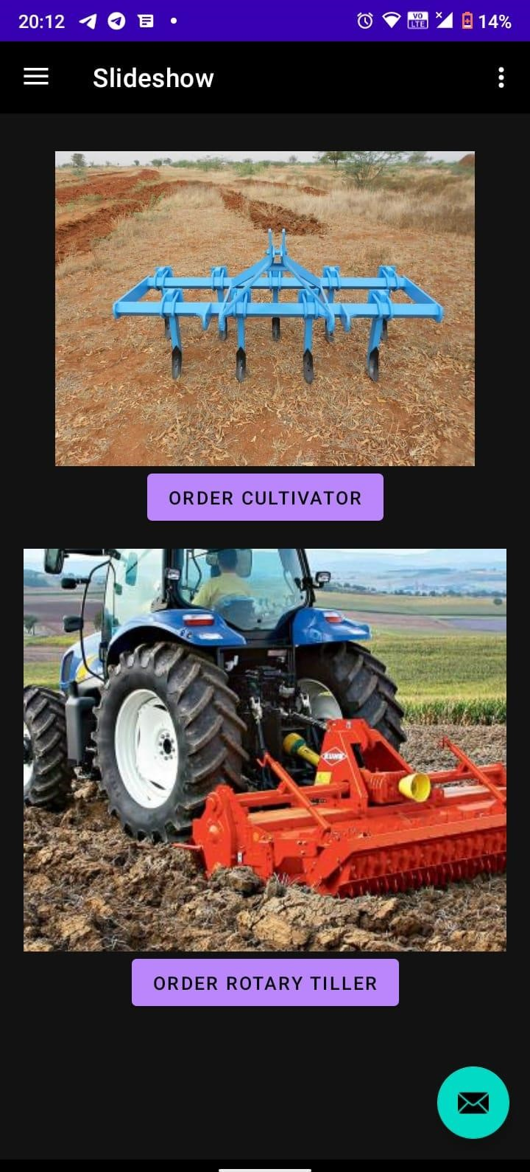

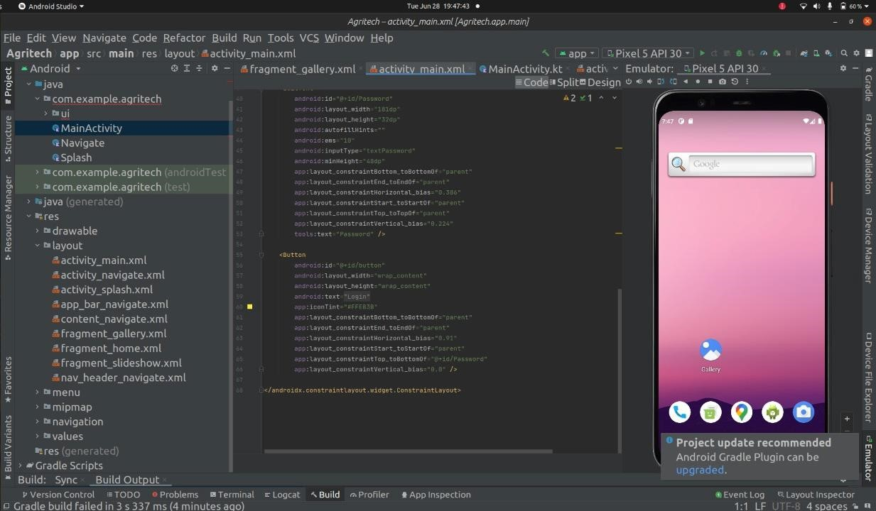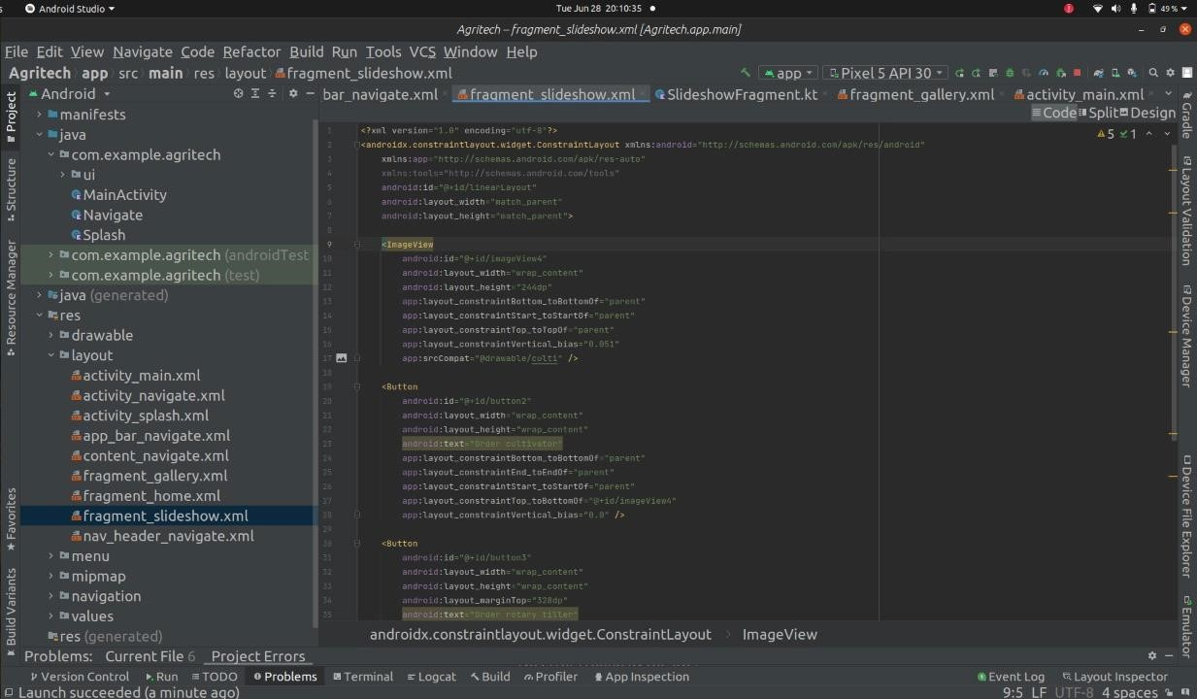

Result:

Thus, the details of architectural design/framework/implementation along with the screenshots were provided.