**CABLEPAY**

**Front End**

***Version 1.0***

***Christophe Cartwright***

***Clint Roberts***

***IT Developers***

# **Table of Contents**

Table of Contents 2

Introduction 3

I. Four Core Functions of CablePay 3

A. My Profile 4

B. My Statement 5

C. Payment Centre 7

D. Contact Us 8

II. Additional Functions of CablePay 9

A. Sign Up 9

B. Login 12

C. Reset Password 13

D. Welcome Screen 14

E. Log Out 14

Security 15

I. Communication Between Customer and Web Server 15

A. Forced HTTPS Connections and 128-bit SSL 15

B. Session-Driven Application 15

C. Email Confirmations 15

II. Web Server 15

A. Firewall between Web Server and World 15

B. Logging and Log Analysis 16

C. Pure HTML Served 16

III. Communication Between Web Server and Database Server 16

A. Firewall between Database and Web Server 16

B. IP SEC 16

IV. Database 16

A. Database Encryption 16

B. Secured Sensitive Data 16

C. Audit Tables 16

# **Introduction**

This document gives the User experience with CablePay, a topline view of security measures taken to ensure that CablePay is a secure eCommerce Web application, and Troubleshooting.

CablePay offers users the ability to view and pay their statement online.

Users of CablePay will enjoy the distance we have gone to make CablePay fully usable across many platforms, including all flavours of Windows, Mac OS X, Mac OS 9 and previous, and Linux. In fact, you can use CablePay on a Web-enabled Palm OS or Windows CE device or Cell Phone!

CablePay is designed to be very user-friendly. Every function of CablePay is literally one-click away.

# **Four Core Functions of** Online Billing

The following diagram represents how each of four core modules relate to each other from a navigational perspective:

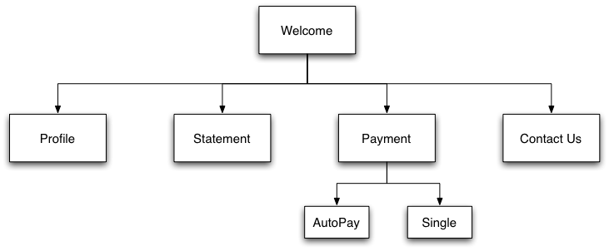

## **My Profile**

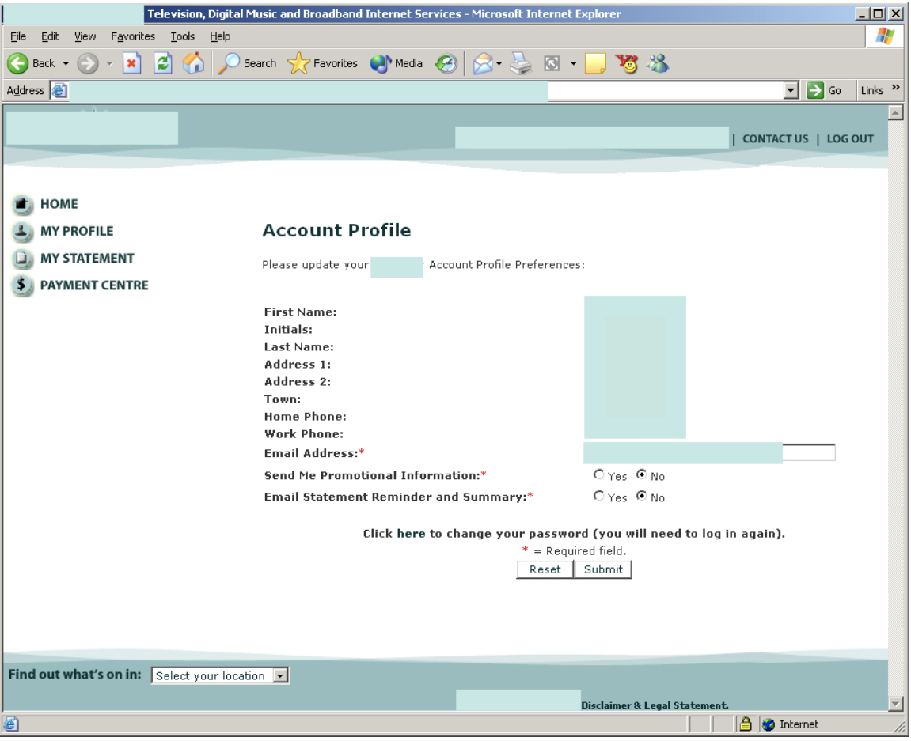

My Profile gives Customers a view of their account information, and allows Customers to update their Email Address, Promotional Information preference, and Email Statement Reminder and Summary Preference.

The following account information is displayed:

1. First Name

2. Initials

3. Last Name

4. Address 1

5. Address 2

6. Town

7. Home Phone

8. Work Phone

Customers are also given a link to the Reset Password form.

## **My Statement**

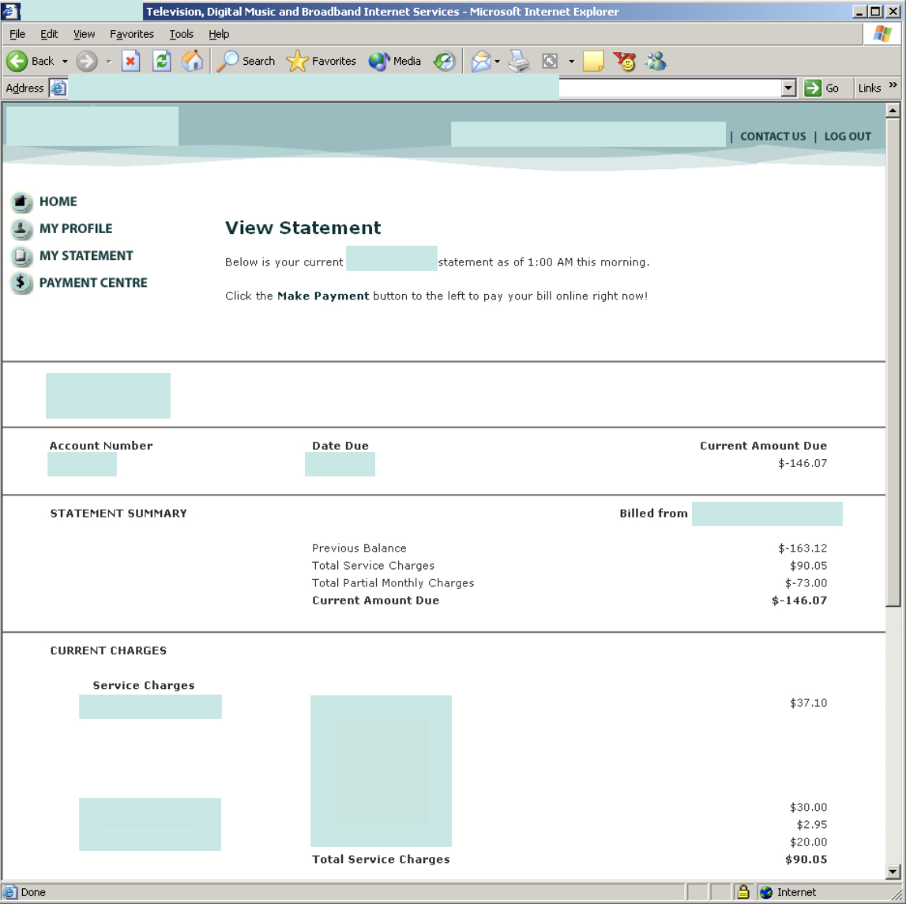

My Statement gives Customers a complete view of their statement in the same format that they are have become accustomed to receiving via mail.

The following statement sections are displayed:

1. General Profile Information

2. General Account Information

3. Statement Summary

4. Statement Details

The following summary and detail sections are displayed if they pertain to the account:

1. Previous Balance

2. Total

3. Payments

4. Service Charges

5. Partial Month Charge

6. Pay Per View

7. Adjustments

8. Write-Off

9. Recovery

10. Deposits Held

## **Payment Centre**

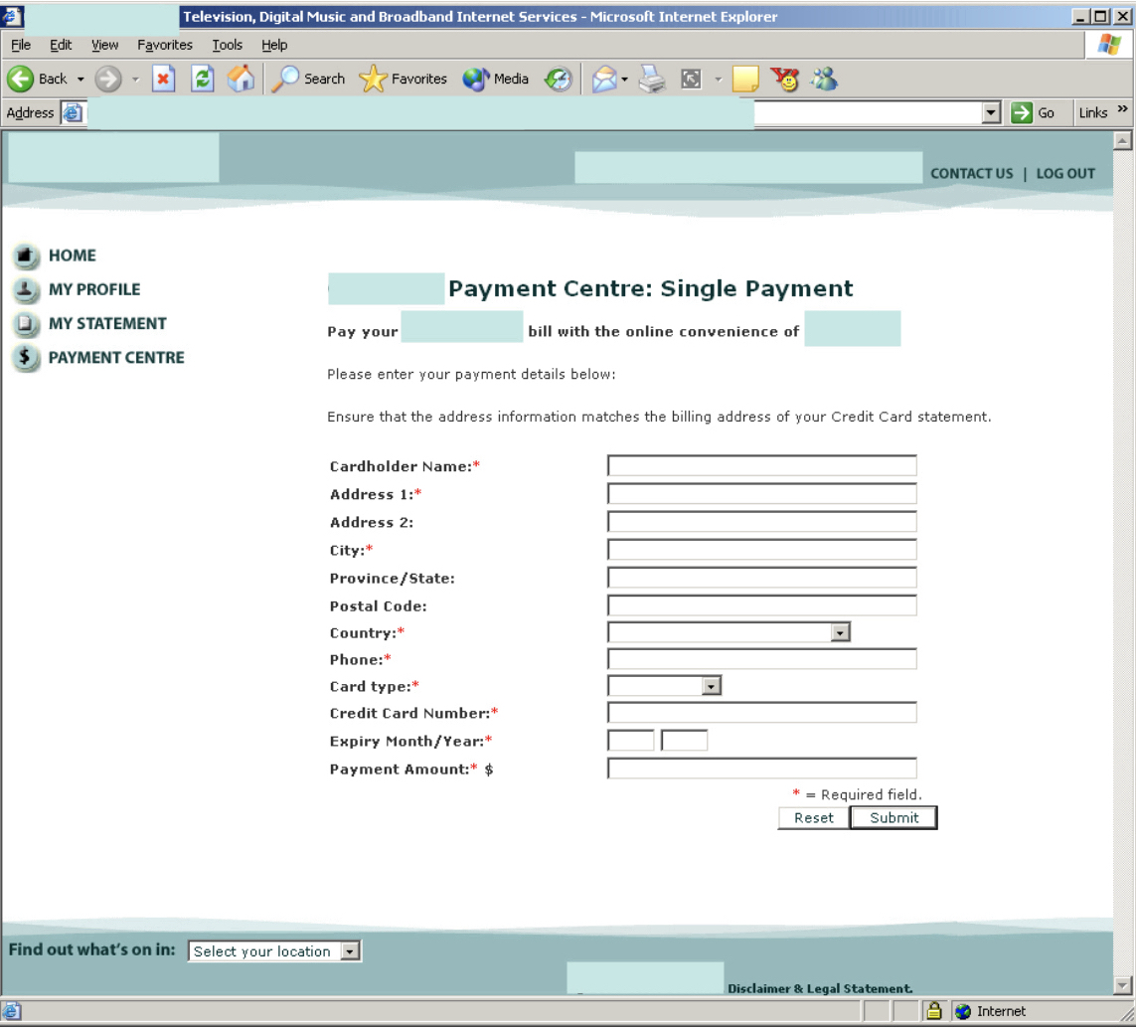

Payment Centre allows Customers to make two types of payments: **One-time | AutoPay**

One-time payments allow Customers to make payments using approved Credit Cards. For convenience, the Payment Amount is auto-filled in the form with the current balance due.

AutoPay, our monthly recurring payment option, allows Customers to sign up to have the current balance due charged to the approved Credit Card on file.

## **Contact Us**

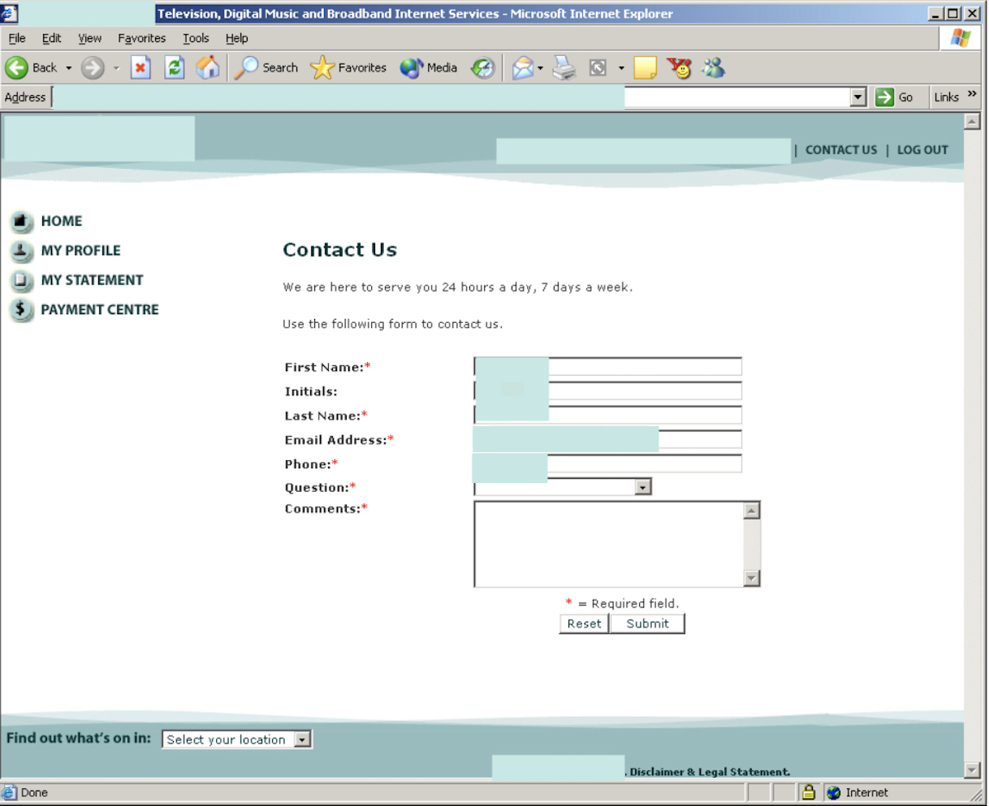

Contact Us provides another way that Customers may use to contact our Customer Support Representatives.

Correspondence is displayed as a record on screen and a copy is sent to the user via email.

All correspondence is tagged with Account number for easy cross-reference with internal systems.

# **II. Additional Functions of CablePay**

## **Sign Up**

Signing up for Online Billing is an easy two-step processes involving a phone call and filling in an online form.

The following flow diagram represents the Sign Up to Log In process:

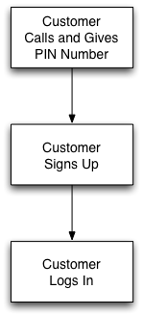

Following assigning a PIN to the current Online Billing account, the customer may Sign Up for online access utilizing the online Sign Up form.

## Sign Up

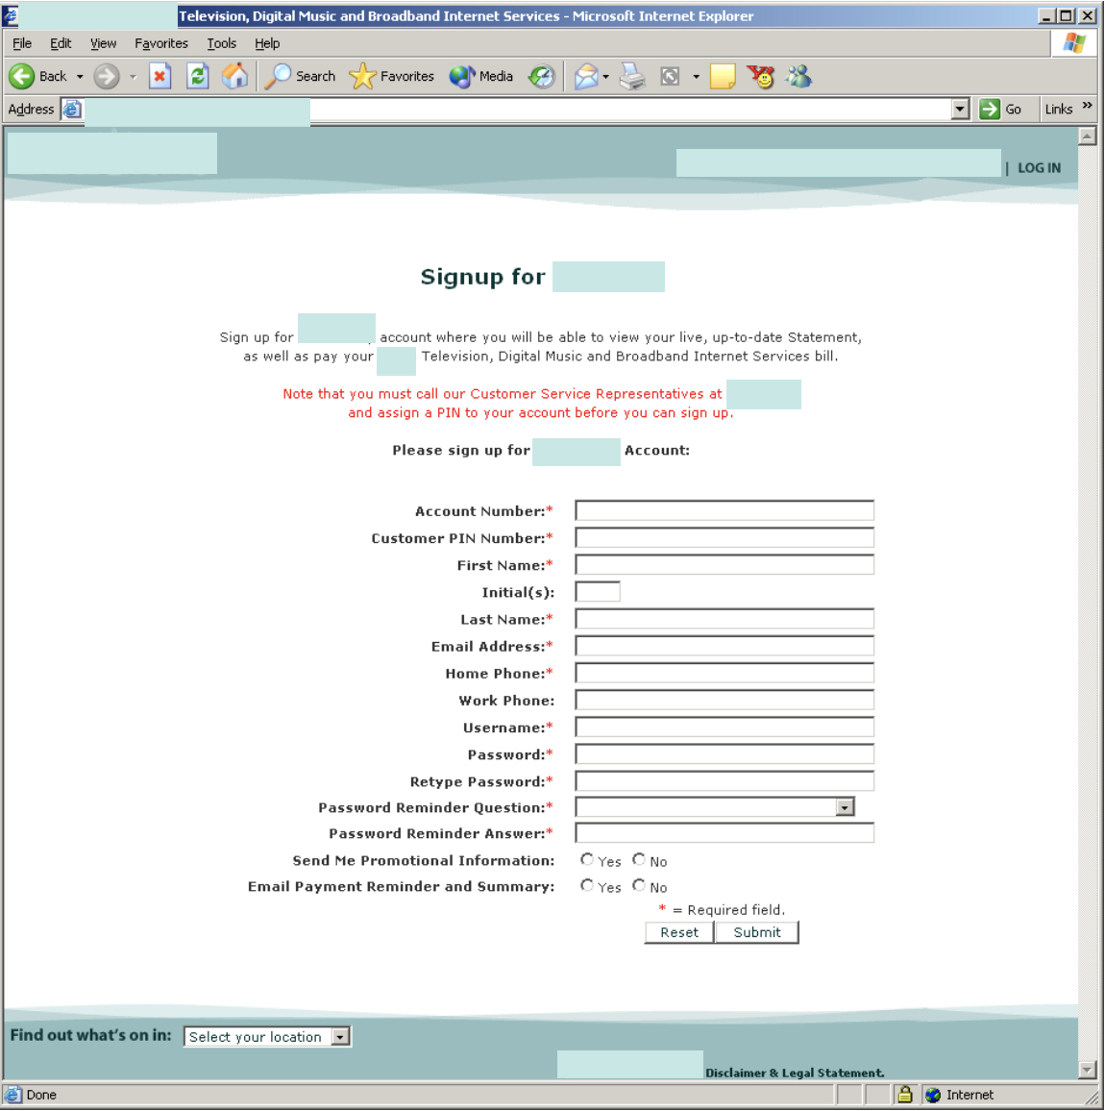

Using online Sign Up form required the Customer to supply the following information:

1. Account Number

2. Customer PIN Number

3. First Name

4. Last Name

5. Email Address

6. Home Phone

7. Username

8. Password

9. Password Reminder Question

10. Password Reminder Answer

As a security measure, the Account Number, Customer PIN Number, First Name, and Last Name must exactly match the information currently associated with the billing account.

The Customer may choose any Username desired; however, the Username must be unique. A number of validation and verification checks are in place to aid the Customer and to secure CablePay.

A secure, custom-written Java module is used to verify Customer data.

On successful completion of the Sign Up form, the Customer is notified on screen and an email is sent to the supplied email address.

## **Login**

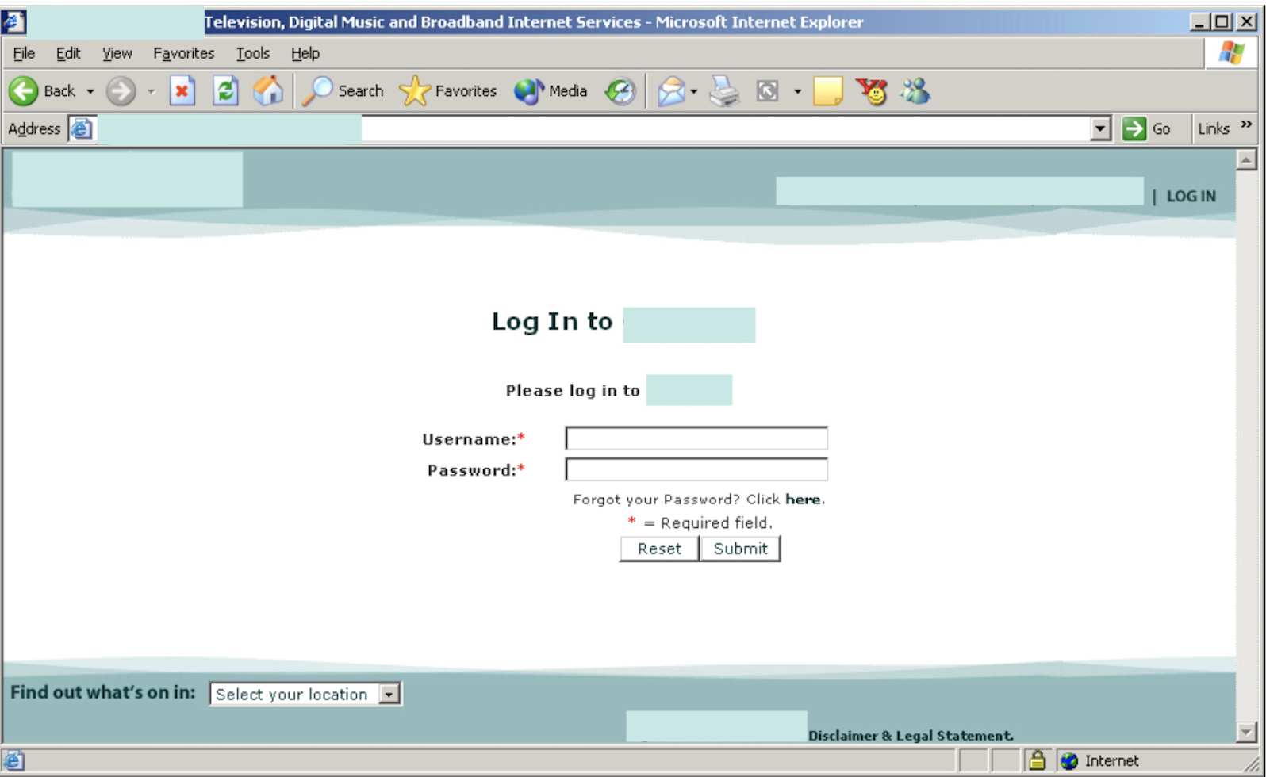

Log In to Online Billing is easy. Supply your Username and Password and click the Submit button.

A link to the Reset Password form is provided in the event that the Customer has forgotten the Account password.

Upon successful Log In, the Customer is taken to the Welcome Screen.

## **Reset Password**

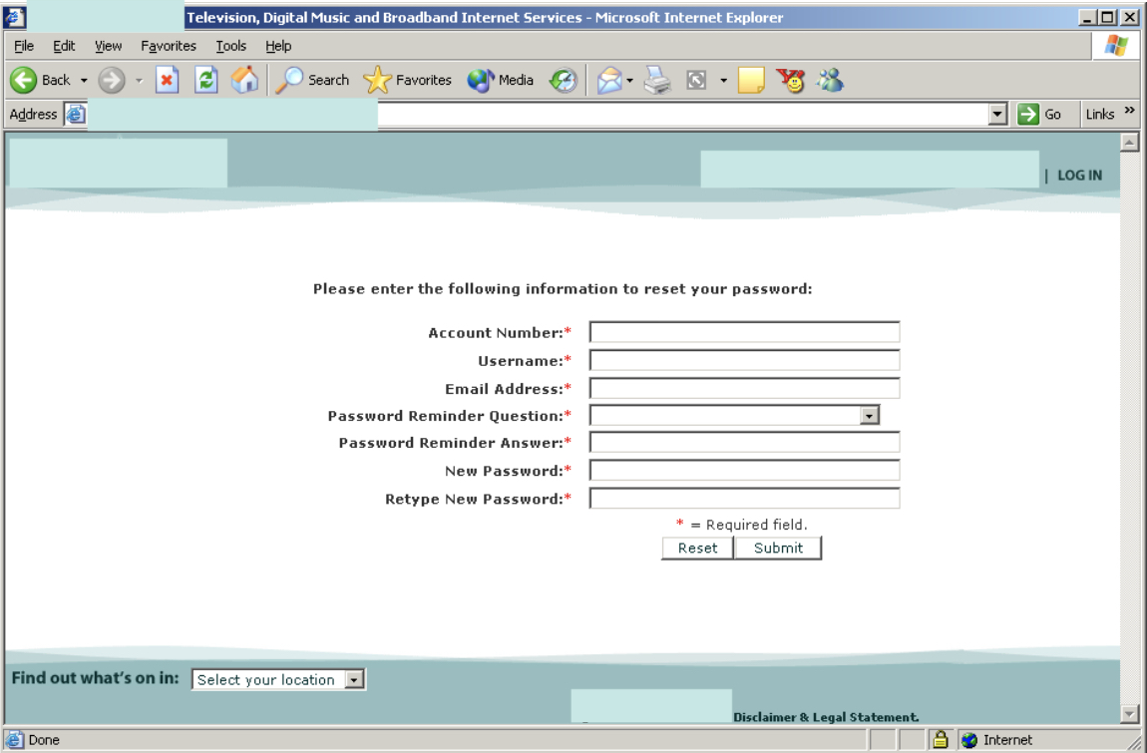

Customers may reset their Password using the Reset Password form. The following information is needed in order to reset an account password:

1. Account Number

2. Username

3. Email Address

4. Password Reminder Question

5. Password Reminder Answer

Each of the above five items must match the account information in order for an account password to be reset.

The Customer also provides a new password and retypes that password in order to ensure that a typographical error was not made when typing the original password.

A confirmation email is sent to the Email address.

## **Welcome Screen**

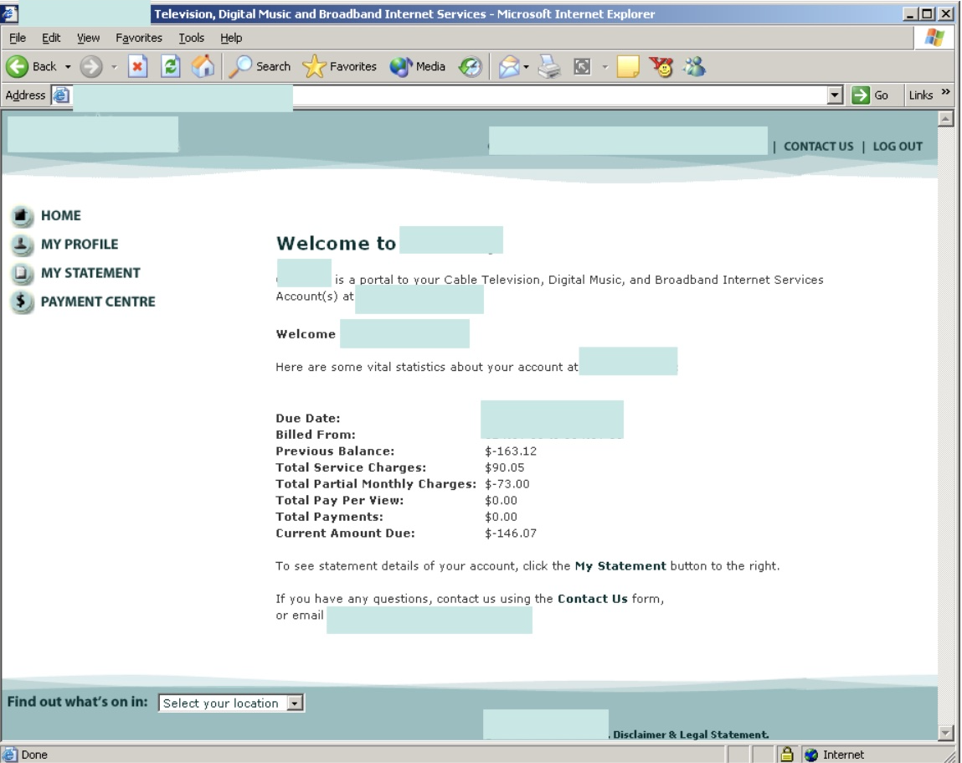

The Welcome Screen is the first screen that our Customers see upon successful log in.

Currently the Welcome Screen displays a topline report of billing information. However, information displayed here is fully customizable. In future, we can display specials offered to any Customer or to online Customers only, etc. Rich media such as Flash animations, streaming video, etc. can also be included.

## **Log Out**

Log Out of Online Billing is as easy as clicking the Log Out button in the top left-hand corner of each Online Billing screen.

# **Security**

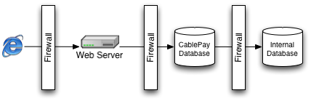

Great attention has been placed on security in CablePay. A multi-tiered security architecture has been put in place to offer maximum protection of our valued Customer data.

## **I. Communication Between Customer and Web Server**

### **A. Forced HTTPS Connections and 128-bit SSL**

Communication between the Customer and CablePay is secure via a forced HTTPS connection utilizing a 128-bit SSL Certificate.

### **B. Session-Driven Application**

All activities with the CablePay application are monitored within a server-side session. Sessions are set to auto-log out after set periods of time - preventing someone from accessing your account on your computer after you walk away.

### **C. Email Confirmations**

All actions taken by our Customer in a CablePay Session initiates a confirmation email sent to the customer.

## **II. Web Server**

### **A. Firewall between Web Server and World**

Enhanced Firewall provides extra protection by monitoring and filtering unwanted traffic.

### **B. Logging and Log Analysis**

All activities on the Web server is logged and analysed to aid in detecting, identifying and stopping intrusion.

### **C. Pure HTML Served**

Only HTML is served to our Customers, providing for maximum Customer compatibility, and reducing any risk of exposing code.

## **III. Communication Between Web Server and Database Server**

### **A. Firewall between Database and Web Server**

Enhanced Firewall provides extra protection by monitoring and filtering unwanted traffic.

### **B. IP SEC**

We utilize packet-level security to monitor and close the door to unwanted calls to our Database server.

## **IV. Database**

### **A. Database Encryption**

Our Databases are encrypted, including our backups.

### **B. Secured Sensitive Data**

Sensitive Customer data, such as credit card information, is encrypted with the latest and most secure available encryption algorythms: MD5 and others. Additionally, sensitive data is moved further within the firewall.

### **C. Audit Tables**

All actions taken on our Database is logged. When data is changed, the change is recorded, including who requested the data, when it was requested, and what the data was before it was changed.