# ***CablePay Account Activation Module and Pay Instruct Module***

## ***Overview***

CablePay Acct Actv Module and CablePay Instruct Module are CablePay’s middle-tier Java-based components. They compose an integral part of the CablePay Billing Portal solution.

**CablePay Acct Actv Module** ensure that the frontend web component of CablePay application can easily and efficiently retrieve critical data from the backend database in order that it provides customers with My Profile and My Statement viewing services.

**CablePay Instruct Module** efficiently obtains the payment instructions and credit card info submitted by the CablePay customer through the frontend Web application. It quickly relays this info for payment and credit card processing, thus providing the means and service for customers to pay their bills

The frontend (Web application) and backend (databases and Java-based modules) form CablePay. These components work together to allow customers to view and pay their accounts online.

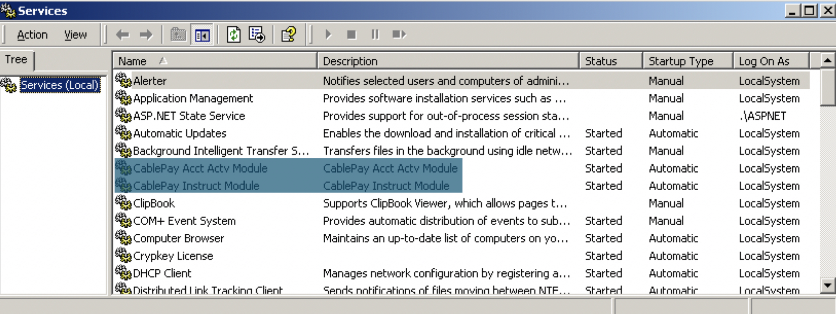

## ***CablePay Users***

| ***User Type*** | ***Access Level*** | ***Reason for Use*** |
| --- | --- | --- |
| CablePay Customers | From a Service Perspective | Receive the services provided by CablePay |
| CSR | CSR level access | Process payment instructions and authorization results. |
| CablePay Administrators  And Developers | Full Access | Supporting, maintaining and developing the CablePay system. |

## ***Roles:***

Along with the CablePay Databases, the CablePay Acct Actv Module and CablePay Instruct Module form the backend component of the CablePay application.

**CablePay Acct Actv Module**

**CablePay Acct Actv Module** has two core functions. The first is to verify customers account registration, and populate customer profile and statement details (upon account verification) within the backend database. By communicating with the backend database, the frontend web application provides an easy to use and friendly graphical user interface to view the backend data information in the form of **Customer Account Profile Viewing and Customer Account Statement Viewing.**

**CablePay Acct Actv Module’s** other core function is to refresh all customer profile and statement details, (in the backend database) to reflect any updates which occurred.

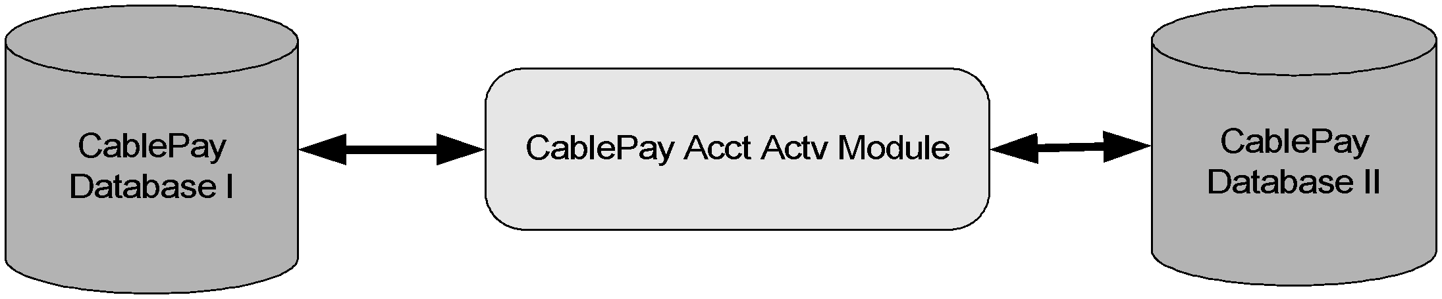

**CablePay Instruct Module**

**CablePay Instruct Module** currently captures both recurring and non-recurring credit card payment instructions for credit card authorization and processing. Once the processing has occurred and the results obtained, the customer’s account is updated to reflect the payment made. This update will be captured by the CablePay Acct Actv Module and placed into the backend database so that the frontend web interface can display this update for customer viewing.

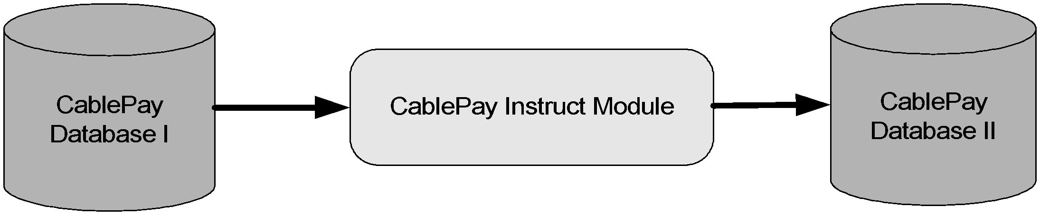

**CablePay Instruct Module**

## ***Security Measures***

### **CablePay Acct Actv Module:**

Verifies Customers Account Registration. Currently, when a customer signs up, they have to provide their first and last name as it is on their bill, their account number and a PIN number order that their account be set up. The PIN number is obtained by calling in, so that customer support can authenticate the user.

### **CablePay Instruct Module:**

Permanently extracts the encrypted Payment and credit card instructions from the backend database, and securely relays this sensitive info for credit card processing. Once relayed, the info is backed up and is always encrypted.

## ***Reliability:***

CablePay Acct Actv Module and CablePay Instruct Module have socket connections to allow LinkAnalyst to monitor the module. Should a module fail, an alarm would be triggered and an email sent to an administrator.

Both modules are installed an NT services, and their recovery features are configured to restart should the server be rebooted or the service fail. Additionally, there are backup CablePay Acct Actv Module and CablePay Instruct Module running. Should the Modules service on the live deployed machine fail, the backup Modules become active to continue the service.