##### ***NEXUS***

##### *Version 1.3*

##### *DEVELOPER DOCUMENTATION*

***Christophe Cartwright***

***Network Architecture Team***

***Columbus Communications***

**Contents**

Documentation Overview 2

NEXUS – THE BASCIS 3

NEXUS Process FLOW 4

NEXUS: ORACLE DATABASE OBJECTS 6

TABLESPACE TBL_DEVELOPMENT_<SCHEMA> 6

SEQUENCES (owner: <SCHEMA>) 6

TABLE NEXUS_PROFILE (owner: <SCHEMA>) 6

TABLE NEXUS_RATECODES (owner: <SCHEMA>) 7

TABLE NEXUS_ERROR (owner: <SCHEMA>) 7

TABLE NEXUS_LOCATION_CHILD_ACCOUNTS (owner: <SCHEMA>) 7

TABLE NEXUS_RATECODE_MENU (owner: <SCHEMA>) 8

GRANT PERMISSIONS (<SCHEMA> and <SCHEMA> users) 8

TRIGGERS (owner: <SCHEMA>) 9

TRIGGER _NEXUS_CRS_STATUS_AI 9

TRIGGER _NEXUS_CRS_STATUS_AU 10

TRIGGER _NEXUS_WIP_RATECD_AI 10

TRIGGER _NEXUS_WIP_RATECD_AU 10

PACKAGE _NEXUS_PKG (owner: <SCHEMA> user) 11

ORACLE (STORED) PROCEDURES (owner: <SCHEMA> user) 11

PROCEDURE NEXUS_GET_PROFILE_COUNT 12

PROCEDURE NEXUS_GET_RATECD_INFO 12

PROCEDURE NEXUS_GET_WIPCUSTRATE_INFO 12

PROCEDURE NEXUS_GET_CUST_OUTLET 12

PROCEDURE NEXUS_GET_CUSTTYPE 12

PROCEDURE NEXUS_GET_RELATION 13

PROCEDURE NEXUS_GET_RELATION 13

PROCEDURE NEXUS_GET_LOCATION 13

PROCEDURE NEXUS_GET_CUSTINFO 13

PROCEDURE NEXUS_GET_CUSTSTAT 14

PROCEDURE NEXUS_GET_HOUSEINFO 14

PROCEDURE NEXUS_DROP_ACCTINFO 14

PROCEDURE NEXUS_GET_ACCTINFO 14

PROCEDURE NEXUS_PUT_ACCTINFO 15

Customer Type (Customer-Centric vs. Rate-Code Centric): 16

Rate Code Input into Nexus (BILLING SQL Menu Option): 18

NEXUS RATE CODE MENU: SQL SCRIPTS 19

NEXUS RATE CODE MENU: SHELL SCRIPTs: NEXUS 19

NEXUS: Microsoft SQL DATABASE OBJECTS 20

TABLE PROFILE (owner: USER user) 20

TABLE CableServices (owner: USER user) 20

TABLE DataServices (owner: USER user) 21

TABLE VoiceServices (owner: USER user) 21

TABLE CONFIG (owner: USER user) 22

Microsoft SQL STORED PRCEDURES (owner: user) 23

PROCEDURE _NEXUS_GET_ACC_ISLAND 23

PROCEDURE _NEXUS_CABLE_SERVICES 23

PROCEDURE _NEXUS_DATA_SERVICES 24

PROCEDURE _NEXUS_VOICE_SERVICES 24

PROCEDURE _NEXUS_PROFILE_SERVICES 24

PROCEDURE _NEXUS_PARENT_PROFILE 25

PROCEDURE _NEXUS_CHILD_PROFILE 26

NEXUS: JAVA CLASSES 27

CLASS _NEXUS_JDBC_Connection 27

CLASS _NEXUS_Run 28

CLASS _NEXUS_Thread 28

CLASS _NEXUS_Module 29

# **Documentation Overview**

| Manual | Version | Contents |
| --- | --- | --- |
| NEXUS:  The Basics | 1.3 | Defines NEXUS and its role between BILLING and |
| NEXUS: Flow Process | 1.3 | Outlines diagrammatically the process flow of NEXUS from a Internet Change Request in BILLING to the Profile Creation / Update in Ticketing |
| NEXUS: Oracle Database objects. | 1.3 | Details the functionality of the Oracle (v 9.2.0.8.0) DB objects used by HSV ADAPTER: Oracle DB objects. They include:   * TABLES * GRANTS * TRIGGERS * SEQUENCES * PACKAGES * PROCEDURES * UserLock.SQL |
| NEXUS: Microsoft SQL Database objects. | 1.3 | Details the functionality of the Microsoft SQL (v 2005) Database objects used by NEXUS. Objects include:   * TABLES * STORED PROCEDURES |
| NEXUS:  JAVA Classes | 1.3 | Details the functionality and dependencies of the Java Source Classes of NEXUS. |
| NEXUS: APPENDIX (source code header comments only) | 1.3 | Contains all of the header description for source code of:   * Oracle Database objects. * Microsoft SQL Database objects. * JAVA Source Code |

# **NEXUS – THE BASCIS**

###### **What is NEXUS?**

* A custom designed java-powered middleware application:
  + Acts as an intermediary between different application components.
  + Nexus links the BILLING Billing System and the Help Desk Support Ticketing application .

**What does it do?**

* Automatically and correctly creates or modifies Profiles:
* **Residential (Phase 1)**
* Populate the “Account Information” Section
* Populate the Profile Type, Service Level and MAC-Address fields of the Services Section
* **Commercial (Phase 2)**
* Populate the “Account Information” Section for “Parent” Profile Accts
* Populate the Profile Type, Service Level, SLA Class, SLA Urgency and MAC-Address fields of the Services Section for “Parent” Profile Accts
* Populate the “Account Information” Section for “Child” Configuration Profile Accts
* Populate the Profile Type, Service Level, SLA Class, SLA Urgency and MAC-Address fields of the Services Section for “Child” Configuration Profile Accts
* **Customer Centric Type + BILLING Rate Code Menu (Phase 3)**
* Customer Type Now Customer-Centric vs Rate Code Centric
* Customer-Level Type is Mandatory and is enforced from the BILLING Application Layer
* CSR Selects Customer Type from Controlled Drop down menu **(MUST select a type - required)**
* Nexus now inspects Customer-Centric-Type for its Customer-Type for its Profile
* Nexus Rate Code SQL Menu Option at the BILLING Application Layer (within BILLING Emulator)
* Once Rate Code is added in BILLING (via emulator) rate code can be added by CSR Supervisor to Nexus (from BILLING emulator)
* Controlled Nexus Rate Code SQL Menu Options
* CSR Supervisor is now empowered and determines Nexus Rate Code Process Flow
* Rate Codes input now consolidated onto a single Platform (Billing). Manual Rate Code entry Side eliminated

# **NEXUS Process FLOW**

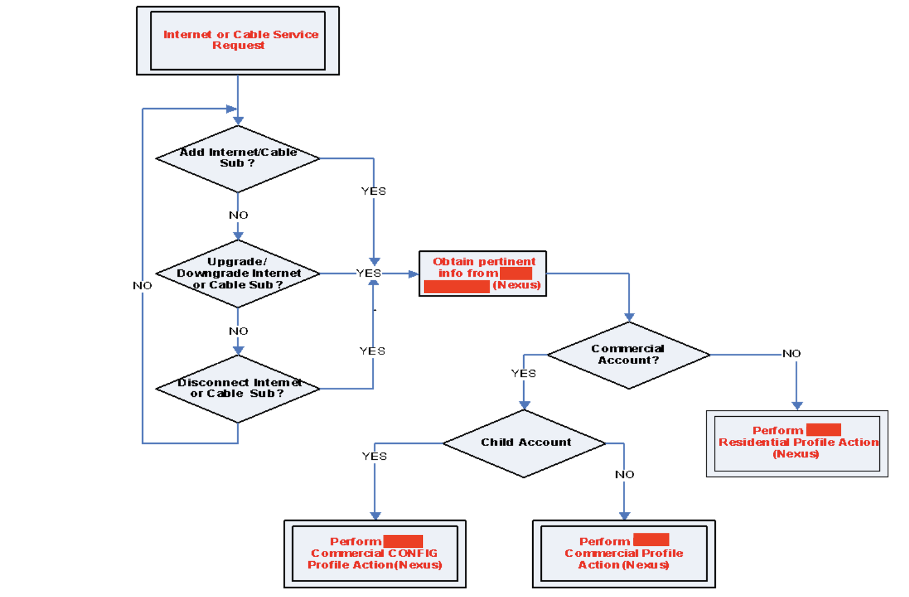

# 

# **NEXUS: ORACLE DATABASE OBJECTS**

## ***TABLESPACE TBL_DEVELOPMENT_***<SCHEMA>

TBL_DEVELOPMENT_<SCHEMA> is the developers Table-Space within the BILLING Billing System Oracle 8i Database. It is the storage home for all the tables and objects used in NEXUS. Any and all development projects going forward that involve any database objects should be installed in this Table-Space.

**Please see _NEXUS_DBOBJECT_CREATION_BILLING.sql within the**

**<** **BILLING\ORACLE\DBOBJECT_CREATION> directory for the Oracle SQL source code for Table-Space TBL_DEVELOPMENT_<SCHEMA>.**

## ***SEQUENCES (owner:*** <SCHEMA>***)***

Sequences are a special Database objects that reside on a table and generate unique numbers for a column to ensure uniqueness for a given row.

Whenever an insert into a table occurs with a sequence, the sequence’s next value only need be referenced to generate the next unique value in the row sequence.

For the NEXUS ADAPTER sequences are currently deployed:

* SEQUENCE NEXUS_PROFILE_SEQ

**Please see _NEXUS_DBOBJECT_CREATION_BILLING.sql within the**

**<** **BILLING\ORACLE\DBOBJECT_CREATION> directory for the Oracle SQL source code for sequence NEXUS_PROFILE_SEQ.**

## ***TABLE NEXUS_PROFILE (owner:*** <SCHEMA>***)***

TABLE NEXUS_PROFILE temporarily stores the account information that is bound for a Parent/Child Profile. Changes made within the Billing application with respect to Internet customers say:

* An upgrade or downgrade of the customers internet services
* A disconnection of an internet service
* An installation of an internet service
* An Update of the Mac Address for a customer

will result in core account information of the customer getting stored in the TABLE <SCHEMA>.NEXUS_PROFILE.

**Please see _NEXUS_DBOBJECT_CREATION_BILLING.sql within the**

**<** **BILLING\ORACLE\DBOBJECT_CREATION> directory for the Oracle SQL source code for Table NEXUS_PROFILE creation + table definition.**

## ***TABLE NEXUS_RATECODES (owner:*** <SCHEMA>***)***

TABLE NEXUS_RATECODES stores the rate code information that is bound for a Parent / Child Profile. Changes made within the Billing application with respect to customers say:

* An upgrade or downgrade of the customers rate services
* A disconnection of a rate/service code(s)
* An installation of rate/service code(s)
* An Update of the equipment for a customer

would result in the customer profile flow from billing to with the rate codes determining a customer’s Service Level Agreement [SLA], and the service descriptions for a customers profile on the Side.

**Please see _NEXUS_DBOBJECT_CREATION_BILLING.sql within the**

**<** **Billing\ORACLE\DBOBJECT_CREATION> directory for the Oracle SQL source code for Table NEXUS_RATECODES creation + table definition.**

## ***TABLE NEXUS_ERROR (owner:*** <SCHEMA>***)***

With any of the triggers, packages and stored procedures associated with the NEXUS ADAPTER, any failures or exceptions generated are captured and stored in the NEXUS_ERRORS table.

The data in the NEXUS_ERROR table details the object that threw the error, the account, date and actual error message.

**Please see _NEXUS_DBOBJECT_CREATION_BILLING.sql within the**

**<** **Billing\ORACLE\DBOBJECT_CREATION> directory for the Oracle SQL source code for Table NEXUS_ERRORS creation + table definition.**

## ***TABLE NEXUS_LOCATION_CHILD_ACCOUNTS (owner:*** <SCHEMA>***)***

NEXUS_LOCATION_CHILD_ACCOUNTS table is used to identify the company name and associated parent account ID for a subsidiary / child company which just had a service / equipment change made on its behalf.

This table is a work-around solution, which should become deprecated upon the implementation of BILLING’s Account Hierarchy (expected deployed date is EOY 2009).

**Please see _NEXUS_DBOBJECT_CREATION_BILLING.sql within the**

**<** **Billing\ORACLE\DBOBJECT_CREATION> directory for the Oracle SQL source code for Table NEXUS_LOCATION_CHILD_ACCOUNTS** **creation + table definition.**

## ***TABLE NEXUS_RATECODE_MENU (owner:*** <SCHEMA>***)***

The NEXUS_RATECODE_MENU table is used to temporarily hold dynamic data used in the new feature: NEXUS BILLING Rate Code SQL Menu.

Together with customized Unix Shell + SQL Scripts, the NEXUS_RATECODE_MENU table takes user input, stores the dynamic values, and assists with performing the appropriate actions on the NEXUS_RATECODES table values based on the user input.

**Please see _NEXUS_DBOBJECT_CREATION_BILLING.sql within the**

**<** **Billing\ORACLE\DBOBJECT_CREATION> directory for the Oracle SQL source code for Table NEXUS_RATECODE_MENU** **TS** **creation + table definition.**

## ***GRANT PERMISSIONS (***<SCHEMA> ***and*** <SCHEMA> ***users)***

* Currently the user <SCHEMA> is the official owner of the BILLING Billing system Database objects.
* The <SCHEMA> user is a database user which has been given both read and write access to the <SCHEMA> schema via views and synonyms and GRANTS.
* Some of the Database objects created on the BILLING Billing system database are owned by the <SCHEMA> user, ex. The NEXUS_PROFILE table. The <SCHEMA> user owns the remaining Database objects.
* To access and use objects owned by other users, the user or DBA can:
* Make the objects public and hence accessible to all Database users
* Explicitly grant certain users access to certain database objects.
* **To enforce database security through control access**, the second method was implemented. Grants to the tables owned by <SCHEMA> were issued to <SCHEMA>. Grants to the objects owned by <SCHEMA> which are used in the NEXUS solution were issued to the <SCHEMA> user.

**Please see _NEXUS_GRANTS.sql within the**

**<** **Billing\ORACLE\DBOBJECT_CREATION> directory for the Oracle SQL source code for NEXUS table / package grants.**

## ***TRIGGERS (owner:*** <SCHEMA>***)***

Triggers are a special PL/SQL construct similar to procedures. However, a procedure is executed explicitly from another block via a procedure call, while a trigger is executed implicitly whenever the triggering event happens.

The triggering event is as INSERT, DELETE, or UPDATE command. The timing can be either BEFORE or AFTER. The trigger can be either row-level or statement-level, where the former fires once for each row affected by the triggering statement and the latter fires once for the whole statement.

For NEXUS four triggers are currently deployed:

* TRIGGER _NEXUS_CRS_STATUS_AI
* TRIGGER _NEXUS_CRS_STATUS_AU
* TRIGGER _NEXUS_WIP_RATECD_AI
* TRIGGER _NEXUS_WIP_RATECD_AU

Each trigger’s functionality is outlined below. **Please see the <Triggers> folders content within the <** **Billing\ORACLE\triggers> directory for the Oracle SQL source code for the above triggers.**

### **TRIGGER _NEXUS_CRS_STATUS_AI**

/*******************************************************************

** **

** Trigger Name : _NEXUS_CRS_STATUS_AI **

** Author : Christophe Cartwright **

** Date : 31st January 2006 **

** Description : When a sub is added or modified for **

** : services, the Account info is captured and **

** : xferred to the application **

** Inputs : none **

** Outputs : none **

** **

** Acks: [https://asktom.oracle.com/tkyte/Mutate/index.html](http://asktom.oracle.com/tkyte/Mutate/index.html) **

** **

*******************************************************************/

/*******************************************************************

** **

** Revision History - Please include author, date and change **

** Author : Christophe Cartwright **

** Date : 22nd Sept 2009 **

** Desc : Removed the SP NEXUS_CHK_RATECD_LIMIT (not used) **

** : Changed the SP NEXUS_PUT_ACCTINFO (removed out_equip) **

*******************************************************************/

### **TRIGGER _NEXUS_CRS_STATUS_AU**

/*******************************************************************

** **

** Trigger Name : _NEXUS_CRS_STATUS_AU **

** Author : Christophe Cartwright **

** Date : 31st January 2006 **

** Description : When a sub is added or modifyed for **

** : services, the Account info is captured and **

** : xferred to the application **

** Inputs : none **

** Outputs : none **

** **

** Acks: [https://asktom.oracle.com/tkyte/Mutate/index.html](http://asktom.oracle.com/tkyte/Mutate/index.html) **

** **

*******************************************************************/

### **TRIGGER _NEXUS_WIP_RATECD_AI**

/*******************************************************************

** **

** Trigger Name : _NEXUS_WIP_RATECD_AI **

** Author : Christophe Cartwright **

** Date : 31st January 2006 **

** Description : When a sub is added or modifyed for **

** : services, the Account info is captured and **

** : xferred to the application **

** Inputs : none **

** Outputs : none **

** **

** Acks: [https://asktom.oracle.com/tkyte/Mutate/index.html](http://asktom.oracle.com/tkyte/Mutate/index.html) **

** **

*******************************************************************/

### **TRIGGER _NEXUS_WIP_RATECD_AU**

/*******************************************************************

** **

** Trigger Name : _NEXUS_WIP_RATECD_AU **

** Author : Christophe Cartwright **

** Date : 31st January 2006 **

** Description : When a sub is added or modifyed for **

** : services, the Account info is captured and **

** : xferred to the application **

** Inputs : none **

** Outputs : none **

** **

** Acks: [https://asktom.oracle.com/tkyte/Mutate/index.html](http://asktom.oracle.com/tkyte/Mutate/index.html) **

** **

*******************************************************************/

## ***PACKAGE _NEXUS_PKG (owner:*** <SCHEMA> ***user)***

The Package _NEXUS_PKG groups the NEXUS procedures together based on their functionality.

_NEXUS_PKG package has two sections: the header section that contains a definition of the procedure objects and a body section that contains the implementation of the procedure objects.

**Both _NEXUS Package header definition and body Oracle source code details can be found the files _NEXUS_APP_PACKAGE.sql + _NEXUS_APP_PACKAGE_BODY.sql within the**

**<** **Billing\ORACLE\DBOBJECT_CREATION> directory.**

## ***ORACLE (STORED) PROCEDURES (owner:*** <SCHEMA> ***user)***

(Stored) Procedures are named groups of SQL statements that have been previously created and stored in the server database and accept input parameters. Thus several clients using different input data can use a single procedure over the network.

(Stored) procedures also reduce network traffic, improve performance and can be used to help ensure the integrity of the database.

For NEXUS thirteen (stored) procedures are currently deployed **(within the Package _NEXUS_PKG):**

* NEXUS_GET_PROFILE_COUNT
* NEXUS_GET_RATECD_INFO
* NEXUS_GET_WIPCUSTRATE_INFO
* NEXUS_GET_CUST_OUTLET
* NEXUS_GET_CUSTTYPE
* NEXUS_GET_RELATION
* NEXUS_GET_LOCATION
* NEXUS_GET_CUSTINFO
* NEXUS_GET_CUSTSTAT
* NEXUS_GET_HOUSEINFO
* NEXUS_DROP_ACCTINFO
* NEXUS_GET_ACCTINFO
* NEXUS_PUT_ACCTINFO

Each (Stored) Procedure’s functionality is outlined below**. Details of the source code of the Stored Procedures can be found in the files _NEXUS_APP_PACKAGE_BODY.sql within the**

**<** **Billing\ORACLE\DBOBJECT_CREATION > directory.**

### **PROCEDURE NEXUS_GET_PROFILE_COUNT**

/********************************************************

* Author: Christophe Cartwright: DBA, Cable Billing *

* Date: April 22 2008 *

* *

* Procedure: NEXUS_GET_PROFILE_COUNT (Phase I) *

* Description: Determine row count in Nexus_Profile Table *

* Input: House, Cust, Outlet *

* Output: Row Total (number) *

*********************************************************/

### **PROCEDURE NEXUS_GET_RATECD_INFO**

/***************************************************************

* Author: Christophe Cartwright: Junior DBA, Cable Billing *

* Revision Date: 22nd Sept 2009 *

* Procedure Name: NEXUS_GET_RATECD_INFO *

* Description: Daily Customer AcctDetails extracts for Profile *

* update (Active account-driven) *

***************************************************************/

### **PROCEDURE NEXUS_GET_WIPCUSTRATE_INFO**

/***************************************************************

* Author: Christophe Cartwright: Junior DBA, Cable Billing *

* Revision Date: 22nd Sept 2009 *

* Procedure Name: NEXUS_GET_WIPCUSTRATE_INFO *

* Description: Daily Customer AcctDetails extracts for Profile *

* update (WIP / Pending account-driven) *

***************************************************************/

### **PROCEDURE NEXUS_GET_CUST_OUTLET**

/***************************************************************

* Author: Christophe Cartwright: Junior DBA, Cable Billing *

* Revision Date: 26th May 2006 *

* Procedure Name: NEXUS_GET_CUST_OUTLET *

* Description: Customer Equip Info extracts for Profile *

***************************************************************/

### **PROCEDURE NEXUS_GET_CUSTTYPE**

/**************************************************************

** Procedure Name: NEXUS_GET_RATETYPE *

** Author: Christophe Cartwright *

** Revision Date: 26th May 2006 *

** Description: Stored Procedure obtains Customer Type *

** Inputs: House, Cust *

** Outputs: Customer Type *

***************************************************************/

### **PROCEDURE NEXUS_GET_RELATION**

/**************************************************************

* Author: Christophe Cartwright: Junior DBA, Cable Billing *

* Revision Date: August 2006 *

* Procedure Name: NEXUS_GET_RELATION *

* Description: Determine Relation (Parent Account or Child Subsidiary) *

* for Profile / Child Profile. Incorporates location *

* area in outlet for Accounts having Sites entered in the *

* outlet section *

* *

* Input: House, Cust *

* Output: Relation (Parent / Child), Parent Account, Result *

***************************************************************/

### **PROCEDURE NEXUS_GET_RELATION**

/**************************************************************

* Author: Christophe Cartwright: Junior DBA, Cable Billing *

* Revision Date: 26th May 2006 *

* Procedure: NEXUS_GET_RELATION *

* Description: Determine Relation (Parent Account or Child Subsidiary) *

* for Profile / Child Profile *

* Input: House, Cust *

* Output: Relation (Parent / Child), House, Cust *

***************************************************************/

### **PROCEDURE NEXUS_GET_LOCATION**

/**************************************************************

** Procedure Name: NEXUS_GET_LOCATION *

** Author: Christophe Cartwright *

** Revision Date: 3rd August 2006 *

** Description: Extracts outlet location for account *

** Inputs: House, Cust, Outlet *

** Outputs: (Outlet) Location *

***************************************************************/

### **PROCEDURE NEXUS_GET_CUSTINFO**

/***************************************************************

** Procedure Name: NEXUS_GET_CUSTINFO (Phase I) *

** Author: Christophe Cartwright *

** Revision Date: 26th May 2006 *

** Details: Customer Core Account Info extracts for Profile *

** Input: House, Cust *

** Output: House, Cust, FName, LName, Phone, FTax, Address, *

** FullTag and Status *

** *

** Revision: 10th Sept 2007, Christophe Cartwright (Phase II) *

** History Revised NEXUS_GET_CUSTINFO to include dual status *

****************************************************************/

### **PROCEDURE NEXUS_GET_CUSTSTAT**

/***************************************************************

* Author: Christophe Cartwright: DBA, Cable Billing *

* Date: Sept 10th 2007 *

* Procedure: NEXUS_GET_CUSTSTAT (Phase I) *

* Description: Obtains the custus account status *

* Input: House, Cust *

* Output: Customer Status *

****************************************************************/

### **PROCEDURE NEXUS_GET_HOUSEINFO**

/***************************************************************

* Author: Christophe Cartwright: Junior DBA, Cable Billing *

* Date: 10th Sept 2007 *

* Procedure: NEXUS_GET_HOUSEINFO (Phase I) *

* Description: House Stat Account Info extracts for Profile *

****************************************************************/

### **PROCEDURE NEXUS_DROP_ACCTINFO**

/***************************************************************

** Procedure Name: NEXUS_DROP_ACCTINFO **

** Author: Christophe Cartwright **

** Revision Date: 26th May 2006 **

** details: Removes Account info from the _PROFILE table **

** This in turn manages the table size and growth **

** Input: Account, Status, RateCode **

** Output: Return Code(0=success),(1=failure) **

****************************************************************/

### 

### **PROCEDURE NEXUS_GET_ACCTINFO**

/***************************************************************

** Procedure Name: NEXUS_GET_ACCTINFO **

** Author: Christophe Cartwright **

** Revision Date: 26th May 2006 **

** details: Obtains Account info for the _PROFILE **

** Input: None **

** Output: Account, FirstName, LastName, Phone, FTax, Address, **

** RateCode, CustType, FullTag, Status, MacAddress, **

** Relation (Parent Account or Child Account) **

** **

** Revision : NEXUS_GET_ACCTINFO (Phase IV) **

** Author : Christophe Cartwright: Junior DBA, Cable Billing **

** Date : 22nd Sept 2009 **

** Details : Added CustSLA Field. This will assist in consolidating **

** : RateCode entries (type, sla) into a single system **

** : (BILLING), instead of BILLING + . **

*****************************************************************/

### **PROCEDURE NEXUS_PUT_ACCTINFO**

/***************************************************************

** Procedure: NEXUS_PUT_ACCTINFO **

** Author: Christophe Cartwright **

** Revision Date: 26th May 2006 **

** Details: Revised GetStatus SP to pull additional fields **

** for NEXUS **

** Input: Account String, ratecd, rate code status, outlet **

** Output (table): Account, lname, fname, bphone, rphon, status, island **

** full-tag, street address, mac-address, rate code **

** Output: Return Code (success 0, failure 1) **

** **

** Revision History - **

** Procedure : NEXUS_PUT_ACCTINFO (Phase II) **

** Author : Christophe Cartwright **

** Date : 11 Sept 2006 **

** Details : Revised NEXUS_PUT_ACCTINFO for Commercial Cust **

** : and Indigo Phone # for the Profile **

** Input : Account String, ratecd, rate code status, outlet **

** Output (table): Account, lname, fname, bphone, rphon, status, island **

** : fulltag, street address, macaddress, rate code **

** **

** Revision History - **

** Procedure : NEXUS_PUT_ACCTINFO (Phase III) **

** Author : Christophe Cartwright **

** Date : 11 Sept 2007 **

** Details : Revised NEXUS_PUT_ACCTINFO to include House **

** : Status (Active, Dual, Disc, etc). Added Rate **

** : Code Class and Type to further distinguish **

** : between Commercial vrs Residential and Cable, **

** : Data and voice Rate Codes **

** **

** Revision History - **

** Procedure : NEXUS_PUT_ACCTINFO (Phase IV) **

** Author : Christophe Cartwright **

** Revision Date: 11 Sept 2007 **

** Details : Revised NEXUS_PUT_ACCTINFO to incorporate **

** : Customer SLAs (from their service). Obtaining **

** : Customer Type (Residential, Commercial, etc) **

** : also revised in new SP (NEXUS_GET_CUSTTYPE) **

***************************************************************/

## ***Customer Type (Customer-Centric vs. Rate-Code Centric):***

* Revise Nexus to accurately capture Customer Types at the customer-level vs. the Rate-Code Level :
* Customer-Level Type is Mandatory and is enforced from the BILLING Application Layer
  + BILLING Emulator
    - OPTION 11 [System Maintenance]
    - OPTION 1 [DirectorMaintenance]
    - OPTION 15 [Control Tables]
    - OPTION 3 [Customer Tables]
    - OPTION 2 [Customer Type]
    - Press <F3> to make this field mandatory / optional (see below)

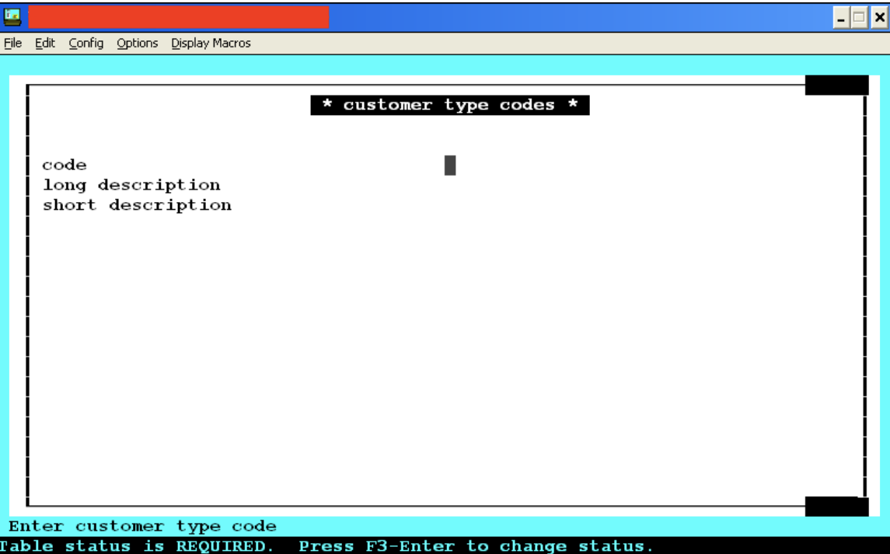

* CSR Selects Customer Type from Controlled Drop down menu **(MUST select a type - required)**

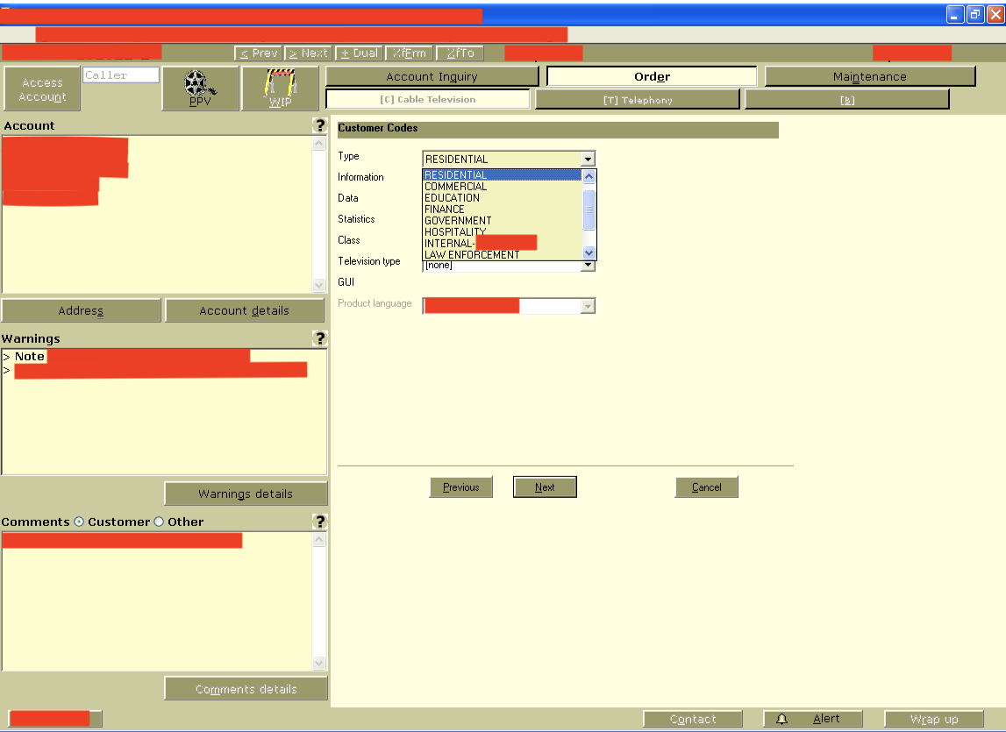

* nexus now inspects Customer-Centric-Type for its Customer-Type for its Profile

## ***Rate Code Input into Nexus (***BILLING ***SQL Menu Option):***

* Nexus Rate Code Menu Option at the BILLING Application Layer



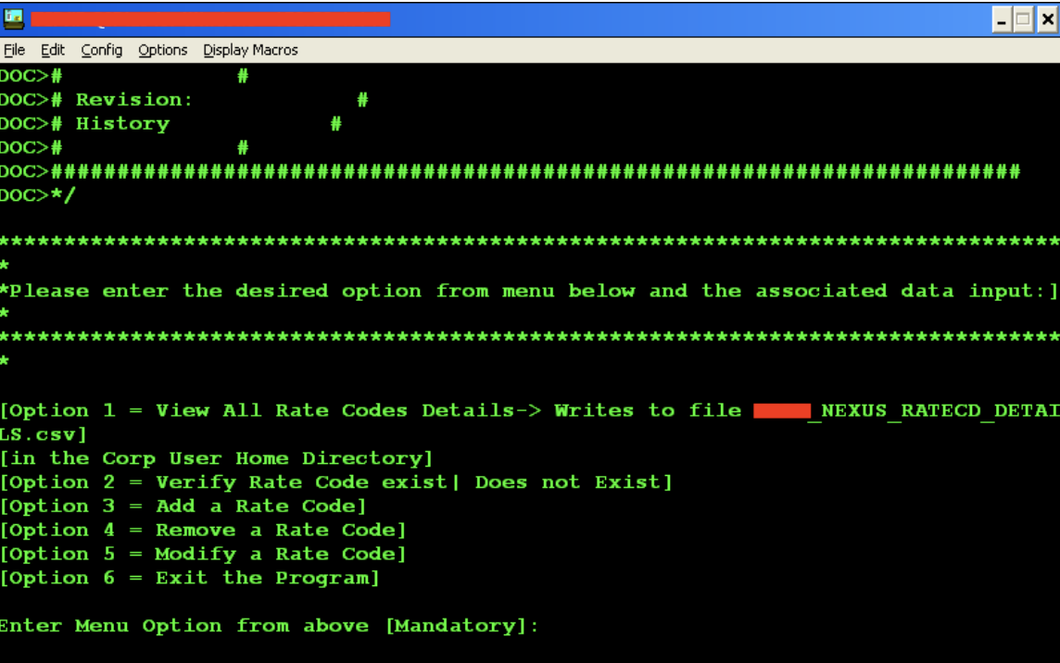

* Once Rate Code is added in BILLING (via emulator) rate code can be added by CSR Supervisor to Nexus (from emulator as well)
* Controlled Nexus Rate Code SQL Menu Options
  + View All Nexus Rate Codes
  + Add Rate Code
  + Remove Rate Code
  + Verify Rate Codes existence in Nexus Service
  + Modifying Rate Code Option
  + Exit Nexus SQL Menu
* CSR Supervisor is now empowered and determines
  + Rate Code
  + Rate Code Description
  + Rate Code Type
  + Rate Code SLA
* Rate Codes input now consolidated onto a single Platform (Billing). Manual Rate Code entry Side eliminated
* No need for Developer involvement (i.e. - to put in Rate Codes)
* Rate Code Input now an operational procedure and not a development request / revision **(Accountability now with operations)**

### **NEXUS RATE CODE MENU: SQL SCRIPTS**

The SQL scripts associated with the NEXUS RATE CODE MENU option allow a CSR to add, remove or view rate codes used by the NEXUS SQL Adapter. Below are the SQL files associated with the NEXUS RATE CODE MENU feature.

* SET-NEXUS-RATECD-OPTIONS.sql
* EXEC-NEXUS-RATECD-OPTION1.sql
* EXEC-NEXUS-RATECD-OPTIONS.sql

### 

### **NEXUS RATE CODE MENU: SHELL SCRIPTs: NEXUS**

The Shell script NEXUS is the unix shell script called from the emulator by NEXUS RATE CODE MENU option. Based on the user input, it will call one of the associated SQL scripts to perform some action on the Nexus Rate Code Table. If the user wishes to view all of the Nexus Rate Codes, the NEXUS shell script will:

* Take the Nexus Rate Code table results and spool them to a dated CSV File
* Using a pre-defined file <NexusMemo.txt> as the emails body content, NEXUS shell script will email the CSV as an attachment to the select group of operators / admins responsible for the maintenance of the Nexus RateCode Tables + its contents

**Details of the source code of the SQL + Shell Scripts can be found in the**

**<** **Billing\ORACLE\Emulator > directory.**

# **NEXUS: Microsoft SQL DATABASE OBJECTS**

## ***TABLE PROFILE (owner:*** Ticketing ***user)***

TABLE PROFILE holds the account profiles of all internet customers within the billing system. It is the destination of the data pulled from the BILLING Billing system by NEXUS.

Listed below are the fields which are touched by Nexus in either a Profile Creation or a Profile Update:

* Custid --Equivalent to the BILLING Account Number
* Custtype --Customer Type –ex Residential / Commercial
* CustStatus --Customer BILLING Account Status
* FirstName --Customer First Name
* LastName --Customer Last Name
* Address1 --Customer Primary Address
* Island --Island Customer account resides on
* FullTag --Customer Census (Node + Management Area)
* ResPhone --Customer Primary Phone
* HouseStatus --House Status (Ex: Dual, Active, etc)
* SLA Urgency --Service Level Urgency of Customer

## ***TABLE CableServices (owner:*** Ticketing ***user)***

TABLE Cable Services is a table that is linked and referenced by the Profile table to display a customer’s Cable TV Services, and its associated equipment and outlets.

Listed below are the fields touched by Nexus in either a Child Profile Creation or a Child Profile Update of their Cable TV Services:

* RateCd --Equivalent to the BILLING RateCode
* RateCode Desc --Equivalent to the BILLING RateCode Description
* RateCode Type --Customer Rate Code Type (Cable)
* RateCode SLA --Customers Rate Code SLA
* Outlet --Outlet Rate Code + Equipment is on
* Equipment --here the Digital Set Top Box Serial Number

## ***TABLE DataServices (owner:*** Ticketing ***user)***

TABLE Data Services is a table that is linked and referenced by the Profile table to display a customer’s High Speed Data Services, and its associated equipment and outlets.

Listed below are the fields touched by Nexus in either a Child Profile Creation or a Child Profile Update of their High Speed Data Services:

* RateCd --Equivalent to the BILLING RateCode
* RateCode Desc --Equivalent to the BILLING RateCode Description
* RateCode Type --Customer Rate Code Type (Cable)
* RateCode SLA --Customers Rate Code SLA
* Outlet --Outlet Rate Code + Equipment is on
* Equipment --here the Cable Modem MacAddress

## ***TABLE VoiceServices (owner:*** Ticketing ***user)***

TABLE Voice Services is a table that is linked and referenced by the Profile table to display a customer’s Voice Services, and its associated equipment and outlets.

**NOTE:** **At this present time Company LTD does NOT have a voice license. This feature is built in for scalability; in the event that a Voice License is secured – development will be complete / at a minimal.**

Listed below are the fields touched by Nexus in either a Child Profile Creation or a Child Profile Update of their Voice Services:

* RateCd --Equivalent to the BILLING RateCode
* RateCode Desc --Equivalent to the BILLING RateCode Description
* RateCode Type --Customer Rate Code Type (Cable)
* RateCode SLA --Customers Rate Code SLA
* Outlet --Outlet Rate Code + Equipment is on
* Equipment --Here the Voice Phone Number

## ***TABLE CONFIG (owner:*** Ticketing ***user)***

TABLE CONFIG is usually tasked with holding device information of a profile account. However, the unique demands of the Parent / Child model warrants the use of the config table as host to the child profile forms and data.

Because the config table can host multiple forms under one profile it is ideal for the parent-child hierarchical structure.It is the destination of the data pulled from the BILLING Billing system by NEXUS for accounts who have a parent account in the profile table.

Listed below are the fields touched by Nexus in either a Child Profile Creation or a Child Profile Update:

* Custid --Equivalent to the BILLING Account Number
* Seq --s internal Sequence number.

***When a new Child Profile form is created the current maximum Config sequence number is returned, incremented by 1, and this assigned as the Seq number to the incoming Child Profile***

* Custtype --Customer Type –ex Residential / Commercial
* ConfigType --Config Type for the Config Table (Child Profile)
* FirstName --Customer First Name
* LastName --Customer Last Name
* Address1 --Customer Primary Address
* Island --Island Customer account resides on
* FullTag --Customer Census (Node + Management Area)
* ResPhone --Customer Primary Phone
* HouseStatus --House Status (Ex: Dual, Active, etc)
* SLA Urgency --Service Level Urgency of Customer

## ***Microsoft SQL STORED*** PROCEDURES ***(owner: ticketing user)***

(Stored) Procedures are named groups of SQL statements that have been previously created and stored in the server database.

(Stored) Procedures accept input parameters. Hence several clients using different input data can use a single procedure over the network.

(Stored) procedures reduce network traffic and improve performance. Additionally, stored procedures can be used to help ensure the integrity of the database.

NEXUS uses seven (stored) procedures (currently deployed on the Microsoft SQL Server Database):

* _NEXUS_GET_ACC_ISLAND
* _NEXUS_CABLE_SERVICES
* _NEXUS_DATA_SERVICES
* _NEXUS_VOICE_SERVICES
* _NEXUS_PROFILE_SERVICES
* _NEXUS_PARENT_PROFILE
* _NEXUS_CHILD_PROFILE

Each (Stored) Procedure’s functionality is outlined below**. Details of the source code of the Stored Procedures can be found in the**

**<** **Ticketing\<Server>-MSSQL > directory.**

### **PROCEDURE _NEXUS_GET_ACC_ISLAND**

/*************************************************************

** Procedure Name: _NEXUS_GET_ACC_ISLAND **

** Author: Christophe Cartwright **

** Date: 26th May 2006 **

** Description: Determine the Correct Island Based on the**

** FTax Value **

** Inputs: FTAX **

** Outputs: Island **

**************************************************************/

### **PROCEDURE _NEXUS_CABLE_SERVICES**

/*******************************************************************

** Procedure Name: _NEXUS_CABLE_SERVICES **

** Author: Christophe Cartwright **

** Date: 17th Sept 2007 **

** Description: Updates | Creates Customer Service Sections **

** (Cable) **

** Inputs: AccountID, Account Class, Outlet, RateCd, Equip**

** RateType, RateStatus, Rating **

** Outputs: Results **

*******************************************************************/

### **PROCEDURE _NEXUS_DATA_SERVICES**

/*******************************************************************

** Procedure Name: _NEXUS_DATA_SERVICES **

** Author: Christophe Cartwright **

** Date: 17th Sept 2007 **

** Description: Updates | Creates Customer Service Sections **

** (Data) **

** Inputs: AccountID, Account Class, Outlet, RateCd, Equip**

** RateType, RateStatus, Rating **

** Outputs: Results **

*******************************************************************/

### 

### **PROCEDURE _NEXUS_VOICE_SERVICES**

/*******************************************************************

** Procedure Name: _NEXUS_VOICE_SERVICES **

** Author: Christophe Cartwright **

** Date: 17th Sept 2007 **

** Description: Updates | Creates Customer Service Sections **

** (Voice) **

** Inputs: AccountID, Account Class, Outlet, RateCd, Equip**

** RateType, RateStatus, Rating **

** Outputs: Results **

*******************************************************************/

### **PROCEDURE _NEXUS_PROFILE_SERVICES**

/*******************************************************************

** Procedure Name: _NEXUS_PROFILE_SERVICES **

** Author: Christophe Cartwright **

** Date: 17th Sept 2007 **

** Description: Envokes one of the SPs (Cable/Data/Voice) **

** Service SPs based on Parameters from Parent / **

** Child Profile call **

** Inputs: AccountID, Outlet, RateCd, RateCd Desc, RateCd **

** Type, RateCd Stat, Equipment **

** Outputs: Results **

*******************************************************************/

### **PROCEDURE _NEXUS_PARENT_PROFILE**

/*****************************************************************

** Procedure Name : _NEXUS_PROFILE (Release I) **

** Author : Christophe Cartwright **

** Date : 14th February 2006 **

** Description : Inserts or Updates a Profile from the BILLING **

** : billing application **

** Inputs : Account, Cust-Type, First-Name, Last-Name, **

** : Address, phone, full-tag, rate-code **

** Outputs : Results **

********************************************************************

** Procedure Name : _NEXUS_PARENT_PROFILE (Release II) **

** Author : Christophe Cartwright **

** Date : 17th May 2006 **

** Description : Inserts or Updates a Profile from the BILLING **

** : billing application for a Parent (Res / Comm) **

** : profile. **

** Inputs : Account, Cust-Type, First-Name, Last-Name, **

** : Address, phone, full-tag, rate-code **

** Outputs : Results **

********************************************************************

** Procedure Name : _NEXUS_ PARENT_PROFILE (Release III) **

** Author : Christophe Cartwright **

** Date : 12th September 2007 **

** Description : Inserts or Updates a Profile from the BILLING **

** : billing application for a Parent (Res / Comm) **

** : profile. Services now include Cable, Data and **

** : voice. Added Stored Procedure (SP) **

** : _NEXUS_PROFILE_SERVICES. **

** Inputs : Account, Cust Type, Cust Status, **

** : FirstName, LastName, Address, FTax, Fulltag, **

** : RateCdStat, Ratecd, Equip, Res + Bus Phone, **

** : Relation, ParentAcct, HouseStat, RateCdTally **

** Outputs : Results **

********************************************************************

** Procedure Name : _NEXUS_PARENT_PROFILE (Release IV) **

** Author : Christophe Cartwright **

** Date : 23rd September 2009 **

** Description : Added RateSLA. This removes the need for the **

** : BILLING_RATECD table on the Side. All data **

** : now comes from billing. Adding new RateCodes **

** : will be done on the billing side and all info **

** : associated with it will come over to **

** : Code Snippets with BILLING_RATECD table & SLA **

** :removed (eg: SP _NEXUS_GET_SLA **

** Inputs : Account,RateType,RateSla,CustType,CustStatus, **

** : FirstName,LastName,Address,FTax,Fulltag, **

** : RateCdStat,Ratecd,Equip,Res + Bus Phone, **

** : Relation,ParentAcct,HouseStat,RateCdTally **

** Outputs : Results **

*****************************************************************/

### 

### **PROCEDURE _NEXUS_CHILD_PROFILE**

/*****************************************************************

** Procedure Name : _NEXUS_PROFILE (Release I) **

** Author : Christophe Cartwright **

** Date : 14th February 2006 **

** Description : Inserts or Updates a Profile from the BILLING **

** : billing application **

** Inputs : Account, Cust-Type, First-Name, Last-Name, **

** : Address, phone, full-tag, rate-code **

** Outputs : Results **

********************************************************************

** Procedure Name : _NEXUS_CHILD_PROFILE (Release II) **

** Author : Christophe Cartwright **

** Date : 17th May 2006 **

** Description : Inserts or Updates a Profile from the BILLING **

** : billing application for a Parent (Res / Comm) **

** : profile. **

** Inputs : Account, Cust-Type, First-Name, Last-Name, **

** : Address, phone, full-tag, rate-code **

** Outputs : Results **

********************************************************************

** Procedure Name : _NEXUS_CHILD_PROFILE (Release III) **

** Author : Christophe Cartwright **

** Date : 12th September 2007 **

** Description : Inserts or Updates a Profile from the BILLING **

** : billing application for a Parent (Res / Comm) **

** : profile. Services now include Cable, Data and **

** : voice. Added Stored Procedure (SP) **

** : _NEXUS_PROFILE_SERVICES. **

** Inputs : Account, Cust Type, Cust Status, **

** : FirstName, LastName, Address, FTax, Fulltag, **

** : RateCdStat, Ratecd, Equip, Res + Bus Phone, **

** : Relation, ParentAcct, HouseStat, RateCdTally **

** Outputs : Results **

********************************************************************

** Procedure Name : _NEXUS_CHILD_PROFILE (Release IV) **

** Author : Christophe Cartwright **

** Date : 23rd September 2009 **

** Description : Added RateSLA. This removes the need for the **

** : BILLING_RATECD table on the Side. All data **

** : now comes from billing. Adding new RateCodes **

** : will be done on the billing side and all info **

** : associated with it will come over to **

** : Code Snippets with BILLING_RATECD table & SLA **

** :removed (eg: SP _NEXUS_GET_SLA **

** Inputs : Account,RateType,RateSla,CustType,CustStatus, **

** : FirstName,LastName,Address,FTax,Fulltag, **

** : RateCdStat,Ratecd,Equip,Res + Bus Phone, **

** : Relation,ParentAcct,HouseStat,RateCdTally **

** Outputs : Results **

*****************************************************************/

# **NEXUS: JAVA CLASSES**

The NEXUS Java classes combine to create the transport-layer application component of NEXUS. The classes are designed and developed entirely in Java and perform the following:

* Connects to the BILLING system
* Extracts internet customer data from the NEXUS back-end Oracle Database objects
* Transports the data to the help Desk support system
* Updates the appropriate Internet profile account with the BILLING data using the NEXUS back-end table and stored procedures.
* Log accounts which:
  + Have the incorrect BILLING account format
  + Have failed to be correctly created or updated in the profile section

Each Class’ functionality is outlined below**. Details of the Java Class source code can be found in the appendix (pgs 75 - 95).**

**Details of the Java Class source code can be found in the**

**<** **Ticketing\NEXUS_SOURCE_FILES> directory.**

### 

### **CLASS _NEXUS_JDBC_Connection**

/*******************************************************************

** **

** Class Name: _NEXUS_JDBC_Connection, version 1.1 **

** **

** Author: Christophe Cartwright **

** **

** Position: IT Developer, <Company> Ltd **

** **

** Release Date: 8th March 2007 **

** **

** Description: Declares and Instantiates the JDBC connection, **

** usernames and passwords for the thread **

** connections to the and BILLING DataBases. Also **

** it contains the port that the module will **

** establish a socket connection on. This file **

** should be kept secured **

** **

** Dependencies: None **

** **

** Inputs: None **

** **

** Outputs: None **

** **

*******************************************************************/

### **CLASS _NEXUS_Run**

/****************************************************************

** Class Name: _NEXUS_Run, version 1.1 **

** **

** Author: Christophe Cartwright **

** **

** Position: IT Developer, <Company> Ltd **

** **

** Release Date: 8th March 2007 **

** **

** Description: Implements the Runnable Interface to allow the **

** threads to access the various methods and variables **

** of the Object **

** **

** Dependencies: _Thread **

** **

** Inputs: none **

** **

** Outputs: none **

** **

****************************************************************/

### **CLASS _NEXUS_Thread**

/****************************************************************

** Class Name: _NEXUS_Thread, version 1.1 **

** **

** Author: Christophe Cartwright **

** **

** Position: IT Developer, <Company> Ltd **

** **

** Release Date: 8th March 2007 **

** **

** Description: Declares and Instantiates a NEXUS Object, and launches **

** threads. The threads simultaneously and independently **

** run through the NEXUS Object to update the **

** Profile Account. **

** **

** _NEXUS_Thread also creates a socket connection to **

** allow the NOC (with LinkAnalyst) to monitor HET NEXUS.**

** This option is not used **

** **

** **

** Dependencies: None **

** **

** Inputs: None **

** **

** Outputs: None **

** **

****************************************************************/

### **CLASS _NEXUS_Module**

/****************************************************************

** Class Name: _NEXUS_Module, Version 5, Release I **

** Author: Christophe Cartwright **

** Position: Oracle Resource, IT Developer, Cable Billing Ltd **

** Release Date: 15th October 2009 **

** Description: Automatically Creates | Updates customer Parent **

** or Child profile from BILLING **

** All Services (Cable, Data & Voice) are now automatically created **

** updated with their associated equipment + outlet. Customer status is **

** more granular (Active, Disc, Inactive, Pending Restart, etc). Finally **

** house status is introduced (Active, Never, Dual, Plant, Disconnect). **

** **

** Release 5 Add On features: **

** All information about Rate Codes now consolidated into Single **

** Platform (BILLING) (ex Type, SLA, Desc). RateCode Table on Side **

** deprecated **

** **

** Dependencies: **

** **

** Classes: **

** _NEXUS_JDBC_Connection_Acct **

** _NEXUS_Run **

** _NEXUS_Thread **

** **

** Stored Procedures: **

** MSSQL 2005: **

** _NEXUS_GET_ACC_ISLAND **

** _NEXUS_CABLE_SERVICES **

** _NEXUS_DATA_SERVICES **

** _NEXUS_VOICE_SERVICES **

** _NEXUS_PROFILE_SERVICES **

** _NEXUS_CHILD_PROFILE **

** _NEXUS_PARENT_PROFILE **

** Triggers: **

** BILLING Oracle 9i: **

** _NEXUS_CRS_STATUS_AI **

** _NEXUS_CRS_STATUS_AU **

** _NEXUS_WIP_RATECD_AI **

** _NEXUS_WIP_RATECD_AU **

** Packages: **

** BILLING Oracle 9i: **

** _NEXUS_APP_PKG **

** Tables: **

** MSSQL 2005: **

** Cable + Data + Voice Services, Config, Profile **

** **

** BILLING Oracle 9i: **

** <SCHEMA>.NEXUS_PROFILE **

** <SCHEMA>.NEXUS_RATECODES **

** <SCHEMA>. NEXUS_LOCATION_CHILD_ACCOUNTS **

** <SCHEMA>. NEXUS_ERROR **

** <SCHEMA>. NEXUS_RATECODE_MENU **

** **

** Input: Thread-Name **

** Output: None **

***********************************************************************/