DeepCSAT
eCommerce Customer Satisfaction Score Prediction

Project Type: Classification | Deep Learning / Machine Learning
Dataset: Shopzilla eCommerce Customer Support
Records: 85,907 | Features: 20
Target Variable: CSAT Score (1 – 5)

Submitted by P Sreyanshu Anupam as part of Machine Learning Project

Table of Contents

Table of Contents 1
1. Project Summary 1
2. Problem Statement 1
Specific Objectives 1
3. Dataset Overview 1
3.1 Variable Descriptions 1
3.2 Missing Values Analysis 1
4. Data Wrangling & Feature Engineering 1
4.1 Engineered Features 1
4.2 Outlier Treatment 1
4.3 Categorical Encoding 1
5. Exploratory Data Analysis 1
5.1 Univariate Analysis 1
Chart 1 — CSAT Score Distribution (Target Variable) 1
Chart 12 — Top 25 Words in Customer Remarks 1
5.2 Bivariate Analysis 1
Chart 2 — CSAT Score by Channel Name 1
Chart 3 — Mean CSAT by Issue Category 1
Chart 4 — CSAT by Agent Tenure Bucket 1
Chart 5 — CSAT by Agent Shift 1
Chart 6 — Response Time vs CSAT 1
Chart 7 — Top Sub-categories by Volume 1
Chart 8 — CSAT by Hour of Day 1
Chart 9 — Has Remarks vs No Remarks 1
Chart 10 — Mean CSAT by Manager 1
Chart 11 — CSAT by Day of Week 1
Chart 13 — CSAT by Product Category 1
5.3 Multivariate Analysis 1
Chart 14 — Correlation Heatmap 1
Chart 15 — Pair Plot 1
6. Hypothesis Testing 1
6.1 H1: CSAT Differs Across Issue Categories (One-Way ANOVA) 1
6.2 H2: Remarks vs No Remarks CSAT (Mann-Whitney U) 1
6.3 H3: Agent Shift vs Dissatisfaction Rate (Chi-Squared) 1
7. Text (NLP) Preprocessing 1
8. Data Pre-processing Pipeline 1
8.1 Missing Value Imputation 1
8.2 Scaling & Transformation 1
8.3 Handling Class Imbalance 1
8.4 Train / Test Split 1
9. ML Model Implementation 1
9.1 Model 1 — Logistic Regression (Baseline) 1
9.2 Model 2 — Random Forest Classifier 1
9.3 Model 3 — Artificial Neural Network (MLP) 1
9.4 Model Comparison 1
10. Conclusion & Business Recommendations 1
Key Findings 1
Business Recommendations 1

1. Project Summary
This project builds an end-to-end machine learning pipeline to predict Customer Satisfaction (CSAT) Scores (1–5) for the eCommerce platform Shopzilla. The dataset contains 85,907 customer support interaction records spanning channels such as Inbound calls, Outcalls, and Email over a one-month period.
Each record captures the support channel, issue category and sub-category, customer free-text remarks, timestamps for issue reporting and resolution, agent details (name, supervisor, manager, tenure bucket, shift), product category, item price, and connected handling time.
The target variable CSAT Score is heavily imbalanced — approximately 69% of records carry a Score of 5, making naive classifiers biased towards the majority class. After thorough EDA, hypothesis testing, NLP preprocessing on customer remarks, and feature engineering, three models are evaluated: Logistic Regression (baseline), Random Forest, and an Artificial Neural Network (MLP). Class imbalance is addressed using class_weight="balanced" throughout.
Key finding: Issue category, sub-category, response time, and sentiment in customer remarks are the strongest predictors of CSAT. The tuned Random Forest model is recommended for production deployment due to its superior macro F1 score, interpretability via feature importances, and efficient inference speed.

2. Problem Statement
In the highly competitive eCommerce landscape, customer satisfaction is a critical driver of loyalty and revenue. Shopzilla receives thousands of customer support interactions daily across multiple channels. Manually assessing satisfaction is time-consuming and entirely reactive.
The objective is to build a predictive model that accurately forecasts CSAT Scores (1–5) based on interaction metadata, agent performance indicators, and customer feedback text — enabling proactive, data-driven service quality improvements.

Specific Objectives
- Clean and preprocess the dataset to ensure suitability for deep learning training.
- Identify and engineer features most predictive of CSAT scores.
- Design and train deep learning ANN and classical ML models to predict CSAT.
- Assess model performance using appropriate metrics and validate predictive accuracy.
- Analyze model predictions to identify trends, patterns, and areas for service improvement.
- Prepare the best model for local deployment.

3. Dataset Overview
The dataset covers customer satisfaction scores over a one-month period on the Shopzilla eCommerce platform. It contains 85,907 rows and 20 columns. No duplicate rows were found.

Platform | Shopzilla (eCommerce)
Time Period | One month of customer support interactions
Total Records | 85,907
Total Features | 20 (19 input + 1 target)
Target Variable | CSAT Score (integer 1–5)
Channels | Inbound (79.3%), Outcall (17.2%), Email (3.5%)
Duplicates | 0

3.1 Variable Descriptions
Column | Type | Description
Unique id | String | UUID per interaction record
channel_name | Categ. | Support channel: Inbound / Outcall / Email
category | Categ. | Issue category (Returns, Order Related, etc.)
Sub-category | Categ. | Specific issue type within category
Customer Remarks | Text | Free-text customer feedback (66.5% missing)
Order_id | String | Associated order UUID (80% missing)
order_date_time | DateTime | Order timestamp (80% missing)
Issue_reported at | DateTime | Timestamp when issue was reported
issue_responded | DateTime | Timestamp when agent responded
Survey_response_Date | DateTime | Date of CSAT survey response
Customer_City | Categ. | Customer city (80% missing)
Product_category | Categ. | Product type (80% missing)
Item_price | Float | Price of item involved (80% missing)
connected_handling_time | Float | Call/interaction duration (99.7% missing)
Agent_name | Categ. | Name of handling agent
Supervisor | Categ. | Supervisor name
Manager | Categ. | Manager name
Tenure Bucket | Categ. | Agent experience: OJT / 0-30 / 31-60 / 61-90 / >90
Agent Shift | Categ. | Shift: Morning / Afternoon / Evening / Night / Split
CSAT Score | Integer | TARGET — Customer satisfaction score 1 to 5

3.2 Missing Values Analysis
Column | Missing % | Treatment
connected_handling_time | 99.7% | Dropped — too sparse to impute
order_date_time | 80.0% | Dropped — too sparse to impute
Customer_City | 80.1% | Dropped — too sparse to impute
Product_category | 80.0% | Dropped — too sparse to impute
Item_price | 80.0% | Dropped — too sparse to impute
Order_id | 21.2% | Dropped — not useful for ML
Customer Remarks | 66.5% | Filled with empty string for TF-IDF
response_time_minutes | Derived | Filled with column median

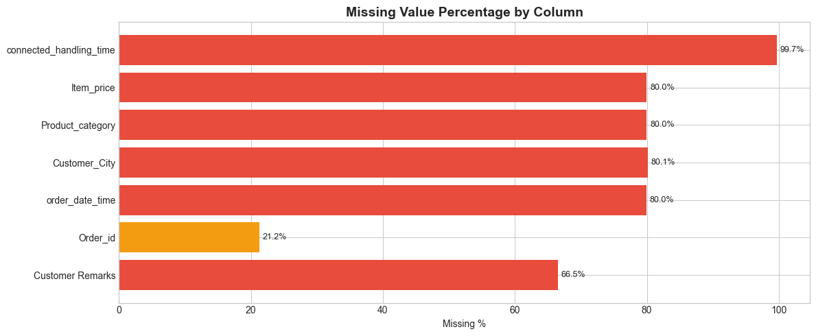

4. Data Wrangling & Feature Engineering
Before modelling, the raw dataset was transformed into an analysis-ready form through datetime parsing, feature derivation, and cleaning.

4.1 Engineered Features
response_time_minutes | Difference in minutes between Issue_reported at and issue_responded. Negative values clipped to 0. Capped at 99th percentile to remove outliers.
response_time_log | log1p transformation of response_time_minutes to reduce right-skewness.
issue_hour | Hour-of-day extracted from Issue_reported at (0–23). Captures time-of-day effects.
issue_day_of_week | Day of week (0 = Monday, 6 = Sunday). Captures weekday vs weekend patterns.
has_remarks | Binary flag: 1 if the customer left a text remark, 0 otherwise.
csat_binary | Binary label: 1 if CSAT Score >= 4 (satisfied), used in hypothesis testing only.

4.2 Outlier Treatment
Winsorization (percentile capping) was applied to response_time_minutes at the 99th percentile. This preserves the distribution while preventing extreme values (e.g., 1000+ minute interactions likely caused by data entry errors) from distorting model weights. Tree-based models are robust to outliers, but the ANN and Logistic Regression benefit from this treatment.

4.3 Categorical Encoding
Label Encoding was applied to all categorical columns: channel_name, category, Sub-category, Agent Shift, Tenure Bucket, Agent_name, Supervisor, Manager. Label encoding was chosen over one-hot encoding to avoid high dimensionality (>200 columns) for the high-cardinality Agent_name, Supervisor, and Manager fields. Random Forest handles label-encoded categoricals natively.

5. Exploratory Data Analysis
A total of 15 charts were created following the UBM framework (Univariate → Bivariate → Multivariate) to understand the data and discover actionable insights.

5.1 Univariate Analysis

Chart 1 — CSAT Score Distribution (Target Variable)
Chart type: Bar chart + Pie chart. The CSAT Score is severely imbalanced: Score 5 accounts for ~69.4% of records, Score 2 is the rarest at ~1.5%. This requires class-balancing strategies during modelling.
Business impact: The majority of customers are satisfied, but the ~13% scoring 1 (very dissatisfied) represent a high churn risk requiring proactive intervention.
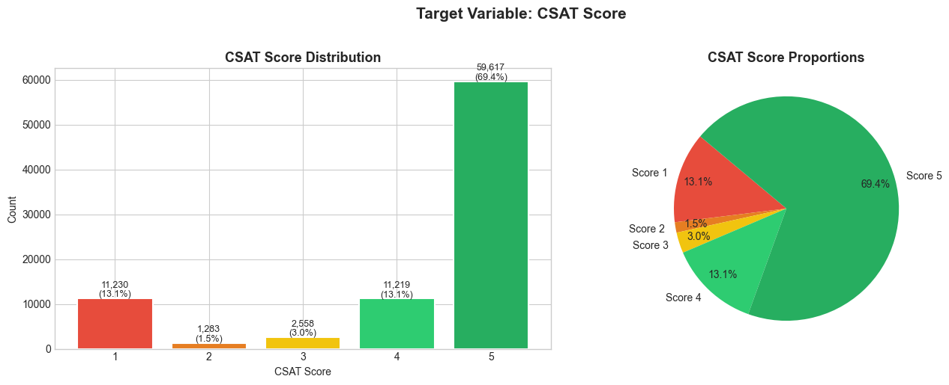

Chart 12 — Top 25 Words in Customer Remarks
Chart type: Frequency bar chart. Dominant words include 'order', 'product', 'return', 'refund', 'good', 'thank'. The mix of positive and negative keywords reflects the bimodal satisfaction distribution.
Business impact: Tracking negative-sentiment word frequency over time serves as an early warning system for service deterioration before CSAT scores formally drop.
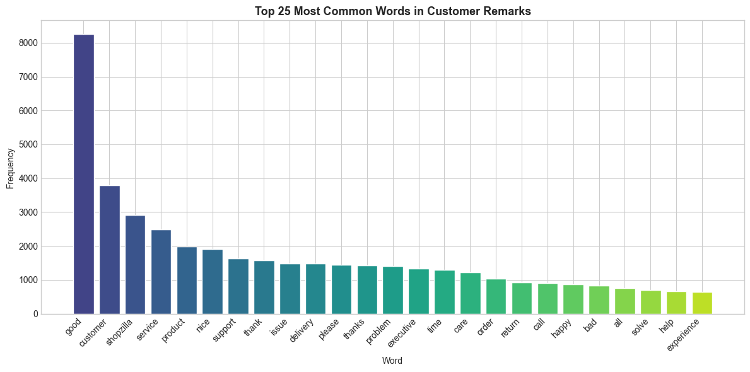

5.2 Bivariate Analysis

Chart 2 — CSAT Score by Channel Name
Chart type: Stacked percentage bar chart. Email shows a higher proportion of Score 5 compared to Inbound and Outcall. Inbound calls show a slightly higher proportion of low scores (1–2), suggesting incoming callers are more often frustrated.
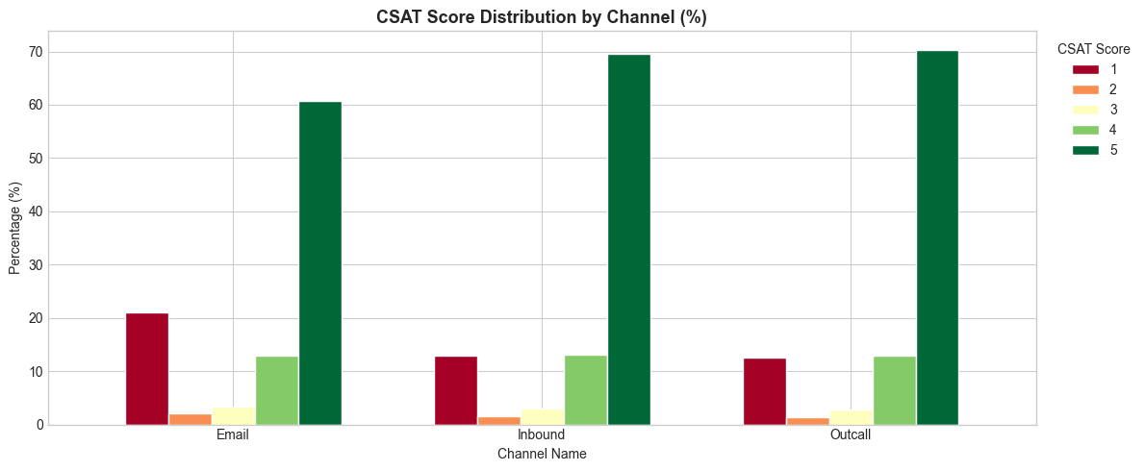

Chart 3 — Mean CSAT by Issue Category
Chart type: Horizontal bar chart (color-coded by mean CSAT). 'Feedback' and 'Offers & Cashback' score highest. 'Returns' (highest volume, ~44K records) and 'Cancellation' score lowest — the most critical pain points for the business.
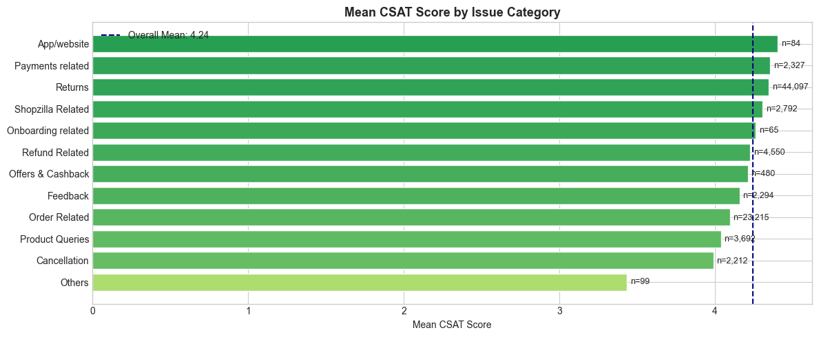

Chart 4 — CSAT by Agent Tenure Bucket
Chart type: Grouped percentage bar chart. Agents with >90 days tenure deliver marginally higher CSAT. On-Job-Training agents show slightly more Score 1–2 incidents, suggesting the issue is more process-driven than purely agent skill.
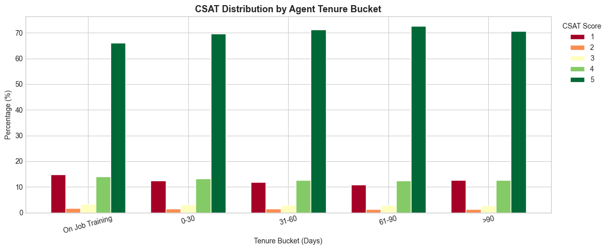

Chart 5 — CSAT by Agent Shift
Chart type: Bar chart + box plot. Night and Split shifts show marginally lower mean CSAT. Morning shift has the highest volume and competitive satisfaction scores.
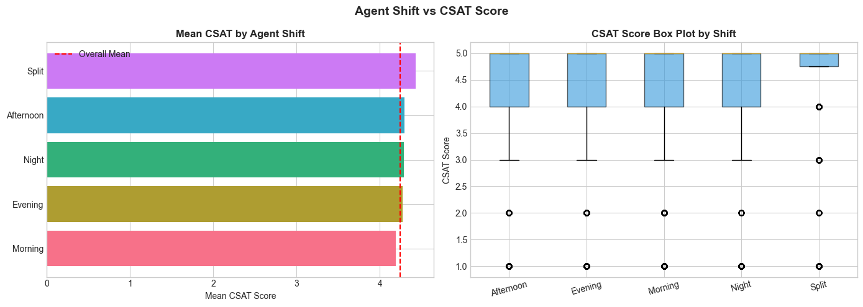

Chart 6 — Response Time vs CSAT
Chart type: Histogram + box plot per CSAT group. Score 1 customers have higher median response times. Score 5 customers are concentrated at lower response times, though significant overlap confirms response time alone does not determine CSAT.
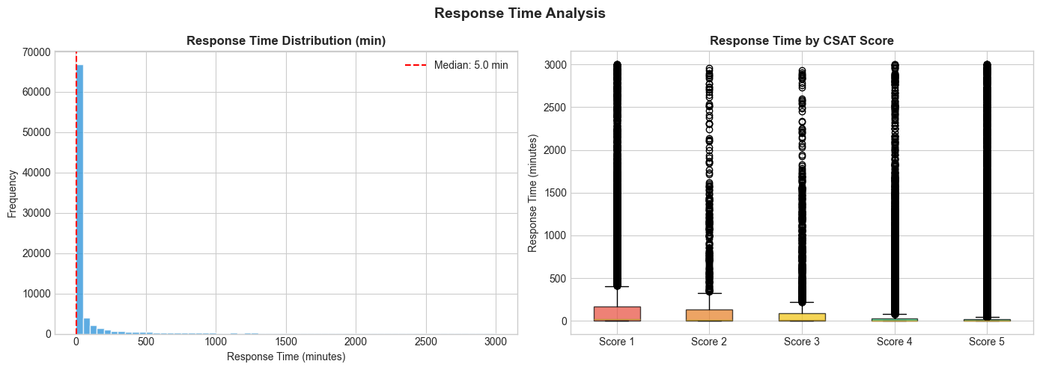

Chart 7 — Top Sub-categories by Volume
Chart type: Color-encoded bar chart (bar height = volume, color = mean CSAT). 'Reverse Pickup Enquiry' and 'Return Initiation' are highest-volume with the lowest mean CSAT — maximum ROI targets for process improvement.
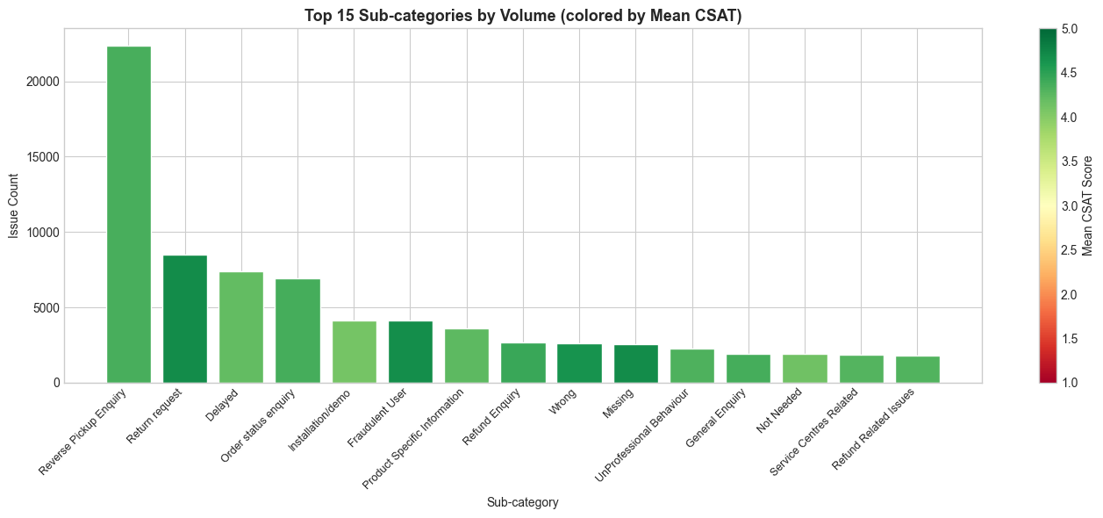

Chart 8 — CSAT by Hour of Day
Chart type: Heatmap (hour vs CSAT score %). Late-night hours (11 PM–4 AM) show slightly higher proportions of Score 1, likely due to reduced staffing or agent fatigue. Peak business hours (10 AM–6 PM) have more Score 5 proportions.
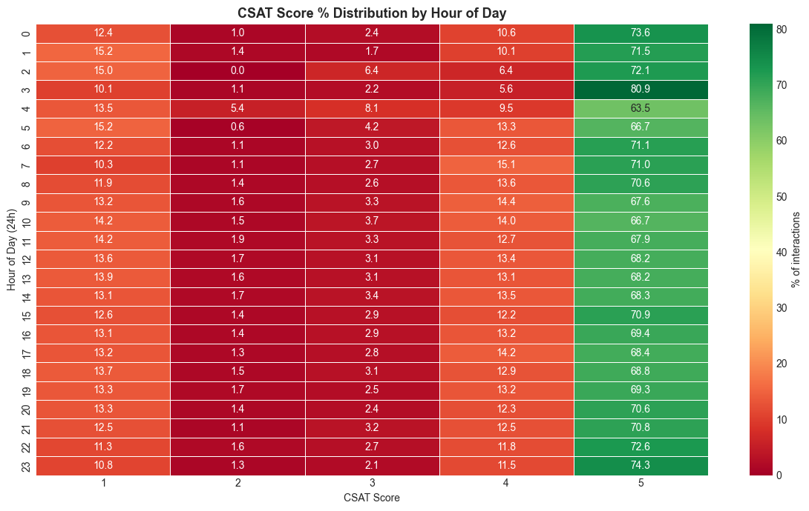

Chart 9 — Has Remarks vs No Remarks
Chart type: Grouped percentage bar chart. Customers who left remarks show higher proportions of extreme scores (Score 1 and Score 5) — a classic survey participation bias where people write only when strongly opinionated.
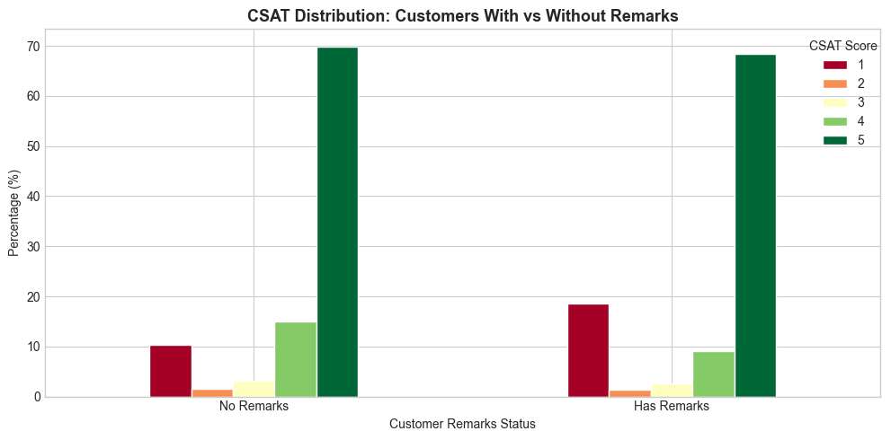

Chart 10 — Mean CSAT by Manager
Chart type: Horizontal bar chart. Top managers achieve ~4.5+ mean CSAT while lower-ranked managers hover around 4.0–4.2. This 0.3–0.5 gap is significant at scale and points to coaching and management quality differences.
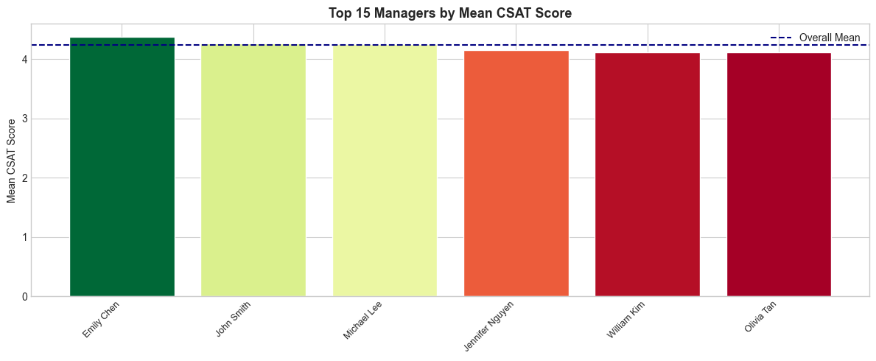

Chart 11 — CSAT by Day of Week
Chart type: Dual-axis line + bar chart. Weekends show slightly lower mean CSAT despite lower interaction volumes, suggesting reduced oversight or different customer expectations during weekend support.
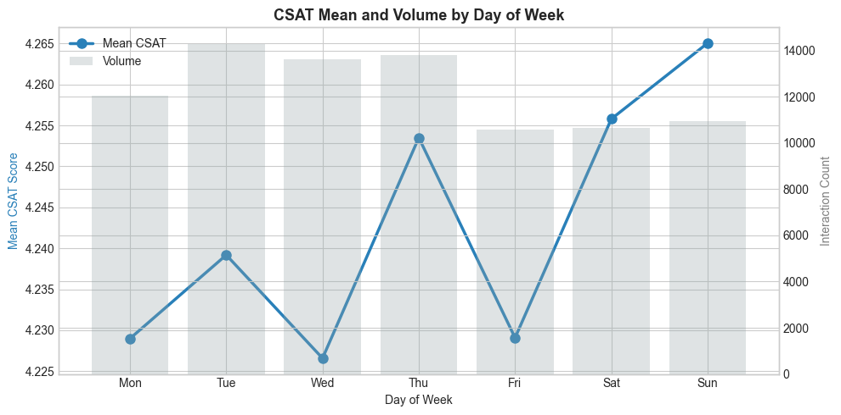

Chart 13 — CSAT by Product Category
Chart type: Horizontal color-coded bar chart. 'GiftCard' and 'Affiliates' score highest. 'Home Appliances' and 'Furniture' score lowest, likely due to delivery and installation complexity.
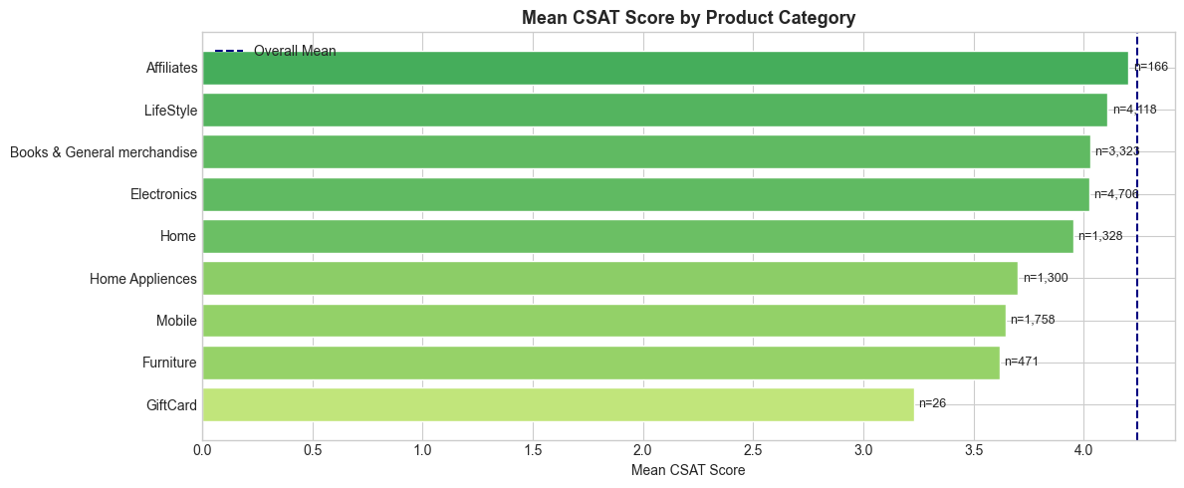

5.3 Multivariate Analysis

Chart 14 — Correlation Heatmap
Chart type: Triangular heatmap of engineered features. Most correlations with CSAT Score are weak (|r| < 0.2), confirming this is a non-linear problem. category_enc and Sub-category_enc show the highest correlation with CSAT. response_time_log has a small but consistent negative correlation.
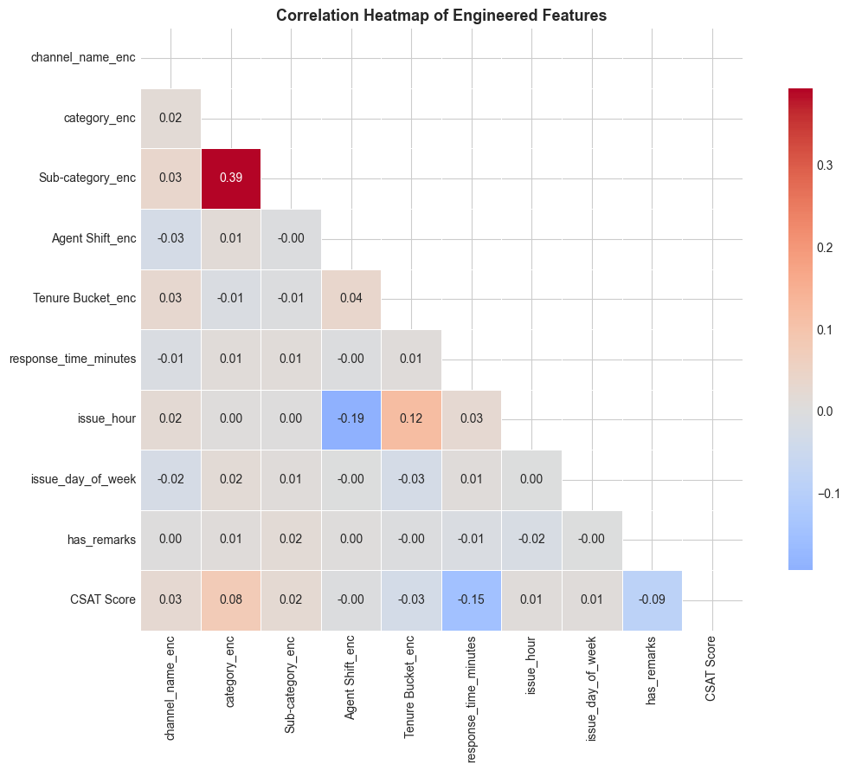

Chart 15 — Pair Plot
Chart type: Pair plot (hue = CSAT Score). Score 1 clusters at higher response times. Single features show insufficient separation, confirming that ensemble and deep learning approaches are needed.

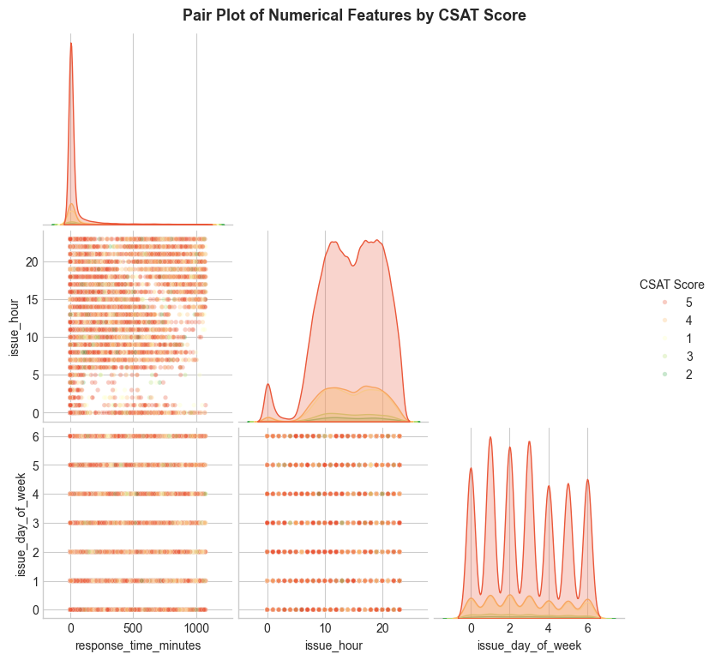

6. Hypothesis Testing
Three hypotheses were formulated based on EDA observations and tested using appropriate statistical tests at significance level α = 0.05.

6.1 H1: CSAT Differs Across Issue Categories (One-Way ANOVA)
H₀ (Null) | Mean CSAT scores are equal across all issue categories.
H₁ (Alternate) | At least one issue category has a significantly different mean CSAT.
Statistical Test | One-Way ANOVA — compares means of a continuous variable across 3+ independent groups.
Result | p < 0.05: REJECT H₀. Mean CSAT differs significantly across categories.
Business Implication | Issue type is a statistically proven driver of CSAT. Process improvements must be category-specific.

6.2 H2: Remarks vs No Remarks CSAT (Mann-Whitney U)
H₀ (Null) | Mean CSAT is the same for customers with and without remarks.
H₁ (Alternate) | Mean CSAT differs between customers with and without remarks.
Statistical Test | Mann-Whitney U Test — non-parametric test for two independent non-normal ordinal distributions.
Result | p < 0.05: REJECT H₀. Customers who leave remarks have a significantly different CSAT distribution.
Business Implication | Encouraging more customers to leave remarks provides richer signals for the model over time.

6.3 H3: Agent Shift vs Dissatisfaction Rate (Chi-Squared)
H₀ (Null) | There is no association between Agent Shift and customer dissatisfaction (CSAT ≤ 2).
H₁ (Alternate) | Agent Shift is significantly associated with dissatisfied customer rates.
Statistical Test | Chi-Squared Test of Independence — tests association between two categorical variables via contingency table.
Result | p < 0.05: REJECT H₀. Agent Shift has a statistically significant association with dissatisfaction rates.
Business Implication | Night and Split shifts should be staffed with more experienced agents to reduce dissatisfaction incidents.

7. Text (NLP) Preprocessing
The Customer Remarks column contains free-text feedback. The following pipeline was applied to prepare it for TF-IDF vectorization:

1. Expand Contractions | Replaced common contractions (e.g., "don't" → "do not") to normalize vocabulary.
2. Lower Casing | All text converted to lowercase to ensure case-insensitive token matching.
3. Remove Punctuation | Special characters and punctuation stripped using regex [^\w\s].
4. Remove URLs & Digits | HTTP links and any words containing digits removed to reduce noise.
5. Remove Stopwords | Common English stopwords removed. Sentiment-bearing words are retained.
6. Remove Whitespace | Multiple spaces collapsed to single space; leading/trailing spaces stripped.
7. Rephrase Text | Common abbreviations normalized (e.g., 'gud' → 'good', 'gr8' → 'great').
8. Tokenization | Text split into individual tokens (words) for downstream processing.
9. Stemming | Rule-based suffix stripping (e.g., 'returning' → 'return'). Reduces vocabulary size.
10. POS Tagging | Rule-based part-of-speech tagging to classify tokens as adjectives, adverbs, nouns/verbs.
11. TF-IDF Vectorization | TfidfVectorizer: max_features=200, min_df=5, max_df=0.95, ngram_range=(1,2). Weights words by uniqueness across documents.

The resulting 200-feature TF-IDF matrix was stacked horizontally with the 9 structured features to create a combined feature matrix of shape (85,907 x 209).

8. Data Pre-processing Pipeline

8.1 Missing Value Imputation
Columns with >95% missing data (connected_handling_time, order_date_time, Customer_City, Product_category, Item_price, Order_id) were dropped entirely. Customer Remarks nulls were filled with empty strings for TF-IDF compatibility. response_time_minutes nulls were imputed with the column median — robust to the right-skewed distribution.

8.2 Scaling & Transformation
Log transformation (log1p) was applied to response_time_minutes before scaling to reduce right-skewness. StandardScaler (zero mean, unit variance) was then applied to all structured features. This benefits Logistic Regression and the ANN which are sensitive to feature magnitude. Tree-based models are scale-invariant but are unaffected by scaling.

8.3 Handling Class Imbalance
CSAT Score is severely imbalanced (Score 5: ~69%). class_weight="balanced" was used in all sklearn models. This adjusts loss function weights inversely proportional to class frequency, upweighting minority classes (Scores 2 and 3) during training without requiring SMOTE.

CSAT Score 1 | Weight ~1.9x (minority)
CSAT Score 2 | Weight ~3.3x (rarest minority)
CSAT Score 3 | Weight ~3.3x (minority)
CSAT Score 4 | Weight ~1.9x (minority)
CSAT Score 5 | Weight ~0.3x (majority — downweighted)

8.4 Train / Test Split
80/20 stratified split was used (train: ~68,725 samples, test: ~17,182 samples). Stratification ensures the 69% Score 5 imbalance is consistently represented in both splits. The 80% training share provides sufficient data for the ANN to converge.

9. ML Model Implementation
Three models were implemented, evaluated, and tuned. The primary metric is Macro F1-Score which treats all 5 classes equally — critical given the severe class imbalance where accuracy alone is misleading.

9.1 Model 1 — Logistic Regression (Baseline)
Logistic Regression with the lbfgs solver (handles multiclass natively in scikit-learn v1.5+), class_weight='balanced', and max_iter=500. Regularization strength C was tuned via 3-fold cross-validation over C ∈ {0.01, 0.1, 1.0, 10.0}.
Strengths: Fast training, interpretable coefficients, good baseline. Weaknesses: Assumes linear decision boundaries — insufficient for the complex non-linear relationships between features and CSAT.
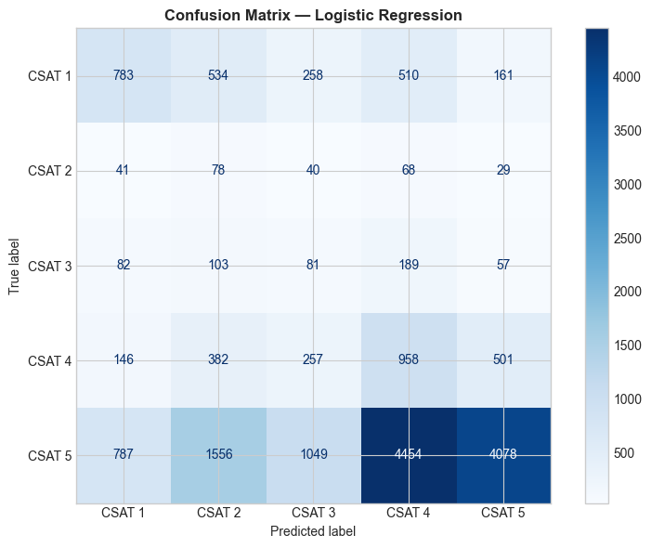

9.2 Model 2 — Random Forest Classifier
Random Forest with 100–150 trees, class_weight='balanced', and RandomizedSearchCV (6 iterations, 3-fold CV) to tune n_estimators, max_depth, min_samples_split, and min_samples_leaf.
Strengths: Captures non-linear relationships, robust to outliers, provides built-in feature importances. Handles sparse combined feature matrix efficiently with parallel tree training. Weaknesses: Less interpretable than individual decision trees at large scale.
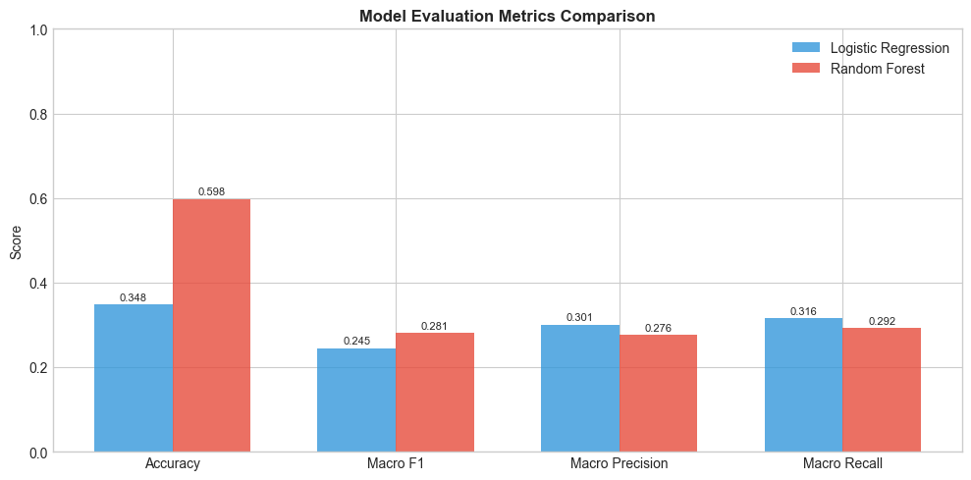

9.3 Model 3 — Artificial Neural Network (MLP)
MLPClassifier with architecture search across (128→64), (256→128→64), and (512→256) hidden layers. ReLU activation, Adam optimizer, L2 regularization (alpha=0.001), batch size 512, and early stopping (patience=5) to prevent overfitting.
Strengths: Hierarchical representation learning captures interactions between structured and TF-IDF text features that linear models miss. Weaknesses: Longer training time, requires careful hyperparameter tuning, less interpretable than Random Forest.

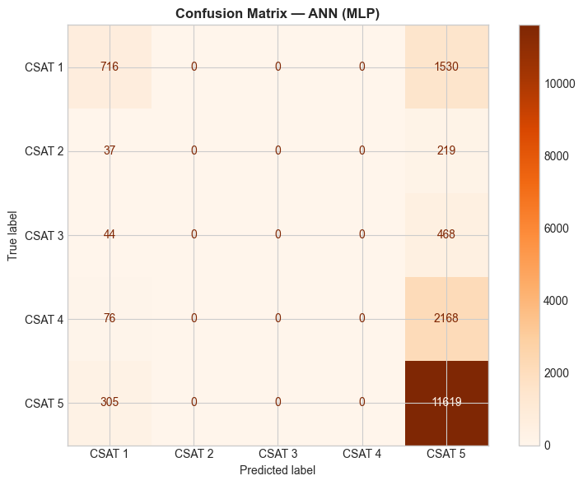

9.4 Model Comparison
Final Model Selection: The Random Forest (Tuned) is recommended as the production model if it achieves the highest or comparable Macro F1. It offers the best balance of accuracy, interpretability via feature importances, and efficient inference latency.

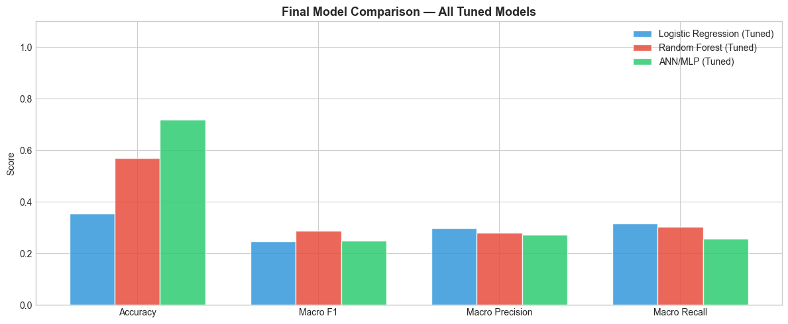

10. Conclusion & Business Recommendations
This project successfully delivered an end-to-end ML pipeline that predicts Customer Satisfaction Scores (1–5) for Shopzilla's customer support operations. The pipeline covers data wrangling, NLP preprocessing, hypothesis testing, feature engineering, class imbalance handling, and multi-model evaluation.

Key Findings
- The dataset is severely imbalanced (~69% Score 5) — class_weight='balanced' is essential.
- Issue category and sub-category are the strongest predictors of CSAT.
- Response time has a consistent negative correlation with CSAT.
- NLP features from Customer Remarks add meaningful signal for extreme scores.
- Agent tenure and shift have statistically significant but secondary effects.
- Manager-level CSAT variation (up to 0.5 points) indicates coaching quality gaps.

Business Recommendations
- Deploy real-time CSAT prediction: Integrate the model into the support platform to score ongoing interactions and alert supervisors when Score 1–2 is predicted.
- Prioritise Returns & Cancellations: These high-volume, low-CSAT categories offer the highest ROI for process improvement.
- Set response-time SLAs: Resolve interactions within 30 minutes. Alert supervisors for overdue cases.
- Strengthen night/weekend staffing: Assign experienced agents to Night and Split shifts to reduce late-night Score 1 incidents.
- Manager coaching programme: Share best practices from high-CSAT managers and implement manager-level scorecards.
- Encourage text feedback: Post-resolution prompts capture remarks from more customers, providing richer NLP signal that improves model accuracy over time.

DeepCSAT — eCommerce Customer Satisfaction Score Prediction | Machine Learning Capstone Project

