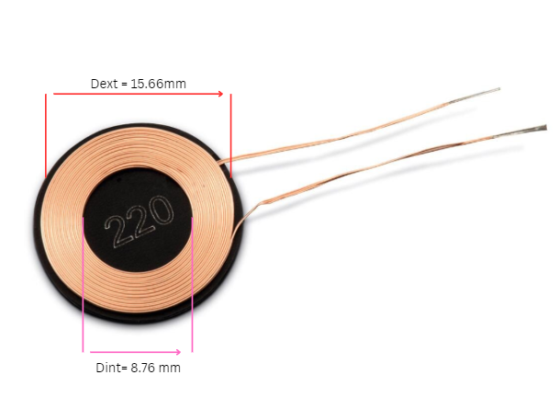

<https://4donline.ihs.com/images/VipMasterIC/IC/ABRC/ABRC-S-A0013178813/ABRC-S-A0013335815-1.pdf?hkey=6D3A4C79FDBF58556ACFDE234799DDF0>