**E-ARPM: EDGE-ASSISTED ASTHAMA RISK PREDICTION AND MITIGATION USING DEEP LEARNING**

**Abstract--**Air pollution is a problematic risk factor for death worldwide and is particularly important in several respiratory diseases. Additionally, it causes about 8 million deaths annually, with 4.2 million of those deaths occurring globally due to outdoor exposure and 3.8 million due to interior pollution. Pollutants cause a variety of respiratory problems. The number of asthma outcomes including incidence, prevalence, hospital admissions, visits to emergency rooms, mortality, and asthma episodes, among others, are also clearly impacted. Admission to the hospital is risky for elderly patients and those with multiple comorbidities including hypertension and diabetes, especially in the current covid situation. An internal monitoring strategy for predicting asthma is necessary to get around this. Therefore, a deep learning-based edge-aided framework for asthma risk prediction (EARPM) is presented to accomplish the objective. Using a convolution neural network and the amount of particulate matter(pm) present in their living environment and the weather outside, E-ARP calculates the vulnerability level of the peak exploratory flow rate. Additionally, the projected PEFR levels are divided into 3 classes based on the best peak flow value that each participant was able to obtain: “Green”, “Yellow” and “Red” based on the level of risk. Countermeasures like turning on sir purifiers should be taken if the current conditions are conducive to raising the risk of asthma.PM sensors are used in the hardware implementation of the E-RMP prototype to find particulate matter. Additionally, Raspberry Pi serves as an edge node that forecasts the degree of risk and triggers the reaction system(purifiers) in response.

**KEYWORDS**-edge computing, machine learning, iot, Asthma prediction, particulate matter (PM), peak expiratory flow rates (PEFR), convolutional neural network, Raspberry pi.

1. INTRODUCTION

Asthma is a breathing problem that we are facing in our day-to-day life. One of the factors causing asthma is environmental pollution and temperature. It damages the respiratory system of a person through the entry of dust or unwanted particles into the lungs. Globally around 300 million people suffer from asthma [1]. Inthe United States, it is nearly 17.7 million adults and 6.3 million children had been diagnosedwith asthma in 2014 [1].

One of the least developed branches of forecasting science is health forecasting. Forecasting health risks is very much needed in our day-to-day life to have a healthy lifestyle. People of all ages are compromising their quality of life because of asthma as it restricts physical, emotional, and social aspects of life. A major role in asthma attacks is environmental health. It is very difficult for patients to go to hospitals for checkups every time. A patient requires expensive equipment that cannot be easily affordable. Therefore,We require an effective predictive model which helps in providing the correct guidance and accurate prediction. It makes the patient to be aware of the surrounding environment and prevents them from becoming ill. It assists the patient according to the environment and performs measures to overcome Asthma.

Here, an asthma predictive model is developed to monitor the surrounding environment of a person by, providing the level of risk in real-time. The deep learning-based asthma prediction tool is developed to monitor the surrounding environment of the person. It is an Edge-based assistive tool for decreasing latency. Only with real-time environmental data, we cannot predict the asthma attack. We need peak expiratory flow rate (PEFR) measurements from different people. The data of PEFR and age and height are collected from different people to find the correlation. A Deep learning technique is used to correlate the environmental data with the PEFR values.

The deep learning, model chosen varies with other existing machine learning algorithms in asthma prediction by the size of the dataset. The performance of the deep learning model depends on a large amount of data. To collect this real-time data, integrate our deep learning model with the Internet of Things (IoT). It plays a major role in asthma prediction for generating real-time data and also for the deployment of models.

In this Proposed model, with the help of the Internet of Things we get real-time sensor data. The risk of asthma is predicted using the air-quality sensor. The particulate matter present in the air causes high risk to patients. The PM2.5 and PM10 values data is gathered from the surrounding environment with the help of an air quality sensor. The temperature and humidity of the environment are gathered by using the temperature sensor. The data collected is used for developing a prediction. A real-time dataset is created from the collected data.

The deep learning algorithmused in the proposed model is a Convolutional neural network (CNN) for predicting asthma. The real-time data collected is used as the labels to train the CNN model. All the sensors are connected to the ESP32 microcontroller. The entire model is trained and tested in the edge device. Raspberry Pi acts as an edge device with gets real-time data from the ESP32 using IoT communication protocols. The edge device is used to predict the level of risk and activate the purifier present in the room according to the level of risk.

This paper is the extension of the study presented in [4].In this proposed model we used an edge-assisted device instead of a cloud-based one and also used an efficient deep-learning algorithm. The main idea of this [4] paper is to make an indoor air monitoring system with a web application.

The measure is to be taken to prevent asthma attacks. The purifier is placed in a room that activates when there is a risk level in the environment by absorbing the dust particulates, which makes the patient get rid of dust and breath properly with good health conditions.

The rest of this paper is organized as follows. A review of the literature on studies related to ML applications to various diseases is mentioned in section 2. A detailed description of the proposed method is presented in section 3. The integration of the sensor platform and the smartphone is explained in section 4. Experimental results are shown in section 5 and conclusions are drawn in section 6.

1. RELATED WORK/LITERATURE SURVEY

Numerous studies have been done on Asthma risk prediction and the impact of the surrounding environment on patients suffering from asthma.A machine learning-based asthma risk prediction has been explained in [4]. All the DNN, CNN, and ANN are compared for asthma prediction in [4] co-relation of temperature and humidity with PEFR in [4]. Diabetic prediction based on DNN is been explained in [5]. DNN-based Parkinson’s disease prediction is explained in [6],[7]. Heart disease prediction based on machine learning by using IoT is explained in [8]. In [9]-[11]. Liver metastatic detection using fully convolutional networks (FCN) is explained in [12]. Asthma predictions are explained using Naïve Bayesian classifiers and Random Forest classifiers. Effects of indoor PM concentrations on children arepredicted in [13]. The LSTM model is used to predict asthma better than the multinomial logistic [13]. All these are integrated together to forms edge-assisted - deep learning-based asthma risk prediction

1. PROPOSED ASTHMA PREDICTION METHOD

This section explains the proposed asthma risk prediction method. It mainly discusses about the data collection and the working of deep learning model. The flowchart of the proposed system is shown in the figure .The PM2.5 and PM10 levels which characterize the weather data and the indoor pollutants data act as the input to the deep learning model and the peak exploratory flow rate(PEFR) show the labels .

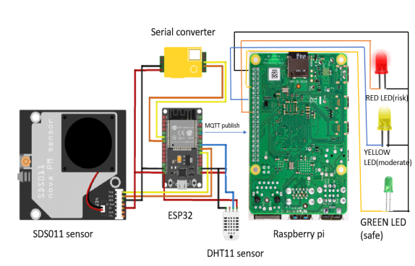

Fig : Proposed model

1. PEAK EXPIRATORY FLOW RATE(PERF)

The volume of air forcibly ejected from the lungs in one fast exhalation is known as the peak expiratory flow rate (PEFR), and it is a good indication of both ventilation adequacy and airflow restriction. The typical peak flow value varies from individual to personand is determined by criteria such as gender, age, and height. The most common condition that affects the peak flow is asthma.Patients with asthma may already have a peak flow meter and record daily readings, which they log on their own individualized charts. Peak flow rates might fluctuate throughout the day.Asthma exacerbations cause air to become trapped due to bronchoconstriction and inflammation, limiting the amount of air exhaled during each breath. This can manifest with varying degrees of severity, affecting peak flow values.The interpolated PEFR values have been classified into three categories: ''green'' (when the reading is above 80% of the best peak flow; normal exacerbation), ''yellow'' (when the reading is between 50% and 80% of the best peak flow; moderate exacerbation), and ''red'' (when the reading is below 50% of the best peak flow; significantly exacerbated). These categories serve as the output labels for our neural network modelling.

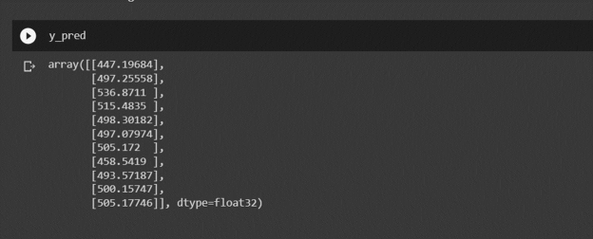

FIG:Predicting the PEFR values

1. ENVIRONMENTAL MONITORING

Around the same time that the PEFR data were obtained, sensors are installed at each patient's house that monitor the particulate matters PM2.5 and PM10, as well as temperature and relative humidity . SDS011 sensor is used to monitor the PM2.5 and the PM10 particulate matter ,DHT11 sensor for the temperature and humidity.

1. CONVOLUTIONAL NEURAL NETWORK-BASED PREDICTION

The proposed convolutional neural network makes a regression-based judgement that estimates the PERF readings. The CNN model takes the matrix input for predicting the risk of asthma. The proposed convolutional neural network (CNN) architecture contains four hidden layers: one convolutional layer, one Max Pooling layer, one Flatten layer, and one Dense layer. The same network has been utilized in IoT deployment and experimental evaluations. The input layer has 7 features and is 7x1 in size. The convolutional layer employs 64 feature maps to achieve greater learning of the input information. The kernel for the convolution layer has a size of 3x3. Convolution is performed using a single stride on the convolution layer. All the activation functions are ReLU, and the output layer with the linear activation function has one neuron. The model is trained for 100 epochs.

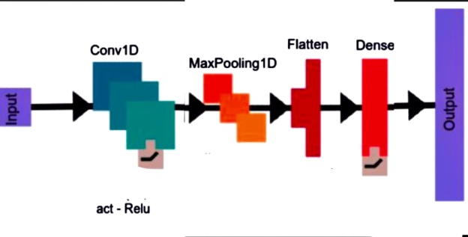

FIG: Layers involved in 1D CNN

1. DATASET CREATION

The dataset required for the training is made from the real time sensors SDS011 sensor and DHT11 sensor which are placed in the patient’s environment .The ESP32 is used for the data acquisition.

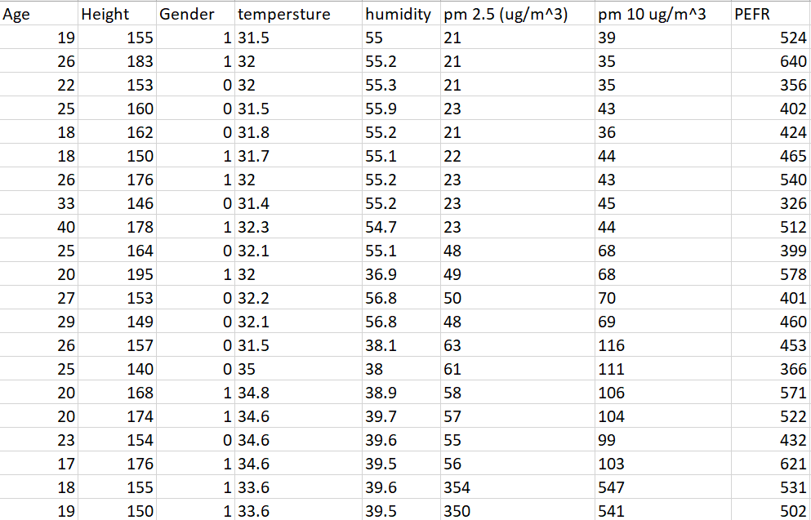

FIG: Real-time dataset

1. MQTT_COMMUNICATION ESTABLISHMENT

The sensors which monitor the environmental conditions and the particulate matter are connected to the ESP32 .A secured mqtt connection is setup between the ESP32 and the raspberry pi ,for the transmission of data.

The ESP32 which collects the data from the sensors sends the data to the edge device i.e. the raspberry pi by using the mqtt. The edge device receives the data and based on the predicted perf the activation is performed.

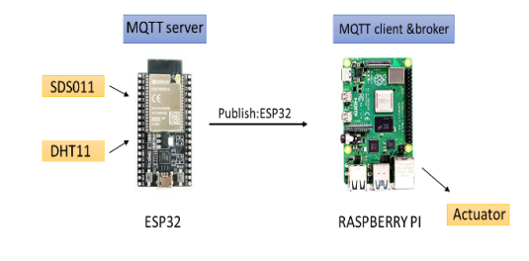

FIG: Publishing real-time data

1. DEPLOYMENT OF DEEP LEARNING ON THE EDGE DEVICE

The trained ml model is deployed on the edge device, which is the raspberry pi. Now ,the patient’s environmental data which is received by the edge device from the ESP32 through mqtt , is sent as an input to the deep learning model in the form of an array ,and this model predicts the pefr value based on the input. Now based on the pefr value the levell of risk is predicted.The patient is shown with the predicted pefr value along with the level of risk

1. IOT AND SMARTPHINE IMPLEMENTATION
2. OVERALL PROCEDURE

The overall procedure of proposed model is to predict the risk level of environment the patient living in. By using IoT and machine learning we are able to predict the environment is suitable for patients are not. The machine learning model is deployed in the Raspberry pi and get the real-time data published by ESP32. According to the sensor value, model predicts the PEFR value and if the PERF value if HIGH then, the condition is safe and need not to turn the air purifier. If PEFR is low then Moderate risk, turn on air purifier moderately. If PEFR value is too low then the environment is risk to the patient so immediately the air purifier will turn ON.

The layers involved in this is sequential layer, flatten layer, Dense layer, Conv1D, maxpool1D . In this architecture, the input is in the form of  1D signal (such as a time series of asthma symptoms), which is passed through one convolutional layer with ReLU activation functions, followed by max pooling and flatten layers to prevent overfitting. The output of the convolutional layers is then flattened and passed through one fully connected dense layers, also with ReLU activation functions and dropout layers.

1. AIR QUALITY SENSOR

The SDS011 air quality sensor is used to monitor the particulate matter in the environment. The sensor is connected to ESP32 and data is published to Raspberry pi through MQTT protocol .The sensor get the values of PM2.5 and PM10. SDS011 sensor is a portable and small sized sensor with accurate measures. The PM2.5 and PM10 are differentiated according to the particle size.

1. ENVIRONMENTAL DATA

With the help of DHT11 sensor we get the environmental data. The DHT11 sensor gathers both temperature and humidity in the environment it is placed. The reason behind gathering temperature amd humidity is, as there is decrease in temperature the patient feels suffocating and the breathing rate also gets decreases which directly effects respiratory organs and makes the patient condition critical.

1. DATA HOSTING ON PI

The data is hosted on Raspberry pi by using MQTT protocol. ESP32 gathers all the real-time data which includes data from DHT11 sensor and SDS011 sensor data. The machine learning or 1D CNN model is deployed in the Raspberry pi which consists of multiple filters. The data is trained to the CNN model. Raspberry pi is used to predict the PEFR value according to the model it is trained. Raspberry pi also helps in activating the air purifier according to the predicted PEFR value.

1. ACTIVATION IMPLEMENTATION

The activation function is performed by Raspberry pi according to the predicted PEFR value. The air purifier turned ON when the predicted PEFR is too low and the condition is “RISK”. When the predicted PEFR value is medium then the condition is “MODERATE”. When the predicted PEFR value is HIGH then the condition is “SAFE”.

1. EXPERIMENTAL RESULTS

The root mean square error (RMSE) and mean absolute error (MAE) are used to evaluating the 1D CNN model. The CNN model is trained with real-time dataset. After training the CNN model with 1D dataset it predicts the PEFR value. As a result, we found RMSE and MAE values.

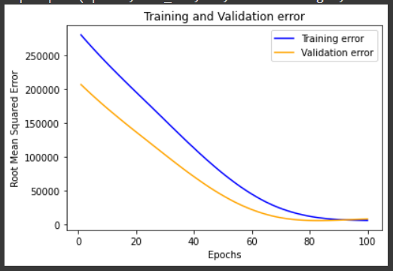

Fig plot between RMSE and epochs

The graph shows the plot of RMSE during epochs. The validation error rate decreases as the number of epochs increases.

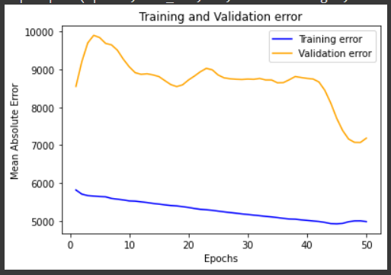

Fig plot between MAE and epochs

The graph shows the plot of MAE during epochs.With the number of epochs the validation error i.e the rmse and mae error rate decreases when compared to train error. The **training loss** indicates how well the training data is being fitted by the model. **validation loss** indicates how well the new data is being fitted by the model.

FIG: MAE comparison of the proposed method with other benchmark techniques using overall data

It is found that the MAE of proposed CNN model is 57.7%, 52.00% and 12.63% better than that of ANN, DNN, FCN respectively.

FIG: RMSE comparison of the proposed method with other benchmark techniques using overall data

It is found that the RMSE of proposed CNN model is 51.70%, 46.50% and 12.63% better than that of ANN, DNN, FCN respectively.

The Raspberry pi is used to predict the PEFR value by taking the realtime data from the sensors. According to the predicted value the led is activating. Here the led represents the level of risk of the environment the patient living.

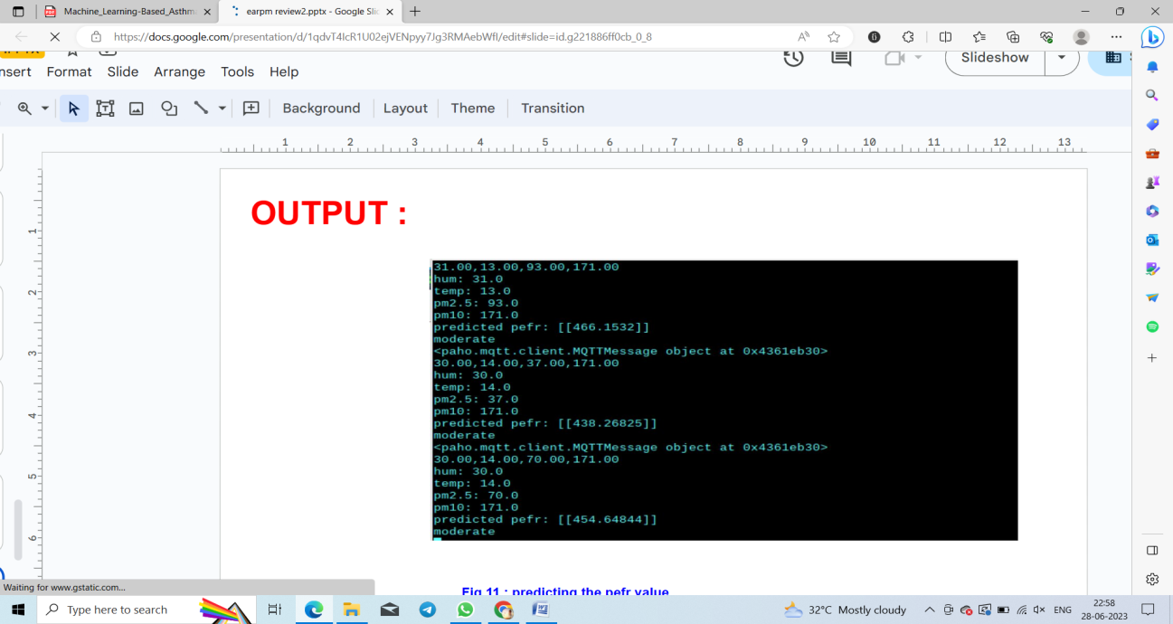

Fig: Prediction of PEFR value according to the sensor data

The YELLOW led represents the moderate condition as shown in figure below. The condition arises when the PEFR value is moderate.

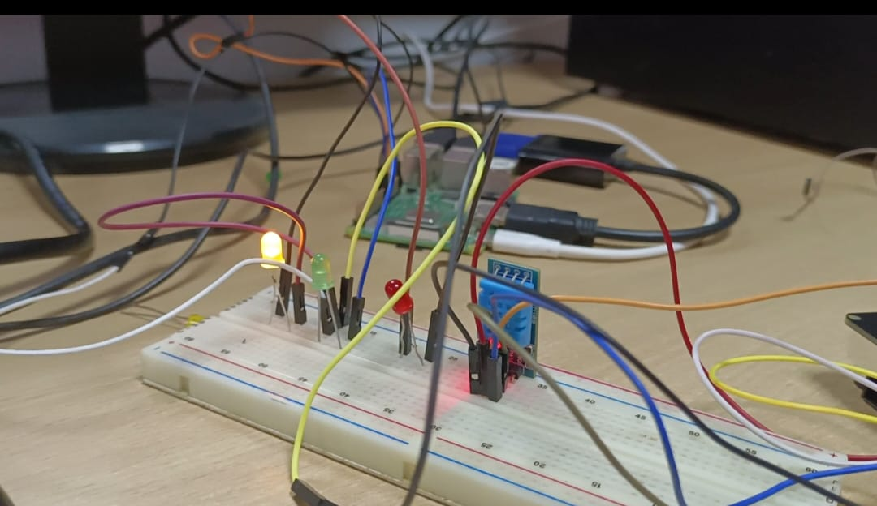

FIG: Activating the yellow Led when the condition is moderate

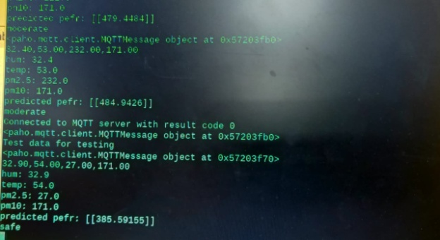

FIG: prediction of PEFR value and shows the safe condition

The GREEN led represents the SAFE condition as shown in fig below. The condition arises when the PEFR value is HIGH

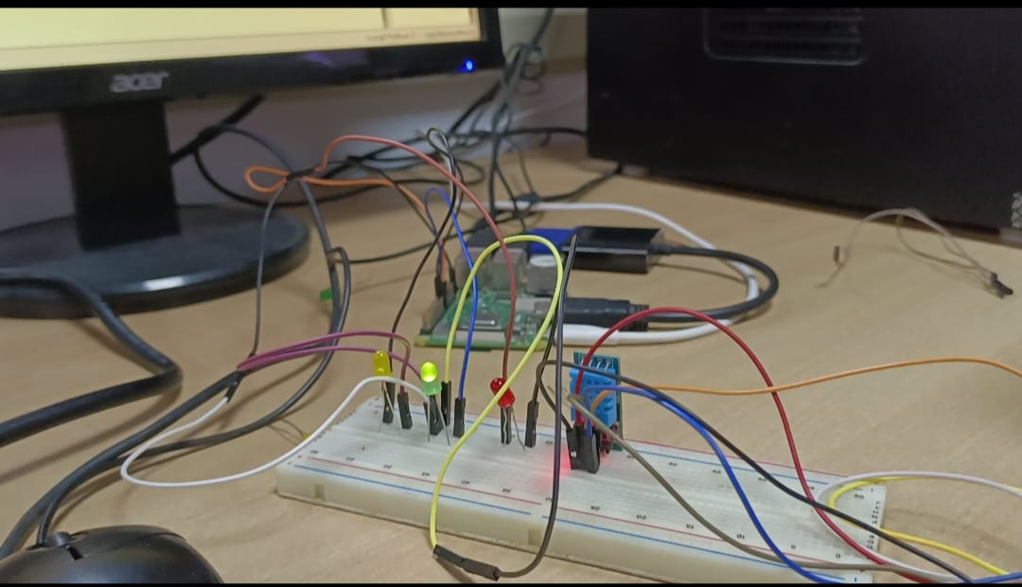

FIG: Activating the green led when the condition is safe

1. CONCLUSION

In this paper, we presented an edge-assisted asthma risk prediction tool using deep learning. i.e., CNN algorithm and IoT technologies. The sensors and edge devices used in this model are cost-effective. The entire model is deployed on an edge device and the activation of the purifier is accordingly without latency. The PEFR reading is predicted according to the weather data and particulate matter. The tool can be used successfully to predict asthma risk in individuals and take safety measures.

1. REFERENCES
2. Futurity. (2021). Lung Inflammation Patients With Asthma. Accessed: Mar. 2021. [Online]. Available: https://www.futurity.org/device-predictsAsthma-attacks-1436782/
3. H. Tibble, A. Tsanas, E. Horne, R. Horne, M. Mizani, C. R. Simpson, and A. Sheikh, ‘‘Predicting asthma attacks in primary care: Protocol for developing a machine learning-based prediction model,’’ BMJ Open, vol. 9, no. 7, Jul. 2019, Art. no. e028375
4. D. Kim, S. Cho, L. Tamil, D. J. Song, and S. Seo, ‘‘Predicting asthma attacks: Effects of indoor PM concentrations on peak expiratory flow rates of asthmatic children,’’ IEEE Access, vol. 8, pp. 8791–8797, 2020.
5. GAUTAM S. BHAT, NIKHIL SHANKAR, DAE JIN SONG, SUNGCHUL SEO, ISSA M. S. PANAHI, AND LAKSHMAN TAMIL, “Machine Learning-Based Asthma Risk Prediction Using IoT and Smartphone Applications” IEEE Access, vol 8, pp 118708-118715, 2021.
6. T. R. Gadekallu, N. Khare, S. Bhattacharya, S. Singh, P. K. R. Maddikunta, and G. Srivastava, ‘‘Deep neural networks to predict diabetic retinopathy,’’ J. Ambient Intell. Humanized Comput., pp. 1–14, Apr. 2020.
7. S. Grover, S. Bhartia, A. Yadav, and K. R. Seeja, ‘‘Predicting severity of Parkinson’s disease using deep learning,’’ Procedia Comput. Sci., vol. 132, pp. 1788–1794, May 2018.
8. R. M. Sadek, S. A. Mohammed, A. R. K. Abunbehan, A. K. H. A. Ghattas, M. R. Badawi, M. N. Mortaja, B. S. Abu-Nasser, and S. S. Abu-Naser, ‘‘Parkinson’s disease prediction using artificial neural network,’’ Int. J. Acad. Health Med. Res., vol. 3, no. 1, 2019.
9. S. Grover, S. Bhartia, A. Yadav, and K. R. Seeja, ‘‘Predicting severity of Parkinson’s disease using deep learning,’’ Procedia Comput. Sci., vol. 132, pp. 1788–1794, May 2018. [18] R. M. Sadek, S. A. Mohammed, A. R. K. Abunbehan, A. K. H. A. Ghattas, M. R. Badawi, M. N. Mortaja, B. S. Abu-Nasser, and S. S. Abu-Naser, ‘‘Parkinson’s disease prediction using artificial neural network,’’ Int. J. Acad. Health Med. Res., vol. 3, no. 1, 2019.
10. G. Gayathri and S. Satapathy, ‘‘A survey on techniques for prediction of asthma,’’ in Smart Intelligent Computing and Applications. Singapore: Springer, 2020, pp. 751–758.
11. A. Silveira, C. Muñoz, and L. Mendoza, ‘‘Severe asthma exacerbations prediction using neural networks,’’ in Proc. Int. Conf. Eng. Appl. Neural Netw. Cham, Switzerland: Springer, 2019, pp. 115–124
12. R. A. Aroud, A. H. Blasi, and M. A. Alsuwaiket, ‘‘Intelligent risk alarm for asthma patients using artificial neural networks,’’ 2020, arXiv:2009.12175. [Online]. Available: <http://arxiv.org/abs/2009.12175>
13. A. Ben-Cohen, I. Diamant, E. Klang, M. Amitai, and H. Greenspan, ‘‘Fully convolutional network for liver segmentation and lesions detection,’’ in Deep Learning and Data Labeling for Medical Applications. Cham, Switzerland: Springer, 2016, pp. 77–85.
14. DOHYEONG KIM, SUNGHWAN CHO, LAKSHMAN TAMIL 2 , (Senior Member, IEEE), DAE JIN SONG 3 , AND SUNGCHUL SEO 4, “Predicting Asthma Attacks: Effects of Indoor PM Concentrations on Peak Expiratory Flow Rates of Asthmatic Children” IEEE Access , vol 8, pp 8791-8797