##### Logo-IIITDM

##### INDIAN INSTITUTE OF INFORMATION TECHNOLOGY,

##### DESIGN & MANUFACTURING KANCHEEPURAM

**INT 303 – PRODUCT DESIGN PRACTISE**

**DESIGN OF**

**HANDY WASHING MACHINE**

**Session: JAN-APRIL, 2012**

EDM09B002 – DEBAJIT SARDAR

EDM09B010 – PRAVEEN SAHU

MDM09B014 – SHAKTI SHALIGRAM

COE09B002 – ANAS FARUQUI

COE09B011 – SIDDHARTH DARBHA

COE09B013 – VIJAY YADAV

##### ABSTRACT

A washing machine is a machine that is used to wash, rinse and dry clothes. Washing machines available in the market are for domestic and industrial purposes. Both of these are heavy, large, fixed devices that are used to drive heavy loads of clothes.

For this practice, the aim is to apply a novel idea to build a washing machine that is portable, light and cheap.

CONTENTS

|  |  |
| --- | --- |
| 1 | INTRODUCTION |
| 1.1 | CONCEPT OF WASHING CLOTHES |
| 1.2 | AGITATION: INTRODUCTION TO WASHING MACHINES |
| 2 | FEATURES, PRINCIPLES AND IMPLEMENTATION |
| 2.1 | STRUCTURE |
| 2.2 | PUMPS |
| 2.3 | TIMER & LEVEL DETECTION |
| 3 | APPENDIX |
| 3.1 | COMPETING PRODUCT |
| 3.2 | POSTER |
| 3.3 | COST ESTIMATION |
| 4 | CONCLUSION |
| 5 | REFERENCES |

1 INTRODUCTION

1.1 CONCEPT OF WASHING CLOTHES

Dirt is physically attached to cloth surface. The oily nature of dirt makes it hydrophobic, and hence water is usually not sufficient to help remove dirt. Soap/detergent is added to the water because soap has both a hydrophilic end and a hydrophobic end. The hydrophobic end binds with the oil, while the hydrophilic tail is free-flowing. Water molecules interact with this tail, and hence the oil+soap component is free to move.

1.2 AGITATION: INTRODUCTION TO WASHING MACHINES

A washing machine consists mainly of a tub. The dirty clothes are inserted in to this tub along with soap water. The soap in the water does the work of making the dirt mobile. The washing machine now creates agitation amongst the clothes, to help detach dirt that is firmly attached to the clothes. Over time, all the dirt is now a part of the fluid. This dirty water is then drained. The clothes are then rinsed with fresh water and the spin-dried.

2 FEATURES, PRINCIPLES AND IMPLEMENTATION

The product is called Vortex, as an indication to the central principle used in this device. It is a portable washing machine that can be used to wash clothes in any bucket that is available, while the consumer cannot avail a full-fledged washing machine. It has the following features:

* Light Weight/Portable: It is light weight and portable. This is a core feature of the product that distinguishes it from conventional washing machines.
* Timer: To conserve energy and to not over-work the pumps, a timer is provided.
* Level detector: Most motors and pumps have a short lifetime because they run in low-water scenarios. To prolong the life of the device, a level detector is fitted.
* Noiseless operation: The machine is noiseless because it uses noiseless pumps, instead of motors.
* No vibration: The placement of the pumps is such that vibration is minimized.
* Stable: Symmetric configuration helps make the machine stable and topple-free.
* Tangle free operation: No working portions are exposed, hence keeping the clothes from tangling.

2.1 STRUCTURE

The Vortex consists of three pumps. Two of these are mounted on the inner side of the bucket, and are used to produce circular, horizontal spin in clockwise/anti-clockwise direction. The third pump is placed in the center of the bucket, on the bottom surface, pointing upwards. This pump produces proper agitation of the water.

2.2 PUMPS

The pumps being used in this device are fully submersible, compact and noiseless. They have a high range of operating voltage (160-240V). The pump heads are stated to be 1.2m, but in real use they deliver up to 0.9m. The stated wattage is 18W.

2.3 TIMER & LEVEL DETECTION

We have added three electronic switches to run the washing machine for 5 minutes, 10minutes, and reset respectively. To have this kind of electronic system we have used the microcontroller called Atmega16.

Most of the submersible pumps are damaged/burnt whenever they are used without water.

To eliminate this kind of situation completely we have built a level detection module which doesn’t allow the pumps to be switched on until water level reaches a predefined optimum level.

ALGORITHM FLOWCHART

yes

yes

no

Start

no

If

TimerB=1 AND Level sensor=1

If

TimerA=1 AND Level sensor=1

Machine works till

5 min

Machine works till

10 min

Figure 1

CIRCUIT DIAGRAM

The circuit has been made using National Instruments MultiSim.

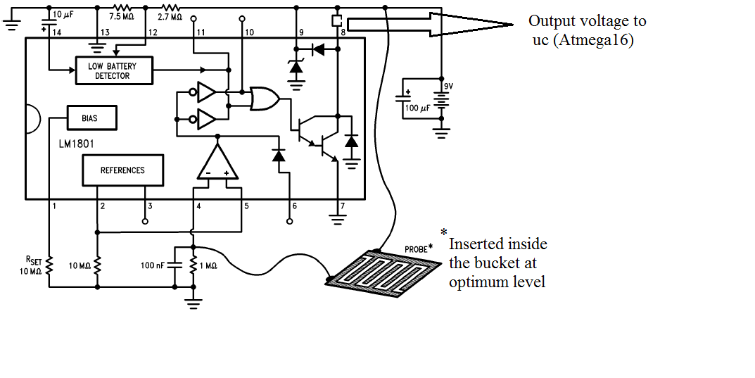

Figure 2

For level detection, two thick copper wires separated by a distance have been used.

BLOCK DIAGRAM OF THE ATMEGA 16 SET-UP

Atmega16

Power (9V)

S1(5 min)

S2(10 min)

S3 RESET

Level Detection

Relay

Pumps

Figure 3

The whole electronic control setup will be encapsulated inside a sealed plastic box, to avoid shocks.

ATMEGA16 CODE

The coding has been done on AVR Studio.

#include<avr/io.h>

assign portA.1=timer_5;

assign portA.2=timer_10;

assign portA.3=level_sensor;

assign portB.1=relay_op;

void main()

{

DDRA portA=#FFxh; // port a is set as input from timer switch

DDRA portB=#00xh;

while(1)

{

if(timer_5==1 && level_sensor==1) %delay generation

{

for(int i=0;i<=500;i=i+1)

{

relay_op=#01xh;

for(int j=0;j<=10000;j=j+1);

}

relay_op=#00xh;

break; % as soon as 5 minutes is over it comes out of loop

}

if(timer_10==1 && level_sensor==1)

{

for(int i=0;i<=500;i=i+1)

{

relay_op=#01xh;

for(int j=0;j<=10000;j=j+1);

}

relay_op=#00xh;

break;

}

}

}

3. APPENDIX

3.1 COMPETING PRODUCT

The market for this field of devices is very

Venus Handy Washing Machine

Cost: Rs. 3499/-

Core Idea: Motor creates water circulation

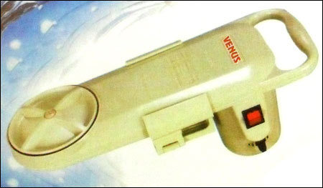

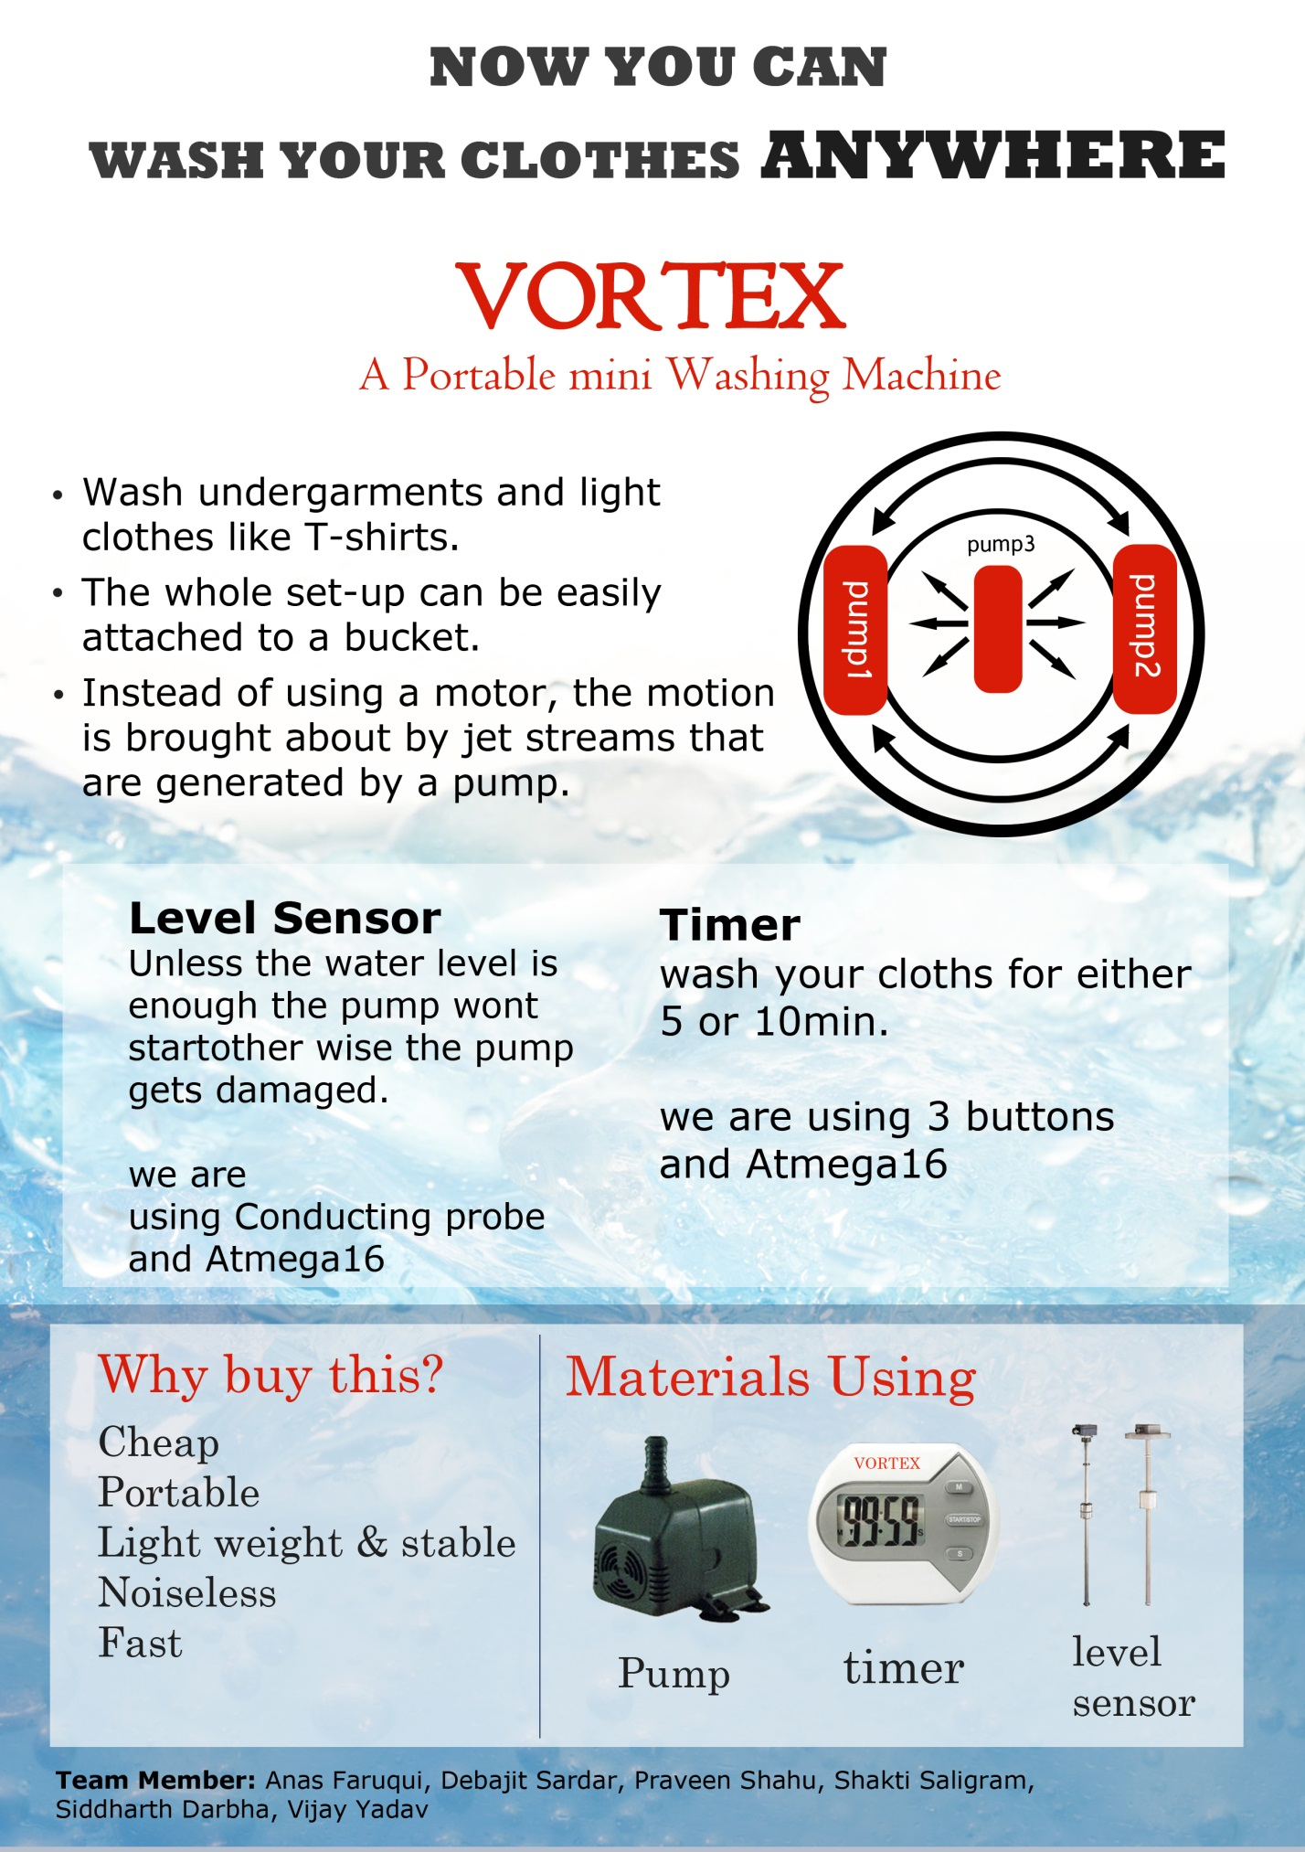3.2 POSTER

3.3 COST ESTIMATION

One time :

ATMEGA Programmer : Rs.1000

Soldering Setup : Rs.120

MultiMeter : Rs.145

Bread Boards : Rs.130

Per Unit (off the Shelf) :

Submersible Pump : 400 (x3) = Rs.1200

ATMEGA 16 Controller : 270 (x1) = Rs.270

Relay : 075 (x1) = Rs.75

Misc. (Electronics) : 300 = Rs.300

Misc. (Frame) : 150 = Rs.150

-----------------

Total : Rs.1995

----------------

Per Unit (Large Scale Production) :

Submersible Pump : 200 (x3) = Rs.600

Controller : 100 (x1) = Rs.100

Relay : 050 (x1) = Rs.50

Misc. (Electronics) : 100 = Rs.100

Misc. (Frame) : 100 = Rs.100

---------------

Total : Rs.950 ---------------

4. CONCLUSION

The market for this product was found to be optimal through local survey. The addition of the aforementioned features is beneficial in competition.

5. REFERENCES

* Washing Machine, Wikipedia

{ http://en.wikipedia.org/wiki/Washing_machine }

* Atmega 16, Atmel  
  { http://www.atmel.com/devices/atmega16.aspx }
* Venus Handy Washing Machine  
  { http://handywashingmachine.blogspot.in/ }

THANK YOU