**Three-Thirteen Documentation**

**Complete Score Sheet:**

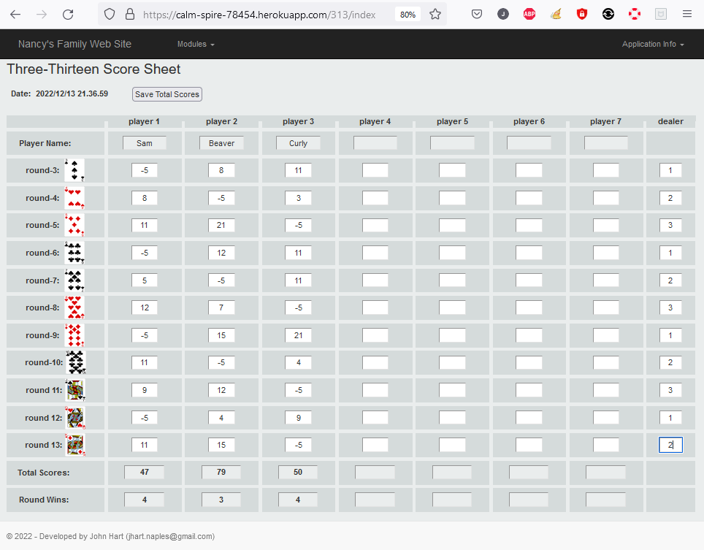

Player names must be entered manually. The maximum number of players is 7. Scores are entered manually. The values for Total Scores and Round Wins are generated by the application. When entered data is completed the ‘Save Total Scores’ will display near the top of the display. Clicking the ‘Save Total Scores’ will enable the application to save game data to a database. When this is completed the Save Status page will be rendered.

**Save Status:**

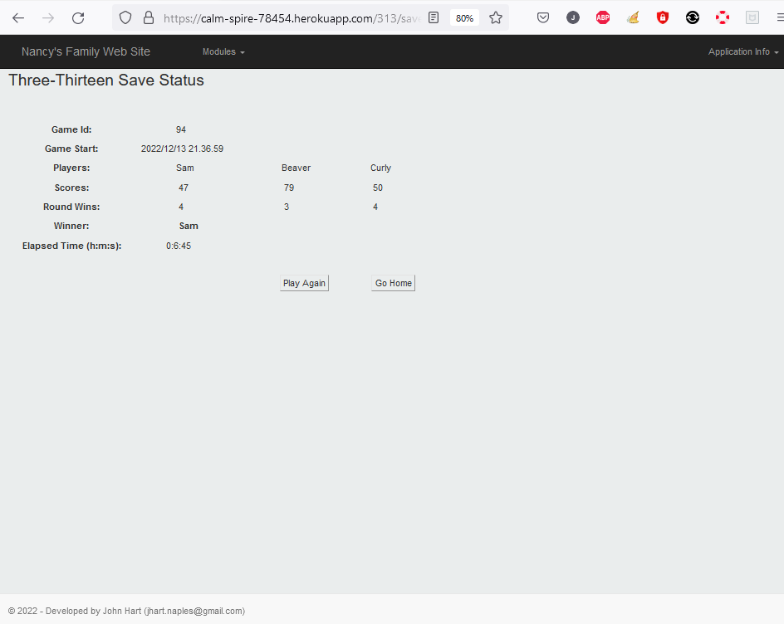

The save status page will display the Game Id that created in the database. It will display the game start time and the elapsed time to complete the game. The players and their scores are displayed. The player with the lowest score is displayed as the winner. If there is a tie, all players with the lowest score are considered the winners and will be displayed as such. Round wins are provided for information only.

The button ‘Play Again’