Project documentation

1.Introduction

Project Title: MicroGoal
Team ID : SWTID-2026-7593

Team Leader : SATHIYAMOORTHY B
Psakthi2304@gmail.com
Team Members :
SARATHKUMAR P
Sarath1627s@gmail.com
  - SENTHALNATHAN S
Senthilsekar726@gmail.com
JEROREX S
Jerorex2@gmail.com
NAVANEETH V
Nnavaneeth330@gmail.com

2. Project overview:

Purpose :

Break big goals into small tasks.

Make work easier to manage.

Improve focus on each step.

Track progress clearly.

Increase productivity.

Achieve goals step-by-step.

Features :

User Registration

Secure Login with JWT

Create Goal

Update Goal

Delete Goal

View User-specific Goals

Protected Routes

Centralized Error Handling

3.Architecture :

Technical Architecture

Runtime: Node.js

Framework: Express.js

Database: MongoDB

Authentication: JWT

ArchitecturePattern: MVC

4.Setup instructions:

Pre-requisites:

Node.js(v18 or higher)

Express.js

MongoDB(Local/Atlas)

VS Code

Thunder Client(Extension)

Basic knowledge of JavaScript & REST APIs

Installation steps:

1. npm init-y

2. Install dependencies:

npm install express mongoose jsonwebtoken bcryptjs dotenv

3. Start server:

node server.js

5.Folder Structure:

MicroGoals/

├──middleware/

│ ├──authMiddleware.js

│ └──errorMiddleware.js

├──Schema/

├──User.js

├──GoalSchema.js

├──models/

│ ├──userModel.js

│ └──goalModel.js

│ ├──routes/

│ ├──authRoutes.js

│ └──goalRoutes.js

│

├──.env

├──Index.js

└──package.json

6.usersflow:

1. User registers

2. User logs in

3. JWT token generated

4. User sends token in header

5. Access protected routes

6. Perform CRUD operations

7. Backend Development:

Created Express Server:

An Express server was set up to handle APIrequests,

connectroutes,and enable Json parsing for backend operations

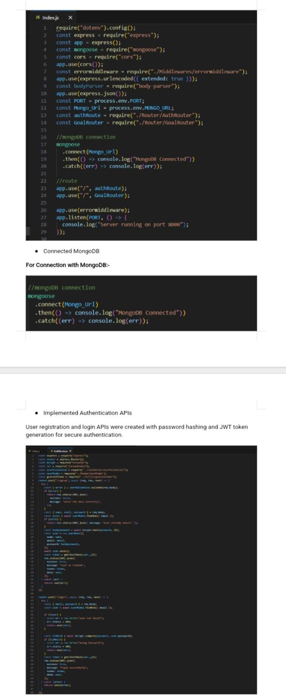

8. Database Development:

Configure MongoDB

Use MongoDB Atlas or Local MongoDB

Store connection string in.env

Create Database Connection

Index.jsfile:

Use mongoose.connect()

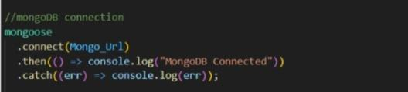
Handle connection errors.

9. Project Execution:

Project execution steps

1. Start MongoDB

2. Run server

3. Test APIsin Thunder Client

4. Register User

5. Login and get JWT

6. Perform CRUD operations

10. Project Output Screenshots:

Successful User Registration(Signup/Login)

In this Apicall the user register or login and token was generated

