Laboratory Exercise No. 4
Working with Database and MVC in LavaLust User Management Module

Name: Danielle Psalm V. Rodel
Course: Web Systems and Technologies 2
Render Link: https://rodel-danielle-psalm-lavalust.onrender.com/

Database Screenshot
mydb.users table browsed via Navicat , confirming all 10 records stored:
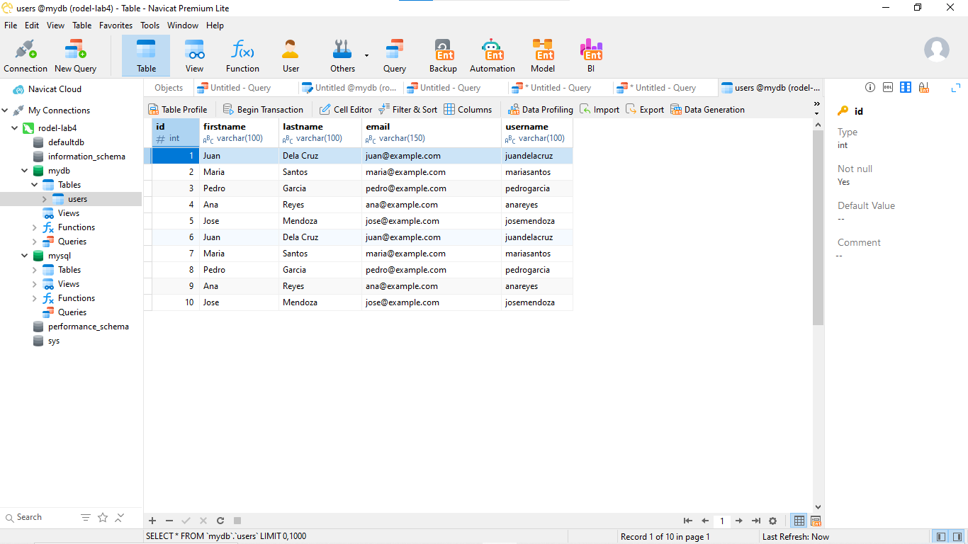

Database Configuration Screenshot
app/config/database.php — reads credentials from environment variables (Render). No password is hardcoded or exposed:

.env
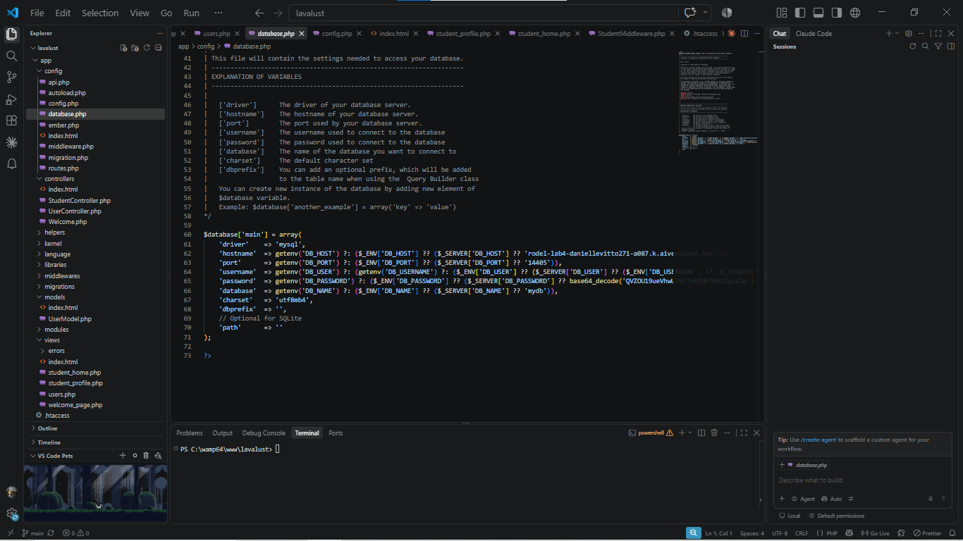
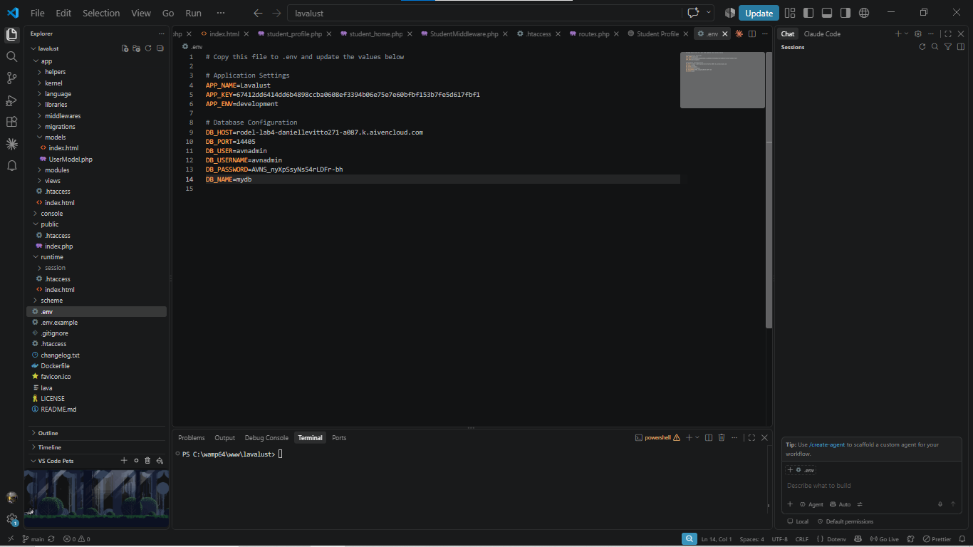

Model Screenshot
app/models/UsersModel.php:
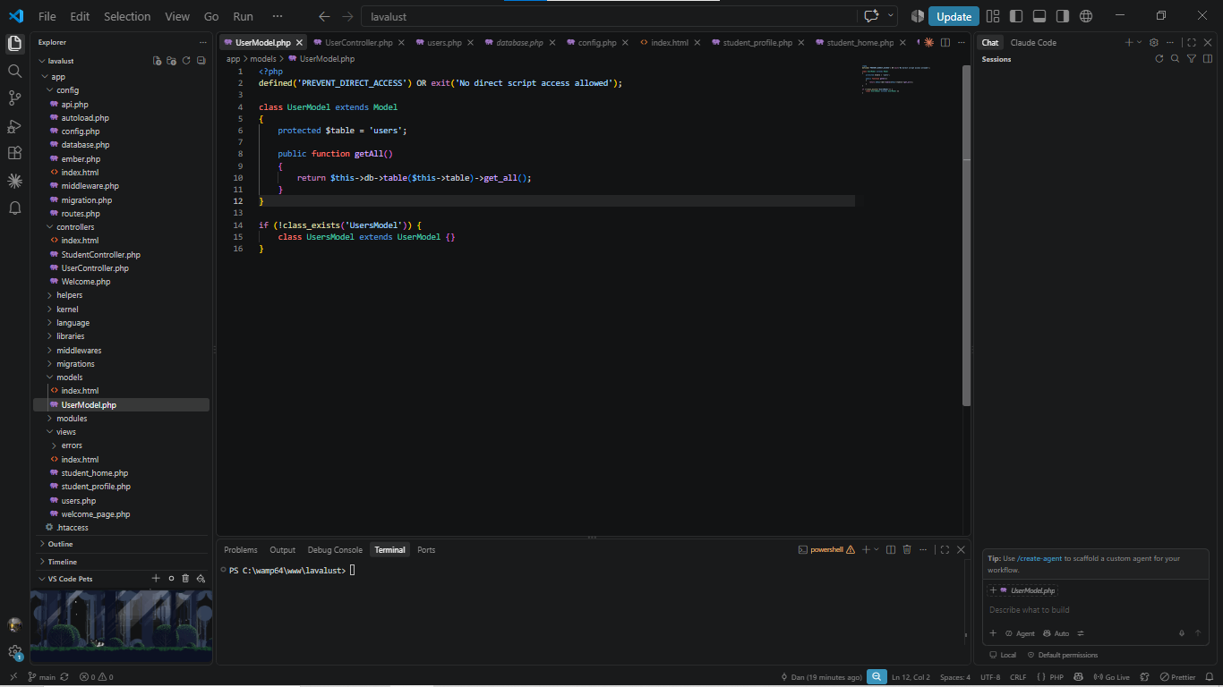

Controller Screenshot
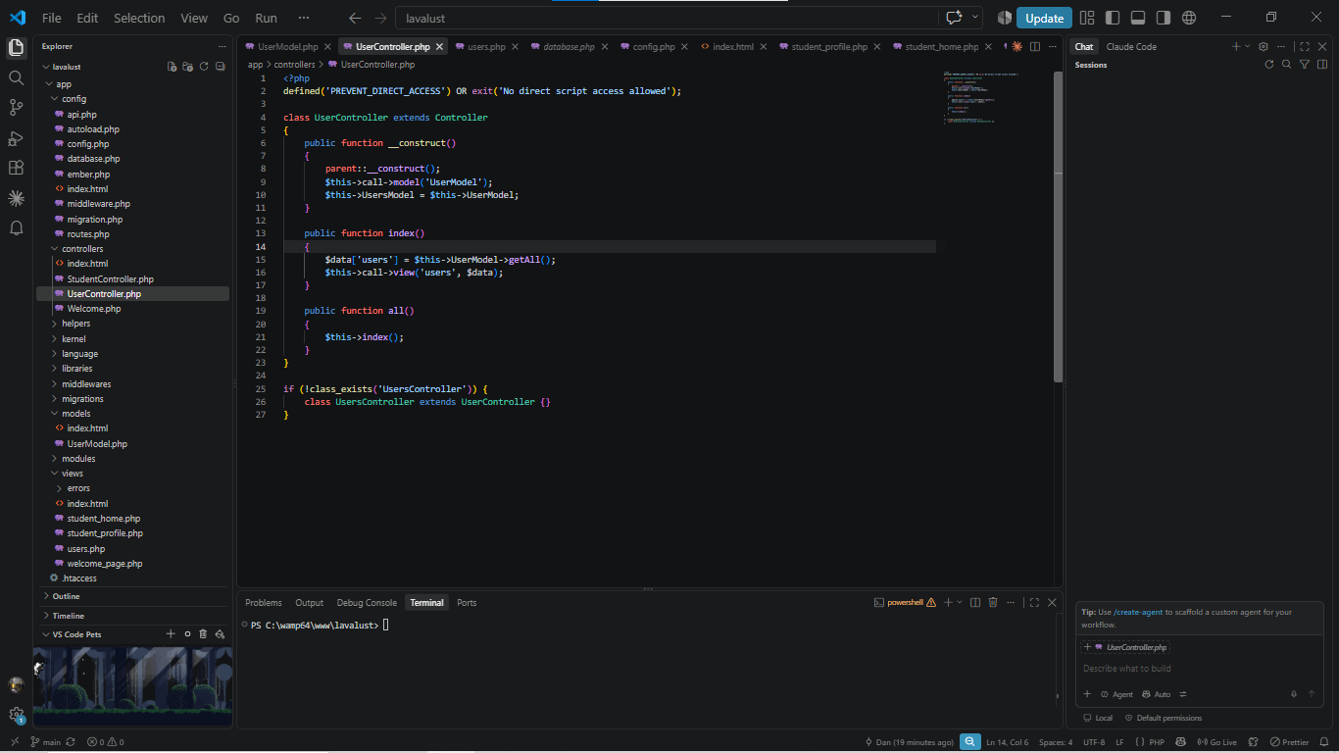
app/controllers/UsersController.php — uses UsersModel's all() method:

View Screenshot
app/views/users_view.php — loops through $users and builds the HTML table dynamically:
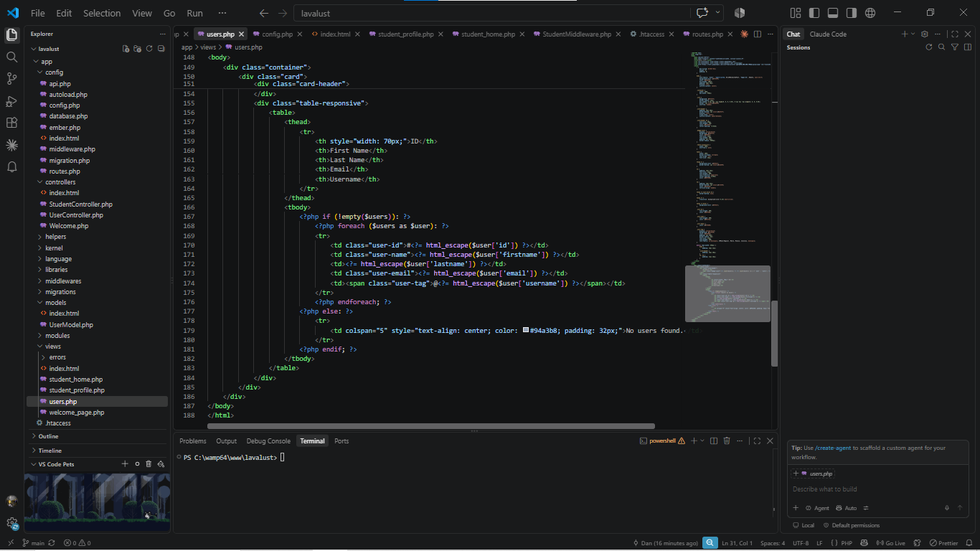

Route Screenshot
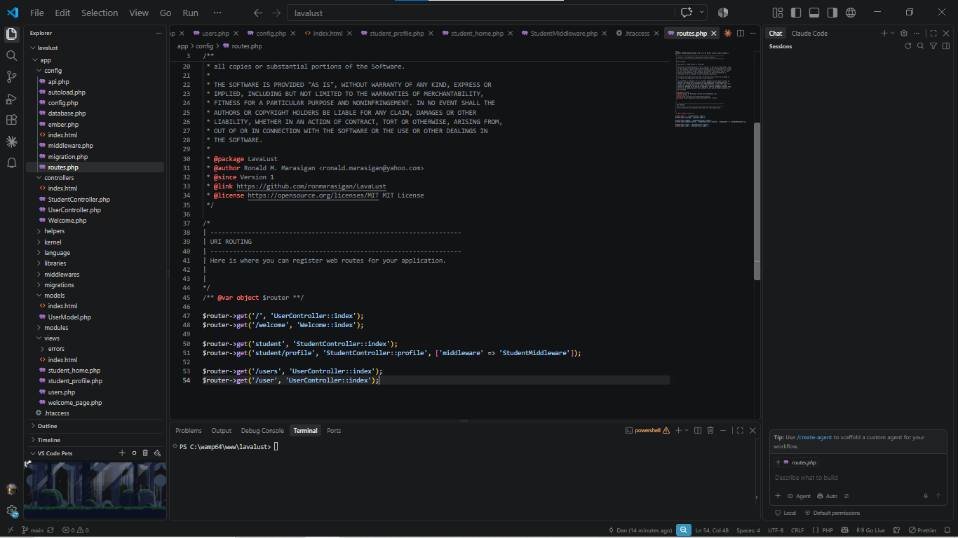
app/config/routes.php — /users route calling UsersController:

Application Output
Live application at hhttps://rodel-danielle-psalm-lavalust.onrender.com/, displaying all10 users dynamically retrieved from the MySQL Navicat database:
