Landing page:
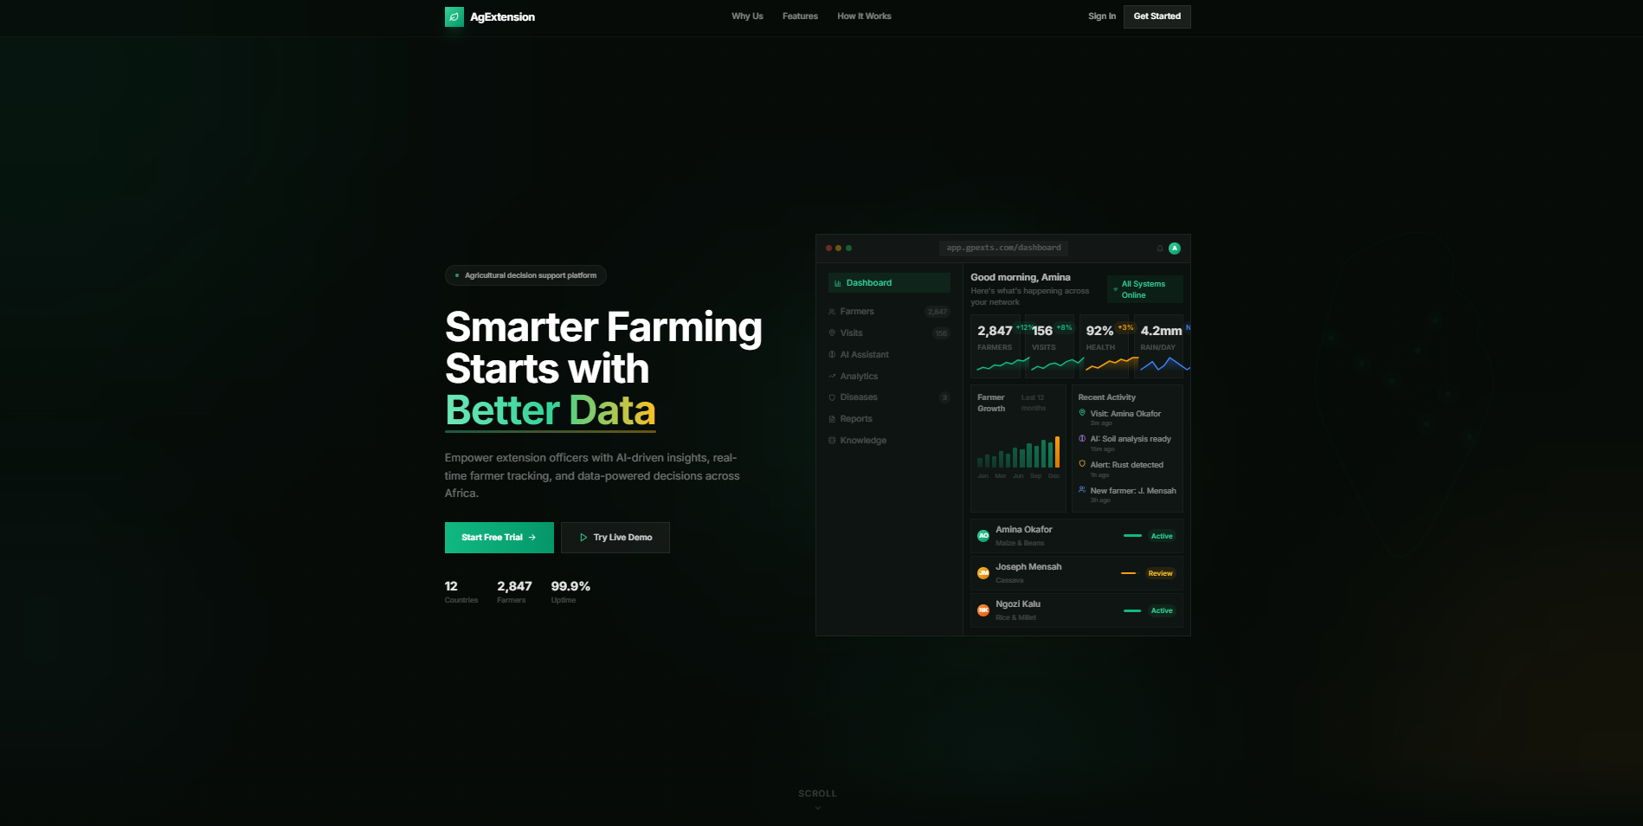

What Works already:
- All links
- Default font for texts
- Though would be improved, the overall information the age gives

Scaling issue:
- It covers 50% of the page.
- Every link (Why Us, Features, How it works, etc.) has irregular heading vs content text
- Readability of the text requires optimization

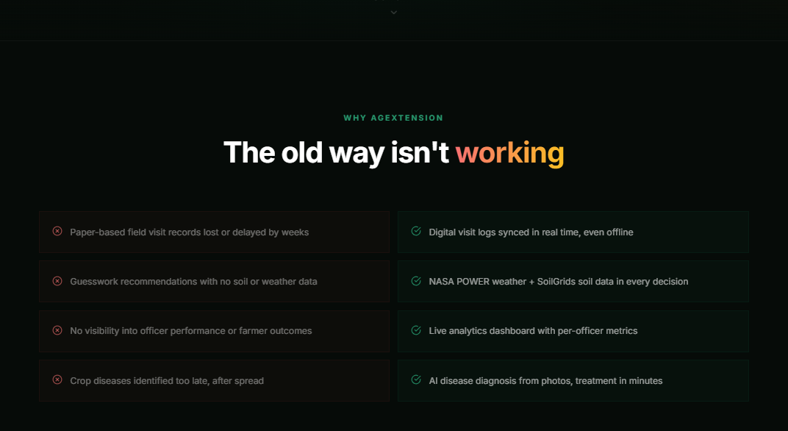

Recommendations
- Right now, the page jumps immediately into the dashboard UI — numbers, cards, activity feed, etc. This looks impressive, but it doesn’t tell a first‑time visitor what the platform is about or what AgExtension is or why they should care.
  - Place a clean top section above the dashboard preview, containing a short description of the platform
  - Our dashboard should support the story — not start it.

- We should use a design with background/images/etc. that sells Agricultural related message. IT HAS TO LOOK LIKE AGRICULTURE, not like financial data/ commercial statistic center or tool, e.g.:
  - What We Do: Extension | NIFA
  - Agriculture – Extension

Registration Page
Looks good to me

Login Page
Links work
Looks good to me

Reset Password
Looks good to me

Demo-User Section

What work:
- Menu drop-down
- Shortcuts to Operations Dashboard, System Analytics, Data Reports

What to improve:
- Logo is not linked
  - Link to Dashboard
- All links and tabs use the same dashboard extension https://gpexts.com/dashboard
- Search option is not functioning.

- Language text selection option
  - Replace language selection to be user-friendly


Classic Interface/ Tabs
- Operations Dashboard
- Regional Distribution location update is often disable
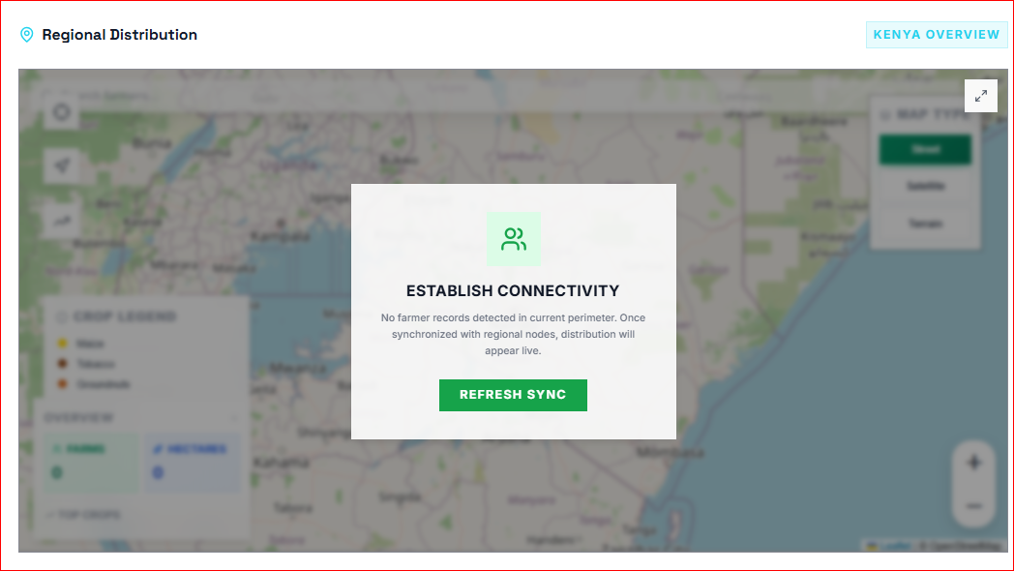
- Make this option stable in next deployment

- AI Assistance:
- Not needed for a Guest /Demo-user)
  - To be removed

- Farmer chat
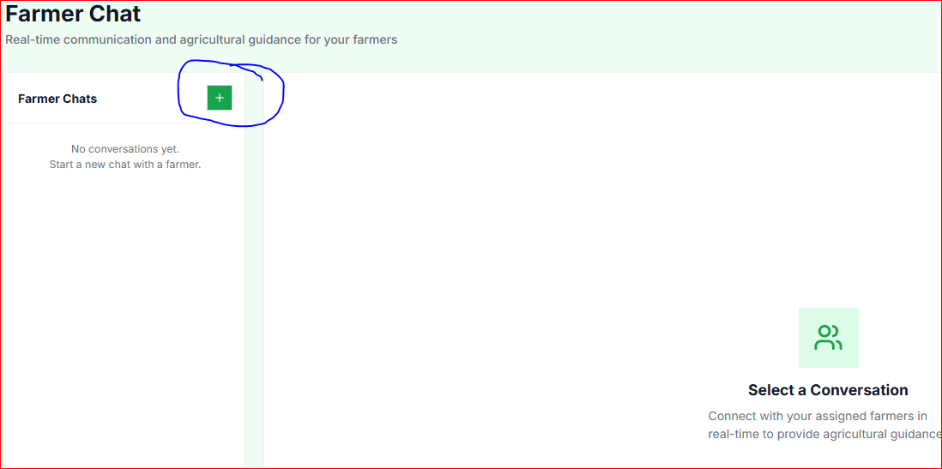
- Demo user should only be able to see the demo chat, not to add farmer and chat with them with the demo account
  - To be redesigned for demo click?
  - To be removed?

- Knowledge Base
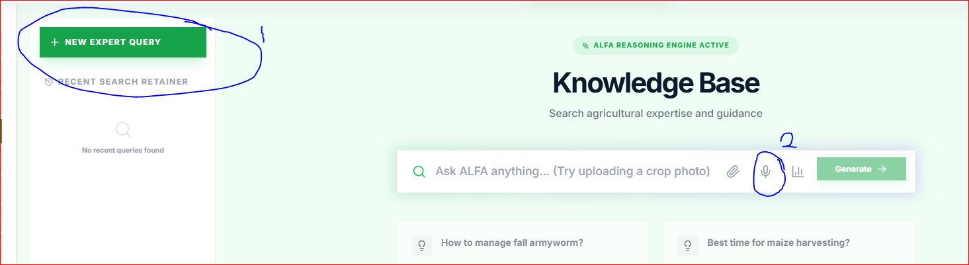
- “New Expert Query” button: Though not working, it should be made that it will show something like “Not available in demo version” with a Mouse Hover
- The Mic is not responding

- Client Portfolio

- Instead of living it blank, we can display the information that “this option is not available in Free-version”

- Register Client
- “Add a new farmer to the network” option will not be allowed for a Guest

- Visit Synthesis
- This feature is not functioning

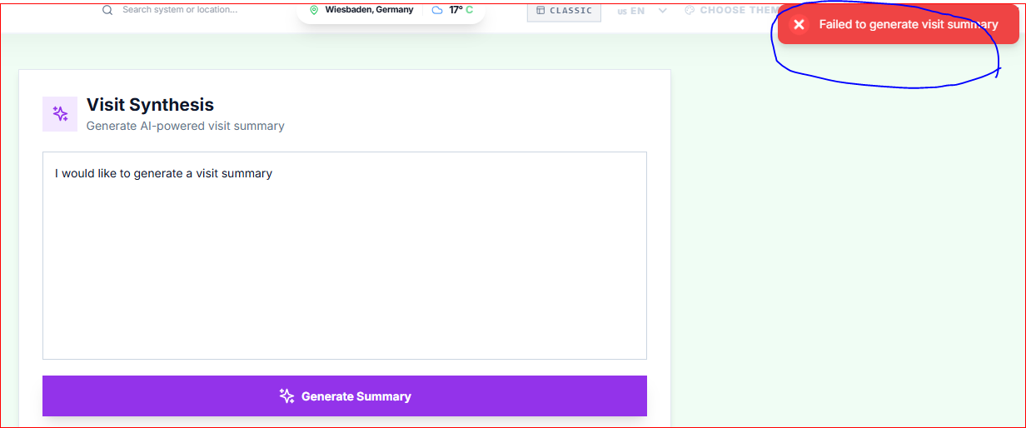

- Field Visits
- “Schedule New Visit” form should ONLY show a dummy farmer in Demo-User mode!
