**Exercise 01**

**Web Designer Profile**

By Allison Pinz

**Paul Armstrong**

[](http://parsons.ojusdoshi.com/wp-content/uploads/2015/09/0a94761.jpg)

Paul Armstrong- Graphic Designer

A. Currently, the graphic designer is the Co-Founder and Chief Creative Officer of the company ChoreMonster. In addition to that, Paul Armstrong was the founder, designer, developer, and photographer of the creative company Wiseacre Digital, LLC. He has also spent time volunteering as a graphic designer and photographer for the Four Corners Community Church.

In the past, Armstrong has designed logos for CMWealth Management, Sideshow Coffee, Flock, Subway and Facebook. Currently, as the Co-Founder of ChoreMonster, Armstrong works with a demographic of mostly parents and creates work appealing to their children.

B. The designer developed his skill at Taylor University from 1991 to 1993. He then completed his bachelors degree in graphic design at Messiah College and graduated in 1995. Armstrong has been working in the field for over 18 years in total.

C. Everyday Paul Armstrong uses his skills in illustration and photography to design projects on the computer for his website ChoreMonster. He constantly works on the content and design of the website and all other creative aspects that are associated with it. Armstrong also works everyday to promote and develop the branding of the website.

D. The graphic designer knows html web design. He also works with user interface design and user experience design. He is also proficient in the Adobe Suite.

E. Someone that Armstrong would ad mire would be his business partner and the Co-Founder of ChoreMonster, Chris Bergman. Bergman had worked with Armstrong at Wiseacre Digital for two years before they created ChoreMonster. Before that he was the marketing and product manager of Buzz360, the marketing manager of Photrade, the founder of Pause Magazine, and the art director of Daily Bread Skate Magazine.

**Project 1:**

I love Armstrong’s fun personality and I feel that carries over to his designs. I like this in particular because he managed to create a brand identity that appeals to an audience that is older and younger. When parents find the website they are interested enough in its design and the content to show to their children. I also enjoy the colors the artist used. I feel like they add to the experience to make it more enjoyable and uplifting.

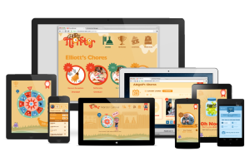 

Link: https://www.choremonster.com

**Project 2:**

Armstrong also did the branding of his previous company, Wiseacre Digital. I love the design of this logo he had created because it is extremely sleek and modern. The line zig zags and then turns into what appears to be an arrow pointing upwards. It is also faded towards the beginning and gets darker toward the end. I feel that this can be perfectly representative of the company because it has had ups and downs, but the more it goes through, the stronger it gets. The company solidifies and continues to advance. The website is also extremely impressive in that it is easy to navigate and simple. There is a very minimal color palette allowing the viewer to focus on the content.



Link: http://wiseacredesign.com

**Project 3:**

This is a logo Armstrong had designed for Sideshow Coffee. I really enjoy the type of font he had used as well as the color. It has a nice style to it and I feel it suits the company well. I also like the types of warm colors he used since they contrast each other so well. The typeface feels somewhat classic and modern because of the way it is styled.

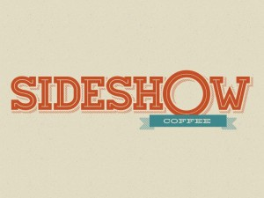

No link

**Project 4:**

For this project, Armstrong took popular websites and broke them down into their basic wireframes in a project called *Web Without Words.* This project was created “to visually represent my core belief that hierarchy, grid systems and uniformity ultimately lead to a more natural user experience.” The artist believes that the user should be able to see the core of the site without the stress of ads, and other visual representations so he/she can learn to appreciate the design more. I believe that this website is a great one to check out when learning about web design and hierarchy. It teaches you the importance of order and structure in the simplest way. The artist’s use of simplifying popular websites is also a great way to bring familiar sites into examples.

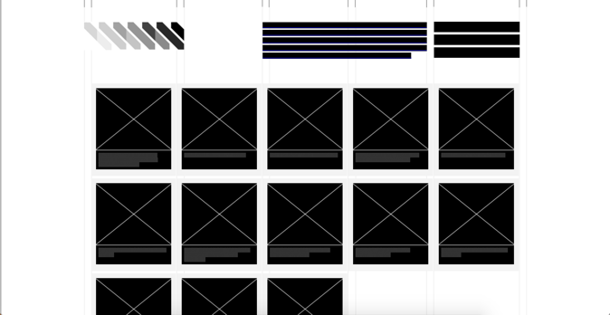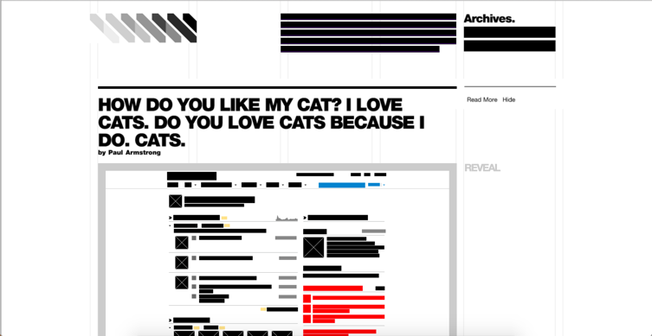

<http://webwithoutwords.com/>