Allison Pinz

**Final Project Proposal**

For my final project in Web Design I will be creating my personal portfolio. This portfolio will be coded to represent me as a designer, as well as a business student. It will be comprised of multiple pages that represent my work as well as a little bit about me. I will be getting the inspiration for this website from other web portfolios that I find have beneficial qualities and will create interest amongst my peers as well as professionals that will also pose as my main target market.

The purpose of creating this website is to challenge my coding skills while setting myself apart from others in this creative world. I would like to create a platform that displays all of my creative and professional work from my time at Parsons as well as some freelance work I have done. I feel that an online representation of an artist is just as important as the content. I want to show my work off differently while also showing off who I am. A project as advanced as this will challenge my coding abilities and I am enthusiastic to take it on and see what I can do. I will be using the skills I have gained throughout the semester through Codecademy, in-class exercises, and my mid term project to implement my project. I will also be looking toward the work of other great portfolios to get additional ideas and inspiration.

My ultimate goal is to have an aesthetically appealing, functioning portfolio that showcases my progress over the semester as well as my working history. I would like my site to contain two different personas as it will appeal to two target markets, creative and business professionals. I will do this by having a section for my creative work and another for my business. I will also have pages that link to my contact info, resumes, and a short blog.

Another goal I have applies toward the coding of the site. In the past, I have struggled with starting a new page of code, as well as some other essential coding tools. In this project I would like to go back to exercises from the beginning of the year and make sure that I have all of the correct coding. I will constantly be comparing my coding to in-class exercises, the coding tutorials on Codecademy and the Mozilla Developer Network for accuracy.

My final goal is to have an impressively artistic layout. Using what I have so far, I would love to dig deeper into CSS and apply so much more to my overall web design. As a designer, I am very complex, yet organized and my designs have energy. Last project I had the opportunity to work a lot with Adobe Illustrator and I would like to do that again on this project and incorporate it into my CSS. I would also like to go back to Codecademy for more CSS help, tips, and tricks on making my project the best it can be.

Over my last semester in web design, I have learned that I have a passion for the craft, and I would love to exploit that through this project. I have also learned that there is more than one styling to a website and that is proven through the many artists that put up their creative portfolios each and every day. After browsing the websites under the Creative Bloq article “40 Brilliant Design Portfolios to Inspire You” (http://www.creativebloq.com/portfolios/examples-712368) I was able to see the diverse ways in which creatives represent themselves through their different stylings.

The first artist I came across has combined her love of illustration and animation for a scrolling masterpiece. The artist’s name is Lizzie Seymour (http://lizz.es/#about). Once you enter the site you are greeted by this cartoon of a girl and several sheep with social media icons on them. There is also the name of the artist and some text below and a post with several signs. 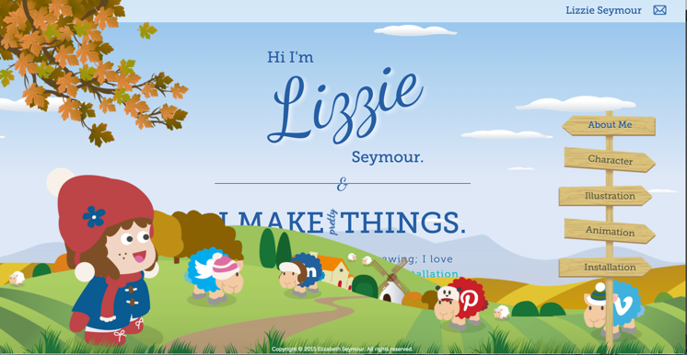Once you hover over the sheep they jump up. The signs also move and some of the text gets highlighted once hovered over. The background has several layers. As you scroll down with the text, one of the background layers moves as well causing your eye to follow the text.

I feel that this website will be essential when planning my own. I love the designer’s use of illustration and multiple layers. I plan on creating many layers, some scrolling and others static, to create a visually appealing background. I also love her use of animations. I plan on learning a bit more about CSS animations through our class-exercise to apply to some of the text, and design for my portfolio. I am just not a fan of the idea of having one page. As impressive as the background is, it covers way too much of the page and there is an uneven balance between image and text. I will be sure to maintain that balance through having multiple pages on my portfolio.

The next website I found interesting the for the design firm Delete (http://www.deleteagency.com/). Delete is a firm of collaborative strategists that work with rebranding. Once on the website you enter a slideshow of the firm’s work. Once you enter their page of work, the images reveal a giant X once hovered over. As you scroll down the next page, small animations follow you providing for an engaging experience.

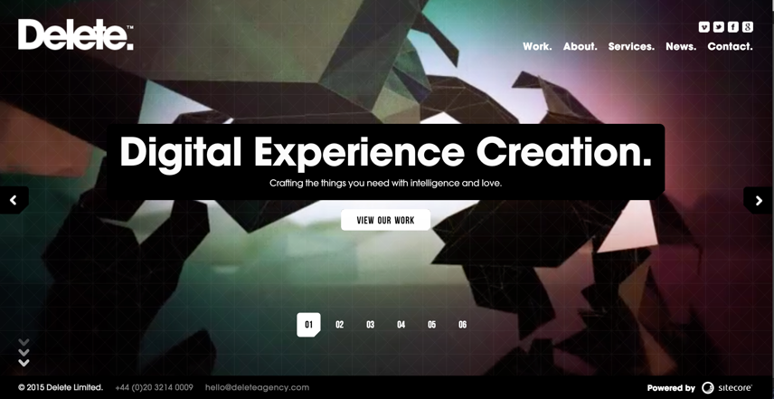Website like this make the user want to keep browsing through. I think my website would benefit greatly from animations as you scroll down the page. I also love the way an X appears on the image once you hover over it. I definitely want to have something like that on my website. With a feature like that, it is easier to determine which page is being entered next and it is an impressive feature overall. I am not crazy about the darkness of the website. I feel that the black background makes the rest of the picture a bit overwhelming. The content does not help either. When it comes time to creating my portfolio, I will keep this in mind and try to be minimal.

My target audience for this project would be professional creatives and businesspeople. Portfolios are usually targeted towards these markets, but I would also like to market my website to my peers as a continuous piece to draw inspiration from and to critique. Using the right colors, projects, and fonts, I will market this website towards my target audience. I feel that with this research, and the skills I have collected over the semester, I can effectively create a website of my own.

**Site Map**

