[h1]FiveThirtyEight[/h1]

[img]

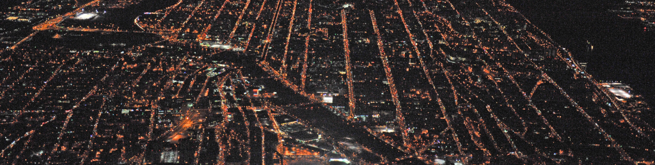

[/img][caption]An aerial view of New York City, on Jan. 29, 2014.[caption]

[credit]LI-AERIAL / GETTY IMAGES[/credit]

[catergory]TRANSPORTATION[/catergory] [time]6:30 AM AUG 28, 2015[/time]

[h1]Public Transit Should Be Uber’s New Best Friend[/h1]

[h2]The two combined could take personal cars off city streets.[/h2]

[author]By Nate Silver and Reuben Fischer-Baum[author]

[p]If Uber is worth its $50 billion valuation, it will have to do more than win over the market historically occupied by the taxi and limo industry — it will have to identify new types of customers.[/p]

[p]The biggest potential market is among people who own their own cars: The average American household spends around $8,500 on personal vehicles per year; multiply that by 125 million households, and you have a market worth in excess of $1 trillion per year. Persuading even a small fraction of households to give up their cars for Uber could be very lucrative for the company.[/p]

[p]But if Uber is to achieve its goal of becoming cost-competitive with car ownership, it may have an unlikely ally: public transit. A combination of (mostly) public transit along with some Uber rides can be affordable for a wider range of customers than Uber alone.[/p]

[p]New York City is the biggest market for public transit in the country — in fact, about 40 percent of all public transit trips in the United States occur in the New York metro area. And as it happens, we have some very good data on how New Yorkers are using Uber, public transit and other services. Earlier this month, we published an analysis based on about 93 million Uber and taxi trips in New York from April to September 2014, including information about Uber trips that we obtained via a Freedom of Information Law request. That analysis focused mostly on the differences between Uber and taxi coverage: As compared with taxis, for instance, Uber use is proportionally higher in Brooklyn.[/p]

[p]But in New York overall, there isn’t much difference between the people picked up by Uber and the ones who ride in cabs. Uber and taxis both disproportionately serve wealthy areas within Manhattan or just across the bridges and tunnels from it. What’s more, these customers usually live in neighborhoods with abundant public transit access also. In other words, the combination of public transit and for-hire vehicles is something that New Yorkers have been relying on for years.[/p]

[p]Take a look at the maps we’ve produced below, which track pickups by Uber and taxis on a per capita basis, census tract by census tract.[a]1[/a] The data includes an adjustment for the ratio of residents to workers in each census tract, with the goal of identifying rides that originate from a person’s place of residence rather than where they work, shop, go to school or spend leisure time.[a]2[/a][/p]

[img]

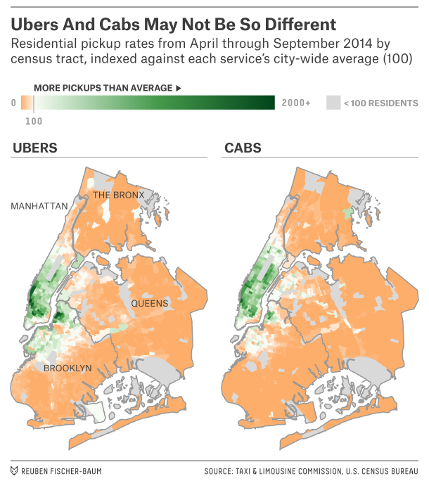[/img]

[p]As you can see, Uber and taxi usage have a lot in common. The correlation coefficient between per capita Uber use and per capita taxi use[a]3[/a] is 0.89, not that far from a perfect correlation of 1.[/p]

[p]We can also consider these differences by various geographic and demographic categories on a scale where 100 represents average per capita residential usage for each service.[a]4[/a] Here’s a comparison of how often cabs and Ubers are used by borough, for example.[/p]

[img]

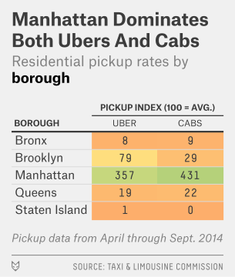[/img]

[p]As of mid-2014, the average Manhattanite used Uber about 3.6 times as often as residents of New York overall, and taxicabs about 4.3 times as often. Remember, our method seeks to adjust for the fact that many of the pickups in Manhattan are from commercial rather than residential locations; without that adjustment, the differences would be even greater. The closest thing to an Uber borough is Brooklyn, where cabs were used 70 percent less often as in the city overall, but Uber rides were used just 20 percent less often. Otherwise, the differences between the services are quite modest. In Queens and the Bronx, Uber and taxi use is fairly proportionate. In Staten Island, which is not connected directly by road to Manhattan, both Uber and taxi use is extremely rare.[/p]

[img]

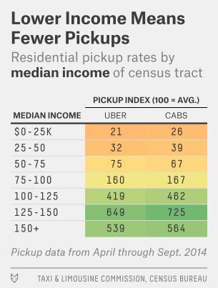[/img]

[p]But while there are some geographic differences in Uber and taxi usage, the demographics of their passengers seem to be mostly the same. In particular, passengers of both services are highly concentrated in wealthier areas. A resident of a census tract where the median income is $135,000 per year takes about 20 times more Uber rides and 20 times more taxi rides than one where the median income is $35,000, for example.[a]5[/a][/p]

[p]This is a reminder that a taxi or an Uber is a big expense. Given the current fare schedule for yellow cabs, a 5-mile journey in a New York taxi might cost $20, including a reasonable tip and depending on traffic. (Pricing for one of Uber’s lower-cost services, UberX, is pretty similar.) Subway rides cost $2.75, by contrast — about $17 less. If traveling by taxi saves a passenger 15 minutes — a possibly generous estimate given that the subway is sometimes faster than a taxi stuck in traffic[a]6[/a] — that means she must value her time at $68 an hour or more to make taking the cab worthwhile, equivalent to her earning an income of about $140,000 per year from a 40-hour work week. For a well-paid lawyer or banker, that’s nothing, but the median household income in the city is closer to $50,000.[/p]

[h2]The subway is the quintessential New York mode of transportation[/h2]

[p]How big is the for-hire car market in New York? Our data set includes 93 million taxi and Uber rides over a six-month period in 2014. Double that and round up,[a]7[/a] and you get to about 200 million rides per year. By contrast, the New York subway provided 1.75 billion rides in 2014, about nine times as many. There were also almost 800 million MTA bus rides[a]8[/a] in 2014.[/p]

[p]Public transit use, in contrast to taxi and Uber rides, is relatively egalitarian in New York. In census tracts where per capita income is $50,000 or less, 62 percent of workers commute by public transit; but so do 53 percent in tracts where per capita income is $100,000 or higher.[/p]

[p]For a few upper-middle-class and wealthy New Yorkers, Uber and taxi service may serve as a substitute for comparatively poor subway service. For instance, taxis and Ubers are used especially heavily on the far west side of Manhattan between Houston Street and 59th Street, an area not currently well-served by the subway (although service will improve following completion of the No. 7 line extension). Taxi and Uber use is also high in areas with crowded subway service, like on the Upper East Side along the Lexington Avenue line9 and in Williamsburg along the L train.[/p]

[img]

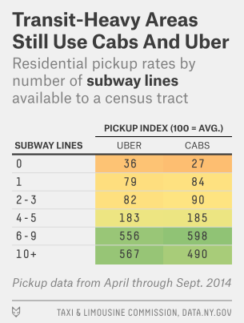[/img]

[p]But for the most part, Uber and taxis provide service in places where public transit is a good option also. We collected data on how many subway lines[a]10[/a] are located within a quarter-mile of a census tract’s boundary line in any direction.[a]11[/a] In census tracts that have no nearby subway lines, taxis are used only 27 percent as often, and Ubers 36 percent as often, as in New York overall. Use of taxis and Ubers is markedly higher in census tracts with even one nearby subway line, and it continues to increase until you get to the handful of census tracts saturated with 10 or more nearby subway lines. The differences hold[a]12[a] even if you account for the distance from Midtown Manhattan: Where public transit is poor, taxi and Uber service tend to be uncommon also.[/p]

[h2]Cars are a big deal, even in New York[/h2]

[p]All of this might seem counterintuitive: Why is taxi and Uber use high in neighborhoods where public transit is a good option? The reason may be that in neighborhoods where public transit has historically been a poor option, a personal vehicle is still the dominant mode of transportation. Car ownership is not as uncommon in New York as you might infer from media portrayals of life in Manhattan or well-off neighborhoods of Brooklyn. Instead, almost half of New York households own a car, and more than 10 times as many New Yorkers drive themselves to work as arrive there by taxi, according to the American Community Survey.[/p]

[p]Put another way: Given the high fixed costs of vehicle ownership, the first and most important transportation choice a New York household makes is whether to own a car. Residents who go without a car may use some combination of public transit, taxis, Ubers and other alternatives (like bicycling and carpooling) to get where they need to go. In that sense, Ubers, taxis and public transit are complements to one another instead of competitors.[/p]

[p]But transportation options are also constrained by a commuter’s income. Our data suggests that we might place New Yorkers into about five broad categories, based on their income and ease of access to public transit.[/p]

[img]

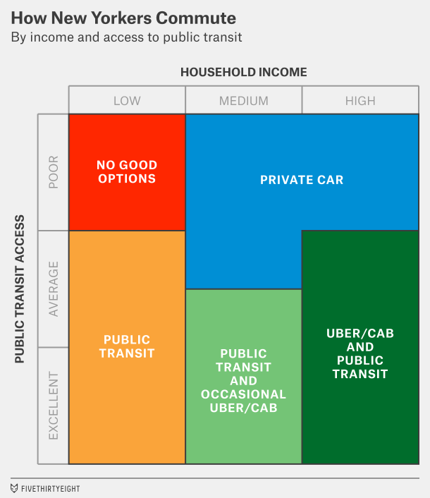[/img]

[p]Group 1 — Low income, poor public transit access: In census tracts with no nearby subway line, 66 percent of households have access to a private vehicle.[a]13[/a] An exception among these neighborhoods, however, is those where incomes are below $35,000 per year: Car ownership remains low there. Given the high cost of living in New York, a $35,000 income is the equivalent of about $20,000 for an average American household, making even a clunker a stretch to afford. Families like these have no great choices.[/p]

[p]Group 2 — Low income, better public transit access: Households in census tracts that have median incomes below $35,000 and access to at least one subway line are heavy users of public transit, making about two-thirds of their commutes to work that way.[/p]

[p]Group 3 — Middle to high income, poor public transit: Your choice is pretty clear if you’re a New Yorker with relatively poor public transit access but enough income to afford a car. Like most Americans, you’ll buy a car. In census tracts with median incomes of $35,000 or more but with no nearby subway lines, about 72 percent of households have cars. These census tracts are concentrated in Staten Island and the eastern part of Queens, which are more suburban than other parts of New York City (in other words, more like the rest of the United States).[/p]

[p]The last two groups are more interesting for Uber:[/p]

[p]Group 4 — Middle income, average-or-better public transit: You might think that car ownership is concentrated among the upper class in New York, but this isn’t really true. Instead, car ownership peaks in census tracts with median incomes of about $75,000 per year. Part of this is because neighborhoods with the worst public transit access in New York tend to be middle class, and people in those neighborhoods are more likely to need cars.[/p]

[p]The most interesting case may be for customers who can conveniently make some, but not all, trips on public transit. Consider a household that makes about 2,000 vehicle trips per year, in line with the national average. (If that sounds like a lot of trips, remember the figure is per household and not per person.) It can either spend $10,000 a year on car ownership,[a]14[/a] or it can use a combination of public transit (at a cost of $2.50 per journey[a]15[/a]) plus Uber and taxis.[/p]

[p]If the household can make all its trips by public transit, then that’s by far the cheapest option. But suppose it cannot. How many Uber rides can it afford to take before owning a car becomes cheaper?[/p]

[img]

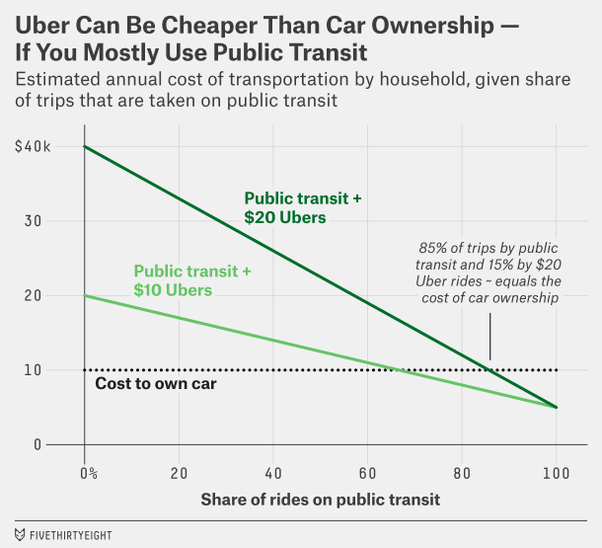[/img]

[p]If Uber costs about $20 per ride — about what an UberX costs now for a 5-mile ride in New York in moderate traffic — then the household can make up to about 15 percent of its trips by Uber and the combination of Uber and public transit will remain cheaper than owning a car. On the one hand, that figure implies that the household still needs excellent access to public transit since it must make 85 percent of its journeys that way. On the other hand, 15 percent of 2,000 trips is still 300 Uber rides per year.[/p]

[p]Uber is also introducing some cheaper services, such as its carpooling service UberPool. Suppose that the price of an Uber ride could be halved, to $10 per ride. In that case, this household could take about a third of its trips by Uber, filling in the rest with public transit, and it would still be cheaper than car ownership.[/p]

[p]But there’s a long way to go before Uber becomes cost-competitive with car ownership without an assist from public transit. A car ride costs an owner in the United States $4 or $5,[a]16[/a] including both fixed expenses (mainly, the cost of buying the car) and marginal expenses like gasoline. Even Uber’s cheapest services like UberPool aren’t yet competitive with that price.[/p]

[p]Analyses like this one which suggest that Uber is already often cheaper than car ownership depend, in part, on accounting for opportunity costs. You can potentially use your time more productively when someone else is driving you instead of when you’re driving yourself. But those opportunity costs vary from person to person depending on how much people value their time.[/p]

[p]Group 5 — High income, average-or-better public transit: For the time being, indeed, the principal consumers of both Uber and taxis in New York are upper-income passengers who can afford to value their time highly. Relatively few of them own cars, perhaps because it’s more convenient for them to be driven around in a taxi or Uber than to drive themselves. However, it’s likely that many of these customers also use public transit frequently, especially when (like during rush hour) the subway is potentially faster than an Uber or a cab.[/p]

[p]Put another way, Uber’s market in New York right now consists mostly of people who want to save time, or at least save productive time (you can make a private phone call in your Uber when you can’t on the C train). From Uber’s standpoint, that’s good and bad: It’s an audience with lots of money to spend, but also one that cabs and other ride-sharing services are vigorously competing for.[/p]

[p]But there’s a much wider potential audience if Uber can also reach middle-class customers who want to save money. Perhaps in the distant (or even the not-so-distant) future, Uber can build its own version of “public” transit, making rides so cheap that they cost less than the $4 or $5 that Americans now pay, on average, to make a trip in their personal cars. In the meantime, it might have more success among “car-cutting” customers who can use Uber along with public transit. That might mean Uber’s growth is concentrated more in cities like New York, San Francisco and Chicago — and in Europe and Asia — that already have reasonably strong public transit networks.[/p]

[contributors]Carl Bialik, Andrew Flowers and Dhrumil Mehta contributed to this article.[/contributors]

[footnotes]Footnotes[/footnotes]

[ol]

1. [li]Except where otherwise mentioned, the demographic data in this article comes from the Census Bureau’s American Community Survey. Data on how many people work in each census tract is from the 2006 through 2010 versions of the survey; see our source here. Other variables are from the 2009 through 2014 versions of the ACS.[/li]
2. [li]The adjustment works by comparing the number of people who live in each census tract and the number of people who work there. For instance, if there are 2,000 residents in a census tract and 1,000 workers (excluding people who work from home), we assume that two-thirds of the rides originated from residents of the neighborhood. This is a simplistic assumption, but it produces what we think is a reasonable estimate: that around 40 percent of taxi and Uber rides originate from someone’s residence. If everyone took taxis (or Ubers) from home to another destination like work and then returned by taxi or Uber along the same route, then 50 percent of rides would originate at home. However, sometimes passengers will take taxis between two nonresidential locations, like from work to their doctor’s office after work, which should reduce the percentage below 50 percent. Since we’re focused on residential pickups, this means that pickups from JFK Airport, LaGuardia Airport, Central Park and similar landmarks play little role in our analysis.[/li]
3. [li]Weighted by the population of each census tract.[/li]
4. [li]All the calculations in this article are weighted by population.[/li]
5. [li]Some of this is because the wealthiest neighborhoods are also centrally located and have more taxis and Ubers roaming the streets; however, the differences are highly statistically significant even after controlling for location.[/li]
6. [li]On the other hand, a taxi might allow the passenger to spend her time in transit more productively, like by placing a phone call.[/li]
7. [li]Rounding up is probably appropriate since our data consists of rides from April through September, including the summer months, when ridership is typically lower than at other times of the year, and since our data doesn’t consider for-hire vehicle services other than taxis and Uber.[/li]
8. [li]Including rides provided by the MTA Bus Co.[/li]
9. [li]Construction of the Second Avenue subway might eventually relieve congestion along the Lexington Avenue line.[/li]
10. [li]Same-colored lines like the Nos. 4, 5 and 6, which have partly overlapping routes, were considered separate for our analysis.[/li]
11. [li]A quarter-mile radius is a fairly common standard in evaluating public transit accessibility. We excluded lines if the only available stop was outside of the census tract’s borough.[/li]
12. [li]In a regression analysis.[/li]
13. [li]This percentage falls to 41 percent when there’s even one nearby subway line.[/li]
14. [li]As I mentioned earlier, the average household spends about $8,500 per year to own or lease vehicles, but this average includes households that don’t have any cars. The average expenditure for households that do have at least one vehicle is closer to $10,000.[/li]
15. [li]Although the nominal cost of a subway ride in New York is $2.75, there are various types of discounts for buying rides in bulk.[/li]
16. [li]As we’ve stated above, the average household spends about $8,500 on cars and makes about 2,000 trips.[/li]

[endnotes]Nate Silver is the founder and editor in chief of FiveThirtyEight.

Reuben Fischer-Baum is a visual journalist for FiveThirtyEight.[/endnotes]