**Ramakrishna Mission Residential College (Autonomous)**

**Narendrapur, Kolkata – 700103**

**B.A./B.Sc. Fourth Semester Examinations, 2022**

**Subject: Computer Science (Honours)**

**Course Name: Design and Analysis of algorithm**

**Paper Code: HCOM4CC09L**

**Time: 2 hrs. F.M.: 50**

Answer ***Question No. 1*** and ***any five questions*** from the rest

1. Answer ***any five*** questions: (2 × 5)
2. Define: Ɵ notation.
3. Show that 1K+2K+....+nK is O (nK+1), where K is a positive integer.
4. State Master method.
5. Use recurrence tree to solve: T (n) = T (n/4) + 1.
6. What do you mean by greedy algorithm?
7. What is prefix code? Give example.
8. What do you mean by principle of optimality in case of finding shortest path between two vertices?
9. What do you mean by external path length? Give example.

2. a) What do you mean by Divide and Conquer?

b) Describe divide and conquer approach for merge sort. Derive the complexity of the

algorithm. 2+(4+2)

3. a) What do you mean by fractional knapsack problem? Write an algorithm to solve

fractional knapsack problem.

b) We have 5 objects having weights {30,50,10,70,40} and the price of the respective

weights as {150,100,90,140,120}. Given the maximum capacity of the knapsack as 150,

find the set of objects to be selected such that the price is maximized, using fractional

knapsack algorithm. (2+3)+3

4. a) Define Spanning tree and Minimal Spanning Tree (MST) of a weighted graph.

b) Use Kruskal’s algorithm to find the MST of the following graph. 3+5

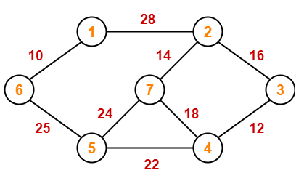

5. a) Write Floyd algorithm to find shortest path between every pair of vertices. Find its complexity.

b) Apply Floyd algorithm on the following graph. (3+1)+4

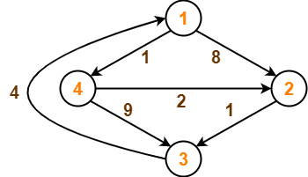

6. a) Write dynamic programming approach to solve Longest common subsequence. Find its

complexity.

b) Find the Longest common subsequence between “ACCGATCG” and “GACAT”.

4+4

7. a) Differentiate between depth first search, breadth first search and D-search (depth

search).

b) Find solution of 4-Queen problem using backtracking method. 4+4

8. a) What do you mean by branch and bound?

b) Solve following assignment problem using branch and bound technique. 2+6

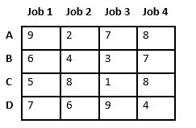

9. Write Ford-Fulkerson algorithm to find maximum flow in a flow network. Apply the

algorithm on the following network. 4+4

