**Graph Theory Questions**

1. Definitions (2 marks): Graph, Degree, Edge; regular graph, Null graph, Cubic graph, intersection graph, interval graph, complete graph, bipartite graph, isomorphic graph, Walk , Path, Circuit,Euler graph, Hamiltonian graph, Unicursal graph, Self complementary graph.
2. Prove that the number of odd degree vertices of a graph is always even. (3)
3. Prove that for a self complementary graph there are 4n or 4n+1 vertices. (5)
4. Prove that a graph is bi partite if and only if all its cycles are of even length. (6)
5. Prove that a graph with n vertices and k components the maximum number of edge possible in the graph is (n-k)(n-k+1)/2. (8)
6. Define arbitrarily traceable graph. Show example of graph that is arbitrarily traceable from one vertex, 2 vertices and no vertices. (3+1)
7. Describe the process to determine whether a vector is graphic or not. (Hakimi-Havel theorem). (3)
8. Prove that a graph is Euler iff all its vertices are of even degree. (8)
9. Describe with an example the fusion of vertices in a graph and ring sum operation of two graphs. (2+2)
10. What is a clique?(2)
11. Prove that a tree with n vertices has n-1 edges. (5)
12. Define eccentricity, center, and diameter of a tree. (3x2)
13. Define spanning tree, Rank and Nullity in a graph. (3+3+3)
14. Define fundamental circuit w.r.t. a spanning tree in a graph.(3)
15. Prove that a graph is connected if we can find a spanning tree in it.(4)
16. What is minimum spanning tree in a weighted graph? Explain.(3)
17. Write down Kruskal’s algorithm to find Minimum Spanning Tree in a weighted connected graph. (5)
18. Write down algorithm to detect cycle in a connected graph. Explain with an example.(4+2)
19. Write down Prim’s algorithm to find Minimum Spanning Tree in a weighted connected graph.(5)
20. Differentiate between Kruskal and Prim’s algorithm for MST. (4)
21. What do you mean by shortest path in a graph? (2)
22. Write down Dijkstra’s single source SP algorithm . Are negative weight values are allowed in a graph in Dijkstra’s algorithm ?(6+2)
23. What is negative cycle?(2)
24. Write down the Depth First Search(DFS) algorithm on a graph. How to trace the search tree in this algorithm? (5+3)
25. Write down the Breadth First Search(BFS) algorithm on a graph. (5)
26. Compare DFS and BFS. (4)
27. Prove that there are n^(n-2) labeled trees possible with n vertices. (Caley’s theoram.)
28. What is adjacency matrix? Write down steps how a path matrix can be determined from adjacency matrix. (2+4)

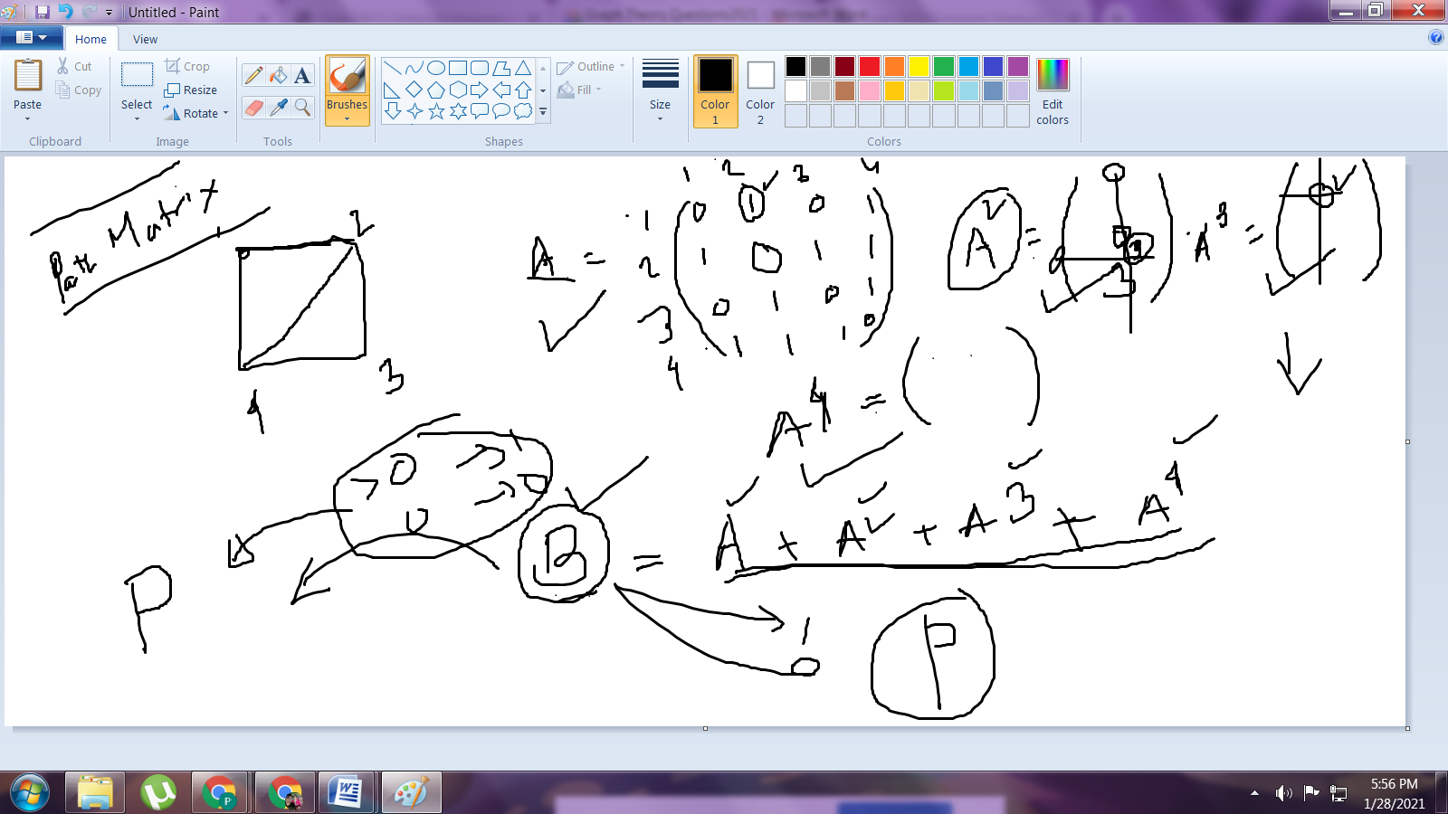

1. What is adjacency list? Write down steps to create adjacency list from adjacency matrix. (2+4)
2. What are simple graph and multi-graph? (2+2)