Coding Exercise 2:

1. Numbers: Example code to add two numbers 50+50 and 100-10 and print it.
2. 30+*6,6^6,6**6,6+6+6+6+6+6
3. Print “Hello World” on the console output. Print output “Hello World : 10”

Make sure capitalization and spacing matches.

1. Below is a mathematical calculation exercise :

Mathematically, mortgage works by the following algorithm:

* Joel borrows big money sum **P** from bank (and performs purchase);
* bank tells him its interest rate **R** in percents - the speed of growth of the debt;
* at the end of each month the debt is increased by **R / 12** percents;
* immediately after it Joel gives to bank some predefined small sum **M** to decrease the debt;
* debt is considered settled when its value is reduced to zero (this could take several years).

For example, Joel takes **P = $800,000** from bank with interest rate of **R = 6%**. He is willing to pay **M = $10000** at the end of each month.

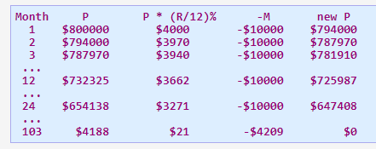

So after **103 months** (which is about **8.5 years**) the debt could be payed out. The last payment of course could be less than **M** (since **P** need not to become negative). Note that he will pay out about:



which is **25%** more than the cost of the house.

Joel asks you (the mighty programmer) to help him with the calculation of necessary monthly payment **M**.

**Input data** contains values for loan size **P**, interest rate **R** and length of time to pay out **L** in months.  
**Answer** should contain the required monthly payment **M** rounded up to whole dollars (i.e. if you get non-integer result, increase it to nearest integer which is greater).

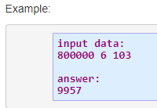

Can you derive using python code.