
MARLY 1.0
Model-Assisted Rescue for Lost-person recoverY
Executive Summary — Development Progress Report
Date: May 12, 2026

Project Overview
MARLY 1.0 is a web-based Search and Rescue (SAR) planning tool built in Python using the Flask framework. It is designed to assist SAR teams by automating the generation of search zones based on lost person behavioral profiles derived from the Robert Koester / ISRID dataset. MARLY takes key inputs about a missing subject—including subject type, last known position, terrain, and observational notes—and produces actionable search plans with downloadable GPX files compatible with CalTopo.

Accomplishments to Date

Phase 1 — Data Input Form (Complete)
A fully functional web-based input form that captures all critical subject information needed to initiate a search plan:
- Subject type classification (Dementia, Lost Hiker, Lost Child, Lost Hunter, Lost Vehicle, Mental Health Crisis)
- Last Known Position (latitude/longitude coordinates)
- Time last seen (date and time)
- Subject age and terrain type
- Notes field for additional details including direction of travel
- Data persistence via JSON file storage
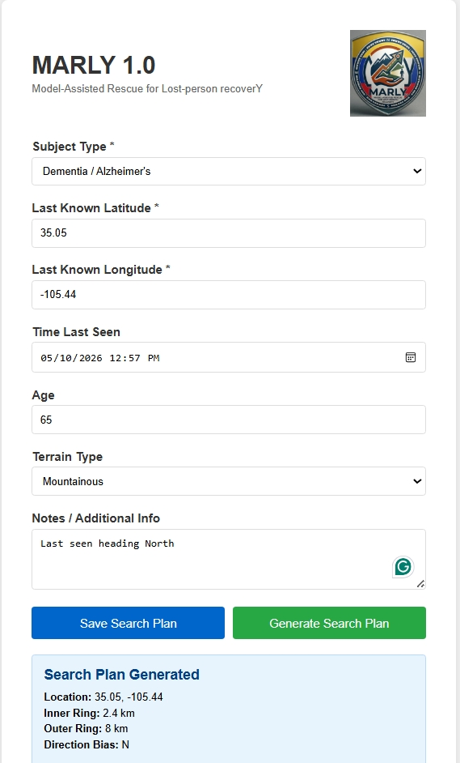
Figure 1: MARLY 1.0 web input form showing a sample dementia subject search plan with subject type, last known coordinates, terrain, and directional notes. The generated plan summary appears below the form.

Phase 2 — Search Zone Calculation & GPX Export (Complete)
The core analytical engine that transforms input data into search plans:
- Inner range ring calculation based on average travel distance for the subject type (Koester/ISRID profiles)
- Outer range ring calculation based on maximum travel distance
- 8 compass-bearing search sectors (N, NE, E, SE, S, SW, W, NW)
- Dual-priority sector system: Inner sectors (Priority 1) and outer sectors (Priority 2)
- Directional weighting: 1.5x boost for dementia subjects with known exit door direction; 1.3x boost for known direction of travel
- Automatic parsing of notes field for directional keywords
- GPX file generation for range rings (circular tracks centered on LKP)
- GPX file generation for search sectors (pie-shaped polygon tracks with priority and weight labels)
- Successfully tested: GPX files import and render correctly in CalTopo
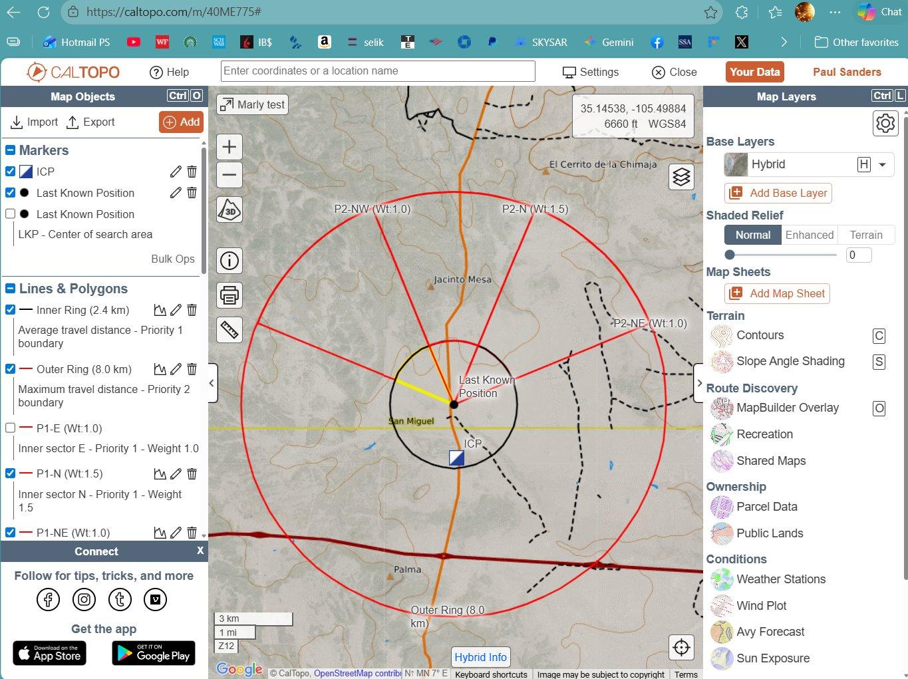
Figure 2: MARLY-generated search zones displayed in CalTopo. The inner ring (2.4 km) and outer ring (8.0 km) are visible as concentric circles around the Last Known Position. Search sectors are drawn as pie-shaped wedges with priority and weight labels (e.g., P1-N Wt:1.5 indicates Priority 1, North sector, weighted 1.5x due to directional bias).

Built-in Subject Behavioral Profiles
MARLY currently includes the following Koester/ISRID-based profiles:
Subject Type | Avg Distance (km) | Max Distance (km)
Dementia | 2.4 | 8.0
Lost Child | 1.6 | 4.5
Lost Hiker | 5.0 | 25.0
Lost Hunter | 4.0 | 15.0
Lost Vehicle | 10.0 | 50.0
Mental Health Crisis | 3.0 | 8.0

Future Development Roadmap
The following enhancements are planned for subsequent phases of MARLY:

Phase 3 — Search Parameters & Adaptive Sizing
- Separate Search Parameters form (Step 2) allowing users to adjust max sector size, team size, and terrain settings before plan generation
- Adaptive sector sizing: automatic subdivision of sectors exceeding a user-defined maximum area threshold so field teams receive manageable search areas
- Integration with user-provided spreadsheet data for custom behavioral profiles

Phase 4 — Terrain-Aware Weighting
- Integration with mapping APIs (OpenStreetMap, Mapbox) for real trail and road network data
- Terrain-aware sector weighting: bias search priorities based on trail density, road accessibility, and terrain features
- Sector boundaries aligned with natural terrain features (trails, roads, ridgelines)
- SarTopo API integration (if access is available)

Technical Details
- Language: Python 3.14
- Framework: Flask (web application)
- Export Format: GPX 1.1 (compatible with CalTopo and SarTopo)
- Data Source: Koester / ISRID lost person behavioral profiles
- Hosting: Runs locally on a Windows laptop via localhost

MARLY 1.0 is operational and producing usable search plans that import directly into CalTopo. The tool is designed to reduce planning time and improve consistency in initial search zone development. Further enhancements will add terrain intelligence and greater customization for field operations.

