# **Horror Movie Viewership Analysis**

Author: Sean Barnes

Last updated: Jan 12, 2029

## **Executive Summary**

**The sponsorship program with horror game streamers was a major success.** Horror movie viewership increased by 17% over the past month, the largest month-over-month increase ever recorded for any genre. This significant growth was primarily driven by our partnerships with top horror game streamers. By expanding the sponsorship program to other genres, we can expect to see similar impressive growth across our platform.

## **Data Sources and Methodology**

We analyzed the behavior of over 30,000 users, including both first-time horror movie viewers and users who had previously shown interest in the genre. Our analysis focused on user behavior following sponsored link clicks, including metrics such as:

* Click-through rates
* Total watch time
* Average session duration
* Retention rates
* Partner satisfaction scores

The data collection period spanned the previous month (April 2025), with baseline comparisons to the three months prior. Our goal was to determine the effectiveness of the streamer sponsorship program and identify patterns that could predict user behavior across all genres.

## **Key Findings**

### **1. Significant Growth in Horror Viewership**

Horror movie viewership increased by 17% over the past month, compared to an average growth of only 2% across all other genres. This represents an 8.5x higher growth rate than the platform average.

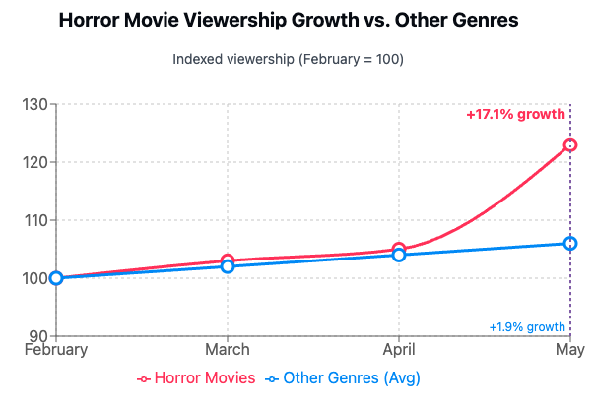

### **2. Sponsorship Impact on User Acquisition and Engagement**

The sponsorship program attracted 24,000 users to horror content, consisting of:

* 10,000 new users (42%)
* 14,000 existing users (58%)

Users who discovered horror movies through sponsored links demonstrated remarkably different viewing habits:

| **Metric** | **Sponsored Link Users** | **Non-Sponsored Users** | **Difference** |
| --- | --- | --- | --- |
| Average Watch Time | 140 minutes | 117 minutes | +20% |
| Completion Rate | 87% | 72% | +15% |

This difference was statistically significant at the 1% level, giving us high confidence that the sponsorship program directly caused increased engagement.

### 

### **3. User Journey Analysis**

When analyzing the first horror movie viewed by users, those who discovered it through a sponsored link had an average watch time 17% higher compared to users who found the movie through other avenues (homepage recommendations or discovery view).

For example:

* **User Profile: Fajad (New User via Sponsorship)**
  + Account created after clicking sponsored link
  + Watched two horror movies
  + Total watch time: 140 minutes
  + Continued platform engagement after initial viewing
* **User Profile: Kelly (Existing User)**
  + Regular platform user
  + Watched first horror movie this month
  + Watch time: 117 minutes
  + Less likely to watch additional horror content

Across our platform, we now have approximately 10,000 users like Fajad and 14,000 users like Kelly engaging with horror content.

### **4. Overall Platform Impact**

Total horror movie watch time reached 20 million minutes last month, up from 17.1 million minutes the previous month. Notably, over 8% of this watch time came directly from sponsored links.

### **5. Partner Satisfaction**

Our sponsorship partners reported over 95% satisfaction with the program, indicating strong potential for expanding these relationships.

## **Recommendations**

1. **Expand the sponsorship program** to additional genres, prioritizing those with similar audience characteristics to horror (e.g., sci-fi, thriller).
2. **Optimize the user journey** from sponsored links to content viewing by reducing friction points identified in our analysis.
3. **Increase investment** in the most effective streamer partnerships based on performance metrics from this initial program.
4. **Develop targeted content recommendations** for users who enter through sponsored links to maximize their engagement.

