Key Equipment: Noraxon EMG System, Vicon Motion Capture System, two Bertec Force Plates, HUMAC Isokinetic Dynamometer, and NexGen Ergonomics Biometric Systems for pinch and grip strength assessment.
• Noraxon EMG System
The Noraxon electromyography system is used to measure muscle activity during physical tasks, occupational movements, and ergonomic assessments. This system allows researchers to evaluate muscle activation patterns, muscle fatigue, physical workload, and the demand placed on specific muscle groups during work-related activities. It is particularly useful for studying tasks involving repetitive motion, awkward posture, manual material handling, wheelchair propulsion, exoskeleton use, and other physically demanding activities.
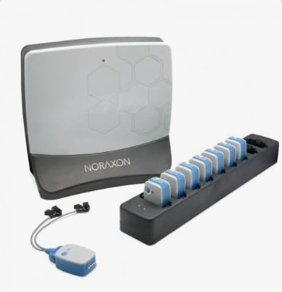 | 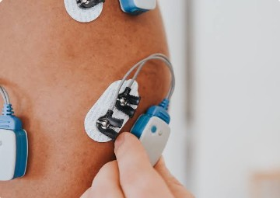

• Vicon Motion Capture System
The Vicon motion capture system is used for three-dimensional human movement analysis. It allows precise tracking of body segments, joint angles, posture, movement patterns, and task performance during dynamic activities. This system supports research on gait, reaching, lifting, pushing, pulling, wheelchair mobility, workplace posture, and ergonomic risk assessment. By capturing detailed movement data, the system helps identify biomechanical risk factors associated with musculoskeletal disorders and supports the evaluation of ergonomic interventions.

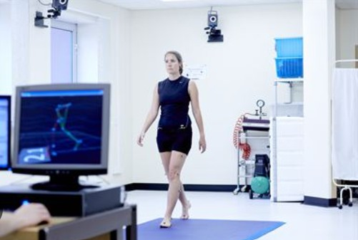

• Bertec Force Plates
The lab is equipped with two Bertec force plates for measuring ground reaction forces, center of pressure, balance, postural stability, and force exertion during static and dynamic tasks. These force plates support biomechanical analysis of standing balance, gait, lifting, pushing, pulling, stepping, and other occupational movements. When integrated with motion capture and EMG, the force plates provide a more complete understanding of how external forces, body movement, and muscle activity interact during human performance and ergonomic tasks.
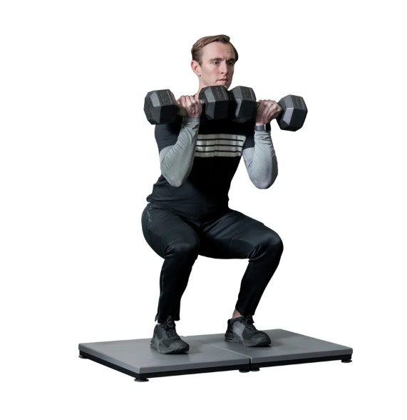
• HUMAC Isokinetic Dynamometer
The HUMAC isokinetic dynamometer is used to assess muscle strength, joint torque, range of motion, and functional capacity under controlled testing conditions. It can evaluate strength performance across different joints and movement speeds, making it useful for studying occupational strength demands, rehabilitation-related performance, fatigue development, and physical capacity. This equipment supports objective assessment of upper- and lower-body strength and can be used to compare performance before and after ergonomic or rehabilitation interventions.
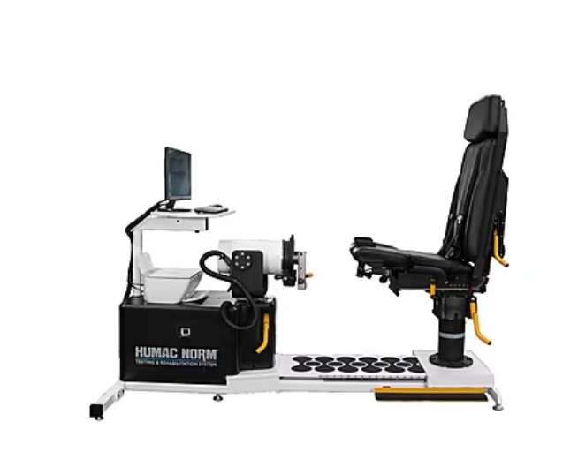

• NexGen Ergonomics Biometric Systems
The NexGen Ergonomics biometric systems are used to assess hand function, including pinch strength and grip strength. These tools support the evaluation of hand and upper-extremity capacity during ergonomic and occupational tasks. Grip and pinch strength measurements are useful for studying manual task demands, hand-tool use, worker capability, fatigue, functional performance, and risk factors related to upper-extremity musculoskeletal disorders. These systems can also be used to compare strength performance across populations, work conditions, or intervention strategies.
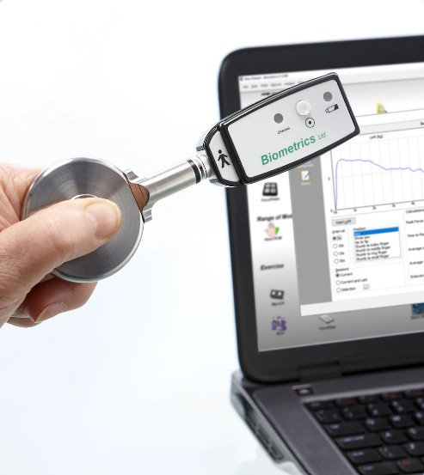 | 