RecipeMaster
PROJECT DOCUMENTATION
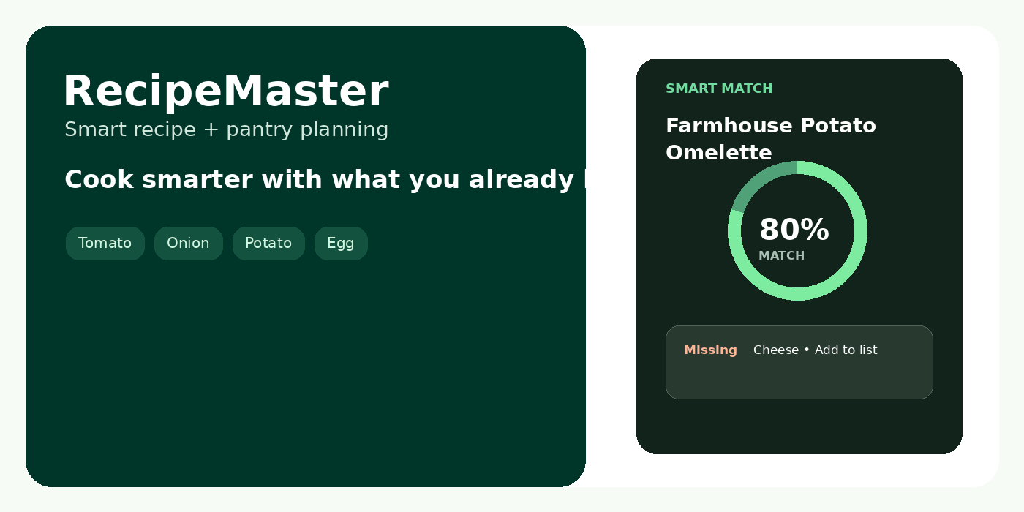
INTRODUCTION
RecipeMaster is a full-stack web application for recipe discovery and kitchen planning. It connects recipes with pantry inventory so users can identify what they can cook, track missing ingredients, plan meals and maintain shopping lists.
OBJECTIVE
Goal | Implementation
Recipe discovery | Browse, search and view recipe details.
Pantry awareness | Maintain available ingredients and use them for matching.
Smart matching | Calculate ingredient match percentage and show missing items.
Planning | Schedule meals and manage shopping requirements.
Assistance | External recipe search/import and AI culinary advice.
This compact document keeps only the project-specific content required for understanding the application.

SYSTEM REQUIREMENTS
Software | Requirement
OS | Windows / macOS / Linux
Runtime | Node.js + npm
Frontend | React 19, TypeScript, Vite, Tailwind CSS
Backend | Node.js + Express
Database | MongoDB + Mongoose
Tools | Visual Studio Code, modern browser, Postman (API testing)
PROJECT ARCHITECTURE
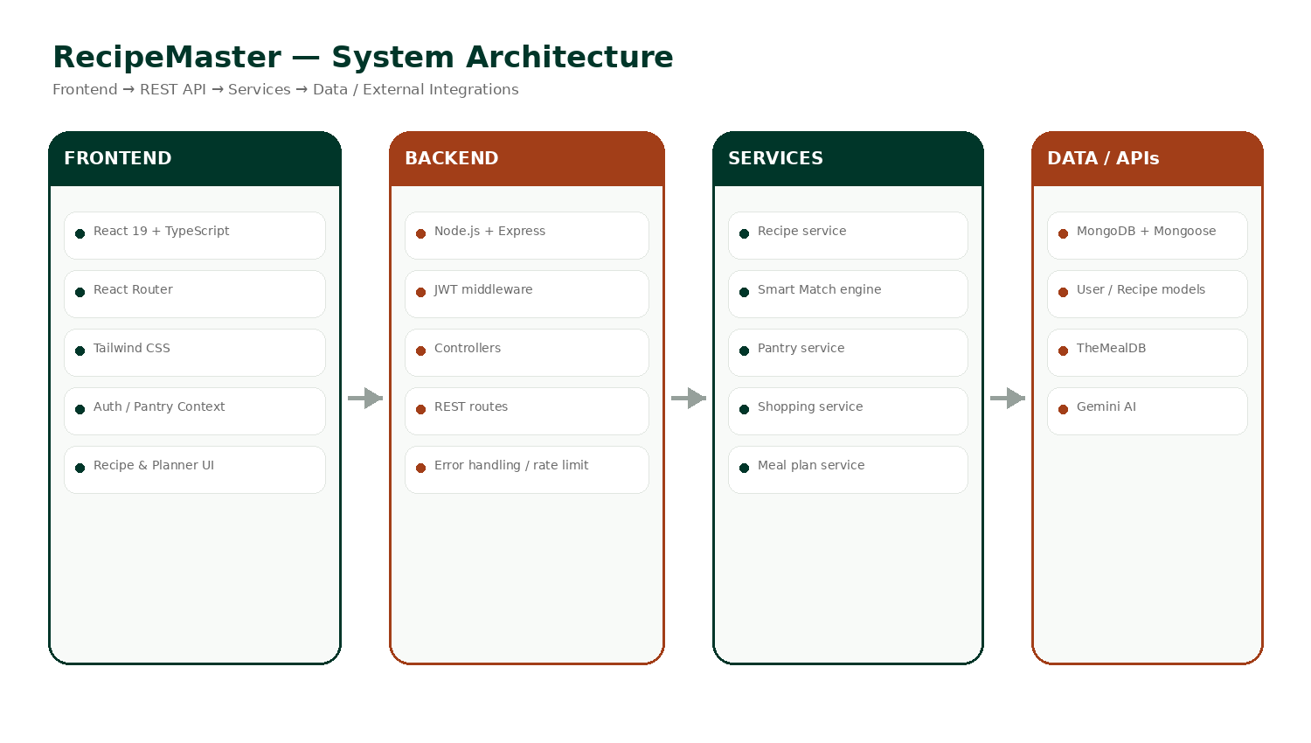
The application separates the React user interface from the Express REST API. Backend services handle business logic, while MongoDB/Mongoose stores application data. TheMealDB provides external recipe data and Gemini supports the culinary advisor.

CORE MODULES
Module | Main functions
Authentication | Register, login, protected access, profile and password operations.
Recipes | Explore, details, create/edit/delete personal recipes and filtering.
Smart Match | Normalize ingredients, compare pantry with recipes, return match % and missing items.
Pantry | Add, edit, delete and quick-add ingredients.
Meal Planner | Create and manage daily/weekly meal plans.
Shopping List | Add missing recipe ingredients, mark complete and move items to pantry.
Favourites | Save/remove recipes and view saved recipes.
External Recipes | Search and import recipes from TheMealDB.
AI Advisor | Provide culinary substitution/advice through Gemini.
USER FLOW
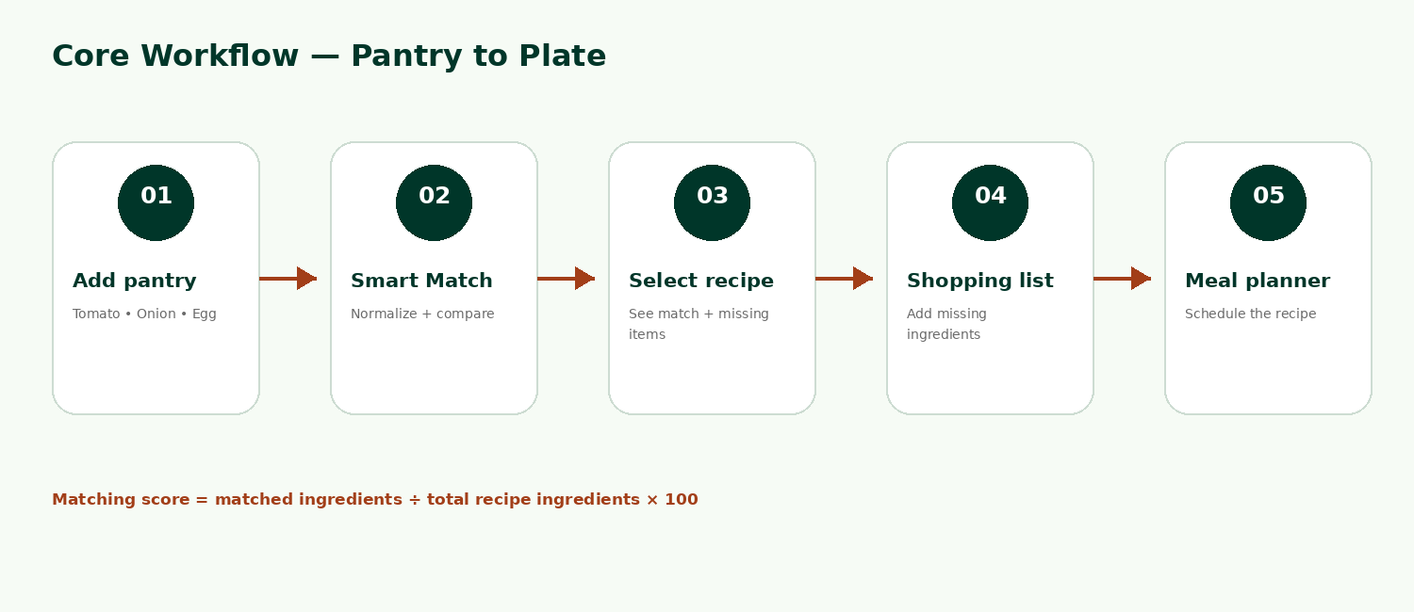
Typical flow: user logs in → adds pantry ingredients → runs Smart Match → selects a recipe → adds missing ingredients to Shopping List → schedules the recipe in Meal Planner.

DATABASE & BACKEND
Entity | Purpose
User | Account, profile and preferences.
Recipe | Recipe information, ingredients, instructions, cuisine, tags and timing.
PantryItem | User pantry inventory.
ShoppingList | Shopping items and completion state.
MealPlan | Scheduled meals.
Favorite | Saved recipe relationship.
API GROUPS
Endpoint | Purpose
/api/auth | Authentication and account operations
/api/recipes | Recipe CRUD and retrieval
/api/pantry | Pantry management
/api/matching | Smart ingredient matching
/api/shopping-list | Shopping-list operations
/api/meal-plans | Meal planning
/api/favorites | Favourite recipes
/api/external-recipes | TheMealDB integration
/api/ai | AI culinary advisor
SECURITY
JWT authentication protects user-specific operations. Passwords are hashed with bcryptjs. Helmet, CORS and rate limiting are configured on the server.

OUTPUT SCREENSHOTS — APPLICATION SCREENS
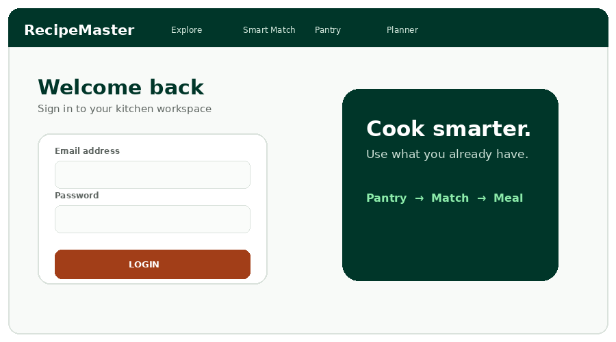  Login | 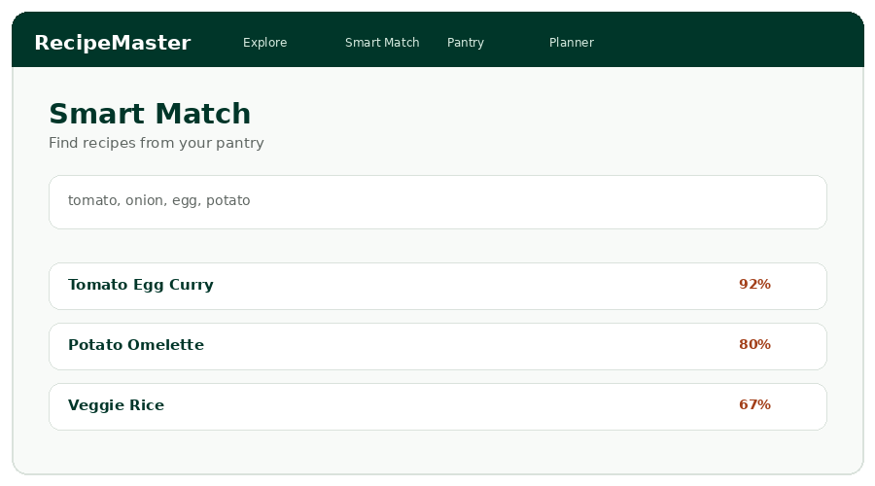  Smart Match
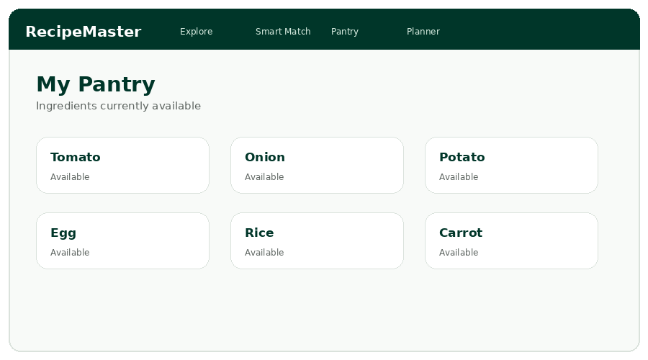  Pantry | 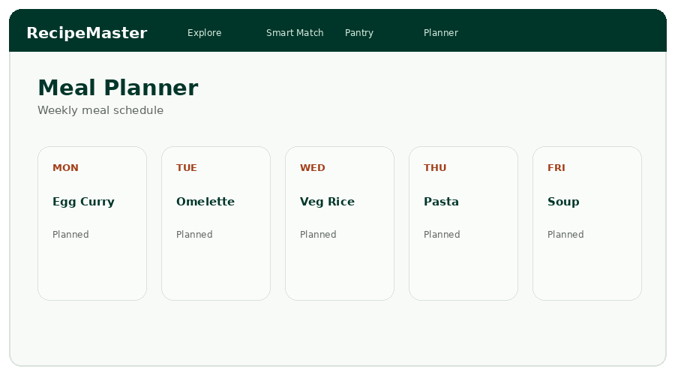  Meal Planner
RECIPE DETAIL
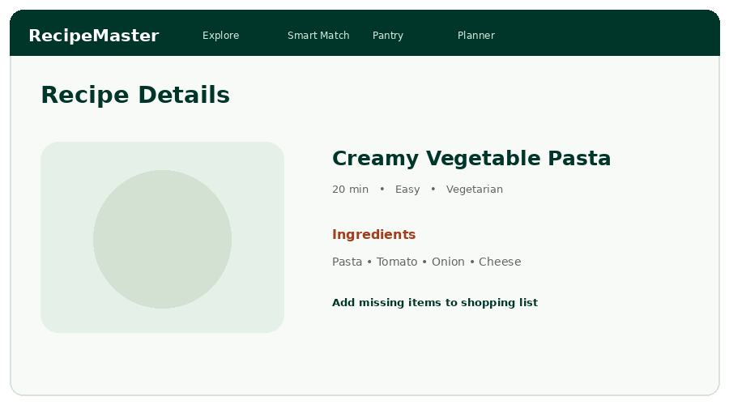

PROJECT SETUP & EXECUTION
Step | Command / action
Install | npm install --legacy-peer-deps
Development | npm run dev
Build | npm run build
Production | npm run start
Validation | npm run lint
IMPLEMENTATION SUMMARY
RecipeMaster combines recipe management, pantry inventory, ingredient matching, shopping automation and meal planning in one workflow. The modular frontend/backend structure allows additional recipes, integrations and intelligent kitchen features to be added without changing the overall application flow.
CONCLUSION
The project delivers a practical smart-kitchen platform where the pantry is the starting point for recipe discovery and planning. The Smart Match feature connects the major modules and reduces the need for users to manually compare ingredients.
— End of Project Documentation —

