TSAR Team Meeting
26 January 2018

Attendees

Agenda

Last Meeting Follow up
- We now have a mechanical calibration system for the pressure transducer calibration.
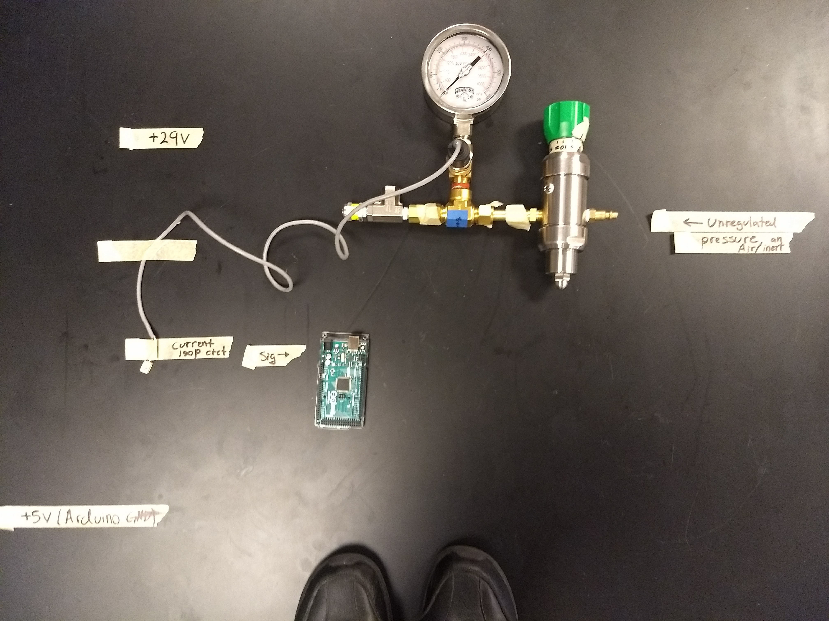
- Decided on the power system – lift the ground
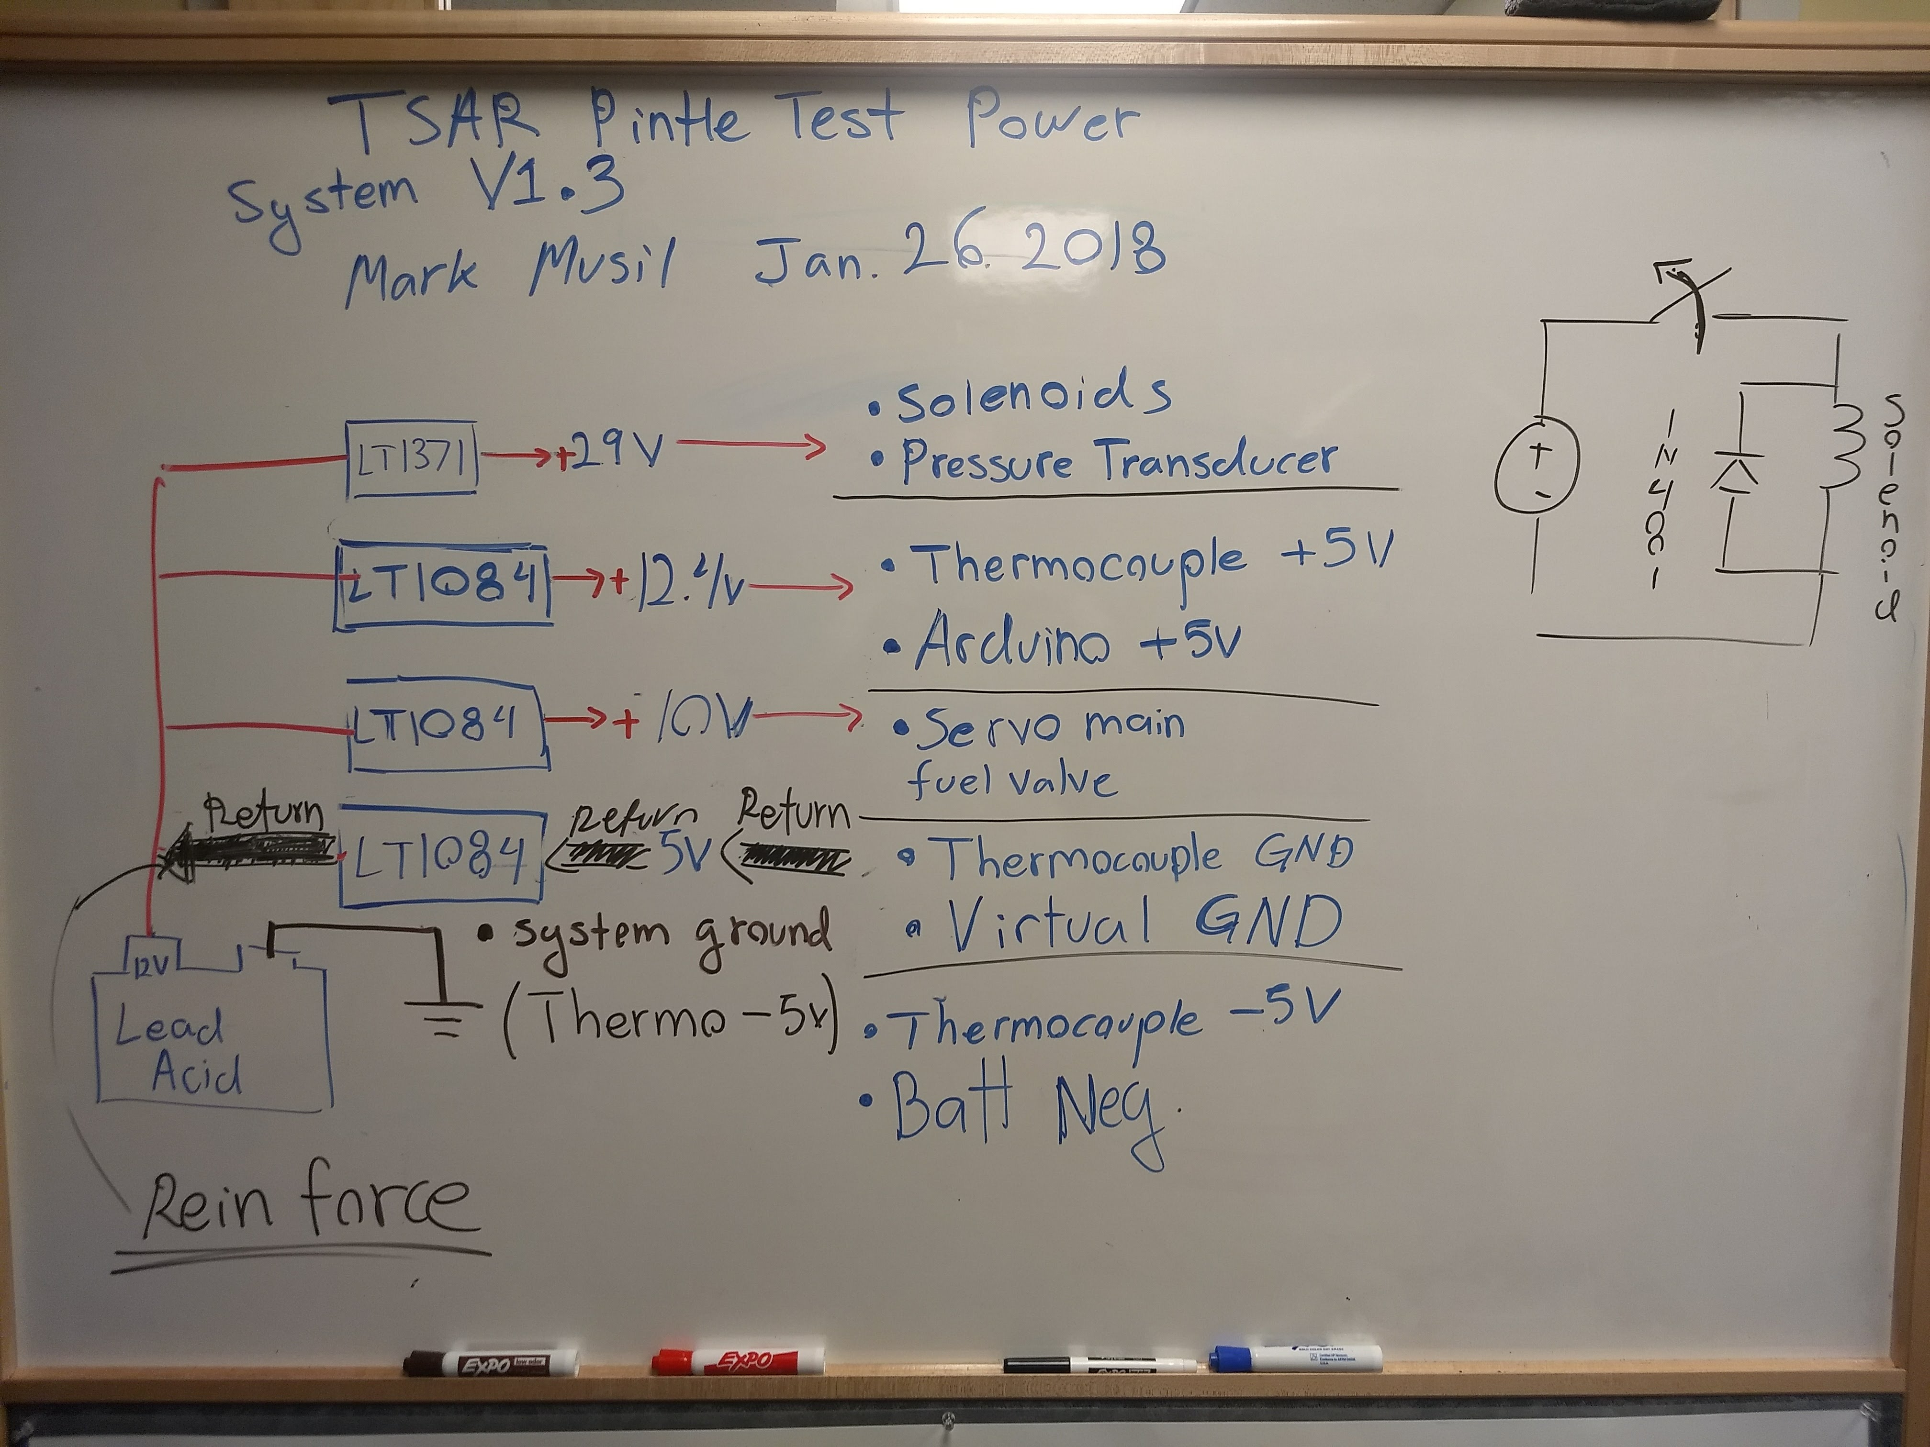
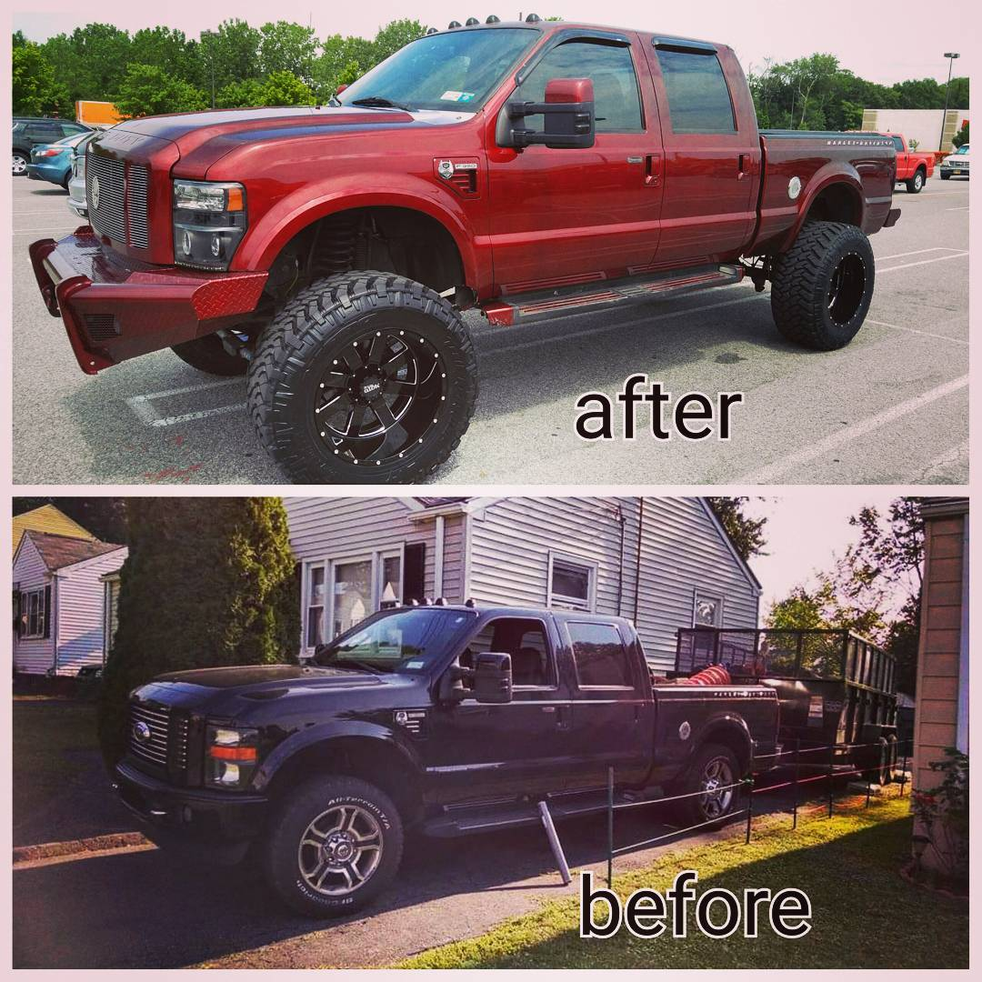
Figure 1: Automotive analogy for ‘lifting’ the ground of a circuit.

- Ordered a few misc. Components for the LT1371 29V

New Info
1. Test stand meeting Thrusday at 4:30
2. Add a 1N4004 rectifier diode in parallel with the solenoid (relays, etc) and any inductive loads.

Member Updates

What did you do last week?What will you do this week? Are there any impediments in your way?

Action Items/Next Steps

Mark – email peter and arman about power issues.

Anyone – work on:
1. Building Power supplies
2. Calibrating pressure transducers
3.

Next Meeting Agenda

