close all
clear
%import all trial data and split the runs and time start at zero
data = importdata('data.txt');
state0 = data(:,1);
state0 = state0(8:end);
time0 = data(:,3);
time0 = time0(8:end);
time0 = time0 - time0(1);
vel0 = data(:,2)*-1;
vel0 = vel0(8:end);
data = importdata('impulse1.txt');
state1 = data(:,1);
time1 = data(:,3);
vel1 = data(:,2);
state11 = state1(8:2924);
time11 = time1(8:2924);
time11 = time11 - time11(1);
vel11 = vel1(8:2924)*-1;
state12 = state1(2925:end);
time12 = time1(2925:end);
time12 = time12 - time12(1);
vel12 = vel1(2925:end);
data = importdata('impulse2.txt');
state2 = data(:,1);
time2 = data(:,3);
time2 = time2 - time2(1);
vel2 = data(:,2);
data = importdata('impulse3.txt');
state3 = data(:,1);
time3 = data(:,3);
vel3 = data(:,2);
state31 = state3(1:2945);
time31 = time3(1:2945);
time31 = time31 - time31(1);
vel31 = vel3(1:2945);
state32 = state3(2946:end);
time32 = time3(2946:end);
time32 = time32 - time32(1);
vel32 = vel3(2946:end);
%Graph all the collected data
figure
plot(time0,vel0,time0,state0)
legend('Velocity (rad/s)','Duty Cycle State')
title('Impulse Data')
figure
plot(time11,vel11,time11,state11)
legend('Velocity (rad/s)','Duty Cycle State')
title('Impulse Data 11')
figure
plot(time12,vel12,time12,state12)
legend('Velocity (rad/s)','Duty Cycle State')
title('Step Data 12')
figure
plot(time2,vel2,time2,state2)
legend('Velocity (rad/s)','Duty Cycle State')
title('Step Data 2')
figure
plot(time31,vel31,time31,state31)
legend('Velocity (rad/s)','Duty Cycle State')
title('Step Data 3')
figure
plot(time32,vel32,time32,state32)
legend('Velocity (rad/s)','Duty Cycle State')
title('Step Data 3')
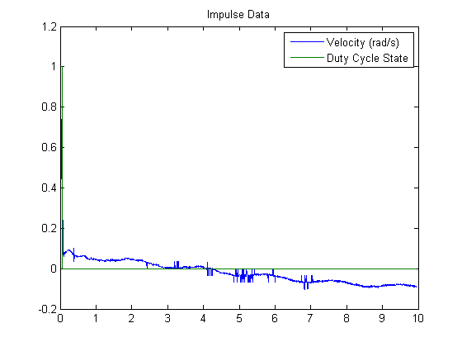
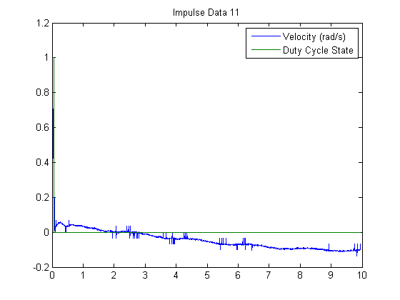
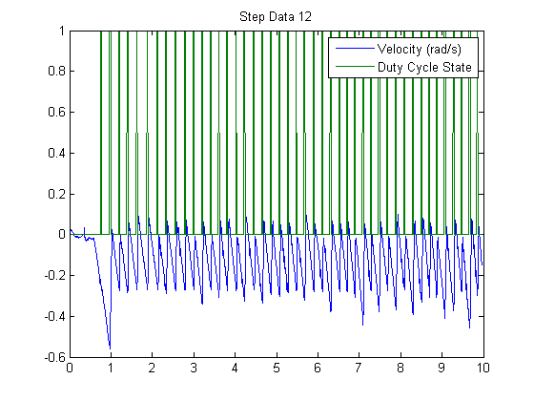
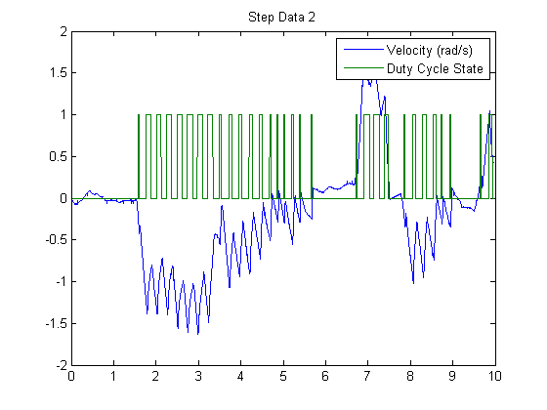
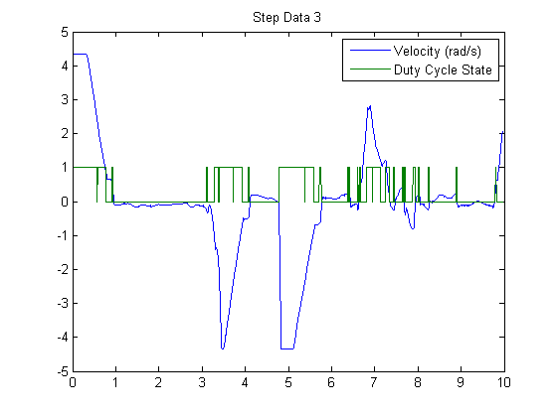
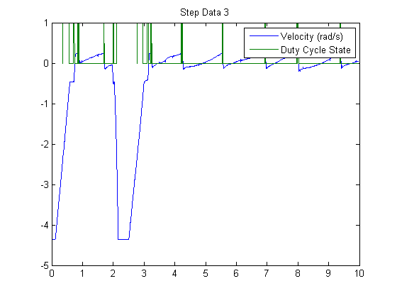
%define variables
I = 0.0198;
Ftot = 7;
fr = 2.75*.0254;
b = 0.002;
a = 2; %I/(Ftot*ct*fr)
ct = 0.2;
Tau = 0.02;
hz = 5;
simout = sim('roll_sim.slx');
figure
plot(theta_dot.time,theta_dot.signals.values)
title('Step response of Theta Dot (rad/s)')
figure
plot(error.time,error.signals.values,time0,vel0,time11,vel11)
legend('Simulation','Experimental 1','Experimental 2')
title('Disturbance Rejection of Error (rad/s)')
xlim([0 .2])
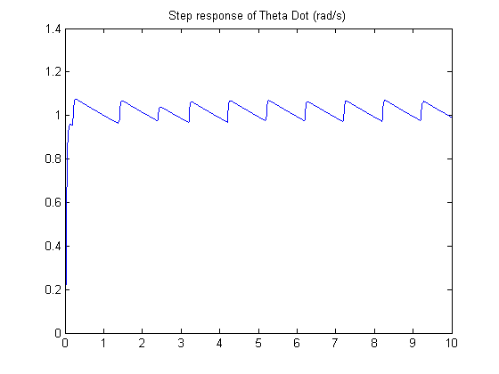
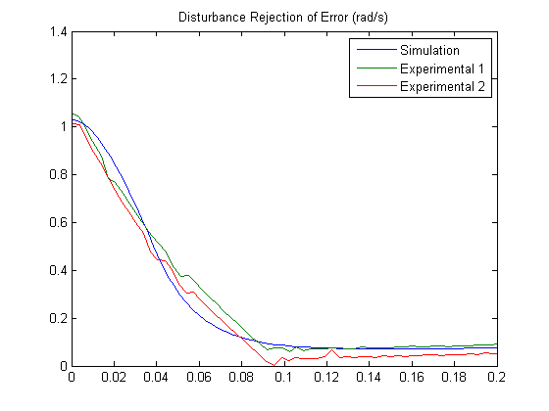
Published with MATLAB® R2013b

