|  |  |  |
| --- | --- | --- |
| **المملكة العربية السعودية**  **وزارة التعليم**  **جامعة الأمير سطام بن عبدالعزيز**  **كلية هندسة وعلوم الحاسب** |  | **Kingdom of Saudi Arabia**  **Ministry of Education**  **Prince Sattam Bin Abdulaziz University**  **College of Computer Engineering and sciences** |

Project

Booking.com

|  |  |  |
| --- | --- | --- |
| N | Student Name | Student Number |
| 1 | Abdullah Fahad Tamim | 442050471 |
| 2 | Rayan Abdullah Alsamari | 442050802 |
| 3 | Naif Nasser Aldawsari | 442051143 |

Supervised by: D.Mohammed Assiri

Year: 2023

1. **Feasibility Study & Project Proposal**
   1. **Introduction**

Booking.com is a well-known online travel agency that serves as an online travel agency, allowing users to search for and book various accommodations, flights, car rentals, and other travel-related services. With millions of users worldwide, Booking.com has established itself as a trusted platform for travelers seeking a seamless and convenient travel planning experience.

* 1. **Problems**

Before the advent of Booking.com, travelers faced several challenges while booking accommodations, including:

* **Limited access to accommodation information:** Travelers had to rely on travel agents, brochures, or word of mouth for information about accommodations, which was often insufficient or outdated.
* **Inconvenience in booking:** Travelers had to visit multiple websites or make phone calls to book accommodations, making the process time-consuming and inconvenient.
* **Difficulty in comparing prices and features:** Limited information made it difficult for travelers to compare accommodations based on various parameters, such as price, location, and amenities.
* **Inability to access reviews:** Travelers had no easy way to access genuine reviews from other travelers, making it difficult to make informed decisions.
  1. **Background**

Booking.com was founded in 1996 in Amsterdam, Netherlands, and has grown into one of the largest travel e-commerce companies in the world. The mobile application was launched to cater to the growing demand for on-the-go travel planning and to provide users with an accessible and user-friendly platform. The Booking.com app has been continuously evolving, with regular updates and enhancements to improve user experience and provide more relevant and personalized travel options.

* 1. **Proposed solution**

Booking.com aimed to solve the above-mentioned problems by providing a comprehensive online platform that offers:

* **Detailed information on accommodations**: The platform offers extensive information on accommodation facilities, including photos, descriptions, pricing, and availability.
* **User-friendly interface:** The platform provides an easy-to-use interface that allows travelers to search, filter, and sort accommodations based on various criteria, such as price, location, and amenities.
* **Price comparison:** The platform allows users to compare accommodation prices across various booking websites, ensuring that they get the best deal possible.
* **Access to genuine reviews:** The platform features millions of reviews from verified users, allowing travelers to make informed decisions based on real experiences.
  1. **Work Plan**

To bring the project to fruition, the Booking.com team would have followed these steps:

1. Conducted detailed market research to understand the problems faced by travelers, the target audience, the competitive landscape, and the unique opportunities in the market.
2. Identified the key features and functionalities required in the platform based on the market research insights.
3. Determined the functional and non-functional requirements for the platform.
4. Developed various system diagrams, including activity diagrams, use case modeling, sequence diagrams, and class diagrams, to represent the platform's processes and interactions.
5. Designed a user interface focusing on user experience, goals, and objectives of the platform.
6. Implemented the system, incorporating all identified requirements and maintaining iterative development cycles for continuous improvement.
7. Performed rigorous testing to ensure that the platform is bug-free, reliable, and performs optimally under various conditions.
8. Deployed the platform and performed regular updates and enhancements based on user feedback and changing market trends.
9. **Project Requirements:**
   1. **Functional Requirements (FR)**

**2.1.1 User Requirements**

1. The system should provide users with the ability to search for accommodations based on multiple criteria. Additionally, the system shall include a filter and sort functionality to enhance the search experience.
2. The system should provide Users with the ability to access detailed information about each accommodation, including photos, descriptions, pricing, availability, and reviews from other travelers.

1. The system should provide users with access to customer support services, such as live chat, email, or phone, to promptly address any concerns or issues they may encounter while using the platform.
2. The system should provide users with the ability to book accommodations directly within the platform.

**2.1.2 System Requirements**

1. The system should have a reliable search engine capable of processing various user queries for accommodations, considering factors such as location, price range, dates, and amenities, and delivering accurate matching results.
2. The system should offer user-friendly filtering and sorting functionalities to enable users to easily refine their search results based on different preferences, such as price, rating, location, and amenities.
3. The system should use a suitable API to fetch and serve detailed information about each accommodation, including photos, descriptions, pricing, availability, and reviews. Implement caching mechanisms to optimize data retrieval and transfer efficiency.
4. The system should use efficient techniques to optimize the loading times of images and other media assets, ensuring a seamless user experience when presenting the fetched accommodation information in an organized and user-friendly manner.
5. The system should integrate a multi-channel customer support solution that includes live chat, email ticketing, and phone support features.
6. The system should include a comprehensive booking feature that allows users to input their booking details such as dates of stay, number of guests, and room type preferences.
7. The system should incorporate a review and confirmation step in the booking process. This includes displaying a summary of the booking details for user review, and once confirmed by the user, processing the booking and generating a confirmation message or email with all relevant information.
   1. **Non-Functional Requirements (NFR)**
8. The system should maintain a 99.9% uptime and handle at least 10,000 concurrent users without performance degradation. (Operational)
9. The system should provide an average response time of under 2 seconds for user queries and actions, ensuring smooth navigation within the platform. (Performance)
10. The system should recover from failures within 5 minutes, ensuring minimal impact on user experience and data integrity. (Dependability)
11. The system should present unbiased search results, with a fairness assessment conducted regularly to ensure equal visibility of accommodation providers. (Ethical)
12. The system must enforce secure authentication, with at least 256-bit encryption for data transmission and storage, and pass periodic security audits. (Security)
13. The system should maintain a maximum 1% error margin for invoicing and payment processing, with quarterly financial reporting for transparency. (Accounting)
14. The system should utilize cloud-based solutions, with a storage optimization target of at least 20% reduction in required physical space. (Space)
15. **Activity diagram:**

صورة تحتوي على لقطة شاشة, التصميم

تم إنشاء الوصف تلقائياً

1. **Project Use Case Modelling**
   1. **Use Case Diagram**

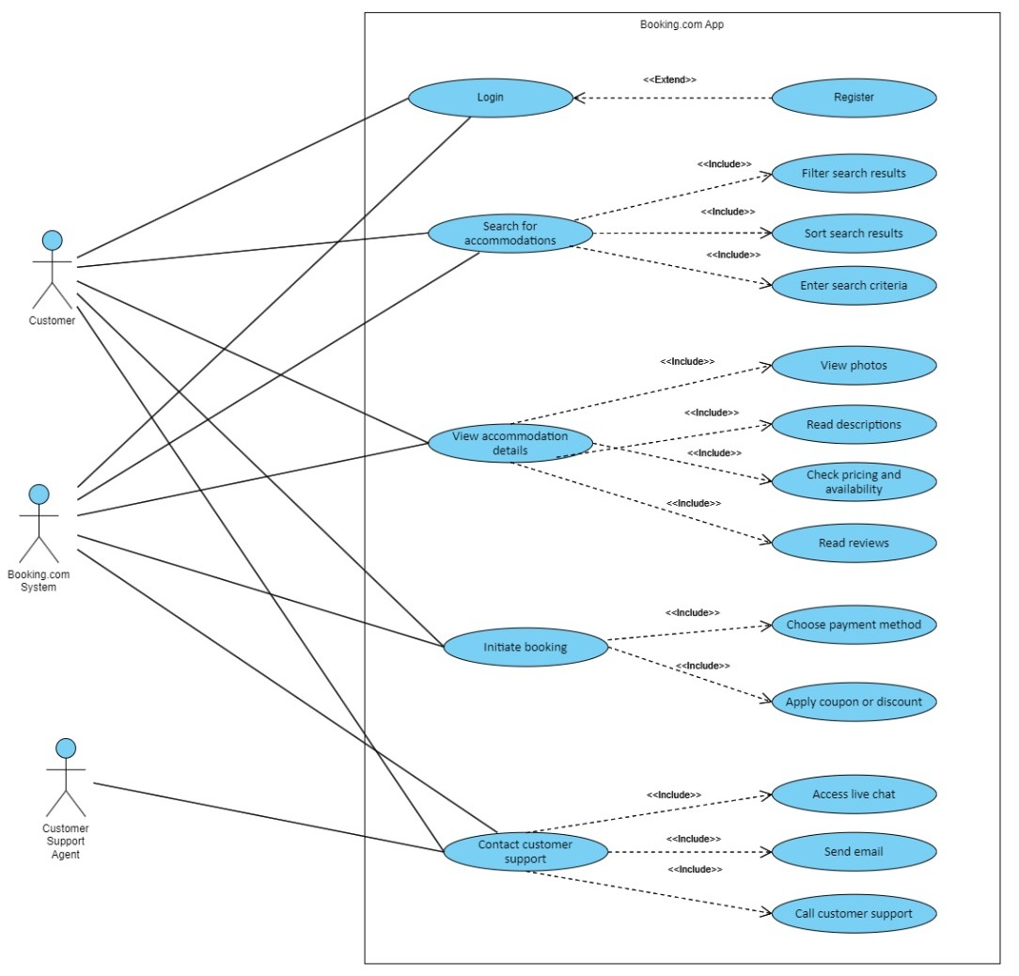

* 1. **Use Case Table (Table 1)**

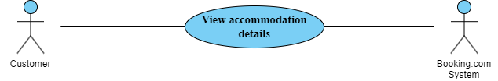

|  |  |
| --- | --- |
| **Booking.com: View accommodation details** | |
| Actors | Customer, Booking.com System |
| Description | The "View accommodation" use case allows users to access comprehensive information, including a description, amenities, photos, and reviews, for a specific accommodation listing within the app. |
| Data | The data can include: photos and videos about the accommodation, reviews and ratings, pricing and room availability. |
| Stimulus | the user clicking a specific accommodation from the search results view its detailed information. |
| Response | System displays detailed information for the selected accommodation, including photos, reviews, pricing, and availability. |
| Comments | This use case includes another related use cases: View photos, Read description, Check pricing and availability, Read reviews |

* 1. **Use Case Table (Table 2)**

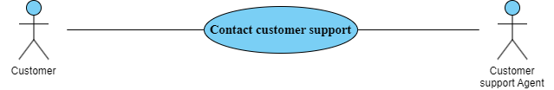

|  |  |
| --- | --- |
| **Booking.com: Contact customer support** | |
| Actors | Customer, Customer Support Agent |
| Description | The "Contact Customer Support" use case enables users to connect with the app's customer support team to seek assistance, report issues, or ask questions, ensuring a seamless and responsive support experience. |
| Data | The data in the use case typically includes user information (name, contact details) and support ticket details (inquiry, attachments). |
| Stimulus | The stimulus for the use case is triggered when a user initiates a request for assistance or reaches out to the app's customer support agents through a designated contact channel. |
| Response | A ticket will be created and a customer support agent will be available to assist the customer with their issue |
| Comments | This use case includes another related use cases: Access live chat, Send email, Call customer support |

1. **Creating Sequence Diagrams**

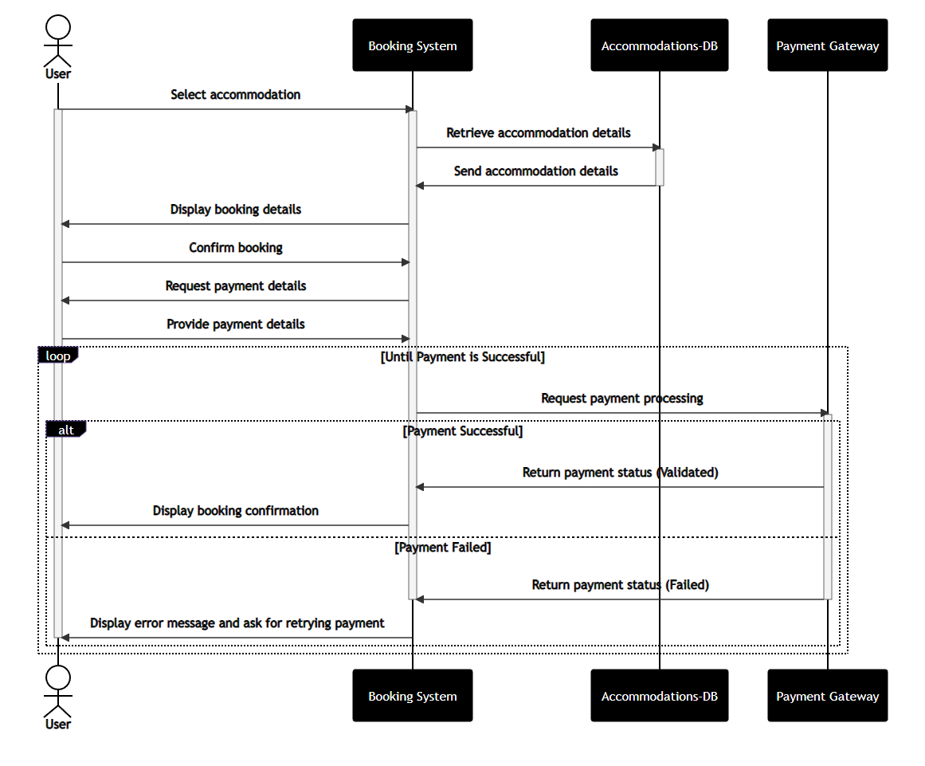

1. **Creating Class Diagrams**

