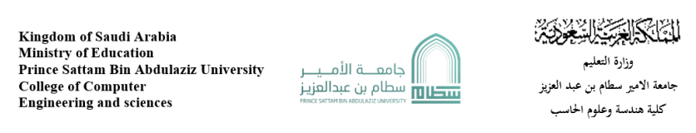

**Duolingo**

|  |  |  |
| --- | --- | --- |
| N | Student Name | Student number |
| 1 | Ali Alqahtani | 437050824 |
| 2 | Asim Alharbi | 441051656 |

Supervised by: Ahmed Asiri

Year : 2023-2022

**Introduction**

**Purpose of the website: The website is made to help people learn languages.**

**Services: The main goal of the website is to teach languages.**

**Under this umbrella there are plenty of ways to accomplish this goal; viewing grammatical rules, translating separate sentences and hearing audio stories**

**Domain address: “duolingo.com”.**

**Strategy**

**Aside from the app I did not find any business category provided. So, through my experience with the website, I can say that its business category is educational and entertainment.**

**The design is very joyful and attractive this is an important aspect in educational fields because you are relying on the attention and focus of the user, the second he gets bored your business falls. so, the vibes are important and Duolingo is absolutely successful in this field it is the most popular language learning website.**

**The website audience may vary but we can see that the main audience that the website is targeting are:**

**1- one people working in a country where the language is different from theirs**

**2- students who are required to score good grades in the language they are studying or studying in.**

**3- people who simply love learning languages.**

**Basically, anyone who wants to learn a language for any reason you can think of and this can mean any age too. So, the joyful design is a good choice for all ages.**

**Usability**

**It takes 2.8s to load the page that is a good time to not make visitors get bored (tool used to calculate the speed: gtmetrix.com).**

**The information can be easily found since the website is very simple and even the actions that can be performed are too few.**

**There is no search button but there is a menu of language, you can choose which language do you want.**

**Links working at Semrush tool.(** [**https://www.semrush.com/analytics/backlinks/overview/?q=https%3A%2F%2Fwww.duolingo.com%2F&searchType=domain**](https://www.semrush.com/analytics/backlinks/overview/?q=https%3A%2F%2Fwww.duolingo.com%2F&searchType=domain)**).**

**Some figure to explain:**

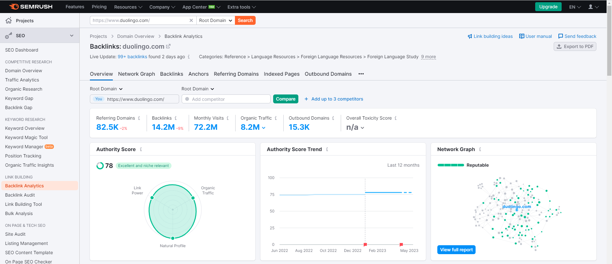

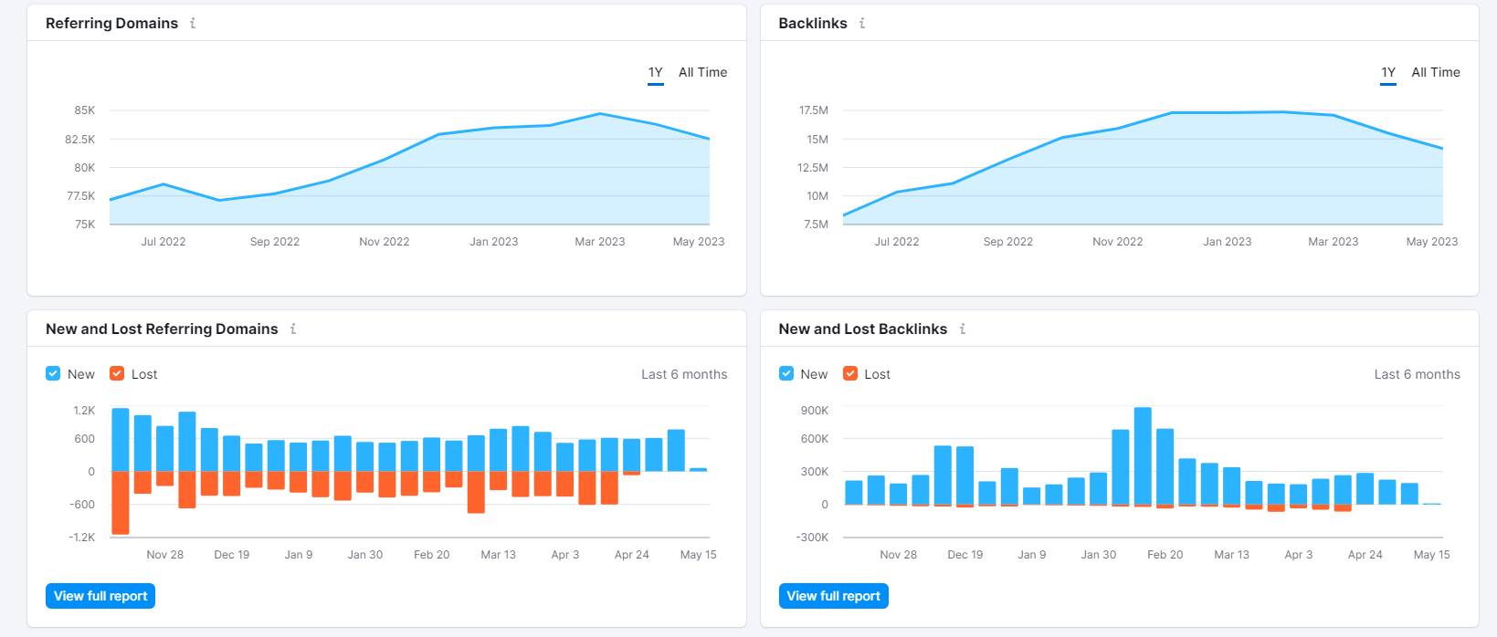

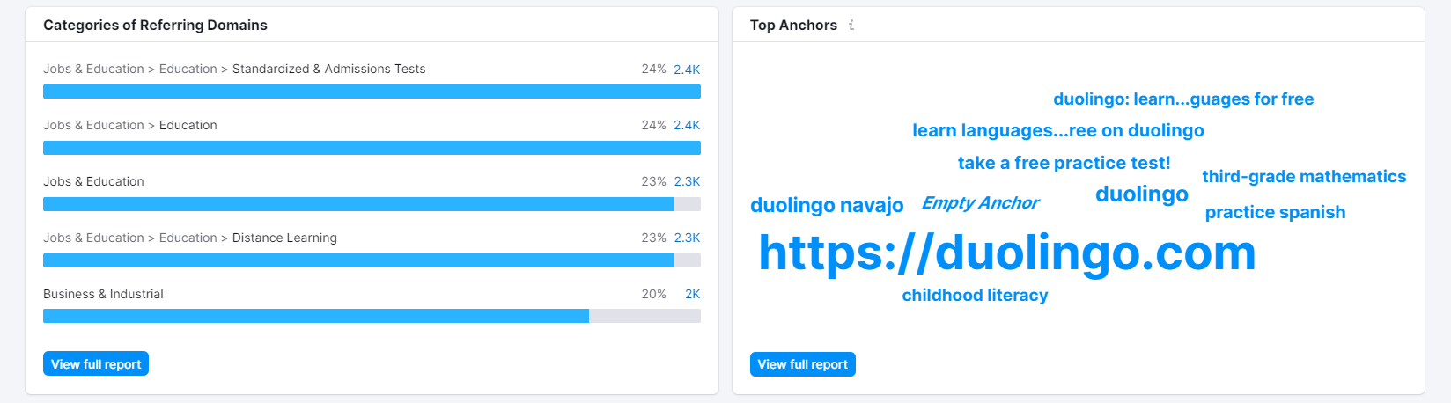

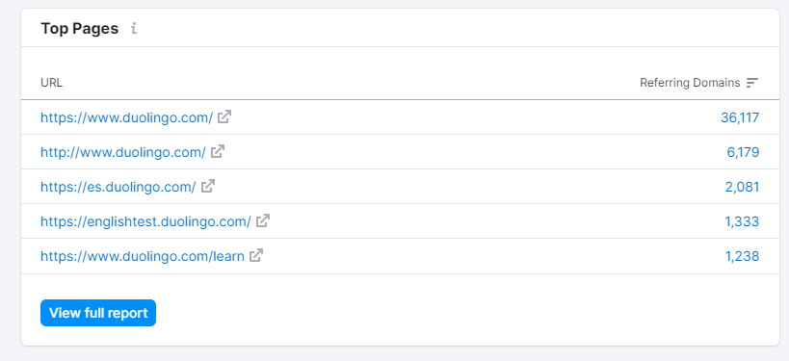

**There are different browser Duolingo work on it:**

**Microsoft edge(Bing):**

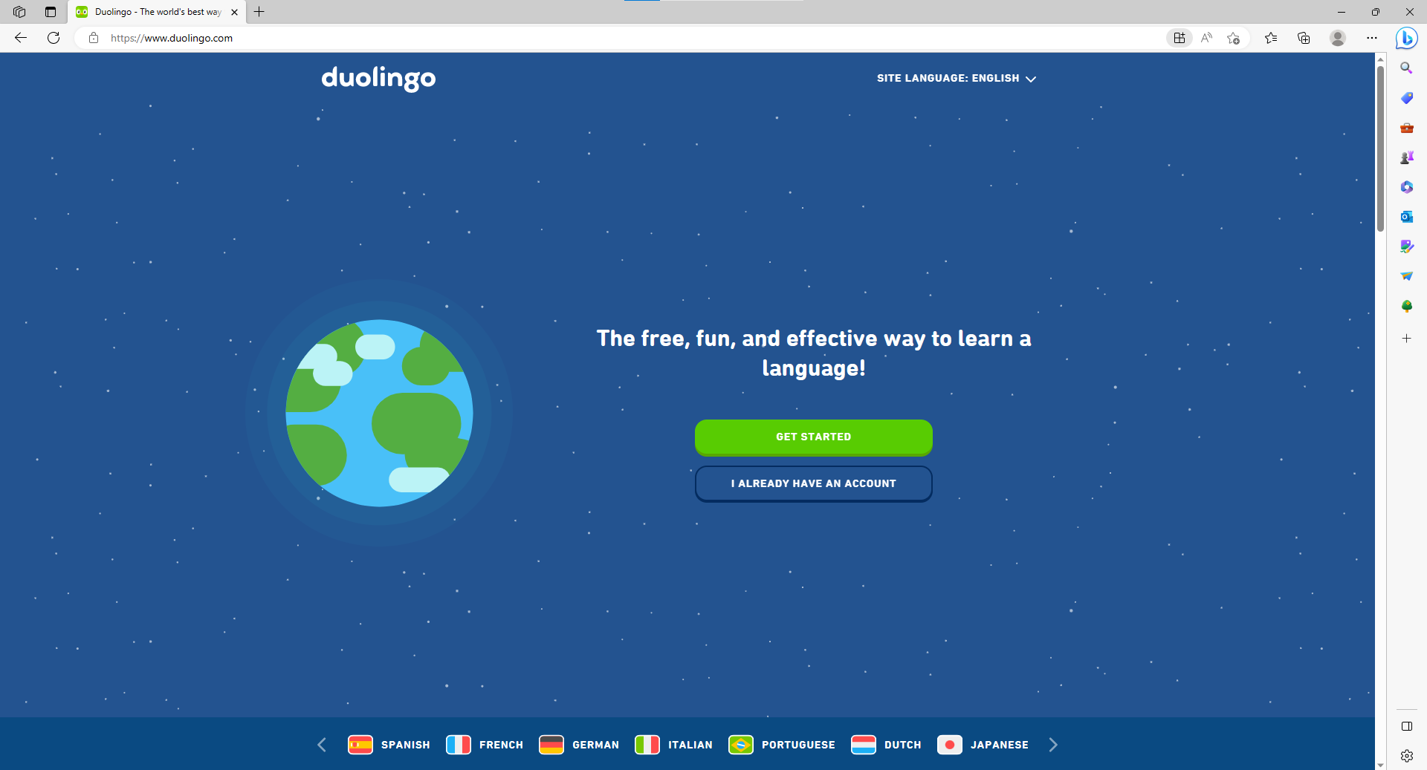

**Google chrome:**

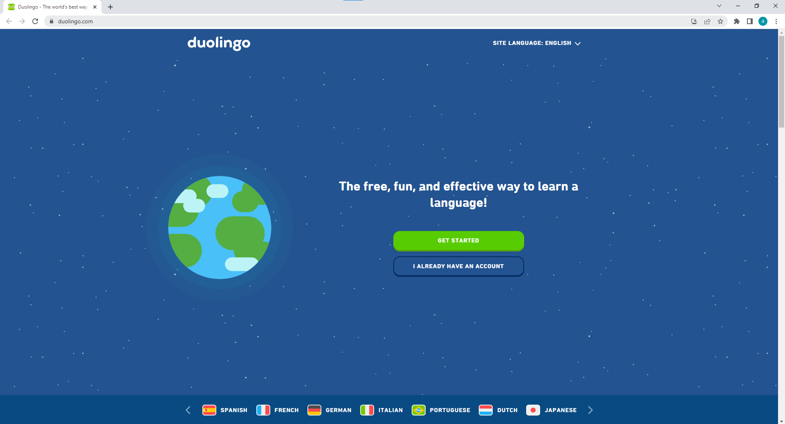

**Yahoo:**

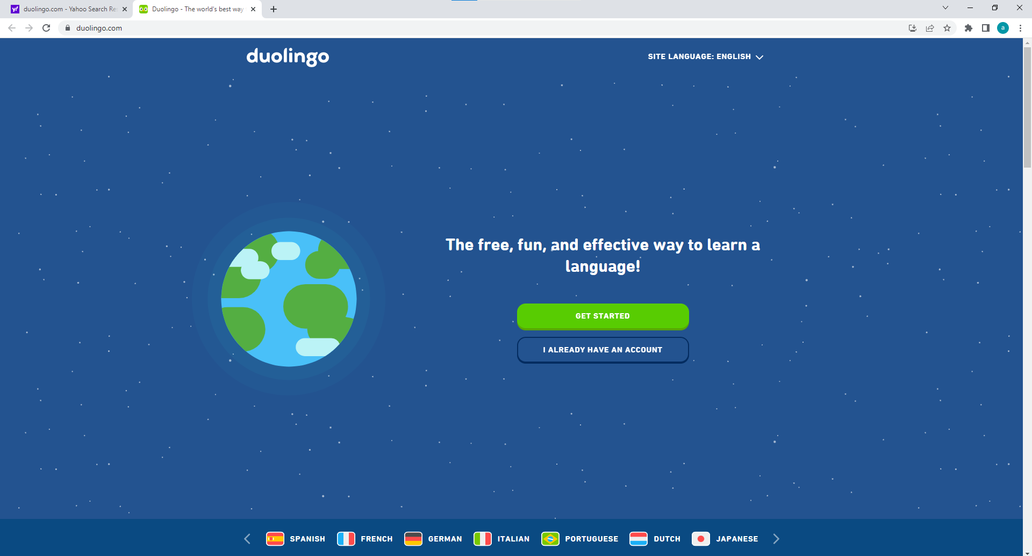

**Website work on mobile device (iPhone (iOS)):**

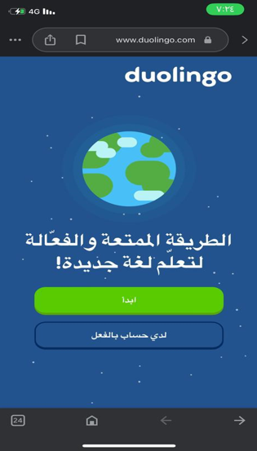

**Content and Readability**

**The main font used on the website called (Open Sans) which is a sans-serif font designed by Steve Matteson. This font is used for the majority of the text on the site, including the lessons and the Duolingo blog. In addition to Open Sans, Duolingo also uses a number of other fonts for different purposes.**

**Here’s the common hierarchy in which they’re used:**

**1. Feather Green is the core color of our brand. This is the hue that the world associates with Duolingo. When in doubt, lean in to green!**

**2. Mask Green is our secondary green color upon which Duo can be placed.**

**3. Eel is commonly used for typography.**

**4. Snow is our primary background color.**

**The background colors are consistent with the font color, where the font color contains:**

**The official font colors of Duolingo are feather green, mask green, eel black, snow white, brown (beak inner), orange (beak lower/feet), golden yellow (beak upper), and light yellow (beak highlight).**

**Body text should have a maximum size of 12 pt and no less than 10 points for screen viewing, with maximum sizes between 14 and 16 points for tablets and phones.**

**Can one enlarge text in Duolingo app? I don't think there is an option to enlarge text in the DL app. But there might be something in the accessibility settings of iOS.**

**The site has a clean, useful and concise interface, but it contains a few help keys for ease of use, but it is highly concise.**

**Conclusion and recommendations**

**In conclusion, the site offers a lot of good services, and good goals for learning in easy and self-learning ways. It also lacks some recommendations and suggestions as follows:**

1. **Ability to select lesson options, so you could choose audio only lessons (listening/speaking, just listening, or just speaking), just like the story lessons (for courses that have them) are reading comprehension lessons**
2. **More robust dialogue problems / lessons.**
3. **Ability to increase font size**
4. **Add More culturally specific stories**
5. **Ability to toggle off characters. and I also think it should be something you can turn off just like sound effects and motivational interruptions.**

**The end.**

**Question1: solution by Asim**

**Question2: solution by Asim**

**Question3:**

**First three point solution by Asim**

**Last three point solution by Ali**

**Question4: solution by Ali**

**Question5: solution by Ali**