Kingdom of Saudi Arabia Ministry of Education



Prince Sattam Bin Abdulaziz University College of Computer

Engineering and sciences

search about

Absher

**Supervised by: Dr. Mohamed Assiri Year: 2023 | 1444**

|  |  |
| --- | --- |
| Azzam Muhammad Al-Quraini | 443050750 |



وزارة التعليم

جامعة الم ري سطام بن عبد العزيز كلية هندسة وعلوم الحاسب





Absher platform is the electronic platform of the Ministry of Interior, and aims to provide the services of the Saudi Ministry of Interior digitally and in an integrated manner to citizens, residents and visitors, by taking advantage of technical possibilities, and harnessing modern technologies; in order to provide a distinguished user experience through automated services with reliability, security and high efficiency.



There are many services provided by the Absher system in Saudi Arabia, which exceeded 180 services, for citizens and residents, and from the sectors of the Absher system that it provides

* The ministry's office
* General inquiry about the remaining balance of service payments.
* Inquiring about circulars
* General inquiry of transactions
* Passports
* Visa service
* Renewal of residence
* Issuance of residence
* Travel permits for followers
* Renewing the passport
* Issuing the passport
* Extension of a visit visa
* Transfer of services
* Modification of profession
* Affiliate services
* Travel record information
* Passport information
* Address information
* Personal information
* General inquiry about the fingerprint
* General inquiry about the eligibility to perform Hajj
* General inquiry about the validity of health insurance for residents only
* General inquiry about the status of the exit and return visa
* Inquiring about the arrival of labor
* Inquiring about the validity of residence
* Good news, travel
* Traffic
* Adding a user to a vehicle
* Renewal of the vehicle form
* Renewal of the driver's license
* Canceling a user of a vehicle
* Driving license information
* Inquiring about traffic violations
* General inquiry about the validity of vehicle insurance
* Electronic Billboard Auction Service
* Civil affairs
* My data service
* Reporting missing documents
* Service of requesting a document instead of a lost
* Book an appointment
* Service of introducing a follower
* Appreciation service
* Inquiring about health insurance
* Address information
* Personal information
* Book an appointment
* General inquiry about the eligibility to perform Hajj



as a subdomain for the Saudi Arabian version.

as a top-level domain (TLD), in addition 46% of websites use a .COM domain name.

The domain name is found by combining SLD with TLD.





absher is simply an engine to serve people and facilitate procedures for them, in my opinion, absher can also be categorized as a combination of multiple things, and I will describe its category as a category that facilitates citizens to conduct transactions related to passports, entry visas and all transactions related to management through the electronic portal of the system “Absher” without the need to go to the Passports Department and to save time and speed in performance and facilitate procedures for citizens and residents and accuracy in performance



Yes, from my point of view, when I visited the site for the first time, to register and produce a national identity, it took me a few minutes on the site to register my data and take a picture while I was in my residential location. Less than a week, the national card came to me for my home, and after months I wanted to issue a driver's license and it was not taken from me for a lot of time to book an appointment to train, and also with the electronic development, the card has become on the mobile phone, so there is no need to take out a card to transfer it.



I would say **yes**; the design of Absher appears to be clean and modern due to the good use of colors and well-taken photos. In addition, the search bar is accessible, and once you find the product, all details will show. But there are some flaws.

* **Whitespace:** The content feels cramped in some areas and could benefit from more whitespace to improve readability and make the content easier to scan.
* **Lack of a CTA (call to action):** It doesn’t do a good job of guiding customers to carry out specific actions or tasks.

And bad CTAs can confuse customers and make them get lost on the website.

* **Communication issues:** There is no phone for customer service or live chat; the available communication methods are Twitter, Facebook, Google+, and mail. In addition, Google+ is not working any more.



Most of them are Saudi clients or expatriates to the Kingdom of Saudi Arabia, especially people who want to work, shop and travel. The site supports both Arabic and English languages. In my experience, the site has won a lot of admiration and excellence in providing services and facilitating the beneficiaries.





First, let's explain the difference between response time (TTFB) and page load time.

Response time refers to the speed at which the server can respond to the request.

Page load time is the time it takes for a page to load completely. Page load time depends on response time; You will get less time to load the page if you have a lower response time.

In my testing, I used Google Page Speed ​​Insight, which will focus on average performance between mobile and desktop.

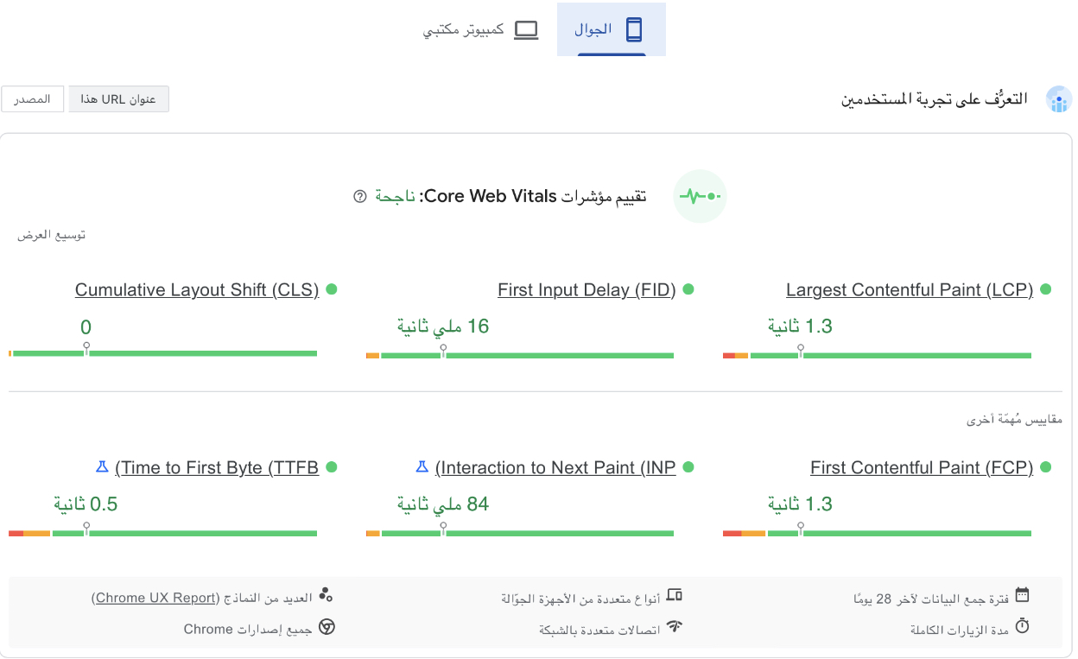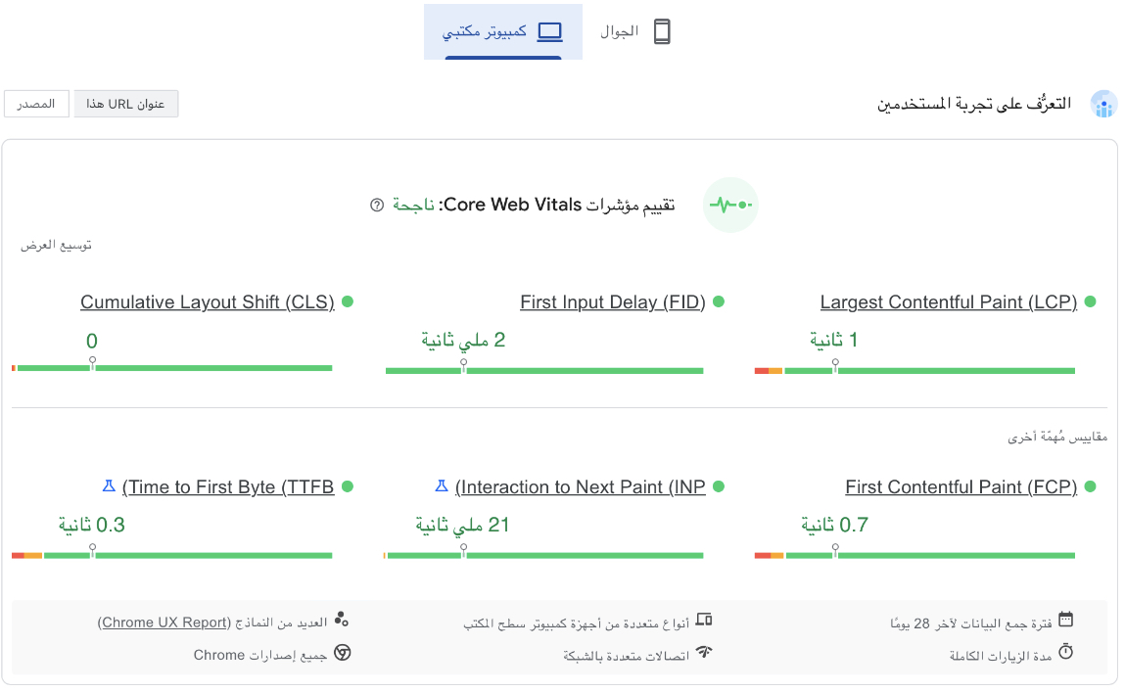You should consider that my test was done using SA servers; the Google test was done once, but I have tried it other times, and the result is not much different. The test was done in a specific way, which means the website is stable.

In general, a response time of less than 100 ms is considered good, and over 800 ms is considered an issue. According to my test, we got around 200ms on average, which is acceptable responsiveness for most websites, but in practice, customers will change the page frequently, so having a slow response time can have a bad effect on UX, particularly on mobile devices with slower internet connections. According to this result, I concluded that the response time on phones is much worse than on desktops, and the home page performance is much worse than on products.



I would say yes; It is possible to reach three target groups, to request a service from the site’s services, and the categories offered are the individuals category, the business category, and the government category.

* **The category of individuals:** serves all that pertains to the individual, whether property, public or private, to his family
* **Business Category:** It is a platform for business proposals whose number of workers does not exceed 100.
* **Government category:** It aims to transform the services of the Ministry of Interior to government agencies into electronic services



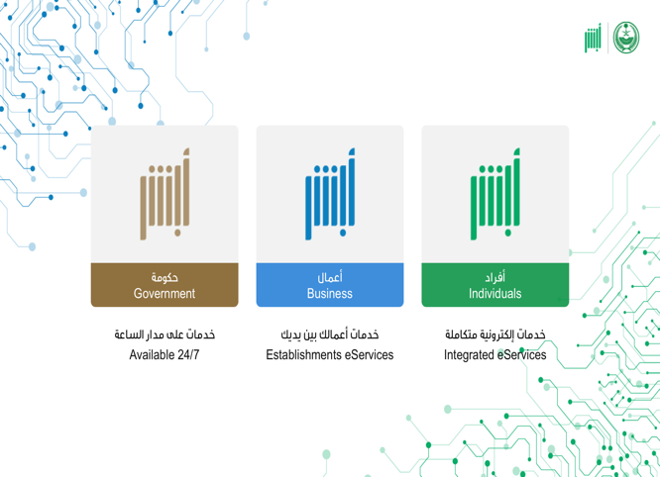Yes, there are three categories to serve the beneficiary. If he wants any of the offered services, he clicks on the file for the category, and the services offered for the category will appear for him..



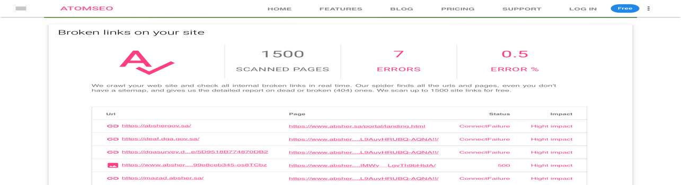 I used the dead links checker and https://error404.atomseo.com/ to test 15,000 URLs, and among all of them, I found 7 errors.



Yes, I have done a cross-browser test manually using the browsers that I have; for Safari, I had to use my iPad to test it. The test was done by searching for anything that is not normal, like bad photo quality, text misalignment, and so on. The result was excellent for Chrome, Firefox, and Safari; they have worked without any issues.



Yes, the app has given me a better experience. With more interactive elements, the user interface is easier to use and more streamlined, but sometimes text is misaligned on iPad and mobile, like in these photos.

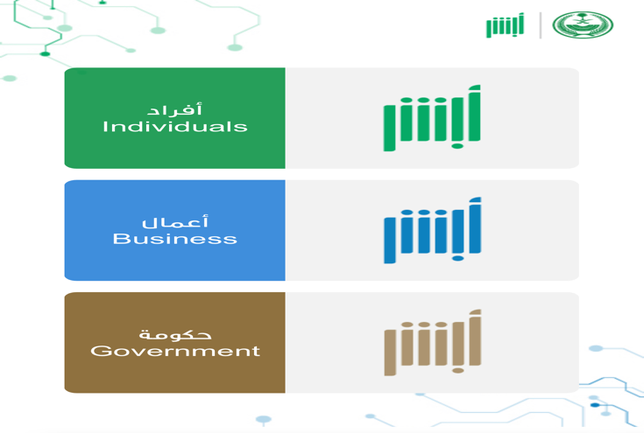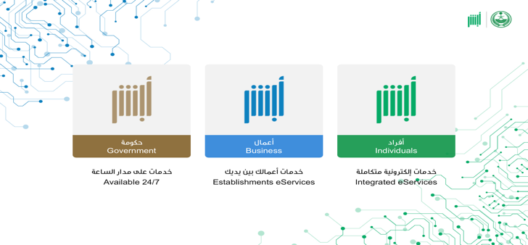





Yes, there are only a few fonts that have been used, which is fine in my opinion, and they are all standard fonts (widely used) and have distinct English and Arabic characters, which makes the fonts easy to read.



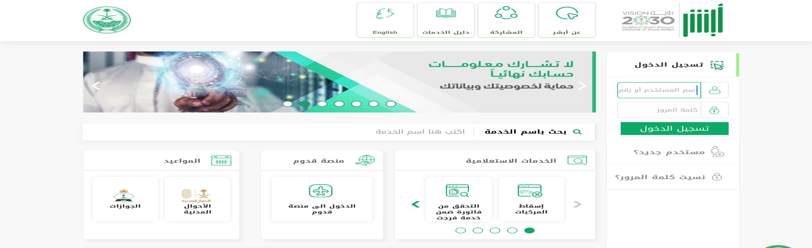**Not always**; most of the website uses too bright colors, mainly white and light green, that with a bad screen are almost unreadable. Sometimes the highlights have a close color difference to the text.



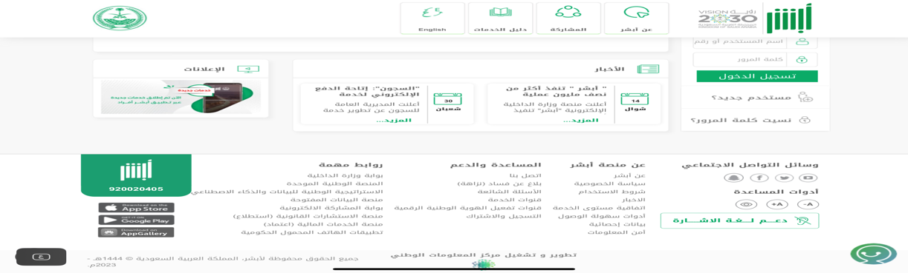 Almost too small, when you compare the size to other websites, you will notice that it is much smaller due to the loss of space on the sides of the site with all the content in the middle. Smaller font size can lead to poor UX, especially for people with low vision and people who use small screens.



Yes, it is very useful for the new and old user, and now everything is electronic and remotely. You can book an appointment, meet whoever you want from the site, set up objections and other services offered.



In general, the website provides useful tools and the idea of ​​the site is great, and one of the things I liked is that you provide everything while you are at your place and take out anything you see at your place. that

It is worth noting that all ministries are connected to it and it serves all sectors, and I am impressed that all this work is to serve the citizen, the resident and the traveler. There are some recommendations that I will give, some of which can be considered an opinion, and I will divide them into three parts.



* **Improve price tracking:** By adding statistical measurements and tracking all retailers.
* **Organize the interface:** The interface struggled with whitespace and small text. I would rather make the UI much simpler.
* **improve response time:** As I have shown, the website struggles with mobile phones, especially.
* **Separate Pricena from Pricena's blog:** I feel that it should be independent because Pricena's blog contains only a few blogs about Pricena and most of the others are about technology.
* **Fix filter issues:** While the website offers a good selection of products, the filtering options are somewhat limited because some of the most famous brands do not exist, like Philips and Samsung. In addition, sometimes you will get mismatch filtering for what you are searching for. For instance, if you are searching for a mobile phone, you will find the Core Processor filter containing desktop processors.



* **Interaction design and audio experience:** The website lacks interaction elements and audio experiences.
* **Dark theme:** It became a standard to have a dark theme, and most customers use it.



* **Remove some stores from the app:** Ebay, Haraj, and any used item are not supported very well; you will only find 2 or 3 items at most, and all of them are out of date.
* **Remove Live (give you what people are searching for at the moment):** It is not useful; I would rather save resources.

