المملكة العربية السعـودية

وزارة التعـلـيم

جامعة الأمير سطام بن عبدالعزيز

كلية هندسة وعلوم الحاسب

Kingdom of Saudi Arabia

Ministry of Education

Prince Sattam Bin Abdulaziz University

College of Computer Engineering and

Sciences

Foundations of software engineering

Project

Students name:  
 7Rayan al-mujalli 44305076

Sultan al-ajmi 443050532

Supervised by:

Dr. Mohammed Assiri

Part1: Project Proposal

**1.1** Introduction

The main purpose of the project is to design a system for the worldwide app YouTube through many steps, starting with defining what YouTube is and the problems that the app will be facing. Then, we propose a solution, and create a workplan for the whole process. We will design an activity diagram for all the main tasks that the app will be capable of performing it, and create a use-case to show how these tasks interact with the system. We will give a detailed sequence of these tasks by drawing a sequence diagram. Finally, we will draw a class diagram for these tasks as classes and show the relationships between them.

1.2 Background

**YouTube** is a digital **platform that allows users to upload, view, and share videos and give feedbacks. The project aims to provide a fast and easily accessible platform for sharing videos with a global audience. The platform is designed with creators who will be uploading videos to the system, and offering a suite of tools and analytics to help them optimize their content and grow their audience.**

1.3 Problems

The project will be facing many problems like legal problems or technical problems for example:

1-the high amounts of videos: that being uploaded

**2-content management**: the problems of the copyrights and also the risk of inappropriate or harmful content being uploaded to the site.  
3- user experience: for example how to make the user spends time in the website without and making them coming back to the website once more.

4- Privacy concerns: the system needs to collect data from the user to provide aa personalize content recommendations and serve targeted ads that may affect the website’s reputation.

1.4 Proposed solution

1-To manage the huge amount of videos: the system should uses many technologies for example to deliver a video to anyone around the world the system should uses CDN content delivery networks helps to reduce the latency from the servers , in the other side databases, the system should uses MySQL to store most of the data ranging from the videos to metadata like users, tags, and descriptions and store them in the hard drives in warehouse-scale Google data centers.

2- **The system is using uses (CMS)**

****which a tool stands for content management system is used to manage contents and its copyright inside the platform and the report feature if the user sees a video whether it’s**** Copyright Infringement or harmful content or inappropriate the user may report that content and the YouTube team going to take action depending on the situation

3- The system will be using a variety of strategies

to encourage users to spend more time on the website one of the most known ways is the Personalized recommendations YouTube's algorithm suggests videos based on a user's viewing history and interests. This encourages users to keep watching videos that are relevant and interesting to them

4- collect IP and ****need to collect data****

****from the user is to provide as personalize the system collecting these info only for improving purposes and to**** Personalized and recommendations depends on their location and their interests****.****

1.5 workplan

First we need to identify and Figure out what the website is for, who the target audience will be , and what it’s should do , Make it easy for content creators to upload, and adding user-friendly interface, and watching videos with low latency , design a strong system for the database to store videos, also making diagrams to understand the system accurately , and add a ways for the channel owners to make money, like ads and sponsorships , Add features that let people interact and work together , Get the website noticed by search engines and promote it to attract visitors, Keep making the changes based on what users want and what's popular.

1.6 User interface design for YouTube

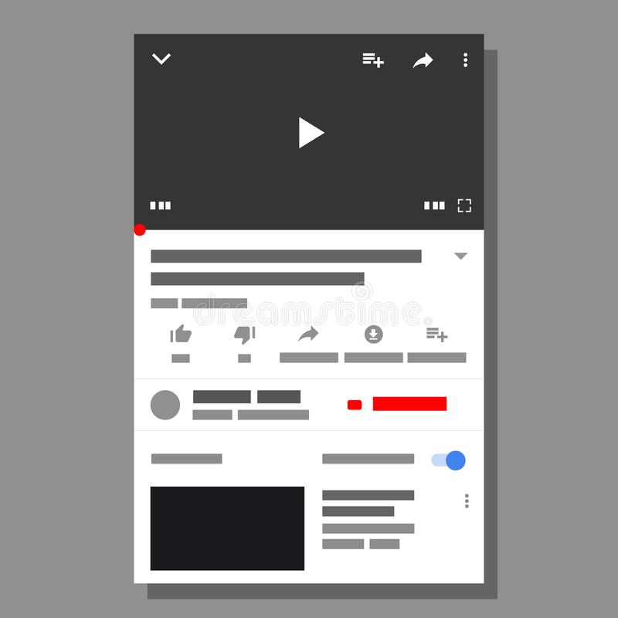

Part 2 – Project requirement

2.1 functional requirements

Video Playback: YouTube should allow users to play videos smoothly without buffering or freezing. Videos should be available in various resolutions, including 1080p and 4K, and should support closed captioning and subtitles.

Search Functionality:YouTube should provide a robust search functionality that enables users to quickly find videos based on keywords, titles, channels, and other filters.

Channel Management: YouTube should allow users to create and manage their own channels, upload videos, and customize their channel's appearance and layout.

Content Recommendations:YouTube should provide personalized content recommendations to users based on their viewing history, preferences, and interests.

Commenting and Interactivity:YouTube should allow users to comment on videos, interact with other users, and share content on social media platforms.

Monetization:YouTube should provide monetization options for content creators, including advertising revenue sharing, sponsorships, and merchandise sales.

Analytics and Metrics: YouTube should provide content creators with detailed analytics and metrics to track their video performance, audience demographics, engagement, and other key performance indicators.

Community Guidelines and Policies: YouTube should enforce community guidelines and policies to ensure that all users are safe, respectful, and comply with legal and ethical standards.

2.1.1-Functional User Requirements:

Smooth Video Playback: As a user, I need YouTube to play videos smoothly without buffering or freezing, so that I can enjoy my favorite content without interruptions.

Personalized Recommendations: As a user, I want YouTube to provide personalized content recommendations based on my viewing history, preferences, and interests, so that I can easily discover new content that I would be interested in.

2.2.NON-Functional Requirements:

Performance: YouTube should be fast and responsive, with minimal latency and fast page load times, to ensure a smooth user experience.

Availability: YouTube should be available 24/7 with minimal downtime or maintenance windows to ensure that users can access the platform whenever they need it.

Security: YouTube should implement robust security measures, such as encryption and authentication, to protect user data and prevent unauthorized access and hacking attempts.

Usability: YouTube should be easy to use and navigate, with clear menus, buttons, and search functionality, to ensure that users can find and watch the content they are interested in.

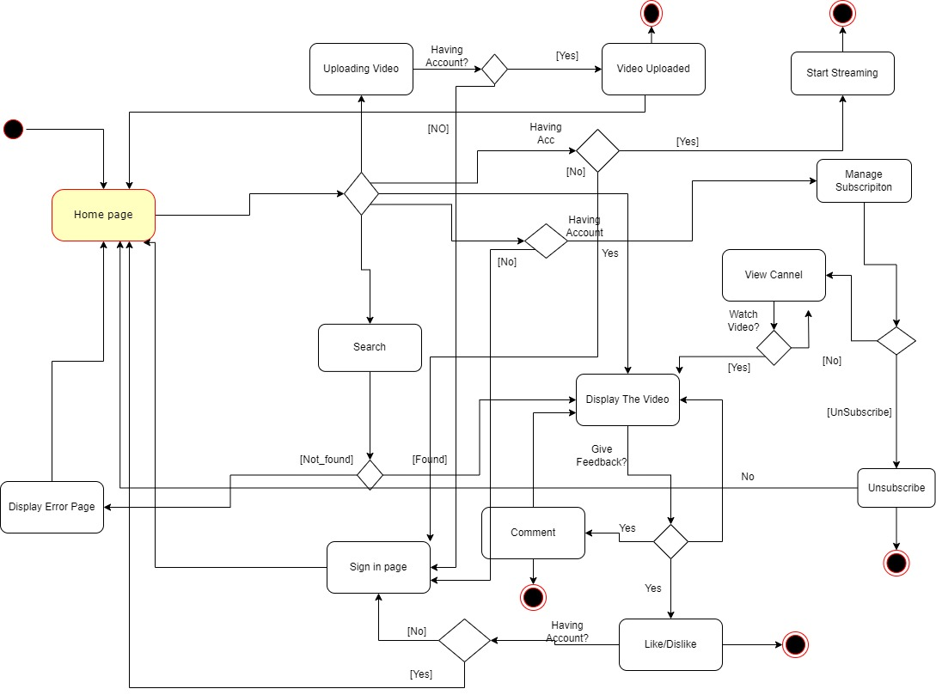Part 3- Activity diagram

Part 4- Use Case Modelling

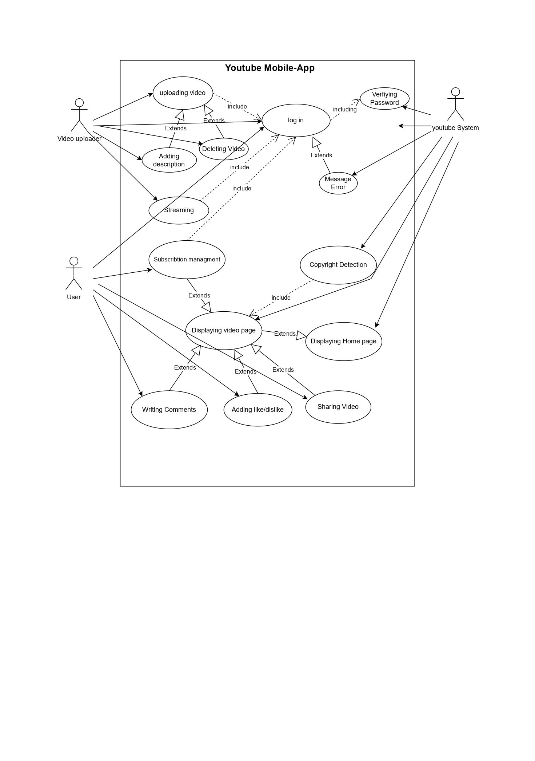

 user YOITUBE DB

|  |  |
| --- | --- |
| Log in: | |
| Actors | The user and YouTube's servers. |
| Description | A new user may want to log in in YouTube system. |
| Data | E-mail and password. |
| Stimulus | The new user has issued an order to log in. |
| Response | The new user is logged in. |

 user YOITUBE DB

|  |  |
| --- | --- |
| Uploading Video: | |
| Actors | Creator or uploader, YouTube's servers, and viewers. |
| Description | The user may upload videos from his device to YouTube system. |
| Data | Videos, texts. |
| Stimulus | The user has issued an order to upload a video. |
| Response | The video has been uploaded. |

Part 5 – Sequence Diagrams

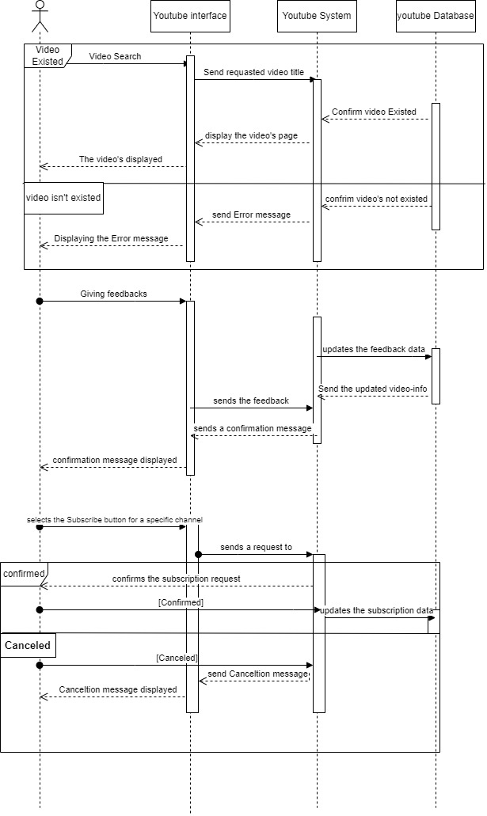

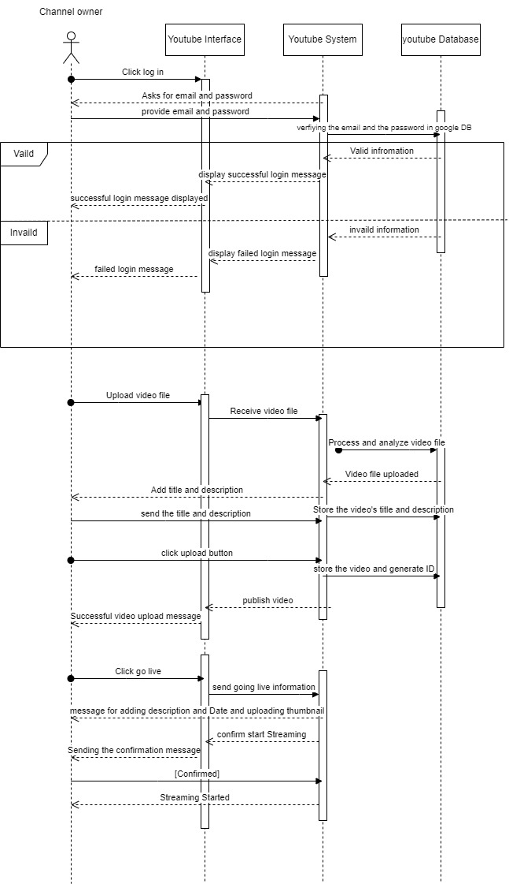

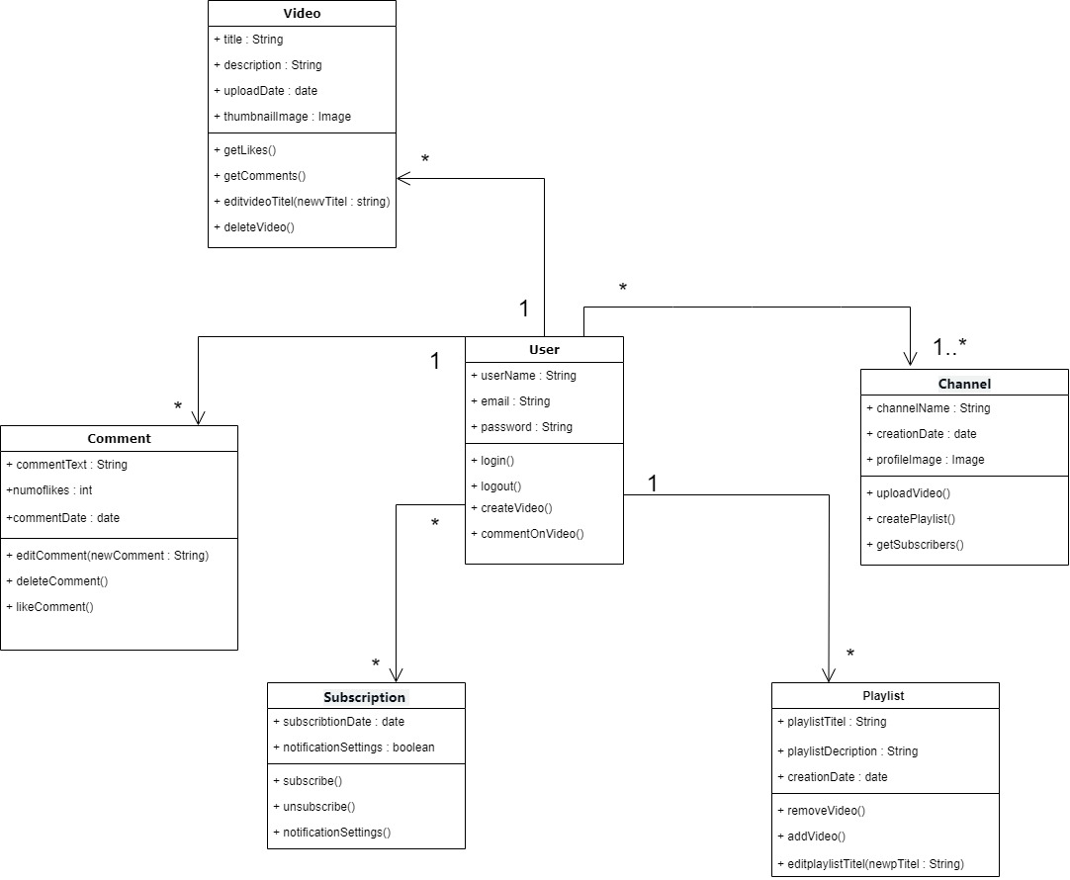part 6 – class diagram