

**Kingdom of Saudi Arabia**

**Ministry of education**

**Prince Sattam Bin Abdulaziz University**

**College of computer engineering**

**and sciences**

**المملكة العربية السعودية**

**وزارة التعليم**

**جامعة الأمير سطام بن عبد العزيز**

**كلية هندسة وعلوم الحاسب**

**Search about:**

**Stackoverflow website**

|  |  |  |
| --- | --- | --- |
| N | Student Name | Student Number |
| 1 |  |  |
| 2 |  |  |
| 3 |  |  |
| 4 |  |  |

Supervised By:

Year: 2023

# Introduction

**Purpose of the website:**

Sharing technologies where it’s a public Q&A platform which enable people to share their technical knowledge.

As shown in about page see figure 1:

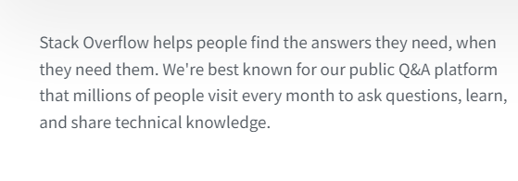

Figure : about page

**Services of the websites:**

Public Q&A.

Ability to share knowledge privately as team.

Ability to attract and engage the right tech talent.

Ability to showcase product or service to developers.

Adding new services for the future of community & AI

As shown in figure 2:

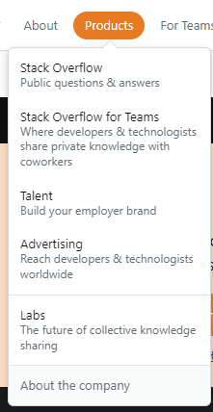

Figure : Services of the websites

**Domain address:**

<https://stackoverflow.com/>

# Strategy

**What is the category of the business, and is this obvious on the website?**

public Q&A, stack overflow for teams, talent, advertising and labs.

Yes, this is obvious on the website as menu and at the main page.

Show figure2 above.

**Is the design accomplishing the purpose of the website?**

Yes, for example Q & A section contain question categorized under different tag and company and etc.

See figure 3 for Q&A section.

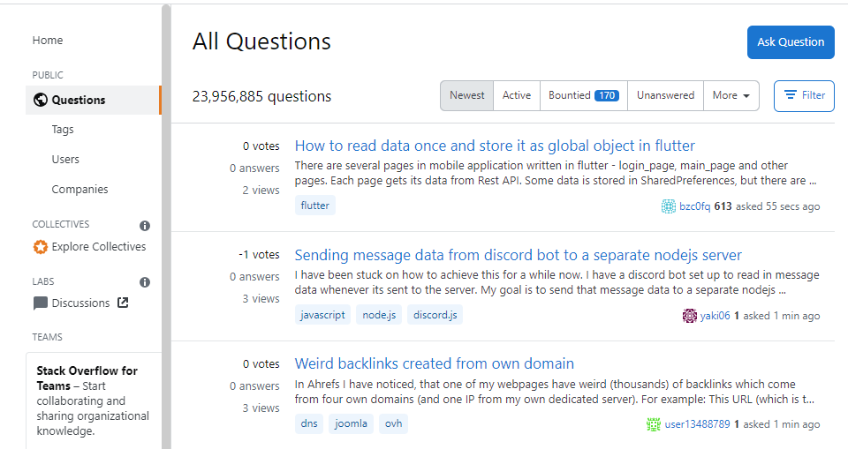

Figure : Q&A section

**Who is the target audience and how does the design take this into consideration?**

General people special who has technical knowledge and able to understand English language.

Yes, the design takes in consideration this type of audience, for example they understand the mean of tag and who to filter the search results and many other aspects can’t be understood easily by all people.

# Usability

**How long does it take for pages to load, and will the visitors get bored waiting? There are free tools online to test page load speeds.**

The website speed is very good as seen at pagespeed.web.dev website

See figure4 speed analysis.

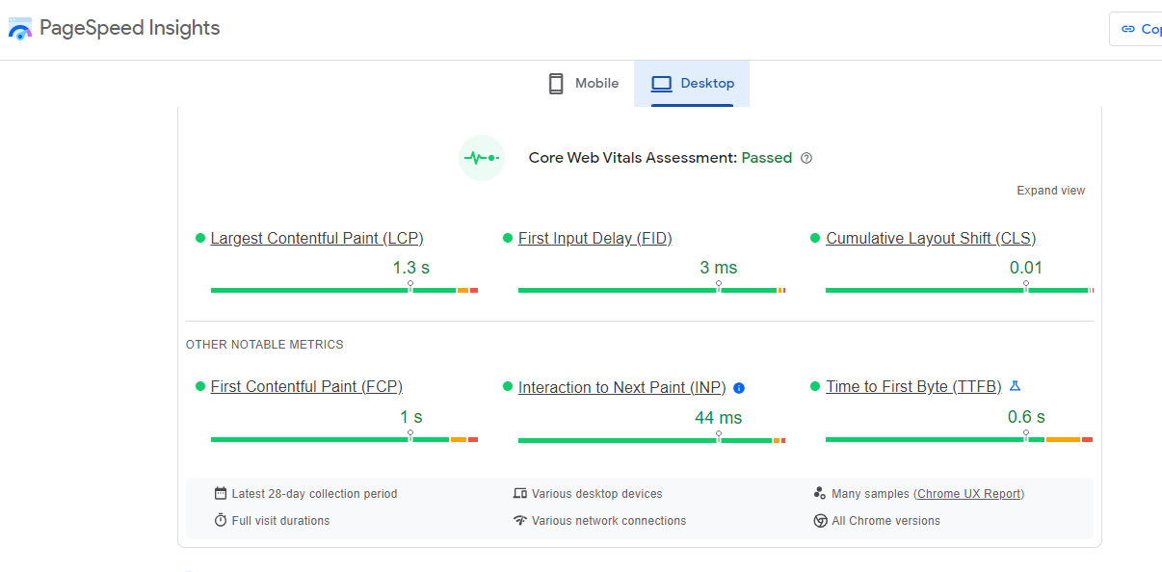

Figure : Speed analysis

**Can information be found easily?**

Yes, there are links for each section and each question categorized under many tags, show figure 2 & 3 above.

**Is there a search button available for visitors?**

Yes, see figure5   


Figure : Search button

**Are all the links working? There are tools available online to check a website's links.**

By using <https://www.drlinkcheck.com/account/subscriptions/1/projects/1/overview> to check some of the website link we found dome deadlink. See figure6

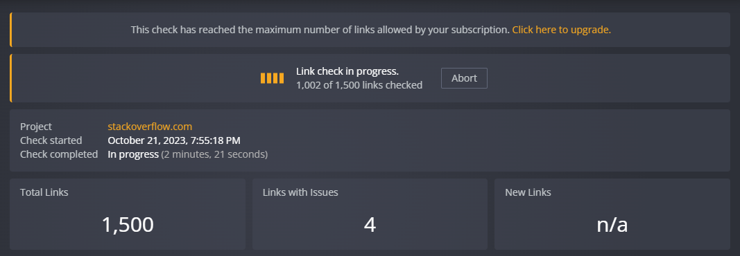

Figure : Dead Links

**Does the website work in different browsers? Check all the widely used browsers.**

Yes, it is. See figures 7-8-9 below on different browsers.

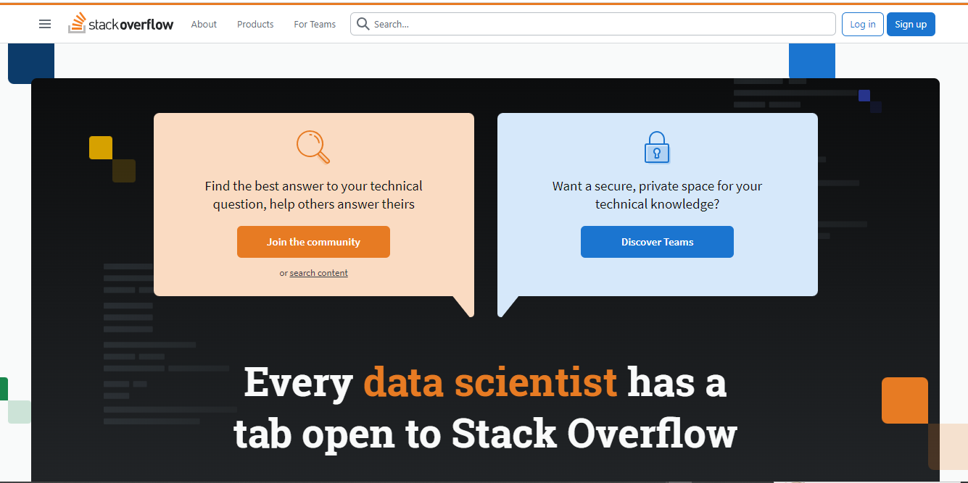

Figure : Website on Chrome browser

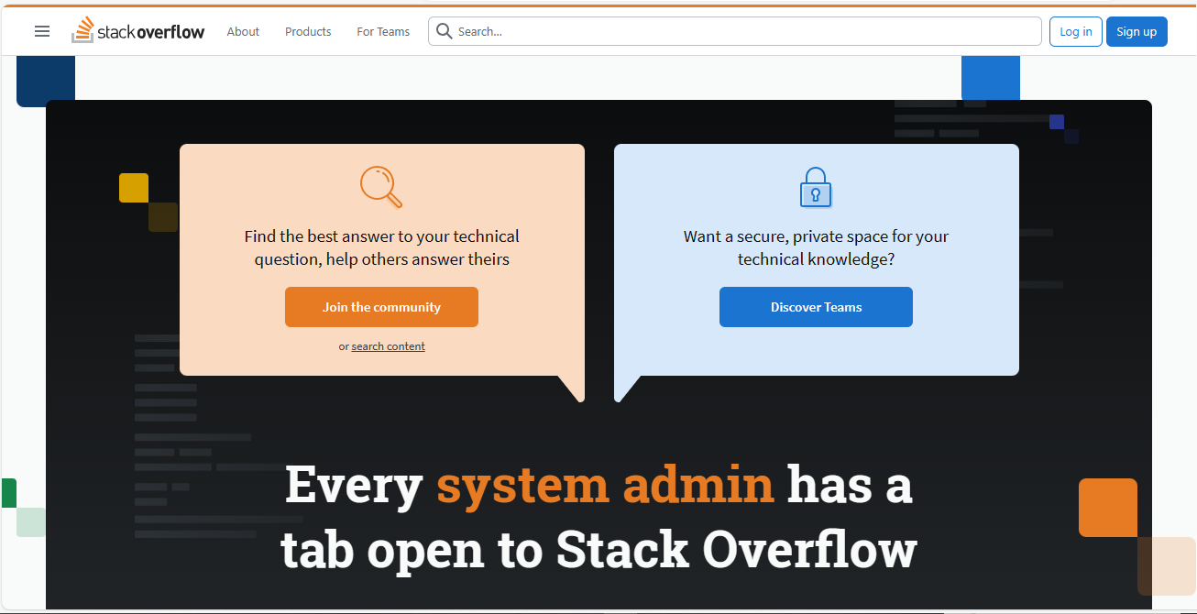

Figure : Website on Microsoft Edge browser

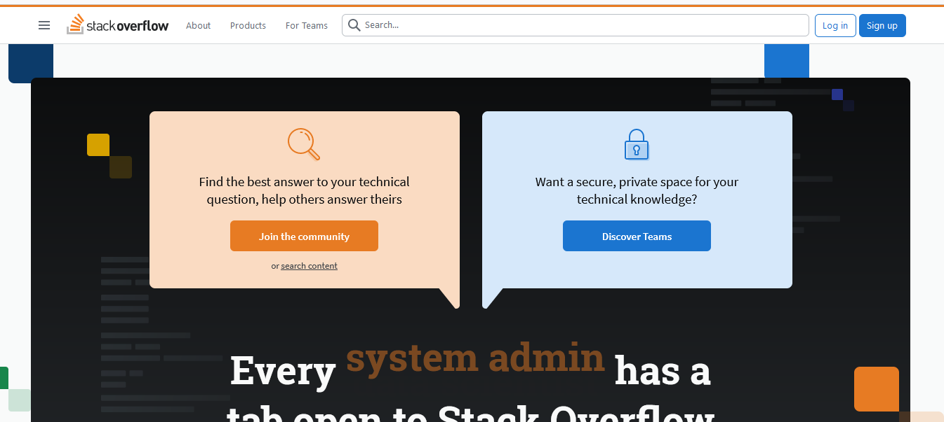

Figure : Website on Firefox browser

**Does the website work on mobile devices?**

Yes, as shown at figure10

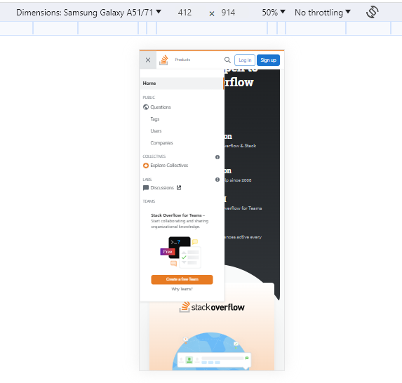

Figure : website on mobile

# Content and Readability (4 points)

**Are the fonts that have been chosen easy to read?**

As shown at all previous screenshots from the website pages the font is suitable and easy to read.

**Is there considerable contrast between the font color in the background color?**

As shown at all previous screenshots from the website pages the commonly color used for font and background is black and white and via versa.

**Is the text an appropriate size?**

As shown at all previous screenshot from the website pages the text size is appropriate where the title is bold and larger than sub titles and the contents, But I see that some font size is better to be larger than current specially the menu font. See figure11 below:



Figure : Menu

**Is the content concise yet still useful?**

Yes, it is. The content of the website is very useful for user who need or has technical knowledge.

# Write conclusion and at least three recommendations. (4 points)

As conclusion we made a study about stackoverflow website which is specialized in Q & A between people who has or need technical knowledge.

Recommendations:

Add multi language to the website.

Made mobile app for this website.

Use lager font in some pages and sections.