

**Search About**

**Amazon’s Website Design**

|  |  |  |
| --- | --- | --- |
| **N** | **Student Name** | **Student Number** |
| 1 | سليمان محمد السبيعي | 442051773 |
|  |  |  |



**Supervised by:**

**Year:**

Table of Contents

Introduction 3

Strategy 5

Usability 6

Content and Readability 8

Conclusion 10

Recommendations 10

References 10

# Introduction

Amazon is a one stop e-commerce website to browse, search, get product details, read reviews and purchase millions of products available from Amazon.com and other merchants.

## Define the purpose of the website.

Amazon website has focused heavily on providing products and goods with an Amazon-to-buyer sales approach. The site offers a massive range of products and inventory, allowing consumers to purchase just about anything, including apparel, beauty supplies, gourmet foods, jewelry, books, movies, electronics, pet supplies, and furniture. Children's toys, garden supplies and household goods.

I obtained the above information from entering the interfaces of the Amazon website.

## Explain its services.

.

* **Today's Deal from Amazon Today's Deal**

The deal of the day is considered one of the most important services provided by Amazon because it is highly discounted products and this service helps to reach low products easily, so it is called a deal. After entering the account, you can navigate between the different tabs to see the products and the percentage of discounts on them. For example, when you click on the Warehouse Deals tab, deals on used and new electronic products appear. Then tabs can be navigated between the computer, the Kindle, the flat screen TV, and so on.

The information was obtained from entering through the interfaces of the site

* **International shipping from Amazon Global**

Sending and receiving money from Amazon Payment A new payment service similar to PayPal, Google Wallet, Skill, etc. In terms of the possibility of data breaches, the percentage is zero "according to the site's statement". It enables the shopper to pay through any website (other than Amazon), but Amazon is accepted. The service does not require the creation of a separate account, it is the same as the regular account used to shop with Amazon, only when the product is added to the cart, the payment with Amazon is clicked. This feature can also be placed in the seller's store after following the instructions for the seller's Amazon Business account.

I got this information from the statements of the Amazon site management and experience through the interfaces.

* **Amazon Cloud Drive**

It is a cloud storage service that only works by logging into the account, then clicking on your account, then your cloud drive. It offers 5GB of free space for storing files and photos, and additional spaces can be purchased afterward. The app can also be downloaded and when you sign into the website or app, they are automatically linked, and whatever you upload to either is automatically stored on the other, in exactly the same ways as the One Drive and iCloud services.

This information was obtained through live experience.

* **Warehouse Deals**

It is an Amazon store that sells electronic devices such as mobile phones, flat-screen TVs, Kindle devices, computers and accessories, in like-new condition, at reduced prices of up to 60% of the original price. To go to that store, you can click on Warehouse Deals at the bottom of the site, then choose from the tabs to browse the products.

The information was extracted from the interfaces of the site.

* **Amazon Gift Cards**

It is a service that enables the friends or relatives of the user or the account holder to shop using gift cards, which are cards bearing numbers that are written when paying for the product and are similar to telephone recharge cards that are gifted by the account holder to his friends or relatives, who may not be able to shop from Amazon in a variety of ways such as email. Or by purchasing a plastic card that the account holder charges with a Visa or MasterCard card at the value he desires, such as the Amazon Card.

The information was extracted from the interfaces of the site.

* **Retail**

Amazon Marketplace. Amazon's e-commerce platform enables third-party retailers to showcase and sell their products alongside Amazon items.

The information was extracted from the interfaces of the site.

* **Amazon Prime.**

This subscription service provides members access to exclusive shopping and entertainment services, discounts and more. As an example, all Amazon Prime members enjoy free one-day or two-day shipping on qualifying orders.

The information was extracted from the interfaces of the site.

## what is the domain address ?

www.Amazon.com

Amazon is a one stop e-commerce website .

Previous information is clear from site design.

# Strategy

## What is the category of the business, and is this obvious on the website?

General e-commerce. In fact, there are many business categories on Amazon, sales, electronic marketing, web design and web applications.

## Is this obvious on the website?

Yes, The categories of products and services offered by Amazon are clearly displayed on the website. Customers can browse through different categories such Furthermore, Amazon's homepage often highlights different categories and promotions to help customers find what they are looking for. Overall, Amazon's website is designed to make it easy for customers to find and purchase products and services.

Previous information was devoted by tracing in the interfaces of the site (amazon, n.d.).

## **Is the design accomplishing the purpose of the website ?**

Yes, Amazon Designed to inspire, Amazon’s site builds a shock and awe value the minute you enter the webpage.A collection of tantalizing product photos fill the homepage, building shopper’s impulse as you scroll through each one. The bright colors, hot deals, and product variety create a multitude of horizontal sliders. Each one gives you the chance to view a number of products within each category. The extensive choices create a sense of “must-haves” and “I want to buy that” simply through its diversity and flashy imagery.

Amazon’s Website Design Wows With Its Efficiency, Simplicity & Organization Focusing on bringing its customers a dynamic and simplistic shopping experience, Amazon focuses on combining strong organization with an easy-to-use system set-up to pack a punch. A collection of great product photographs and bold fonts enhance this to create a user experience that’s highly sought after. Simplicity and a clean, modern interface have a huge impact on the shopping experience and work together to create a user experience that is engaging, intuitive and fun. Once you enter Amazon, it is very difficult to leave.

I got the previous information by researching how to achieve the goal of website design, and I found that they are all available on Amazon (indeed, n.d.).

## Who is the target audience and how does the design take this into consideration?

Amazon's target audience is quite broad and includes anyone who is interested in purchasing products or services online. However, the company has focused on catering to specific segments of the market, such as tech-savvy customers, bargain hunters, and people who are interested in convenience and fast delivery.

## How does the design take this into consideration?

Amazon's website design takes this into consideration by providing a user-friendly interface that is easy to navigate and search. The website is designed to be accessible to people of all ages and backgrounds, with a simple and intuitive layout that makes it easy for customers to find what they are looking for. For tech-savvy customers, Amazon offers a range of high-tech products such as smartphones, laptops, and smart home devices. The website design is optimized for mobile devices, which is important for customers who prefer to shop on their smartphones or tablets. For bargain hunters, Amazon offers a range of deals and discounts that are prominently displayed on the website. The website also offers a variety of payment options, including credit cards, debit cards, and Amazon gift cards, which makes it easy for customers to purchase products and services. For customers who are interested in convenience and fast delivery, Amazon offers a range of delivery options, including free two-day shipping for Amazon Prime members. The website also offers features such as one-click ordering and automatic reordering, which make it easy for customers to purchase products with minimal effort.

Overall, Amazon's website design takes into consideration the needs and preferences of its target audience, providing a user-friendly interface that is tailored to meet the needs of different segments of the market.

I got the previous information by researching how to achieve the goal of website design, and I found that they are all available on Amazon (indeed, n.d.).

# Usability

## **How long does it take for pages to load, and will tile visitors page bored**

## **waiting?**

The time it takes to load pages, see the following figure .

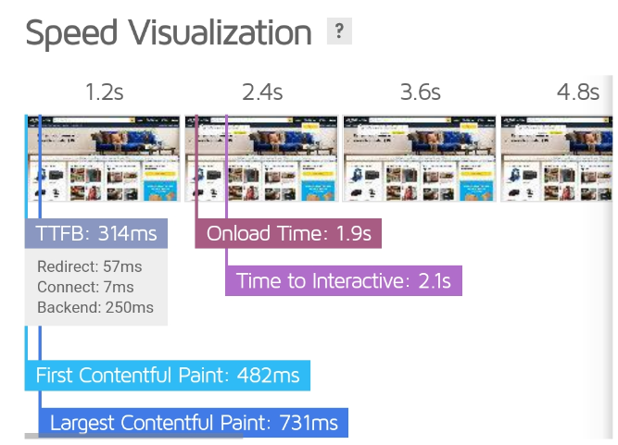

## will tile visitors page bored waiting?

In a recent Harris Poll of frequent online shoppers (in this case, those shopping online at least once per month), over three-quarters said that if a retail e-commerce site performed poorly they would tend to avoid shopping there. More than one in five said they would abandon a web page if it took longer than five seconds to load. So I don't think visitors will feel bored because the time it takes to load pages is less than five seconds.

## Can information be found easily?

Yes, when entering the Amazon website, at the bottom of the page, there is a link in the name of customer service. Through it, you will go to the Help category.

There is a lot of information that you want to get.

## Is there a search button available for visitors?

Yes, there is a search button inside the search box with a search icon that allows you to search matching Amazon products within the tool. This allows viewers to search for Amazon products without leaving your page.

## Are all the links working?

No, the following figure shows links that do not work on the Amazon website (deadlinkchecker, n.d.).

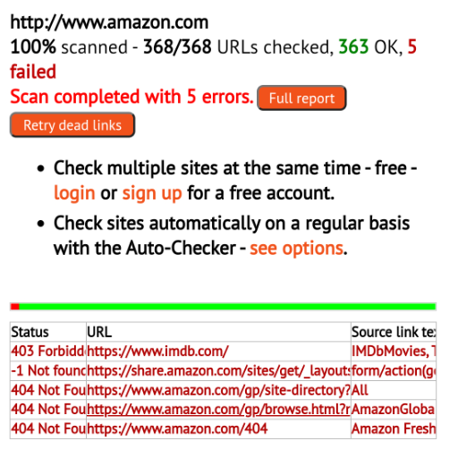

## Does the website work in different browsers?

Yes, the following list shows the browsers that support the Amazon website

* **Supported desktop browsers**

1. Google Chrome
2. Mozilla Firefox
3. Apple Safari
4. Microsoft Edge

* **Supported mobile device browsers**

1. Chrome Mobile
2. Safari Mobile

* **Supported desktop operating systems**

1. Microsoft Windows
2. Apple macOS

## Does the website work on mobile devices?

Yes, I used my phone to log in to the Amazon site and found that the design is correct on my phone... Amazon uses dynamic rendering. Bootstrap uses viewport rendering to change layout via CSS, otherwise known as responsive web design.

# Content and Readability

## Are the fonts that have been chosen easy to read?

Yes, Amazon has chosen fonts that are easy to read, which is important for a good user experience. The fonts used on Amazon's website are generally sans-serif, which makes them more readable on digital screens. The font sizes are also large enough to be easily readable, and the contrast between the text and the background is strong enough to make the text stand out. Additionally, Amazon uses a consistent font and color scheme throughout the website, which helps users navigate and find the information they need more easily. Overall, Amazon's website design is focused on providing a clear and easy-to-use interface for its users.

I got this information after summarizing and searching for the best lines suitable for reading (superhuman, n.d.).

## Is there considerable contrast between the font color in the background

## color?

Yes, Amazon has chosen a font color that provides considerable contrast with the background color, which is important for readability and accessibility. The background color of the Amazon website is predominantly white, and the font color is mostly black. This high contrast between the two colors makes the text stand out and easy to read, particularly for users with visual impairments or who may have difficulty distinguishing between similar colors. Additionally, Amazon uses color sparingly for emphasis, such as blue for hyperlinks and orange for call-to-action buttons, which also provides a clear contrast with the white background. Overall, Amazon's website design is focused on providing a clean and clear visual experience that prioritizes readability and accessibility.

I got this information from The definite guide into signage design and color usage (design, n.d.).

## Is the text an appropriate size?

Yes, Amazon has chosen an appropriate font size for its website, which is important for readability and accessibility. The font size used on the Amazon website is generally large enough to be easily readable, even on smaller screens or for users with visual impairments. The size of the font is also consistent throughout the website, which helps to create a cohesive and easy-to-use interface. Additionally, Amazon uses headings and subheadings in a hierarchical structure, which makes it easier for users to scan and find the information they need. Overall, Amazon's website design is focused on providing a clear and easy-to-use interface for its users, and the appropriate font size is an important part of achieving that goal.

I got this information from Font size guidelines for responsive websites (shaping-design, n.d.).

## Is the content concise yet still useful?

Yes, Amazon's website content is generally concise yet still useful, which is important for keeping users engaged and interested. Amazon's website is designed to be user-focused, with a clear and straightforward layout that prioritizes the most important and relevant information. The descriptions of products and services are generally concise and to-the-point, while still providing enough detail to help users make informed decisions. Additionally, Amazon provides a lot of useful information in a relatively small amount of space, through features like customer reviews and product comparisons. This helps users quickly understand the advantages and disadvantages of different products, without having to read through long and detailed descriptions. Overall, Amazon's website content is designed to be clear, concise, and useful, which is an important part of providing a good user experience.

I got this information from Purdue Online Writing Lab College of Liberal Arts (blog, n.d.) .

# Conclusion

web design is a key factor for getting positive outcomes as it influences on users and online consumers’ perceptions and behaviours. A website design addressed to simplicity and freedom of navigation provides clear, timely and accurate information in all its contents and an appearance that calls for the users’ attention.

# Recommendations

1. Identify the experience of shoppers when they try to narrow it down to their specific intent with multiple filters.
2. Cut down the time taken by shoppers by making it easy to search the item they are looking for and strip out the items they are not interested in.
3. Understand and evaluate the functionality of Sort & Filters on Amazon’s website.

# References

*amazon*. (n.d.). Retrieved from amazon: https://www.amazon.com/

*blog*. (n.d.). Retrieved from highfivedesign: https://www.highfivedesign.co/blog/writing-concise-website-copy

*businessinsider*. (n.d.). Retrieved from prime-members-dont-price-compare-survey-says: https://www.businessinsider.com/amazon-prime-members-dont-price-compare-survey-says-2018-7

*deadlinkchecker*. (n.d.). Retrieved from dead-link: https://www.deadlinkchecker.com/website-dead-link-checker.asp

*design*. (n.d.). Retrieved from designworkplan: https://www.designworkplan.com/read/signage-and-color-contrast

*gtmetrix*. (n.d.). Retrieved from reports: https://gtmetrix.com/reports/www.amazon.com/svQdxlkQ/

*indeed*. (n.d.). Retrieved from web-designing: https://www.indeed.com/career-advice/finding-a-job/what-is-web-designing

*shaping-design*. (n.d.). Retrieved from editorx: https://www.editorx.com/shaping-design/article/font-size

*superhuman*. (n.d.). Retrieved from blog: https://blog.superhuman.com/easiest-fonts-to-read/