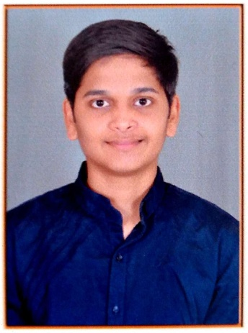**CURRICULUM VITAE**

**Savan Patel**

F402, Silver Gardenia, Nr. Vodafone Tower,

SG Highway, Gota, Ahmedabad-382481

Mobile No.: +91 81550 89510  
Email: patelsavan6595@gmail.com

**Key Skills:**

**Conscientiousness, Exactitude, Communicative, Dedication to work**.

**Personal Strength :**

**I’m.Student of B.E. Computer Engineering in 2nd Sem. In technologies i know C language. I have in-depth knowledge of HTML5, CSS3, JavaScript including advance level. I aim to make a difference through my creative solution and to still learn many more technologies and frameworks.**

**Workshops :**

I have attended Global Azure Bootcamp 2019 in which I have learnt the concepts of a Web App, A Chat Bot, SQL Database, Azure Features and Tips and other Microsoft tools and products.

I have also done my training on Cyber Security in which I have learnt about concepts related to Open Source, Foot Printing, Information Gathering, Cyber Laws, Cyber Crime Investigation, End User Security and much more about the tools as well.

**Experience**

I am working as a Junior Developer and as a Web Designer at Silverwing Technologies Private Limited . Since past 4 months I have been working on designing concepts and now I believe that I am capable to design any website using HTML, CSS, Bootstrap, JavaScript and etc.

### Academic Qualifications

**Bachelor of Engineering in Computer Engineering(pursuing)** (2018)

Silveroak College of Engineering and Technology, Ahmedabad,

Gujarat Technological University,

**HSC –** Science Stream (March 2018) 59.98%

S.S. Divine School, Ahmedabad (Guj.)

Gujarat Secondary Education Board,

**SSC –** Science Stream (March 2016) 90.44%

S.S. Divine school, Ahmedabad (Guj.)

Gujarat Secondary Education Board,

**Personal Profile:**  
Date of Birth: 27th May 2000   
Nationality: Indian  
Marital Status: Unmarried  
Language Proficiency: English, Hindi and Gujarati

**Declaration:**

I hereby declare that the above particulars are true to the best of my knowledge.

Place:

Date:

Signature:

**Savan Patel**