**Big Mountain Resort Report**

**Problem Statement:**

The purpose of this project was to determine how Big Mountain Resort can choose a better value ticket price by the end of the year without undermining the ticket price. They are also increasing operational costs by $1,540,000 by adding a chair lift this season so they must find opportunities to support and maximize ticket prices.

For some background, Big Mountain Resort is a very popular ski resort located in Montana with up to 350,000 visitors who ski on slopes suitable for all skill levels. Currently, Big Mountain charges a premium that is above the average of other resorts, but they are willing to reconsider pricing and consider changes to reduce costs.

**Modelling and Findings:**

While exploring the data, we had to find out how Big Mountain Resort compares against other resorts around the country. Then we can create criteria to maximize profit for the additional $1.5 million expense. We found that Big Mountain Resort was above average in nearly every criteria including vertical drop, area covered by snow makers, total number of chairs, fast quads, runs, longest run length, and skiable terrain area.

Two models were used - linear regression and random forests. By using linear regression, we could predict the price of tickets on the weekend for Big Mountain Resort. We also performed random forest modelling and this model gave us a lower cross-validation mean absolute error.

Big Mountain currently charges $81 per weekend ticket but the model suggests a price of $95.87 which is about 15.5% higher than the current price. The mean absolute error of $10.39 supports there’s room for an increase in price. We are assuming that other resorts have accurate pricing models according to the market, though it's likely that some resorts might be overcharging and others are undercharging.

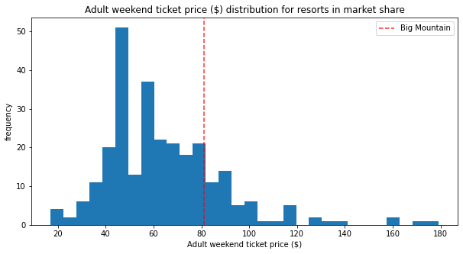

There are four scenarios that were tested to determine what the best option or combination of options would increase the ticket price while also looking at revenue. Closing down at least 3-5 runs and lowering the ticket price by $0.6 and revenue by $1.25 million is the first best-case scenario. The second scenario adds a run, increases the vertical drop by 150 feet, and installs an additional chair lift which can support an increased ticket price by $1.99 and revenue of $3,474,638. The third scenario is the same as the second but adds 2 acres of snow making which makes no difference in ticket price or revenue. The fourth scenario increases the longest run by .2 miles and adds 4 acres of snow making which also has no difference in ticket price or revenue.

**Recommendations:**

The business leadership should take into account all of the different scenarios and the costs associated. Scenario 2, 3, and 4 create no additional revenue but calls for increasing run lengths or installing chair lifts or adding acres of snow making. These additions should support cutting costs without undermining the ticket price. They should give high priority to closing down 1 to 5 of the least used runs which only causes a small decrease in the ticket price and cuts costs. It would be useful for Big Mountain to test run closures by seeing if there’s a decrease in visitors due to run closures or an increase in visitors due to lowered ticket prices.