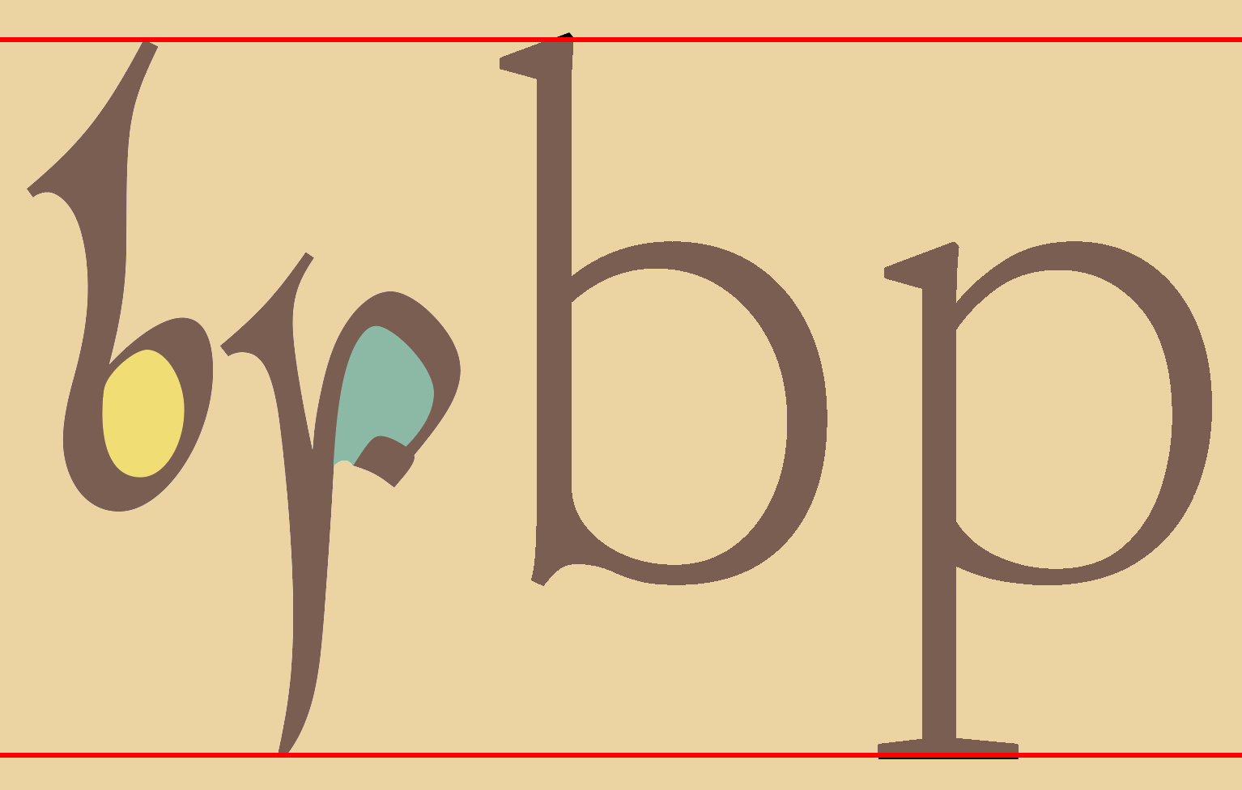
Cerne
A Ninth-Century Script Font
The Book of Cerne (Cambridge University Library, MS Ll. 1. 10), a ninth-century prayerbook, is one of the most notable books produced in England before the Norman Conquest. No small part of this book’s artistic triumph is its script, a fine example of the hand that paleographers call “Pointed Insular Minuscule.”
The principal scribe of the Book of Cerne was especially fond of color, filling or shadowing most capitals (which are modest in size and often lowercase in shape), and also, quite frequently, punctuation marks, accents, and lowercase letters. It thus is appropriate that the Cerne font should be a color font, with colors based on those of the book itself, from the rich brown of its ink to the muted red, blue, green and yellow washes used for fill and shadow. OpenType features can be used to add, omit or vary colors: these are listed beginning on the next page, after a brief demonstration of the font’s “historical mode,” which approximates the look of the original script.
When Cerne and a roman font like Elstob are set at the same point size, so that the vertical distance from the top of a high character like b to the bottom of a low character like p is almost exactly the same, Elstob looks much bigger. This is because the x-height (the distance from the baseline on which most letters sit to the top of the letter x) of the roman font takes up much more of that vertical space than that of Cern, which to compensate must be set about 1.75 times bigger than Elstob or Times and about 1.66 times bigger than Junicode/JuniusX if it is to harmonize with those fonts. Cerne should ordinarily be set “solid”—that is, with the line spacing equal to the point size—or even a little smaller. For example, a line spacing of 18pt would not be inappropriate for a block of text set in 21pt Cerne. To match Cerne’s color for text set in another font (e.g. this paragraph), use RGB values of 105, 76, 66 (#694c42) or HSB values of 15°, 36%, 41%.
From Bede’s Historia Ecclesiastica Gentis Anglorum:
Brittania Oceani insula, cui quondā Albion nomen fuit, inter septentrionem & occidentem locata est, Germaniae, Galliae, Hispaniae, maximis Europae partibus, multo interuallo aduersa. Quae ꝑ miliapassuum .dccc. in Boreā longa, latitudinis habet milia .cc, exceptis dumtaxat prolixioribus diuersorum ꝓmontoriorum tractibus, quibus efficitur, ut circuitus eius quadragies octies .lxxv. milia ꝯpleat. Habet a meridie Galliam Belgicam, cuius proximū litus transmeantibus aperit ciuitas, quae dicitur Rutubi portus, a gente Anglorū nunc corrupte Reptacaestir uocata, interposito mari a Gessoriaco Morynorum gentis litore proximo, traiectu miliū .l., siue, ut quidā scripsere, stadiorum .cccl. A tergo autem, unde Oceano infinito patet, Orcadas insulas habet.

OpenType Features

A. Required features.
The following features should always be on. In most programs they will be on by default, but in Microsoft Word they must be explicitly enabled: kern (which in Word must be enabled for the others to work), ccmp (Glyph Composition/Decomposition), calt (Contextual Alternates), liga (Standard Ligatures).

B. Historical mode
Use hist (Historical Forms) or ss16 (Stylistic Set 16) to turn on Historical Mode, which substitutes old letter-shapes for modern ones (and also punctus interrogativus for the question mark). These features are used for the same purpose in the designer’s Eadui and Cissanthemos fonts.

C. Color of capital letters
The default color scheme will produce a variety of colors in any stretch of text. Use ss02 (Stylistic Set 2) for a different color scheme, or to vary colors within a single stretch of text (for example, if the letter B occurs twice in the same sentence and you want a different color for each occurrence).
To turn off color (except the text color) for all capitals, use ss03 (Stylistic Set 3).
West Seaxe West Seaxe West Seaxe

D. Color of punctuation and accents
Use cv48 (Character Variant 48) to turn on a red wash for accents. This feature also works with precomposed letter + accent combinations like á and ē. Use cv79 for punctuation. In this sequence, both features have been applied:
dm̄ omnip̄ . Qui in ⹎

E. Color of lowercase letters
By default, color is not applied to lowercase letters. Rather than a single feature to turn on color, one feature is suppied for every letter of the alphabet, and also several symbols, as follows:
cv01 | a | cv12 | h | cv22 | p | cv30 | x
cv03 | b | cv13 | i | cv23 | q | cv31 | y
cv04 | c | cv14 | j | cv24 | r | cv32 | z
cv05 | d | cv15 | k | cv25 | s | cv35 | æ
cv07 | e | cv16 | l | cv26 | t | cv40 | & ⁊
cv08 | ę | cv18 | m | cv27 | u | cv42 | ꝫ ꝯ
cv09 | f | cv19 | n | cv28 | v | cv51 | ? ?
cv10 | g | cv21 | o | cv29 | w

These match the mapping of letters to features in the designer’s JuniusX font; but in Cerne, cvXX features only add color: they do not produce alternate letterforms. As some letters have many variants, including ligatures (only a single element of which is usually colored), these cvXX features may not affect every instance of the letters they apply to.
It will rarely work well to apply these features to entire texts: apply them to individual words instead. If you need to apply the feature to only part of a word (for example, because there are two instances of a letter and you only want one highlighted), try to make sure the boundaries of the sequence you apply it to don’t fall between characters that are ligatured or kerned (the default spacing altered)—such boundaries will separate ligatured elements and disrupt letter-spacing. For example, if you want to highlight the initial but not the last y in
yoyo
you should not apply the feature cv31 to only the initial y, since that is kerned with the following o (as you’ll see if you try it), but rather to the initial yo sequence, since o is not kerned with the following y. The difference in the case of “yoyo” would be subtle, but consider this word:
taught
Here the feature cv26 has been applied to the sequence ta, which has a special form of t that forms a ligature with the following a. If you applied the feature only to the initial t, the boundary of that one-letter sequence would fall between the t and the a, breaking the ligature:
taught
This is not a consideration in MS Word, which provides no access to these lowercase variants. In Adobe InDesign, you choose variants from a palette instead of by applying a feature, so you needn’t worry about feature boundaries in that program either.

F. Other features
ss04 “Word-final forms” produces word-final variants of a, e, insular r, and t. This is a context-sensitive feature: it will work only at the ends of words, and so it is safe to apply it to whole words so as to avoid interfering with other formatting. ss05 produces variants of several characters: A, Q, T, h ( > insular abbrev. for autem), i, ı, u, ꝑ ( > insular shape). Use it to introduce variety into your text. dlig (Discretionary Ligatures) produces several ligatures used irregularly in the Book of Cerne:
e + i > ei e + o > eo s + s > ss
Use these in Historical Mode to vary the look of the text.

The Cerne Font
Copyright © 2021 by Peter S. Baker
The font is distributed under the Open Font License and is free to use
for any purpose, either in print or online.
Download it here: https://github.com/psb1558/Cerne-font
This document was created with LibreOffice. The text font is Elstob, the variable font for medievalists.

