Ygt: A graphical hinting program
(a quick introduction)

Ygt is a program for hinting TrueType fonts. Its interface is similar to those of VTT and Glyphs, but it has somewhat different aims:
- Being written in Python, with PyQt6 and fontTools, it runs on all major platforms.
- It is independent of any font editing program.
- It can operate on either TrueType fonts or UFOs with quadratic outlines.
- It can output a hinted font, embed its output in a UFO, or produce a script that can be run from makefiles and other build scripts (it is perfect, for example, for use with fontmake).
- In addition to the kinds of hints that other programs generate, it provides an interface for user-written functions and macros, which can greatly simplify the handling of repeated features of fonts, like serifs and deltas.
- It works only with hints and does not touch any other features of a font (for example, it doesn’t reposition components the way VTT does).

Getting started
To get started on a project, launch Ygt (by typing “ygt” on the command line) and open either a TrueType (.ttf) font or a Unified Font Object (UFO—a directory with the extension .ufo).
If you open a TrueType font, Ygt will save your work in an external file with the same name as the font file but the extension .yaml. This file is in the YAML data serialization language: when you return to your project, open the YAML file instead of the font.
If you open a UFO, Ygt will save your work in the UFO’s data directory, where the file org.ygthinter/source is in precisely the same format as the YAML file. You can switch back and forth between the two modes—saving as a YAML file and saving in a UFO—with File→ Save As.
When you first open a font, any hinting already in the font is ignored. Later on it will be discarded in favor of the hints you’ve added with Ygt.
After you’ve opened a font, the screen looks like this:
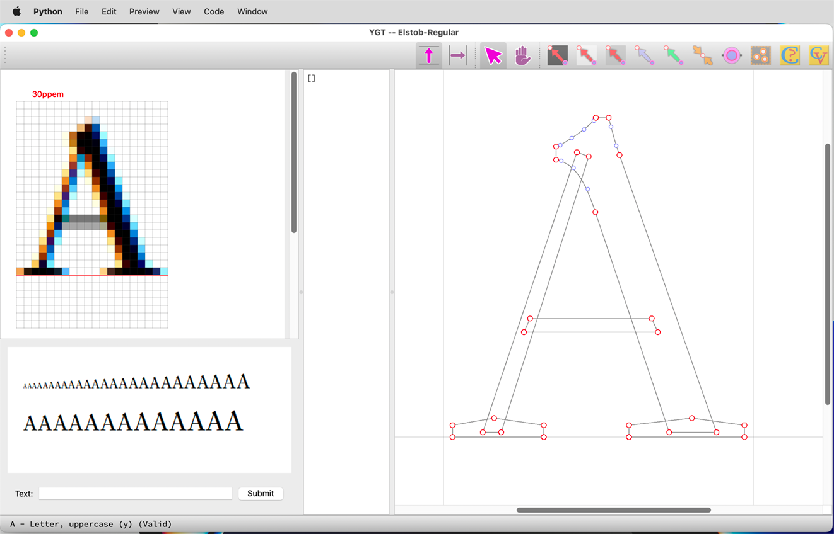
On the left is the preview panel. If it took a long time for the preview to appear (as it will on some older computers), select Preview→Auto Update to disable automatic updating of the preview, and after that select Preview→Update Preview or type Ctrl-U (Cmd-U for the Mac) whenever you want to refresh the preview.
In the middle is the code panel, which displays the source code for either the y or the x axis of the current glyph. This source code is in YAML, a very simple data serialization language. Ygt uses YAML instead of a programming language because it is meant to be descriptive, not imperative: it describes the positions of the points that make up a glyph outline rather than dictating the commands that will position them. The Ygt hinting language will be described in detail below. You can edit the code in this panel: when you have done so, type Ctrl-R to compile it and display the results in the editing panel to the right.
The editing panel displays an outline of the current glyph with the points that define it. On-curve points are displayed as red circles and off-curve points as smaller blue circles. As hints are mostly applied to on-curve points, you may wish to hide the off-curve points. To do this, right-click (or, on a Mac, control-click) anywhere in the panel and select “Hide off-curve points” from the context menu. On the same context menu you can decide whether or not to display point numbers.
Above the editing panel is a toolbar with various tools for editing the glyph’s hints. They are initially disabled, but are enabled whenever you select an appropriate set of points.

Basic hinting
To add a hint, select one or more points (click on them or drag the mouse over them) and either click on a button in the toolbar or type a shortcut key. (The shortcut keys are displayed in the tooltips that appear when you move the mouse over the tool buttons.)
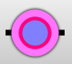
For example, to anchor a point to a position on the grid (which you should do first whenever beginning a sequence of hints), select a point and either click the “Anchor” button (at right) or type “A.” The anchored point will be highlighted in pink:
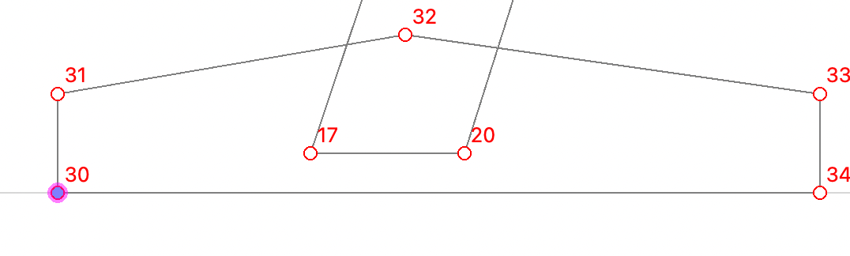
Now you should assign a control value (CV) to this hint. A CV is a number that specifies the position of a point or a distance between two points. Use CVs to regulate features (like serifs and the tops of ascenders) that recur in a number of glyphs. CVs are named rather than numbered in Ygt, making them easy to use. When you first open a font, Ygt creates a little collection of position-type CVs: check over these and add more as you need them.

To use a CV, right-click on a hint, select “Set control value” from the context menu, and choose a CV from the sub-menu. The CVs on this menu are a subset of the whole collection—in this case, the ones most appropriate for a capital letter. They are also alphabetized (a fact you should remember when you name your own CVs). If you’re not sure which CV is best, or if it’s easier, choose “Guess” from the menu. Alternatively, select the hint (for anchors, you’ve got to click to select the hint and drag to select the point that is the hint’s target) and click the “Guess Control Value” button or type a question mark.
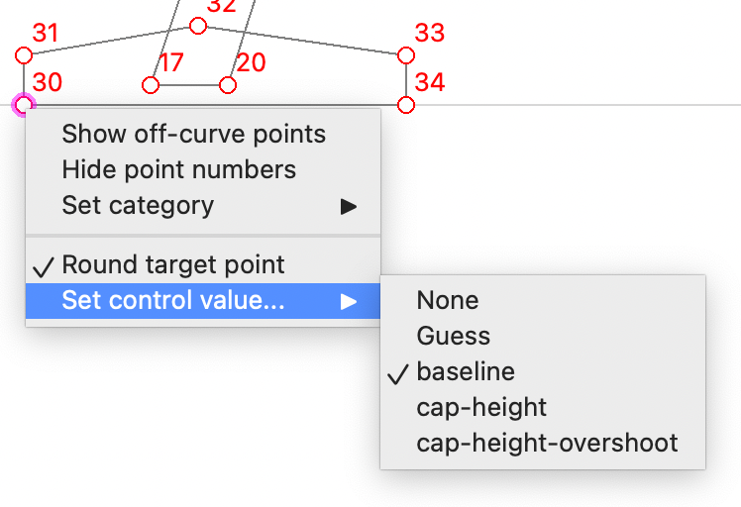
[Tip: You can combine the actions of adding a hint and guessing at a CV by holding down the Control (Command) key when you add an anchor, a blackspace, a whitespace, or a grayspace hint (these being the hint types that can make use of CVs). To round a target point or points (regardless of the default for the hint type), hold down the Shift key while adding the hint.]
As you add hints in the editor, the code panel is automatically updated:
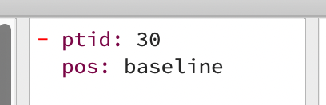
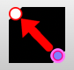
To add another hint dependent on the first, select the point you just hinted (remember the difference between selecting a point and selecting an anchor), then select another point and either click the tool with the red arrow on a black background or type “B”:
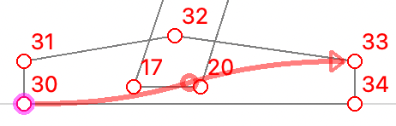

You have just added a “blackspace” hint—that is, one that crosses a space that will be filled (usually by black pixels or black ink). It is displayed as a red arrow running from a reference point (in this case, point 30, which you just anchored) to a target point (33). The button in the middle of the arrow’s stem is there to make it easier to click on. The effect of this hint is to move point 33 to a position on the y axis which is the same distance from point 30 as in the original outline, and then move it to the nearest grid line.

At this point, you can go in either of two directions. One is to assign a distance-type CV to the blackspace hint: this is most appropriate to the CRT screens of yesteryear and early flat screens. The more modern choice is to turn off rounding for the blackspace hint and leave it at that. The top of the serif may look fuzzy at some resolutions, but the overall impression will be of a weight consistent with the glyph’s original design. To turn off rounding for the hint, right click on it and uncheck “Round target point” on the context menu.
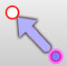
Since we’ve hinted only one serif, the pair of them will be mismatched at some resolutions. To make sure they always match, we’ll add some shift hints (using the tool with the blue arrow). A shift hint causes a target point to be moved by exactly as much as the reference point has been moved. Select points 30 and 25 and click the blue arrow or type “S.” Then do the same with 33 and 26:
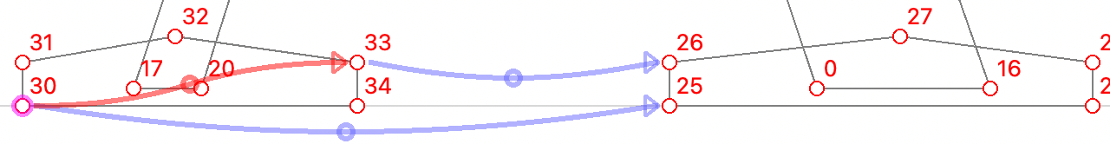
We also need to touch the bottoms of the two diagonal stems to keep them from being pushed above or below the serif. (Any hint that targets a point leaves that point “touched” so that it can’t be moved inadvertently.) The best way to do that is to add one point on the bottom of each stem to one of the nearby “shift” hints.
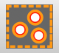
Here you need to know that the shift (blue arrow), align (green arrow) and interpolate (gold arrow) hints can target more than one point. All you need to do, once you’ve added the hint, is select as many points as you want the hint to target (including the point already touched by the hint) and either click the button for the “Make Set” tool or type “K.” The result looks like this:
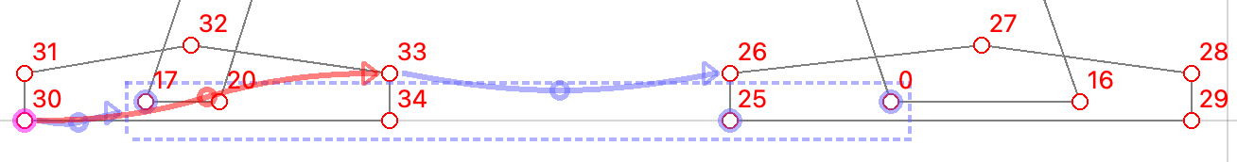
On screen, a set is a group of highlighted points enclosed in a box of dotted lines (points 20 and 34, which are inside the box but not highlighted, are not part of the set). It belongs to and is part of a hint, and the hint’s arrow now points at the box. Clicking on one of the highlighted points or on the box will select the whole hint. As with an anchor hint, you can select a highlighted point (but not the hint) by dragging over it.
The result of our efforts so far looks like this:
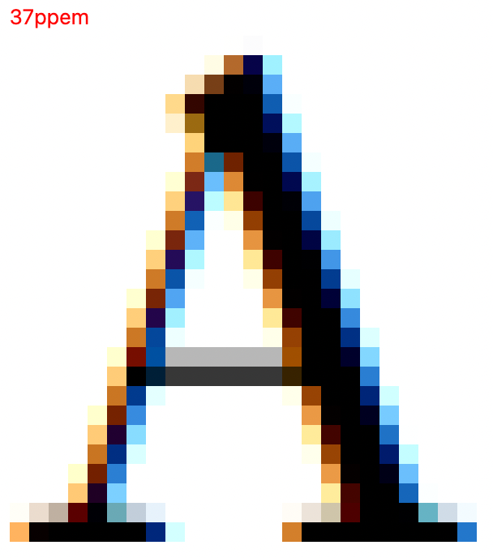
Now the serifs match, but we’ve got more to do. The top of the letter needs to be hinted to make sure it harmonizes with the tops of other capitals, and the cross bar has to be dealt with.
All we need to do at the top of the letter is anchor it with the CV “cap-height-overshoot” (set up by Ygt when we first opened the font) and link the anchored point to the top of the left-hand stem with another shift hint:
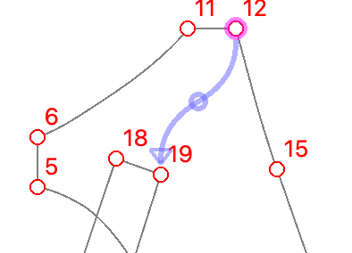
These hints ensure that point 12 always appears at the same y position on the grid, and point 19 is always positioned correctly relative to point 12.
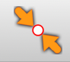
To make sure the bar is correctly positioned, we need an interpolate hint, which positions one or more points relative to two reference points so that their relationship is the same as in the original glyph. To do that, select two touched points and one that has not yet been touched by a hint, and click the “interpolate” tool or type I:
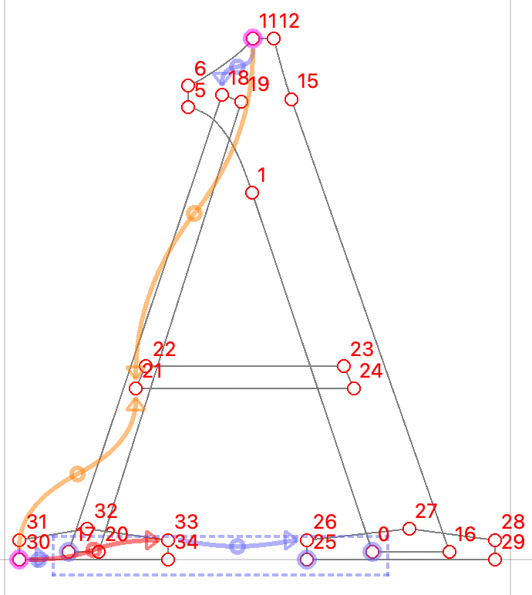
Rounding point 21 to the grid will make sure the bottom edge of the bar is sharp. To do that, right click on one of the “interpolate” hint’s buttons and choose “Round target point” from the context menu. (Alternatively, hold down the shift key when you create the hint to round the affected point or points to the grid.)
For the top edge of the bar, we face a decision like the one we made for the serifs: round to the grid while regulating the bar’s width with a CV or add an unrounded blackspace hint. Once again, the modern choice is the unrounded hint. Select points 21 and 22, type B, and uncheck “Round target point” on the context menu:
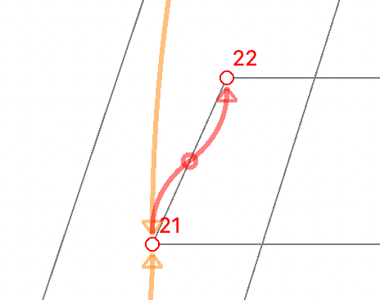
At low resolutions, both edges of the bar will now look sharp, because the blackspace hint maintains a minimum distance of one pixel between the reference and target points. At higher resolutions, the top of the bar will often seem fuzzy if you look closely. But this fuzziness tricks the eye into perceiving the edge of the bar as falling between two pixel edges:
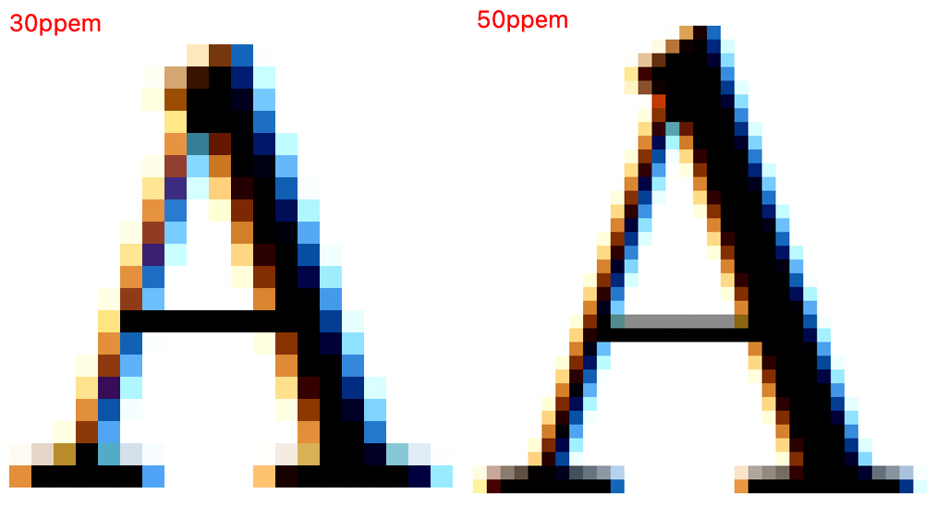
You can dramatize the effect by repeatedly typing the up or down arrow key to change the resolution of the preview while watching the bar and the serifs gradually thicken.
You should save frequently when working with Ygt, as it is new software and may contain bugs that cause it to crash. (If the program crashes, please copy the stack trace from the console and open an issue at the GitHub Ygt site.) To save to either an external .yaml file or a UFO, simply type Ctrl-S. When you return to the project, open either the .yaml file or the UFO—never the TrueType (.ttf) font. To export a hinted font, type Ctrl-E (for “Export font” on the File menu). This will either produce a hinted copy of the TrueType font (with “-hinted” added to the file name) or write the compiled instructions into the individual .glif files of the UFO. Alternatively, run the program Xgridfit (one of Ygt’s dependencies) on the .yaml file:
xgridfit Elstob-Regular.yaml
If you are running the program from a Makefile or other script, add the option -q or -qq to suppress most or all warnings and messages.

The YAML source
The source displayed between the preview and editing pane is editable. Once you have learned the simple hinting language used by Ygt, you may sometimes find that editing the source is the quickest and surest way to manage a glyph’s hints.
The source editor employs a couple of methods to help you write valid code. First, it validates continuously as you type, displaying the status of the code at the bottom of the Ygt window:
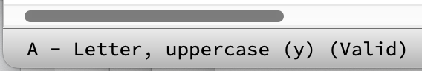
When the source is invalid, Ygt will also display an Error Console window with more detailed information about the error. When this window appears, leave it on screen so that you can consult it if necessary. Nearly all the program’s errors are displayed here.
Second, the code panel employs a simple scheme of color coding. When a hint block (we’ll explain the concept shortly) is nested inside another hint block (nesting signaled by a two-space indentation), it changes color. The hyphen that signals a list in YAML will be red when it is correctly positioned:
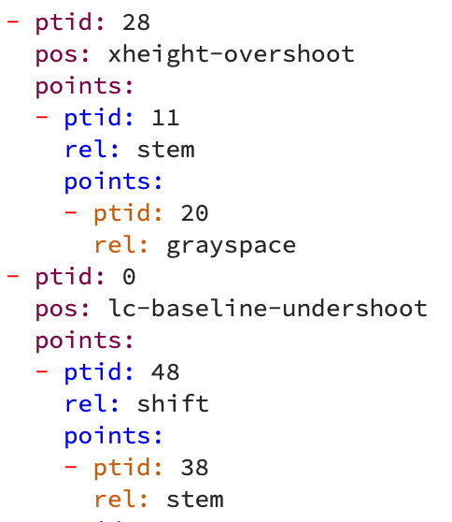
When a keyword in the block is wrong (in the example below, “ptic” for “ptid”), it turns black. When a hyphen is wrongly positioned, it turns a different color (and of course, the status bar will signal that the code is “Invalid”):
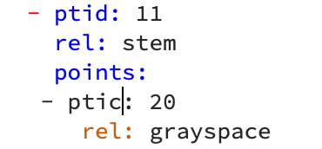
When you have made a change to the source code, type Ctrl-R (Cmd-R on the Mac) or select “Compile” from the “Code” menu. If the code is valid, your changes will be reflected immediately in the editing pane, and a second or so later in the preview pane.
Most of the time, though, the program will compose the YAML code as you work in the editing pane. Ygt will do its best to keep the code in order (for example, making sure that reference points are always touched points). If you suspect that the code is out of order (for example, you have added all the hints you need but the preview still doesn’t look right), try selecting “Clean up” from the “Code” menu. Chances are that will fix the problem; if not, you will have to edit the source yourself.
The YAML source consists of a list of hint blocks—that is, descriptions of how a point or set of points should be positioned on the grid. Each block can contain a list of one or more dependent blocks. For each dependent block, one reference point (in the graphical editor, the point at the starting end of a hint arrow) must be the same as one of the parent block’s target (“ptid” for “point identifier”) points. For example:
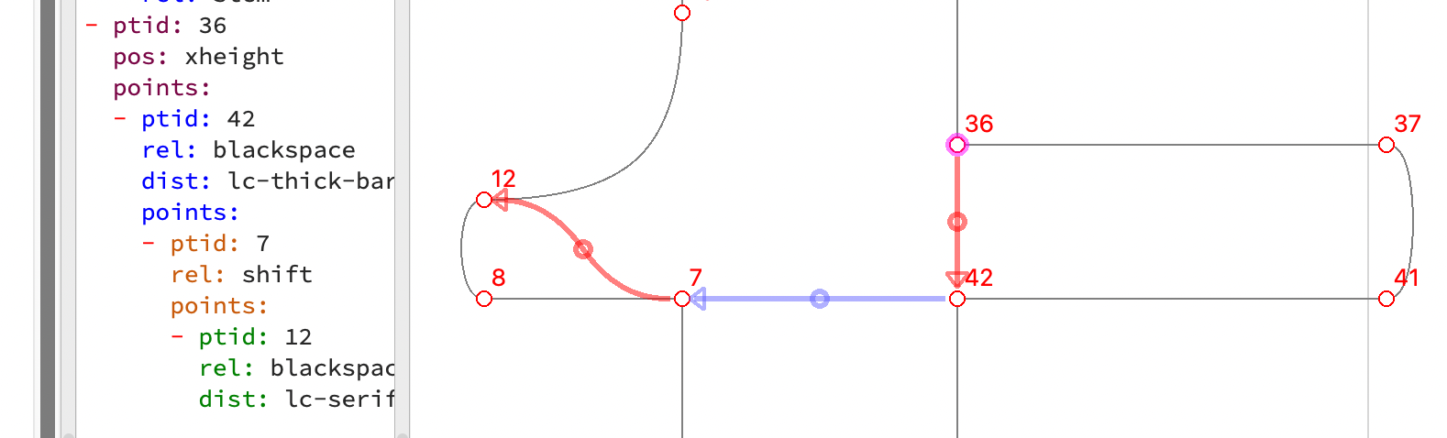
Here is a sequence of four points in the cross bar of the letter f. It begins with an anchored point (36), as sequences always must. Second, point 42 is distance “lc-thick-bar” from 36; third, point 7 is shifted along with 42; fourth, point 12 is distance “lc-serif” from point 7. The reference point (“ref”) for each of the arrow hints is implicit: it is understood to be the same as the parent target (“ptid”), at least when the parent target is unambiguous. When a hint targets more than one point, its child hint must have a “ref” property indicating which of the parent points is its reference.
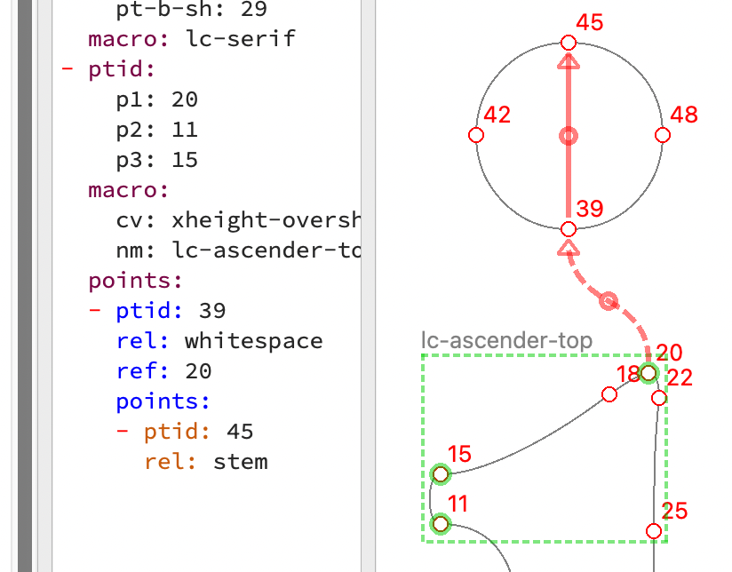
For example, here the macro “lc-ascender-top” (we’ll say more about macros and functions later) regulates three points (11, 15, 20), so the “whitespace” hint that positions the dot must have a “ref” property indicating that point 39 is to be positioned with reference to point 20 (not 11 or 15). But the hint for point 45 does not need a “ref,” since its reference point is implicitly the “ptid” (39) of its parent.
Here is a list of types of hint blocks (excluding functions and macros, which we will discuss later):

anchor
An anchor positions a point at a particular place on the grid. It can take the following properties:
ptid Required. The target point. It must be a single point.
pos Optional. Positions the target point at a place indicated by a CV. If this is absent, the point is either moved to the nearest grid line (if “round” is “true”), or simply touched without being moved (if “round” is “false”). If the original position of the point is too far from the position indicated by the CV, the point won’t be moved to that position, but rather touched or rounded to the grid (see next paragraph).
round Optional. The default is “true.” Whether the point should be moved to the nearest grid line after any other positioning. This may also be a type of rounding: “to-grid” (the default), “to-half-grid,” “to-double-grid,” “down-to-grid,” or “up-to-grid.” At present these must be entered in the YAML code: the GUI offers no way to enter values other than “true” and “false.”

blackspace, whitespace, grayspace
These hints (always represented by red arrows) regulate the distance between a reference point and the target point. With a “blackspace” hint, the distance crosses a space that will be filled with ink. With a “whitespace” hint, the distance crosses a space that will not be filled with ink. A “grayspace” hint crosses a space that is a mix of black and white; or use it when you don’t need or want to indicate what kind of space the hint is regulating.
ptid Required. The target point. It must be a single point.
dist Optional. The name of a distance-type CV. If it is present, the distance between the reference point and the target point will be regulated by the named CV. If absent, the original distance between the two points will be used. In the modern style of hinting, it is seldom necessary to use distance-type CVs.
ref Required when the parent hint has more than one target point. The point that the target point is positioned relative to.
round Optional. The default is “true.” Whether to round the distance between “ref” and “ptid.” If “ref” is on a grid line, then “ptid” will be positioned on a grid line too. You can enter rounding types in the source code, as with the anchor hint.

shift, align
“Shift” moves the target point along the current axis by as much as the reference point has been moved. “Align” aligns the target with the reference point, so that aligned points will end up in a horizontal line when the axis is “y” and in a vertical line when the axis is “x.” The “align” hint can be tempting, but “shift” is generally much more useful.
ptid Required. The target can be either a point or a list of points (a “set”).
ref Required when the parent hint has more than one target point. The point that the target point or set is positioned relative to.
round Optional. The default is “false.” Otherwise, rounding works here much as in the hint types mentioned so far.

interpolate
Positions one or more points relative to two other points in such a way that all points have the same relationship to each other as in the original outline. This hint is never the child of another hint.
ptid Required. The target can be either a point or a list of points (a “set”).
ref Required. A list of two points.
round Optional. The default is “false.” Whether the position of the target point(s) should be rounded to the grid after interpolation.

Functions and macros
Functions and macros are written in the Xgridfit hinting language (one or more other language options will be offered later) and embedded in the YAML source. In the TrueType instruction language, functions are somewhat like functions in other programming languages, but they are numbered rather than named, and they have no formal mechanism for passing parameters. Xgridfit supplies these wants. It also makes available a macro feature. Macros insert code instead of function calls in the program stream. Macros produce a program similar in size to one with equivalent functions, but macros can take advantage of conditional compilation, and can take sets and even bits of code as parameters.
Because functions and macros have to be written in Xgridfit (though you can use Xgridfit’s “command” element to insert raw TrueType instructions if you prefer), writing them involves a learning curve; but a function or macro, once written, may be used (possibly with minor changes) in a number of fonts.
Functions and macros are very much alike from a programmer’s point of view. They consist of a YAML list of parameters and the code itself. Here’s an example of a macro:
lc-ascender-top:
p1:
type: point
subtype: target
p2:
type: point
subtype: target
p3:
type: point
subtype: target
cv:
type: pos
val: lc-ascender
code: |
<code xmlns="http://xgridfit.sourceforge.net/Xgridfit2">
<move distance="cv">
<point num="p1"/>
<move>
<point num="p2"/>
<move distance="lc-serif">
<point num="p3"/>
</move>
</move>
</move>
</code>
The macro definition lives in a “macros” block in the source file: you can edit it by selecting “Edit macros” from the “Code” menu. The macro begins with its name, followed by a list of parameters and the code itself.
Each parameter declaration needs, at minimum, a name and a type. The name should be something that helps you remember what the parameter is for; the type can be point, pos, dist, int, or float. A point parameter can also have a subtype, target or ref. Those who are familiar with the TrueType instruction set will recognize that these types have no counterpart in the compiled code; but they enable functions and macros to behave like other hints in the YAML source.
A parameter declaration can also have the property val. This is the default value of the parameter—the value that is used when the parameter is omitted from the function or macro call.
The code itself must be enclosed in <code></code> tags, and the opening <code> tag must have the Xgridfit namespace declaration, as in the example.
A macro call looks like this:
- ptid:
p1: 10
p2: 12
p3: 14
macro:
nm: lc-ascender-top
cv: xheight-overshoot
If you find it more convenient, you can also use a JSON-like syntax:
{ptid: {p1: 10, p2: 12, p3: 14},
macro: {nm: lc-ascender-top, CV: xheight-overshoot}}
Ygt will convert this to its default YAML syntax.
Those of the macro’s parameters that refer to points are passed in the property “ptid,” others in the “macro” (or “function”) property. The latter property must also declare the macro’s name (“nm”).
It will usually be most convenient to insert the macro or function call via the graphical hint editor. To do this, select the points that will be affected by the macro or function, then right click to bring up a context menu and select the macro or function by name:
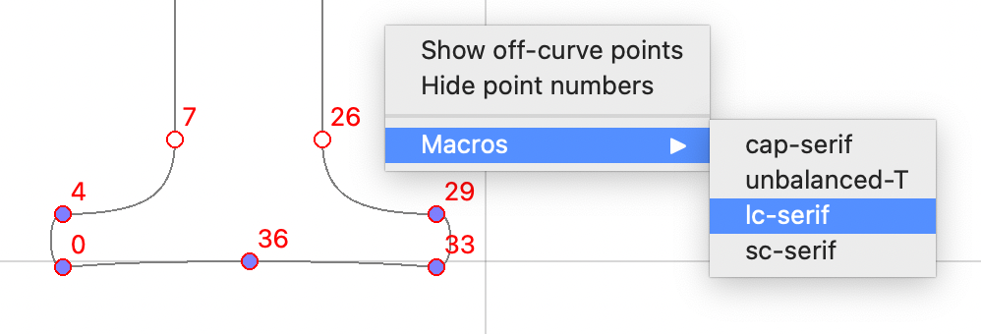
The menu presents only a selection of the macros and functions you have defined, depending on the number of points you selected.
Ygt has no way of knowing how to assign your selected points to parameters: they will be applied more or less at random. To sort them out, first select the macro by clicking on its border or one of its points. When the macro is selected, you will see which parameter is associated with which point. Right click on any point that is incorrectly assigned and assign it to the correct parameter by selecting from the “Point params” submenu:
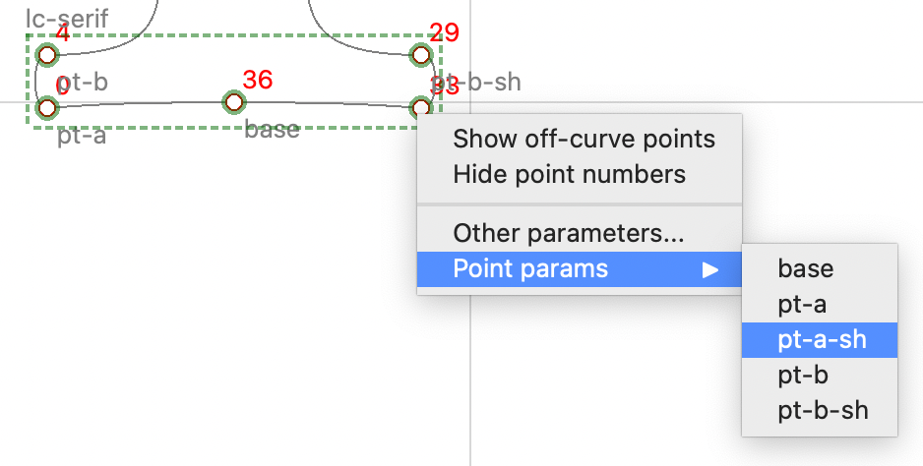
Repeat this operation until all points are correctly assigned. To set other (non-point) parameters, select “Other parameters” from the same menu and adjust them using a dialog box like this one:

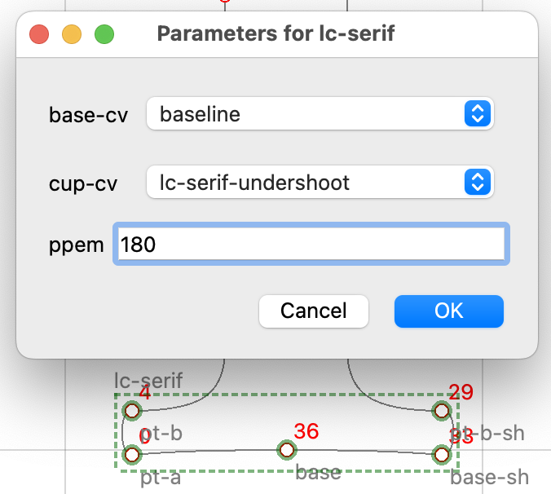
When you first open a font, Ygt inserts one user-callable function in the code: “delta,” which can be called like this:
- ptid:
pt: 26
function:
nm: delta
size: 26
distance: -5
The function takes a single point as a parameter, a size (in pixels per inch) at which the delta is effective, and a distance (from -8 to 8, in eighths of a point) to move the point on the current axis. A distance of zero disables the delta hint. Note also that deltas of this kind should not generally be used in variable fonts.

Point identifiers
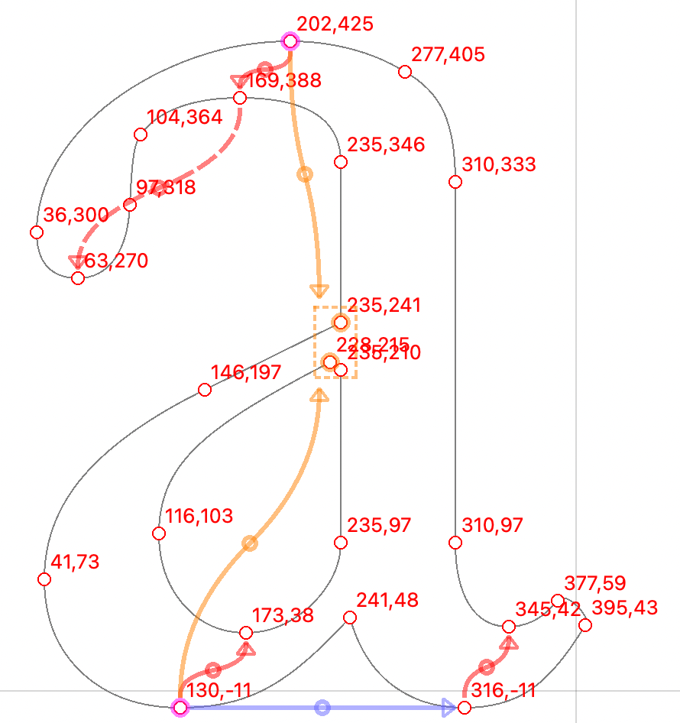
In a TrueType font, the points that define a glyph’s outlines are numbered from zero, and TrueType hints refer to points by these numbers. You’ll have little need to think about point numbers unless you edit the YAML code yourself, but there is one thing worth knowing—namely, that Ygt can refer to points either by number or by coordinates. In the YAML code, a sequence like {548;425} means “the point at coordinates 548,425.”
The reason to use coordinates instead of indices in your code is that index numbers are unstable, especially if you use more than one program to generate fonts, for different programs will number points differently. Further, if you make even a minor change in a glyph’s outlines after you have hinted it, the point numbers will probably change next time you generate the font, even if you always use the same font editor. The result will be invalid hints and messed up glyphs.
But software that generates fonts rarely if ever alters the coordinates of on-curve points—so if you hint only on-curve points and designate those points by their coordinates it won’t matter if you generate the font with, say, Glyphs or fontmake.
Display coordinates rather than indices on screen by selecting “Point coordinates” from the “View” menu. When “Point coordinates” is selected (even if point numbers are hidden), hints added to the YAML code will refer to points by their coordinates. You can also change all indices in the current block of code to coordinates or indices by selecting “Indices to coords” or “Coords to indices” from the “Code” menu. It is a good idea, if you have been working with point indices (which are admittedly simpler to work with than coordinates) to select “Indices to coords” after you are finished hinting a glyph.
Points and collections of points can also be named in Ygt. To do this, select one or more points, select “Name selected point” (or “Name selected points”) from the context menu, and supply a name when the “Name points” dialog appears. The name of a point will become its default label. Ygt will use point names when generating code (making the code more legible), and you can use the name wherever you must supply a point identifier (or a list of point identifiers).

Control Values
CVs are of two kinds: position (pos) and distance (dist). Position CVs specify the location of a point on the current axis (x or y); distance CVs specify the distance of one point from another—again on the current axis. In modern hinting, position-type CVs are used more often than distance-type CVs.

The easiest way to add a CV is via the “Control Value” button on the toolbar. To use it, select one point for a “pos” CV or two points for a “dist” CV, then click the button or type “C.” This dialog box will appear:
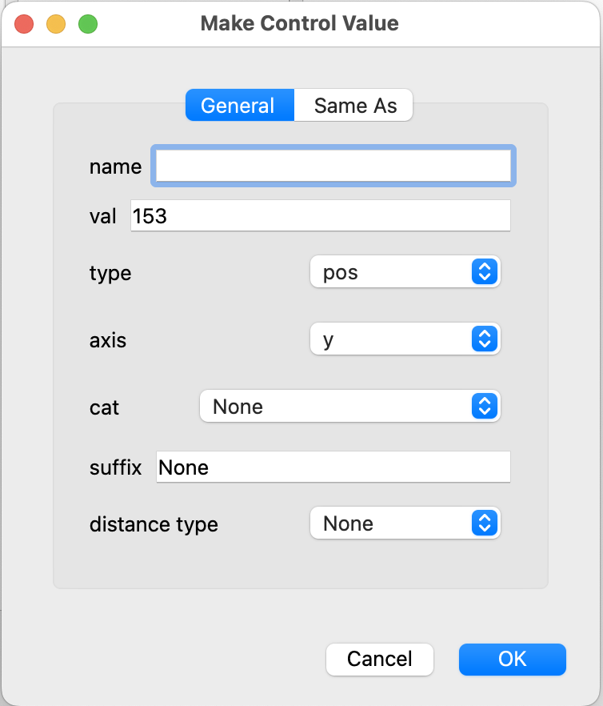
The box is already filled in with most essential information: the position or distance in the “val” box; the type of CV (“pos” or “dist”), and the axis (“x” or “y”). The only information you absolutely must supply is the CV’s name (it should contain no spaces, but it can contain numbers, hyphens and underscores: make the name descriptive but not verbose).
Much of the information you supply in this box is used to filter the list of control values when you need to choose one from a menu. For example, when the current axis is “y,” you only see CVs for the “y” axis. The more information you supply, the fewer choices you’ll confront while hinting a glyph.
type Required. Whether the CV is for positions or distances.
axis Required. Which axis the CV is intended for.
cat Optional. The unicode category of the characters that the CV will be applied to (e.g. “Letter, uppercase”). If supplied, the CV will only be offered for a character in that category (but you can change the category of any glyph, or supply categories where they are missing, by selecting “Set category” from the context menu—see below).
suffix Optional. Glyph names often have suffixes: for example, small caps commonly have names ending in “.sc” (e.g. “a.sc” for “small cap a”). If a suffix is supplied here, the CV will only apply to chararacters whose names have that suffix.
distance type Optional. This property is not for filtering CVs, but rather for affecting the behavior of hints. If a hint’s distance type is not otherwise specified, this value is used. This option will rarely be used in the code, but it may be useful as a reminder of how the CV should be used.
Click over to the “Same As” tab if you want to make this CV equal to another (or others) at certain resolutions.
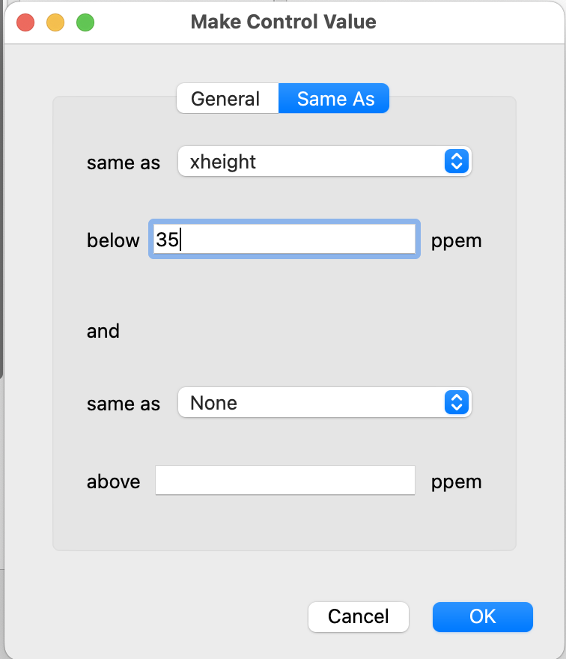
You can make the CV equal to a CV below a certain resolution and equal to another CV above another resolution. Just pick the CV you want to set this one equal to from the “same as” list and enter a resolution in the “below ppem” and/or the “above ppem” box. (You can change this number later in the “Control Values” window.)
The “below ppem” feature is useful for making stems of slightly different width and edges of slightly different height appear consistent at low resolutions. For example, xheight and xheight-overshoot should normally be set equal to each other below 30 or 40 ppem (experiment to find the right ppem number for your font).
Other, more advanced Control Value properties can be managed in the “Control Values” window, discussed below.

Categories
Every character with a Unicode code point belongs to a category assigned by Unicode. To see them, choose “Set category” from the context menu. Ygt uses these categories as filters for CVs: when you assign a category to a CV, that CV only appears on the menu for glyphs with matching categories (but any CV can be entered in the editing pane). This feature keeps the “Set control value” context menu manageable when you have many CVs.
You can override these categories whenever it is useful to do so. (The categories you choose are not recorded in the font, and they have no effect at all except on the selection of CVs in the menus.) For example, the “yen” sign (U+00A5) is categorized as “Symbol, currency,” but its shape is that of a capital Y with bars, and so it is useful to apply to it CVs for capital letters. Simply select “Letter, uppercase” from the “Set category” menu, and all capital CVs will be available for that glyph. Likewise, if you use the Unicode Private Use Area, you’ll find that Unicode classifies all the glyphs there as “Other, private use”—not very useful! But you can assign any category you like to Private Use glyphs for the purpose of hinting them.
Some groupings of characters do not have Unicode categories—small caps, for example. For these, use the “suffix” property of your CVs.

Editing Control Values
The Control Value Table (cvt) and the CVT Variations Table (cvar) can be added, deleted, and edited in the “Control Values” window. To bring it up, select “Edit cvt” from the “Window” menu.
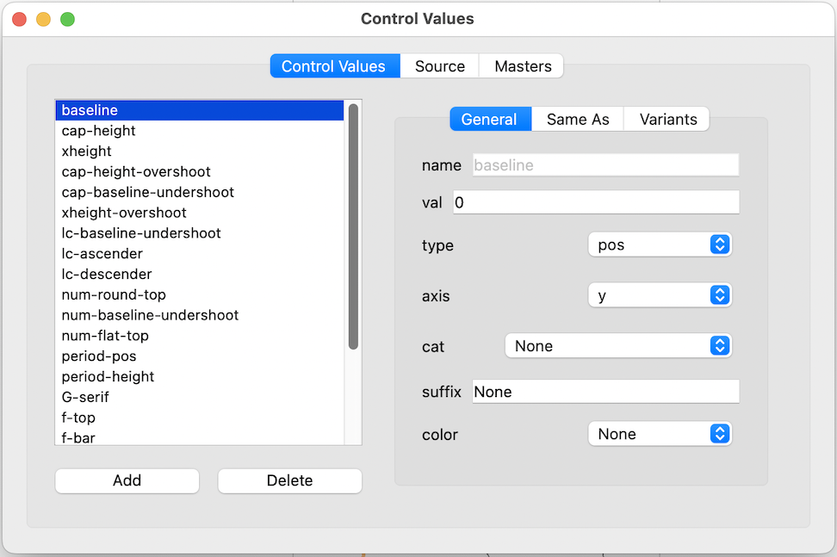
CVs are listed in the panel on the left; on the right is the same panel that appears in the “Make Control Value” dialog (but the “Masters” and “Variants” tabs, discussed in the next section, only appear when you’re editing a variable font).
To edit any CV, double-click its name. Any value associated with the CV can be changed except for its name. The reason the name is not editable here is to guard against disconnecting the CV from the hints that use it. You can rename the CV by clicking over to the “Source” tab:
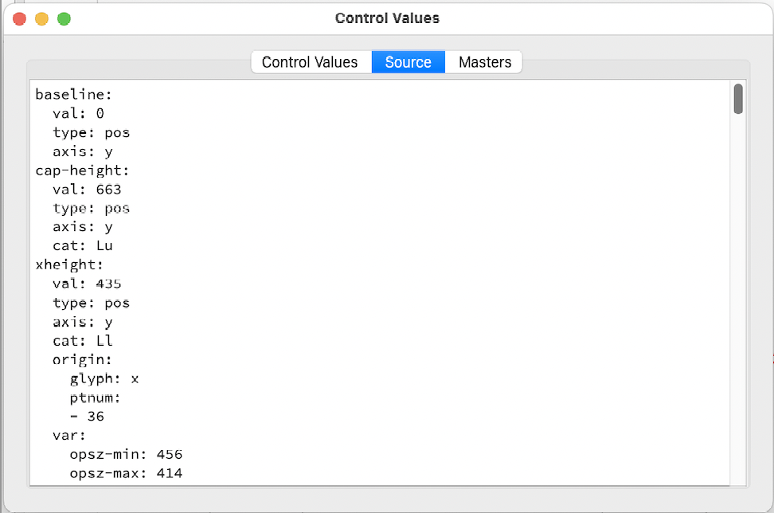
You can change anything you like in this tab. When the YAML code for the CVT is valid, the editor’s background is white. When invalid, it is pink. The background will frequently be pink while you’re typing (because a keyword is incomplete or you have not yet typed a required value). If it is pink when you think you have finished typing, you’ll have to investigate the cause: bad indentation, for example, or an unrecognized value. Here are the parts of a cvt entry:
name Required. Every CV must have a name; Ygt’s collection of CVs is organized with these names as keys. Names should contain no spaces, but they may contain numbers, hyphens, and underscores.
val Required. As in the discussion of the “Make Control Value” dialog (above).
type Required. As in the discussion of the “Make Control Value” dialog.
axis Required. As in the discussion of the “Make Control Value” dialog.
cat Optional. As in the discussion of the “Make Control Value” dialog.
col Optional. The distance type, as in the discussion of the “Make Control Value” dialog.
same-as Optional. As in the discussion of the “Make Control Value” dialog. This may contain one or two keys, “above” and “below.” The “above” and “below” keys, when present, must contain two keys: “ppem,” the resolution above or below which the present CV is set equal to another, and “cv,” the CV that this CV will be set equal to.
var Optional. Variant CVs in a variable font. Discussed below.
deltas Optional. Deltas for adjusting CVs at particular sizes. Discussed below.
origin When a CV is supplied by Ygt, or when you create it using the “Make Control Value” dialog, the program records the glyph name and point index for the point on which the CV was based. This is used when the program automatically generates data for the cvar table; it should not normally be edited.

Control Value Deltas
The “Deltas” pane lets you apply size-specific adjustments to your CVs. For example, at 17ppem, Elstob’s lowercase letters look a little squashed:
You can fix this by adjusting the “xheight” CV. Simply add an entry in the “Deltas” pane for “xheight” and edit the “Size” and “Distance” cells:
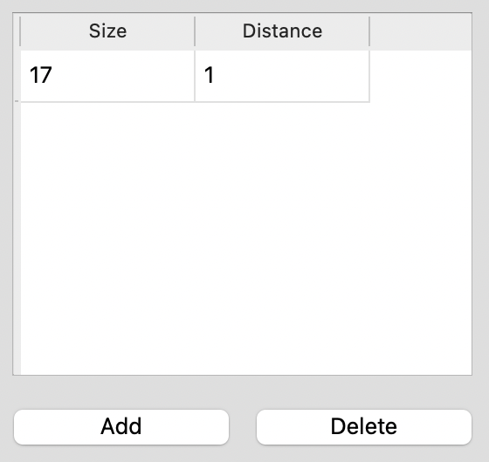
This adds one pixel to the “xheight” CV (note that the “xheight-overshoot” CV, which is set to be the same as “xheight” at this resolution, is automatically adjusted as well):
You can also adjust a CV by a fractional amount, but Ygt may slightly adjust the “distance” value to conform to the requirements of the TrueType engine. An alternative is to use the notation “distance/increment,” where “distance” is a number from -8 to 8 (note that a value of zero here disables the delta), and “increment” is one of 2, 4, 8, 16, 32, 64 (standing for one half of a pixel, one quarter, and so on).
For example, a distance of “8/8” is the same as “1,” and a distance of “-1/16” causes 1/16 of a pixel to be subtracted from the CV.
“Size” must be a number from 9 to 56 inclusive. It is possible to add deltas for other sizes by editing the “prep” code directly, but in general it is unnecessary to add deltas above 56 ppem and useless to add them below 9.
You will see the result of any added delta immediately in the preview pane. When using CV deltas in a variable font, carefully review all instances: CV deltas are not interpolated as CVs themselves are, but are applied after interpolation.

Variant Control Values
In a variable font, CVs need to be interpolated whenever outlines are interpolated. For example, in the Elstob font, the value of the xheight CV is 435, but in the “opsz-min” master the xheight is 456 while in the “opsz-max” master it is 414. The cvt entry “xheight” is 435, and the alternative values 456 and 414 are stored in the cvar (CVT Variations) table.
When you first open a variable font, Ygt takes a few seconds to generate a list of masters and search out values for the cvar table. The masters correspond in function to the masters you created when you designed the font. Their coordinates may also match those of the design masters, and you can supply names, if you like, that match those of the design masters. This is the “Masters” tab for the Elstob font:
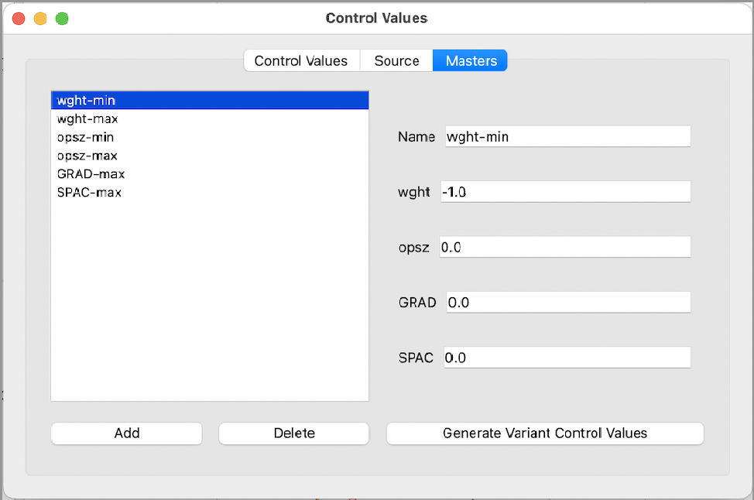
The values for each axis are normalized such that the minimum value (when it is less than the default) is -1.0 , the maximum value is 1.0, and the default value is 0.0. For example, Elstob’s “weight” axis has a minimum of 200, a maximum of 800, and a default of 400. In normalized notation, 200 = -1.0, 400 = 0.0, and 800 = 1.0. Notice that it doesn’t matter if the difference between the default and the minimum differs from that between the default and the maximum: the normalized values are still -1.0, 0.0, and 1.0.
For most masters, one of the axis values will be the maximum or minimum while the others will be the default. However, this is sometimes not the case. You may wish to create a master with more than one non-default value, and you may type any number between -1.0 and 1.0 in any of the axis blanks.
You can add masters if you like, or delete unused ones. (If you don’t delete unused masters, Ygt will ignore them when it compiles the font’s TrueType instructions.)
Variant CVs can be edited in the “Variants” panel of the “Control Values” tab:
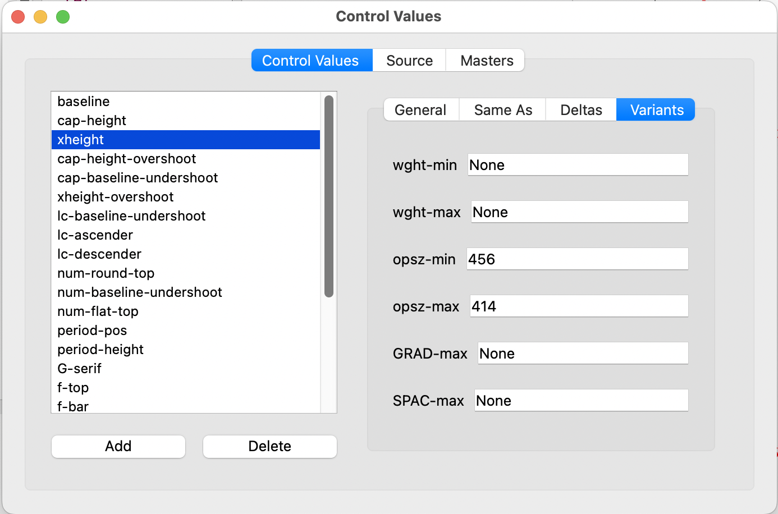
For each master, you can enter either an integer value or “None” (or leave it blank) if the master has the same CV value as the default value in the cvt.
An alternative to entering values here is to press the “Generate Variant Control Values” button in the “Masters” tab. The program will take a few seconds to survey key points (for Control Values with “origin” properties) and fill in variant Control Values.
Test how your hinting behaves at various points on your axes by selecting different instances from the “Preview” menu. For example, here are previews of the Elstob g for the Regular and 8pt Bold instances at 30 pixels per em:
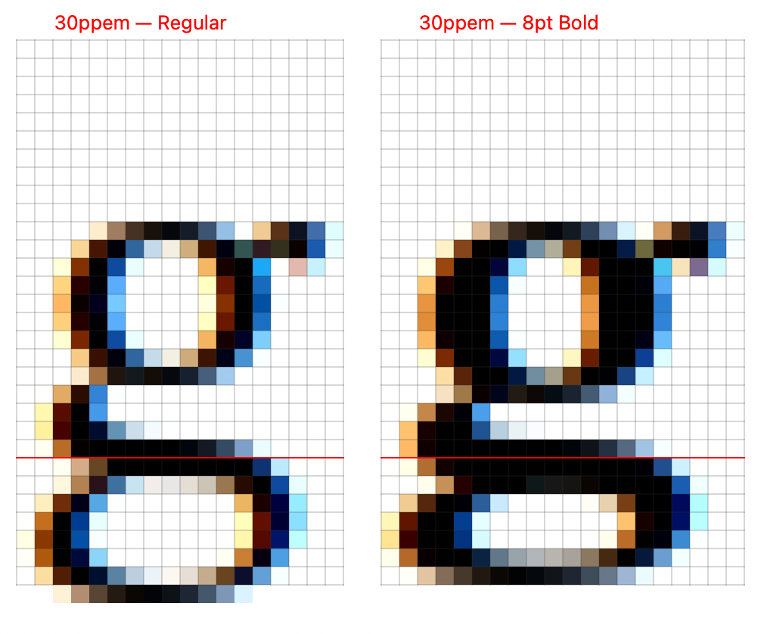

Remember this if for any reason you generate a new UFO for your font: be careful not to lose your work, but instead save the org.ygthinter directory of the data directory separately and then copy it into the new UFO. In addition, bear in mind that a UFO can contain either quadratic (TrueType) or cubic (CFF/.otf) curves. You may wish to use cu2qu to convert the curves of your font to TrueType before you begin hinting; alternatively, do these things: (1) hint only on-curve points (this is good practice anyway) and (2) set Ygt to display point coordinates instead of point indices (View→Point Coordinates). Point indices will certainly change when you generate your font, breaking all your hints, but the coordinates of on-curve points will not change.
The work of generating the preview is done in its own thread so that you can continue editing hints while Ygt is working on the preview.

