**Neural representations of a complex *de novo* motor skill learning**

**Short Title:** Representations of de novo motor skills

**Authors:** Emily Yunha Shin1,3, Yera Choi1,3, Jisu Lee1, Sungshin Kim1,2**\***

1. Center for Neuroscience Imaging Research, Institute for Basic Science, Suwon 16419, Republic of Korea
2. Sungkyunkwan University, Suwon 16419, Republic of Korea
3. These authors equally contributed to this study

*Corresponding Author

N center suite 86363, Sungkyunkwan University

2066 Seobu-ro, Jangan-gu, Suwon, Republic of Korea

Email: sungshin0207@gmail.com

Phone: +82-10-4687-5322

**Abstract**

**Introduction**

Motor learning spans a wide variety of phenomena featuring experience-dependent changes in motor behavior accompanied by changes in the activity of the involved neural networks. The existing literature has established that the cortico-striatal and cortico-cerebellar networks are distinctly responsible for different types of a motor task, namely skill learning and adaptation (Doyon et al., 2003), and has continuously suggested that activity changes in the relevant networks indeed reflect learning. For instance, studies have shown that an increase in network activation may indicate greater neural recruitment for learned behaviors, while a decrease may result from higher neural efficiency achieved by continued practice (Steele and Penhune, 2010; Dayan and Cohen, 2011). Moreover, few model-based fMRI studies have suggested that dynamic activity changes might reflect the presence of motor memory with multiple time scales, distinctly involved in different stages of learning (Imamizu et al., 2000; Kim et al., 2015). Recent approaches using multivariate (Wiestler and Diedrichsen, 2013; Kim et al., 2015) and functional connectivity analysis (Bassett et al., 2015) have further extended the perspective that motor learning entails large-scale functional reorganization.

Although these studies have elucidated many essential aspects of the neural representation of motor learning, they have often employed well-learned motor tasks such as reaching and finger tapping, which do not require explicit action selection to learn a novel arbitrary relationship between actions and outcomes. Thus, they may only provide limited insights regarding complex *de novo* motor skill learning, which involves a multifaced process evolving from explicit and goal-directed action selections to implicit and automatic execution of learned actions (Wolpert and Flanagan, 2010; Diedrichsen and Kornysheva, 2015). Despite the importance of this type of learning that more closely resembles the process of acquisition of many real-world motor skills, the cognitive and neural mechanisms of *de novo* motor skill learning have not been well understood, possibly due to the difficulty of implementing a motor task designed to explore related issues in laboratory settings, including a magnetic resonance imaging (MRI) scanner.

In a novel longitudinal functional MRI (fMRI) experiment, participants learned a *de novo* motor skill to control an on-screen cursor. They moved their right fingers with a data-glove to reach targets appearing in four different locations. To examine the neural activities in the early and later stages of learning, two fMRI sessions separated by five behavioral training sessions were conducted. We expected that, in an early stage of learning, participants would consciously explore the associations among the visual feedback of cursor and target location and their finger movement, and would deliberately choose subsequent actions based on the growing knowledge of these associations. Accordingly, we hypothesized that the neural activities in the early stage would contain sufficient information to discriminate the four targets, which would dissolve to a certain degree in the advanced stage.

To investigate whether such changes in target representation can be detected in neural activities, we performed multi-voxel pattern classification analysis (MVPA), a multivariate approach developed to decode the inherent information distributed in multiple voxels. Recently, an increasing number of studies on motor learning, including a systematically designed longitudinal study (Wiestler and Diedrichsen, 2013{Dayan, 2011 #2}), have noted the apparent discrepancies in reports of learning-related changes in average activity, and have called attention to changes in the *patterns* of activity [REFs], which can be investigated with multivariate approaches including MVPA and may provide a more comprehensive information on how motor skill learning is represented in the brain.

We first tested whether extensive training would change activity patterns representing the four targets in the “task-positive” regions such that they can be discriminated with higher accuracy (Wiestler and Diedrichsen, 2013; Kim et al., 2015). Furthermore, we also investigated a possible role of the “task-negative” default mode network (DMN) because recent studies suggested its role in various cognitive processing such as perceptual learning (Baldassarre et al., 2012), associative learning (Mohr et al., 2016; Kim and Voss, 2019), motor execution, and behavioral consistency (Kelly et al., 2008). We hypothesized that the DMN could be more involved in *de novo* motor task, which may demand greater cognitive resource than motor adaptation task and sequence learning task, which have been typically employed in previous studies [REF]. Finally, we sought to determine to what extent the interaction between the “task-positive” regions and “task-negative” DMN could account for variability of individual learning performance. We thus believe that this unique fMRI experiment may contribute to elucidating the large-scale representation of complex *de novo* motor skill learning through early goal-directed stage to late automatic stage of learning.

**Results**

***Behavioral analysis***

As noted in our previous study [REF], participants’ performance significantly improved after extensive training in terms of the success rate (Figure 1C, lower panels; paired *t*-test: *T*(29) = 15.81, *p* < 10-3; calculated as the proportion of the time during which the cursor was on the target in the practiced mapping) and the cursor trajectories between targets became straighter in the later stage of learning (an example from a representative participant are shown in Figure 1C, upper panels).

***Regional average activations cannot discriminate targets***

To examine whether overall fMRI activities associated with the four targets were different, we conducted whole-brain ANOVA based on a univariate general linear model (GLM). In both Early and Late stages, a single significant cluster was found only in the visual network, specifically encompassing the bilateral occipital pole, lingual gyrus, and occipital fusiform gyrus (voxel-wise *p* < 0.001, FWE-corrected *p* < 0.05, Table X). This result is not surprising as four different targets would be retinotopically mapped in the visual cortex, resulting in the regional difference in fMRI activity [REF]. Outside the visual regions, the univariate voxel-based analysis was not able to discriminate between the different targets, thus motivating us to use multivariate pattern analysis.

***Learning-related change of activation patterns representing targets***

*Contralateral M1/S1****.*** GLM analysis with a contrast of “move” and “stop” condition in the localizer scan data identified seven highly significant ROIs (voxel-wise p < 10-5, voxel size > 150), which encompass the regions that have been established to be involved in finger movement (Figure X, Table X) (Moore et al., 2012). The classification accuracies of the seven localizer ROIs are presented with their respective locations (Figure 3). The classification accuracies of all the seven localizer ROIs were significantly greater than the chance level of 0.25 (Bonferroni-adjusted p < 0.05) regardless of learning stages (Early or Late) and mappings (practiced or unpracticed). However, only in the left precentral and postcentral gyri (M1/S1), two-way (learning stage X mapping) repeated-measures ANOVA revealed the main effect of learning stage, *F*(1,29) = 10.75, uncorrected *p* = 0.003, -adjusted *p* = , p2 = 0.27 as well as the interaction, *F*(1,29) = 17.11, uncorrected *p* < 10-3, adjusted *p* = , p2 = 0.37 ( Figure 3, the leftmost panel). Post-hoc paired *t*-tests significant learning-related changes of the classification accuracy in the left M1/S1 for the practiced mapping (*T*(29) = 4.57, Bonferroni-adjusted *p* < 10-3) and….[described the t-test results for practiced vs unpracticed in the late stage of learning]

*Visual cortices*. The classification accuracy of the cluster combining all of the visual ROIs was significantly greater than the chance level of 0.25 in any stage or mapping (one-sample *t*-tests; Early, Practiced: *T*(29) = 23.71, Late, Practiced: *T*(29) = 19.61, Early, Unpracticed: *T*(29) = 23.23 ; Late, Unpracticed: *T*(29) = 20.70, Bonferroni-adjusted *p* < 10-3) (shown in Figure X, left panel). [Described ANOVA results as in the left M1/S1[

Post-hoc paired *t*-tests (*T*(29) = 2.09, *p* = 0.045) suggested that the classification accuracy of the combined visual ROIs improved after extensive training, [described t-test results for practiced vs unpracticed in the late stage of learning].

*Default mode network*. For each subnetwork of the DMN, including the Core, DMPFC, and MTL networks, the classification accuracies in different learning stages and mappings were calculated and presented in Figure X. The accuracy values were significantly greater than the chance level of 0.25 in Core (one-sample *t*-tests; Early, Practiced: *T*(29) = 9.56, Bonferroni-adjusted *p* < 10-3; Late, Practiced: *T*(29) = 3.26, Bonferroni-adjusted *p* < 0.05; Early, Unpracticed: *T*(29) = 7.74, Bonferroni-adjusted *p* < 10-3; Late, Unpracticed: *T*(29) = 5.97, Bonferroni-adjusted *p* < 10-3), DMPFC (one-sample *t*-tests; Early, Practiced: *T*(29) = 5.78, Bonferroni-adjusted *p* < 10-3; Late, Practiced: *T*(29) = 3.61, Bonferroni-adjusted *p* < 0.05; Early, Unpracticed: *T*(29) = 8.47, Bonferroni-adjusted *p* < 10-3; Late, Unpracticed: *T*(29) = 7.21, Bonferroni-adjusted *p* < 10-3), and MTL network (one-sample *t*-tests; Early, Practiced: *T*(29) = 12.60, Bonferroni-adjusted *p* < 10-3; Late, Practiced: *T*(29) = 7.33, Bonferroni-adjusted *p* < 10-3; Early, Unpracticed: *T*(29) = 10.93, Bonferroni-adjusted *p* < 10-3; Late, Unpracticed: *T*(29) = 9.90, Bonferroni-adjusted *p* < 10-3).

The paired *t*-test to examine the changes in the classification accuracy in the practiced mapping demonstrated a significant decrease only in the Core subnetwork (*T*(29) = 3.05, Bonferroni-adjusted *p* = 0.015). [Described the ANOVA results in a similar way for the M1/S1 and visual ROis]

*Whole-brain searchlight analysis.* We additionally performed searchlight analyses to complement the ROI-based MVPA, only for the data in the practiced mapping. The resultant searchlight map showing Three clusters showing significant learning-related changes in classification accuracies were observed in the left postcentral gyrus (Figure X, upper panel; size = 235 voxels, volume = 4523.5 mm3), left fusiform gyrus (Figure X, middle panel; size = 43 voxels, volume = 827.7 mm3), and right temporal pole (Figure X, lower panel; size = 34 voxels, volume = 654.5 mm3). The resultant searchlight map is presented in Figure X, and detailed information on the clusters can be found in Table 2. The results were thresholded at cluster-forming *p* < 0.001 and FWE-corrected *p* < 0.05. In the left postcentral and left fusiform gyri, the classification accuracies showed learning-related increases, while a learning-related decrease was observed in the right temporal pole, which is a part of the default mode network.

***Changes in visual-DMN Core interaction and behavioral correlation***

We hypothesized that the learning-related change of the large-scale network interactions would be correlated with the individual performance improvement. Specifically, we tested the interactions between the regions of interest showing learning-related changes of target representations, that is, the left M1/S1, visual network, and the DMN Core subnetwork.

In line with our initial hypothesis, the interaction between the visual and the DMN Core networks significantly decreased from the early to late stage of learning (*T*(29) = XX, *p* < 0.xx). The change in the interaction was highly correlated with the improvement in the success rate from the early to late stages of learning across thirty participants (Figure X; *r* = -0.55, *R2* = 0.30, p = 0.002).

**Methods**

***Participants***

Thirty participants (12 females; age range = 19-30 years) completed all the sessions (two fMRI and five behavioral training sessions) and were included in the analyses. All participants were right-handed, had normal or corrected-to-normal vision, and provided written informed consent (approved by the Institutional Review Board of Sungkyunkwan University).

***Task Design***

For detailed information on the task design, see our previous paper [REF] and Ranganathan et al., 2013 (Ranganathan et al., 2013). Here, we briefly describe the main task and experiment schedule.

*Main task*. While wearing an MR-compatible data-glove (14 Ultra, 5DT Technologies) on their right hands, participants learned to control a computer cursor (shown as a white crosshair) and reach a target (shown as a gray rectangular grid with a yellow crosshair at its center, which appeared at one of the four corners of a 5 x 5 grid) by manipulating their right fingers (Figure 1A). The 14-dimensional vector obtained by the 14 sensors located at finger flexures (two sensors for each fingers) and abductions (4 sensors between fingers) on the data-glove was linearly mapped onto the 2-dimensional cursor position.

*Experiment schedule*. The experiment was composed of seven visits on separate days, with two fMRI sessions separated by five behavioral training sessions. On Visit 1, participants completed familiarization and calibration sessions to get used to the data-glove paradigm and construct two individualized mappings (“Practiced”: the mapping to be the direct target of subsequent training; “Unpracticed”: the other mapping that would be presented only in fMRI sessions) between right finger movements and cursor. Then they underwent one resting-state scan, one localizer scan to identify the brain regions involved in finger movement, and the first task fMRI session (“Early”) presenting both Practiced (Runs 1-3, 7) and Unpracticed (Runs 4-6) mappings. On Visits 2-6, participants were instructed to practice on the task during behavioral training sessions, which were conducted outside of the MRI scanner and only included the Practiced mapping. On Visit 7, the second task fMRI session, which presented both Practiced and Unpracticed mappings as in the first task fMRI session, was conducted. The behavioral and the second fMRI sessions were scheduled so that all these sessions could be completed within a 15-day window (Figure 1B).

***3-T MRI acquisition***

A 3-T Siemens Magnetom Prisma scanner with a 64-channel head coil was used to acquire structural and functional neuroimaging data. For the functional images, an echo planar imaging (EPI) sequence and the following parameters were used: 1096 volumes for each of 7 runs; repetition time (TR) = 460 ms; echo time (TE) = 27.20 ms; flip angle (FA) = 44°; field of view (FOV) = 220  220 mm; matrix, 82  82  56 voxels; 56 axial slices; slice thickness = 2.7mm. For anatomical reference, a whole-brain T1-weighted anatomical scan was performed using an MPRAGE sequence with the following parameters: TR = 2400 ms; TE = 2.34 ms; FA = 8°; FOV = 224  224 mm; matrix = 320  224  320 voxels; 224 axial slices; slice thickness = 0.7 mm. For distortion correction, we additionally acquired two EPI images with opposite phase encoding directions (posterior-to-anterior and anterior-to-posterior) and the following parameters: TR = 7220 ms; TE = 73 ms; FA = 90°; FOV = 220  220 mm; matrix = 82  82  56; 56 axial slices; slice thickness 2.7 mm.

*Localizer scan*. In an independent localizer scan, participants were instructed to move their right fingers in a random and continuous manner in the “Move” phase and refrain from moving in the “Stop” phase, which were alternated and lasted for one minute.

***Behavioral and fMRI data analyses***

All analyses were conducted using AFNI (Analysis of Functional NeuroImages, NIH, https://afni.nimh.nih.gov), MATLAB (versions R2015b and R2018a, MathWorks, Natrick, USA), FreeSurfer (version 6.0.0., http://surfer.nmr.mgh.harvard.edu), Python 3.6, and R 3.5.3.

***Selection of ROIs***

For the task-related ROIs, we first used the localizer scan to identify regions involved in random right finger movement. At the threshold of a cluster-forming *p* < 10-5 and a cluster size greater than 150 voxels, seven clusters were identified in the bilateral M1/S1, right cerebellum, left putamen, right SMA, and left thalamus (Figure X, Table X). To compare classification accuracies in the ROIs, they were resized to have top 200 voxels with the highest Z-scores (Bleichner et al., 2014). Second, we defined ROIs in the visual network, Network 1 in specific was chosen from the 17 networks suggested by Yeo et al. (Yeo et al., 2011) Information on the visual ROIs are listed in Fig. X.

For the ROIs in the default mode network (DMN), we created spherical ROIs with a radius of xx mm centered around the coordinates from previous literature (Crittenden et al., 2015), Overall xx ROIs were grouped in the Core (xx), MTL (xx), and DMPFC subnetworks (xx). The created ROIs were then intersected with a combined mask for all participants.

***Mass univariate analysis***

*Preprocessing*. The functional images underwent slice time acquisition correction, realignment to adjust for motion artifacts, and retrospective distortion correction with a field map calculated using the two EPI images in opposite phase encoding directions. Then the images were spatially registered to the structural image, transformed into Montreal Neurological Institute (MNI) template, and resampled into 2.68 mm3 voxels. We then performed spatial smoothing using a Gaussian kernel of 4 x 4 x 4 mm full-width at half-maximum (FWHM) and scaling.

*Creation of the residual data*.Due to the inherent nature of the main task which resulted in a significant difference in the amount of total movement between early and later stages of learning, we further processed our data to control for this difference by including the total amount of movement (calculated using the sensor displacement data) as an additional nuisance regressor.

*Univariate analysis*. Using the data from Runs 1-3, which were under the practiced mapping, GLM analysis using four targets as four regressors was performed to estimate the beta values of target class for each participant. Subsequently, to examine whether the beta values for the targets differ from each other, single-factor ANOVA was conducted separately for Early and Late stages.

***Multivariate pattern analysis (MVPA)***

*Preprocessing*. All multivariate pattern analyses (MVPA) were performed using Scikit-Learn (Pedregosa et al., 2011) and Nilearn (Abraham et al., 2014) Python libraries. In accordance with previous literature (Crittenden et al., 2015), the fMRI data were preprocessed by following the exact same procedures used for the mass univariate analyses, except the exclusion of smoothing. We then obtained trial-by-trial estimated parameters (beta-values) using AFNI’s *3dLSS*, which has been suggested to be a particularly effective approach for rapid even-related designs (Mumford et al., 2012). The estimated beta-values were used as inputs for subsequent classification analyses.

*Multivariate classification analysis.* For the multivariate classification analysis, we used the linear discrimination analysis (LDA) classifiers with least squares solution and covariance shrinkage (tolerance = 0.0001), as shrinkage LDA has been frequently employed for fMRI analysis for its simplicity, computational efficiency, and robustness (Misaki et al., 2010; Hohne et al., 2016). To investigate whether the regional brain activity represented the information on the four targets presented during the main task (see Figure 1A and the “Task Design” section of Methods). For each mapping (a total of three fMRI runs in each visit; see Figure 1B), classification accuracies were calculated by using two of the three runs as the training set and the remaining run as the test set and averaging the resulting accuracies (i.e., three-fold leave-one-run-out cross-validation).

1. *ROI-based MVPA*

*Hand-movement localizer ROIs*. Classification accuracies were computed for each of the size-adjusted hand-movement localizer ROIs. Then, to identify the regions in which the information representing the targets had changed in relation to motor skill learning, paired *t-*tests of the accuracies between learning stages were performed.

*Visual ROIs*. As the localization of the task-related information in the visual network was not of our main interest, the entire visual ROIs were combined into a single ROI, in which the classification accuracy was computed.

*DMN ROIs*. To capture the distributed task-related information in the different DMN subnetworks, ROIs in each subnetwork were combined and used for training and test for classification.

1. *Searchlight analysis*

Whole-brain searchlight analysis (Kriegeskorte et al., 2006) was performed to complement the ROI-based MVPA using the Nilearn Python Library. Multivariate classification analysis was performed within a 6 mm radius sphere, and the three-fold cross-validated mean accuracy across fMRI runs was assigned to the sphere’s center voxel. The individual accuracy map for the Practiced mapping was obtained separately for Early and Late stages, and then the group-level difference (Early vs. Late) was reported.

***Connectivity analysis and correlation with behavior***

Based on the MVPA results, we explored whether the functional connectivities within and between the visual and DMN core networks were associated with learning performance. We hypothesized that, if successful learning had occurred, the integration between the visual network (which may be considered as a task-positive network along with the motor network) and the DMN core network (which may be considered as a task-negative network) would decrease.

**Discussion**

In this study, we designed a novel fMRI task to characterize dynamic plastic changes in the neural representation of long-term acquisition of a *de novo* motor skill. We acquired two fMRI data during skill learning separated by extensive practice over multiple days. To compare two fMRI data sets, we used multi-voxel classification analysis and connectivity analysis, which were recently adopted by few studies in motor learning (Wiestler and Diedrichsen, 2013; Bassett et al., 2015; Kim et al., 2015).

In contralateral M1/S1 region and visual cortices, we found learning-related changes of activity patterns for separate targets such that they became more distinguishable after extensive practice (Wiestler and Diedrichsen, 2013; Kim et al., 2015; Ogawa et al., 2019). This result is not surprising in that skill learning typically involves reduced variability of movement within the same task targets (Verstynen and Sabes, 2011; Wolpert et al., 2011), thereby being more separable across different task targets. It has been well established that the contralateral hand area of M1/S1 represents coordinated finger movement and few studies showed hand postures can be decoded from fMRI activity patterns in the region (Bleichner et al., 2014; Leo et al., 2016). Interestingly, however, the classification accuracy was not learning-related in the other regions related with finger movement, which were identified by a localizer scan although it was higher than a chance level. This result is supported by a recent study showing that individual finger movements are uniquely represented in the contralateral M1/S1, and higher level of the movement such as chunk and sequence are represented in non-primary sensorimotor area (Yokoi and Diedrichsen, 2019). In the late stage of learning, participants learned to quickly make consistent hand postures required to reach targets. Thus, classifying different targets would be related with more elementary multi-joint configuration of hand instead of the movement chunk and sequence, resulting in learning-related changes of representation only in the contralateral M1/S1.

Likewise, the visual feedback for the finger movement also became more consistent within the same targets and more separable across different targets, and thus the classification accuracy of targets in the visual network increased as learning proceeded. Although we removed fMRI activity related to time-varying amounts of the finger movement to control the overall difference of movement between the early and late stages of learning, we cannot fully dissociate learning *per se* from movement and visual feedback. Due to this limitation, the increase of the classification accuracy both in the left M1/S1 and visual region was simply “learning-related”, not necessarily “learning-induced”.

However, the decrease of the classification accuracy in the DMN core subnetwork was surprising and may reflect learning-induced effect. It could be related with the potential role of the DMN in contextual switching externally focused cognitive tasks as suggested by recent studies (Crittenden et al., 2015; Smith et al., 2018). Although the authors argued that the multivariate fMRI activity patterns in the DMN discriminated multiple cognitive tasks only in different domains, switching over the four different targets would require significant cognitive resource in the early stage of learning. In contrast, participants would demonstrate more automatized behavior in the advanced stage of learning along with a generalized representation of the entire mapping with lower cognitive demands for switching over targets. Then, a substantial portion of the cognitive and neural resources originally recruited for this representation may be released (Bassett et al., 2015) and would be reflected in decreased decoding accuracy.

Furthermore, the whole-brain searchlight analysis identified that the classification accuracy significantly decreased in the right temporal pole, which is a part of the DMN (DMPFC subnetworks). A previous study showed that the activity patterns in the anterior temporal regions represent conceptual and abstract object properties rather than low-level sensorimotor features (Peelen and Caramazza, 2012). Our results provide the evidence supporting

The authors questioned whether activity patterns in the anterior temporal regions represent

A recent study has suggested that an increase in the activity of the DMN, especially of the subnetworks, are due to the network’s involvement in the representation of cognitive or environmental contexts, rather than rule retrieval (Smith et al., 2019).

**[Debates on discrepancies in the neural representation of motor learning]**

A recent overview of the relevant studies has suggested that various factors such as experimental paradigm and learning schedule may have contributed to the discrepancies regarding the location and direction of learning-related changes in activations (Immink et al., 2020).

**[Discuss the limitations and make concluding remarks]**

Potential need to use higher-resolution (7T) MRI?

**Figure 1. Experimental design**

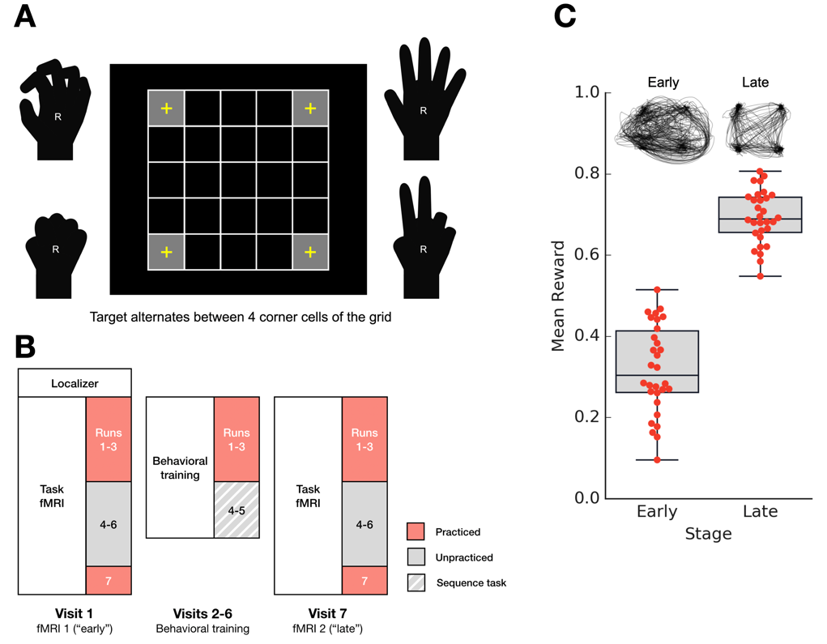

**A. Design of the main task.** In a complex *de novo* motor learning task using a data-glove, participants learned to manipulate their right fingers to control a computer cursor and reach a target, which alternated its location between the four corner cells (gray grid cells with yellow crosshairs at center). The degrees of freedom at finger flexures and abductions were measured by the 14 sensors of the data-glove. The resulting 14-dimensional vector was linearly mapped onto the 2-dimensional cursor position by a predefined 14 by 2 mapping. The goal of the task was to reach the target as soon as possible and stay on it as long as possible. **B. Experiment schedule.** The entire experiment was composed of seven visits, which included two main-task fMRI sessions separated by behavioral training sessions. **Visit 1**: A localizer scan to identify the regions involved in random finger movement was performed. Then, seven runs of the main-task with two different mappings (practiced and unpracticed mappings) were conducted. **Visits 2-6**: Participants underwent behavioral training sessions only on the practiced mapping. **Visit 7**: Seven runs of the main-task with two different mappings (practiced and unpracticed mappings) were conducted. Detailed description of the entire experiment can be found in a preceding article (Choi et al., 2019). **C. Performance in the early and late stages of learning.** The mean success rate for the early and late stages of learning are shown in box plots. Individual data points are indicated with red dots. Actual cursor trajectories made by a representative participant are shown above the box plots. Both the mean success rate and the orderliness of the trajectory improved in the late stage of learning.

**Figure 2. Localizer ROIs**

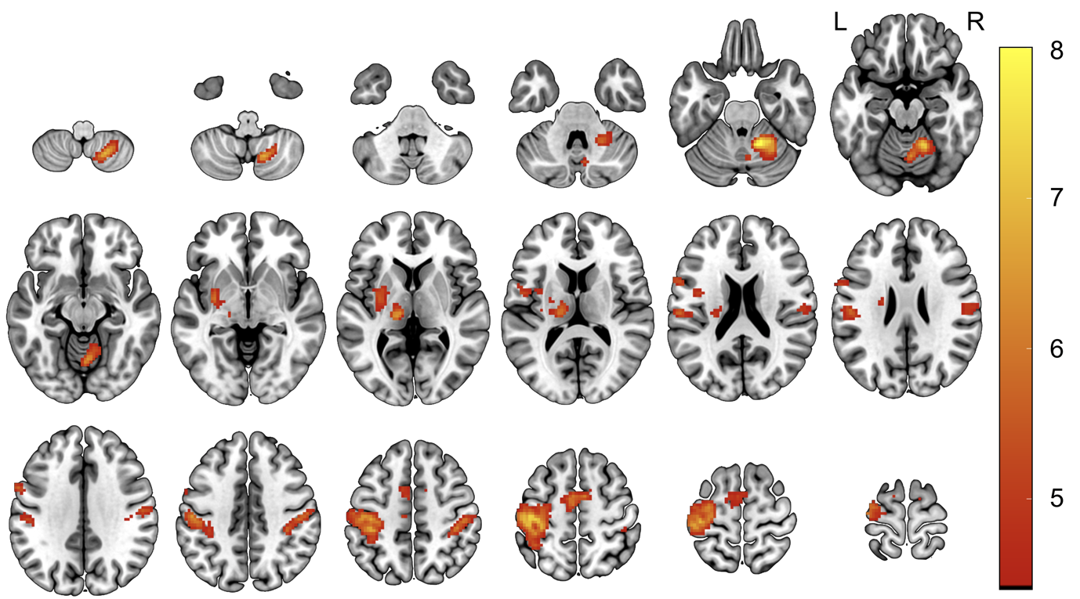

The brain regions implicated in random right finger movement were delineated using the localizer scan, with a cluster-forming *p* < 10-5 and a cluster size greater than 100 voxels. A total of seven localizer ROIs were identified. The locations and peak coordinates of the ROIs are listed in Table X.

**Figure X. Classification accuracy in the localizer ROIs**

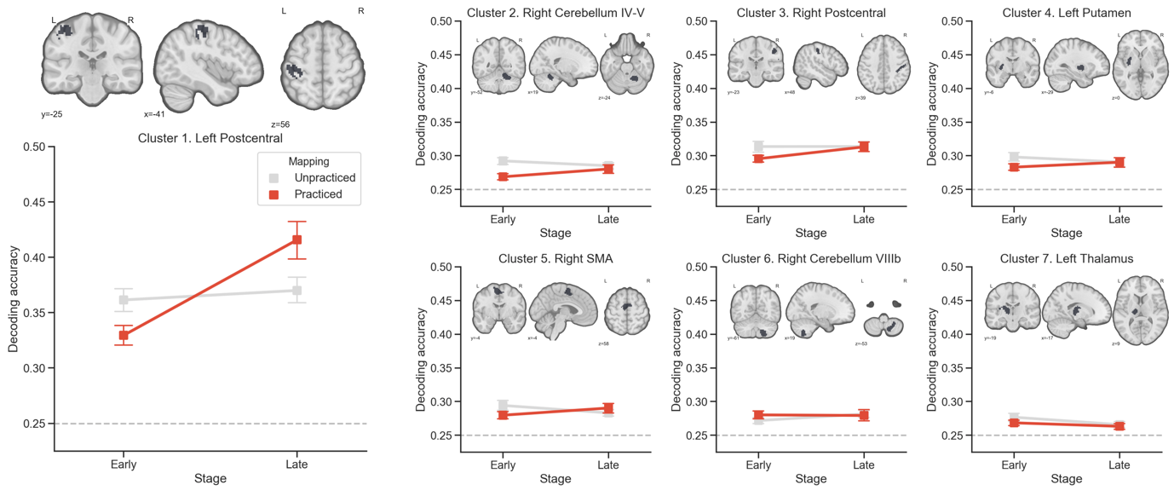

The classification accuracies of the seven localizer ROIs (including the clusters located in the left M1/S1, right cerebellum, left putamen, right SMA, and left thalamus) in different learning stages (early and late) and different mappings (Practiced, red solid line; Unpracticed, gray solid line) are presented. Error bars denote SEM. The chance level (at 0.25) is denoted with a gray dotted line.

**Figure X. Classification accuracy in the default mode network**

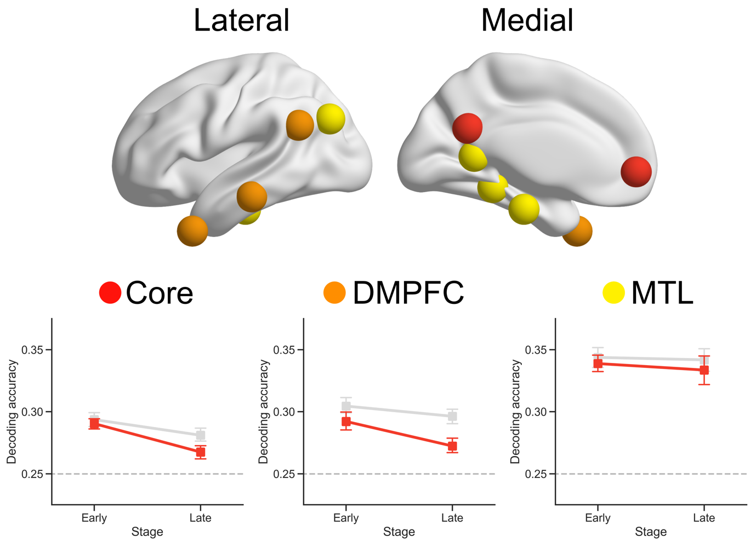

The classification accuracies of the submodules of the default mode network (including the Core (red), DMPFC (orange), and MTL (yellow) modules, as suggested by Crittenden et al., 2015) in different learning stages (Early and Late) and different mappings (Practiced, red solid line; Unpracticed, gray solid line) are presented. The ROIs were created using spherical ROIs (radius = 10 mm, approximately 200 voxels). Error bars denote SEM. The chance level (at 0.25) is denoted with a gray dotted line.

**Figure X. Searchlight analysis**

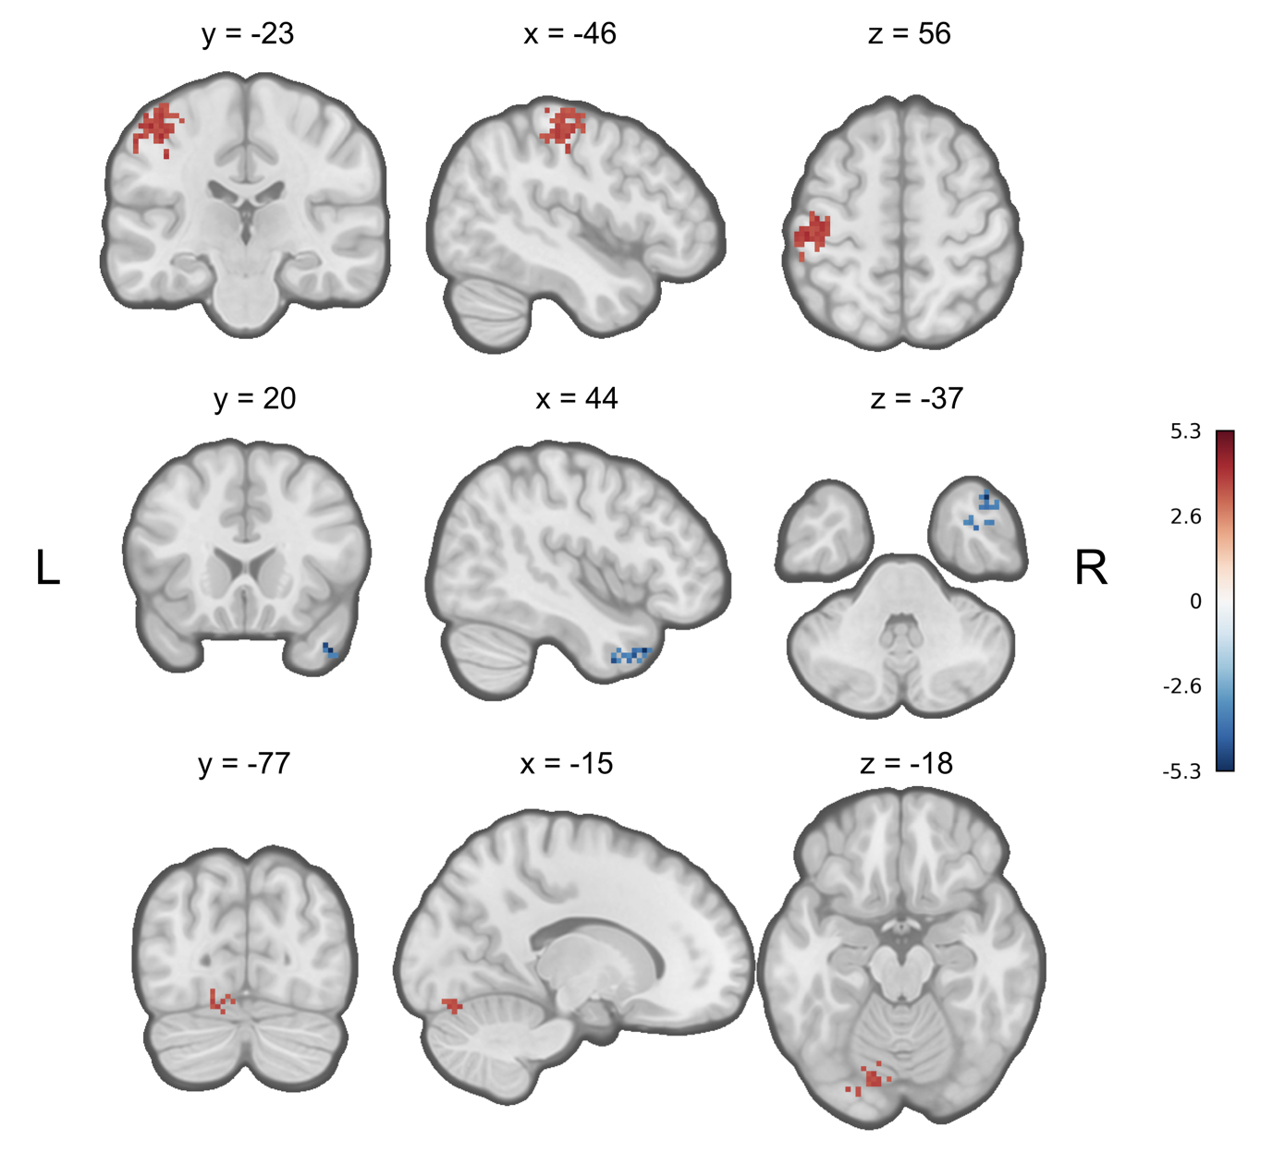

Three significant clusters (shown in coronal, sagittal, and axial views at each row) identified from the searchlight analysis (only including the data for the Practiced mapping) are presented. The clusters in blue denote the regions with significantly greater classification accuracies in the early stage of learning, while the clusters in red denote those with significantly greater classification accuracies in the later stage of learning. The searchlight analysis result is thresholded by a cluster-forming *p* < 0.001 and a FWE-corrected *p* < 0.05. The colorbar denotes the *t*-values. Detailed cluster information is described in Table 2.

**Figure X. Correlation between the change in the visual-DMN core integration and improvement in success rate**

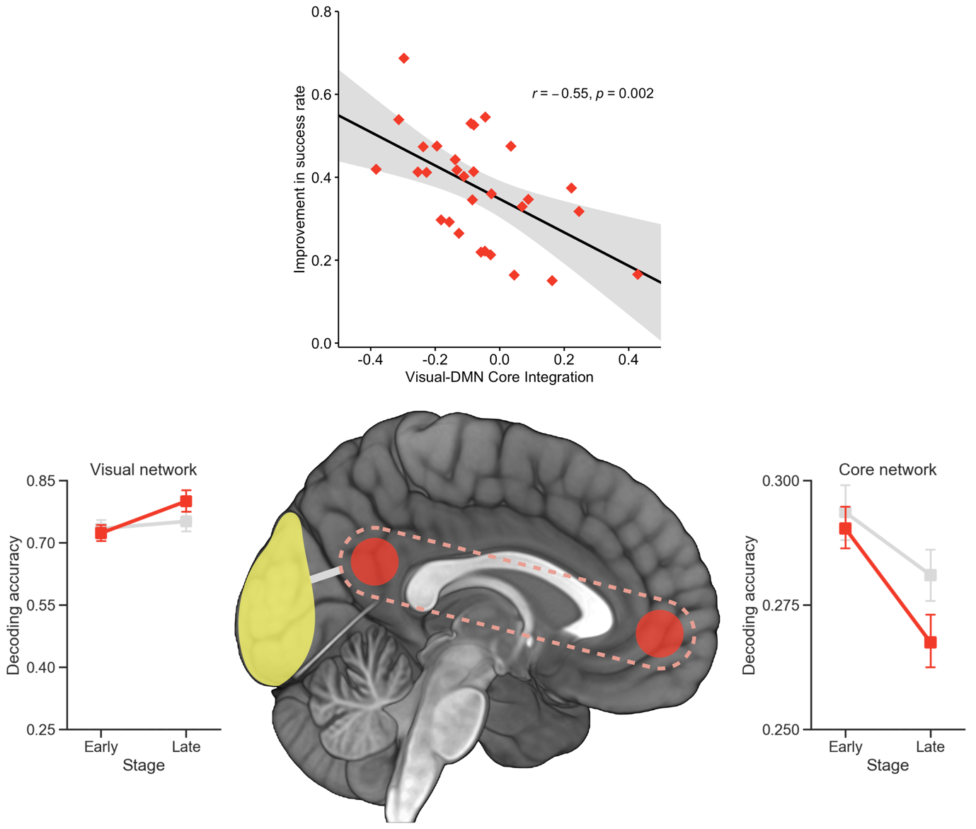

A significant negative correlation was observed between the change in the integration between the visual and DMN core networks and the improvement in the success rate (which was measured by subtracting the success rate in the Early learning stage from the Late learning stage). The classification accuracies of the visual network (created based on the Cluster 1 of the 17 functional networks suggested by Yeo et al., 2011) and core network in different learning stages (Early and Late) and different mappings (Practiced, red solid line; Unpracticed, gray solid line) are presented at left and right side of the figure. The y axes for two classification accuracy graphs start from the chance level (at 0.25). Error bars in the classification accuracy graphs denote SEM.

**Figure SX. Classification accuracy in individual ROIs in the visual network**

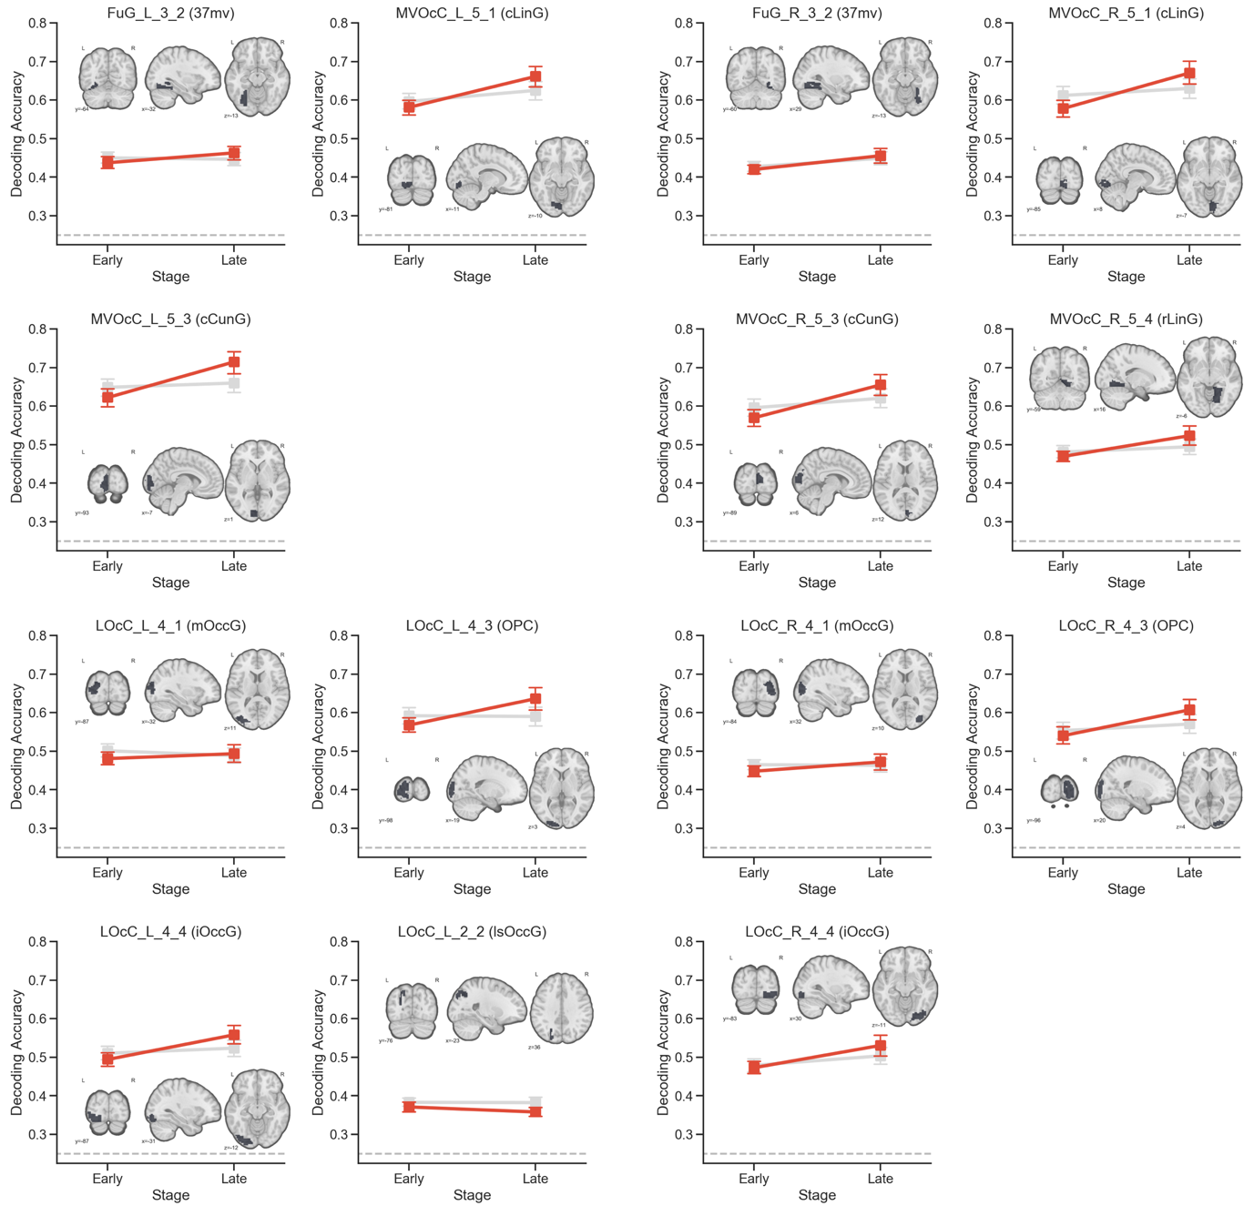

In the main analysis, the selected ROIs for the visual network were combined into a single ROI, for which an overall classification accuracy was calculated. Here we present the classification accuracies for individual visual ROIs. The following ROIs are included: .

Abbreviations:

**Table 1. Regions related with free movement of right fingers**

|  |  |  |  |  |  |  |
| --- | --- | --- | --- | --- | --- | --- |
|  | Peak (MNI) | | |  | *Z*-score |  |
|  | *X* | *Y* | *Z* | Threshold | at peak |  |
| *L Pre/Postcentral Gyrus* | -42 | -23 | 60 | 6.16 | 13.00 |  |
| *R Cerebellum, Lobules IV-V* | 15 | -53 | -26 | 5.64 | 13.00 |  |
| *R Postcentral Gyrus* | 47 | -26 | 46 | 4.82 | 6.22 |  |
| *L Posterior Putamen* | -31 | -7 | -2 | 4.69 | 6.44 |  |
| *R SMA* | 7 | -2 | 57 | 4.64 | 6.14 |  |
| *R Cerebellum, Lobule VIII* | 20 | -61 | -53 | 4.43 | 7.23 |  |
| *L Thalamus* | -15 | -23 | 3 | 4.36 | 6.51 |  |

Abbreviations: L, left; MNI, Montreal Neurological Institute; R, right; SMA, supplementary motor area.

**Table 2. Significant clusters identified by the whole-brain searchlight analysis (Practiced mapping only, Late-Early)**

|  |  |  |  |  |  |  |  |
| --- | --- | --- | --- | --- | --- | --- | --- |
| Size | Peak (MNI) | | | *Z*-score | Difference of |  |  |
| (voxels) | *X* | *Y* | *Z* | at peak | Accuracy (%) | *Locations* |  |
| 236 | -42 | -21 | 57 | -4.01 | 8.32 | *L Postcentral Gyrus, L Precentral Gyrus* |  |
| 43 | -23 | -85 | -13 | -3.41 | 8.75 | *L Occipital Fusiform Gyrus* |  |
| 34 | 42 | 17 | -40 | 4.54 | -3.45 | *R Temporal Pole* |  |

Three clusters were identified by a whole-brain searchlight analysis to delineate the regions showing significant learning-related changes in classification accuracies. The respective locations of the clusters were determined according to the Harvard-Oxford atlas and are listed in the Locations column.Abbreviations: MNI, Montreal Neurological Institute; L, left; R, right.

**Table X. Significant clusters identified by the whole-brain univariate analysis using different target onsets as distinct regressors.**

|  |  |  |  |  |  |  |
| --- | --- | --- | --- | --- | --- | --- |
|  | Size | Peak (MNI) | | | *F*-value |  |
| Stage | (voxels) | *X* | *Y* | *Z* | at peak | *Locations* |
| Early | 479 | 7 | -80 | -5 | 22.0 | *L/R Lingual Gyrus, L/R Occipital Pole,*  *L/R Occipital Fusiform Gyrus, R Intracalcarine Cortex* |
| Late | 697 | 4 | -80 | -2 | 31.3 | *L/R Lingual Gyrus, L/R Occipital Pole,*  *L/R Occipital Fusiform Gyrus, R Intracalcarine Cortex* |

A whole-brain ANOVA to test whether regional average activations could be used to distinguish different targets was conducted separately for the early and late stages of learning. For both stages, a single significant cluster was found in the visual network. The respective locations of the clusters were determined according to the Harvard-Oxford atlas and are listed in the Locations column.

Abbreviations: L, left; MNI, Montreal Neurological Institute; R, right.

**References**

Abraham A, Pedregosa F, Eickenberg M, Gervais P, Mueller A, Kossaifi J, Gramfort A, Thirion B, Varoquaux G (2014) Machine learning for neuroimaging with scikit-learn. Frontiers in neuroinformatics 8:14.

Baldassarre A, Lewis CM, Committeri G, Snyder AZ, Romani GL, Corbetta M (2012) Individual variability in functional connectivity predicts performance of a perceptual task. Proc Natl Acad Sci U S A 109:3516-3521.

Bassett DS, Yang M, Wymbs NF, Grafton ST (2015) Learning-induced autonomy of sensorimotor systems. Nat Neurosci 18:744-751.

Bleichner MG, Jansma JM, Sellmeijer J, Raemaekers M, Ramsey NF (2014) Give me a sign: decoding complex coordinated hand movements using high-field fMRI. Brain Topogr 27:248-257.

Crittenden BM, Mitchell DJ, Duncan J (2015) Recruitment of the default mode network during a demanding act of executive control. Elife 4:e06481.

Dayan E, Cohen LG (2011) Neuroplasticity subserving motor skill learning. Neuron 72:443-454.

Diedrichsen J, Kornysheva K (2015) Motor skill learning between selection and execution. Trends Cogn Sci 19:227-233.

Doyon J, Penhune V, Ungerleider LG (2003) Distinct contribution of the cortico-striatal and cortico-cerebellar systems to motor skill learning. Neuropsychologia 41:252-262.

Hohne J, Bartz D, Hebart MN, Muller KR, Blankertz B (2016) Analyzing neuroimaging data with subclasses: A shrinkage approach. Neuroimage 124:740-751.

Imamizu H, Miyauchi S, Tamada T, Sasaki Y, Takino R, Putz B, Yoshioka T, Kawato M (2000) Human cerebellar activity reflecting an acquired internal model of a new tool. Nature 403:192-195.

Kelly AM, Uddin LQ, Biswal BB, Castellanos FX, Milham MP (2008) Competition between functional brain networks mediates behavioral variability. Neuroimage 39:527-537.

Kim S, Voss JL (2019) Large-scale network interactions supporting item-context memory formation. PLoS One 14:e0210167.

Kim S, Ogawa K, Lv J, Schweighofer N, Imamizu H (2015) Neural Substrates Related to Motor Memory with Multiple Timescales in Sensorimotor Adaptation. PLoS biology 13:e1002312.

Kriegeskorte N, Goebel R, Bandettini P (2006) Information-based functional brain mapping. Proc Natl Acad Sci U S A 103:3863-3868.

Leo A, Handjaras G, Bianchi M, Marino H, Gabiccini M, Guidi A, Scilingo EP, Pietrini P, Bicchi A, Santello M, Ricciardi E (2016) A synergy-based hand control is encoded in human motor cortical areas. Elife 5.

Misaki M, Kim Y, Bandettini PA, Kriegeskorte N (2010) Comparison of multivariate classifiers and response normalizations for pattern-information fMRI. Neuroimage 53:103-118.

Mohr H, Wolfensteller U, Betzel RF, Misic B, Sporns O, Richiardi J, Ruge H (2016) Integration and segregation of large-scale brain networks during short-term task automatization. Nat Commun 7:13217.

Moore RD, Gallea C, Horovitz SG, Hallett M (2012) Individuated finger control in focal hand dystonia: an fMRI study. Neuroimage 61:823-831.

Mumford JA, Turner BO, Ashby FG, Poldrack RA (2012) Deconvolving BOLD activation in event-related designs for multivoxel pattern classification analyses. Neuroimage 59:2636-2643.

Ogawa K, Mitsui K, Imai F, Nishida S (2019) Long-term training-dependent representation of individual finger movements in the primary motor cortex. Neuroimage 202:116051.

Pedregosa F, Varoquaux G, Gramfort A, Michel V, Thirion B, Grisel O, Blondel M, Prettenhofer P, Weiss R, Dubourg V (2011) Scikit-learn: Machine learning in Python. Journal of machine learning research 12:2825-2830.

Peelen MV, Caramazza A (2012) Conceptual object representations in human anterior temporal cortex. J Neurosci 32:15728-15736.

Ranganathan R, Adewuyi A, Mussa-Ivaldi FA (2013) Learning to be lazy: exploiting redundancy in a novel task to minimize movement-related effort. J Neurosci 33:2754-2760.

Smith V, Mitchell DJ, Duncan J (2018) Role of the Default Mode Network in Cognitive Transitions. Cereb Cortex 28:3685-3696.

Steele CJ, Penhune VB (2010) Specific increases within global decreases: a functional magnetic resonance imaging investigation of five days of motor sequence learning. J Neurosci 30:8332-8341.

Verstynen T, Sabes PN (2011) How each movement changes the next: an experimental and theoretical study of fast adaptive priors in reaching. J Neurosci 31:10050-10059.

Wiestler T, Diedrichsen J (2013) Skill learning strengthens cortical representations of motor sequences. Elife 2:e00801.

Wolpert DM, Flanagan JR (2010) Motor learning. Curr Biol 20:R467-472.

Wolpert DM, Diedrichsen J, Flanagan JR (2011) Principles of sensorimotor learning. Nat Rev Neurosci 12:739-751.

Yeo BT, Krienen FM, Sepulcre J, Sabuncu MR, Lashkari D, Hollinshead M, Roffman JL, Smoller JW, Zollei L, Polimeni JR, Fischl B, Liu H, Buckner RL (2011) The organization of the human cerebral cortex estimated by intrinsic functional connectivity. J Neurophysiol 106:1125-1165.

Yokoi A, Diedrichsen J (2019) Neural Organization of Hierarchical Motor Sequence Representations in the Human Neocortex. Neuron 103:1178-1190 e1177.