**Hong Kong Institute of Vocational Education (Tsing Yi)**

**Department of Information Technology**

**Higher Diploma in Software Engineering**

**Enterprise Systems Development (ITP4511)**

Report

Groups: 10

Groupmate List

|  |  |  |  |
| --- | --- | --- | --- |
| Student ID | Student Name(year/class) | Contribution | Signature |
| 160169069 | TAM Chi Ho (2D) | 25% |  |
| 160081477 | WONG Man Lung (2D) | 25% |  |
| 160172756 | CHEUNG Shing Hong (2D) | 25% |  |
| 160022846 | WONG Lok Man (2D) | 25% |  |

Table of Contents

Report 1

Introduction 3

Assumption 3

Function Requirement 4

Learning Resources 4

Assessment Activity 5

Assessment/Report   6

Account Management 6

Skills requirements 7

Site Map 8

System structure 9

Database Structure 10

Entity Relationship Diagram(ERD) 10

Entity Table List 11

Data Dictionary 11

Brief description of application 14

Skill checklist 18

# Introduction

Information Technology is an essential part of our lives today and few can imagine living today. In this project, the one of objectives is using Information Technology in education which is to improve the quality of learning.

E-Learning platform enable an open and flexible learning mode. It facilitates the students’ learning process by allowing interacting with learning material, as well as collaborating with their peers. It provides an interesting and effective learning experiences.

In the following sections of this report will illustrate our E-Learning platform.

# Assumption

Assumption 1:

This project assumes three roles in this platform only. They are teacher user, student user and administrator.

Assumption 2:

The users of this system platform participate through the learning center or administer and all user accounts are created by the administer.

# Function Requirement

These function requirements are separated to 4 types for different users in different purposes. The First one is Learning Recourses which is to provide a depository of learning resources. Second, that is Assessment activity which is to a series of assessments for evaluating students’ abilities. Third, that is Assessment/Report which is a section about test or quizzes for the student. The last one is account management which is for administer to manage user accounts.

## Learning Resources

The following list is the functions of learning recourses:

* Organize material in sections/ category/modules
* Upload of learning materials if the user role is teacher
* Show/search learning materials such as tags or keywords
* Allow student download learning materials
* Allow temporarily restricted student to download the material
* Remove existing leaning materials

The following table shows different function for the corresponding roles.

|  |  |
| --- | --- |
| Function | Roles |
| Organize material in sections/ category/modules | Teacher |
| Upload of learning materials | Teacher |
| Show/search learning materials such as tags or keywords | Student/Teacher |
| download learning materials | student |
| Allow temporarily restricted student to download the material | Teacher |
| Remove existing leaning materials | Teacher |

## Assessment Activity

The following list is the functions of Assessment Activity:

* Manage Exercise/Test/Quiz  (** You can use Multiple Choice and Multiple selection as assessment format)
* Manage question pool and corresponding answers
* Select questions from the pool and assign it to a specific quiz
* Assign quiz to a group of students or a specific student
* Assign the time limit for a quiz
* Allow number of attempts
* Enable a specific period of attempt
* Record student performance in the exercise.
* Participate in the exercise

|  |  |
| --- | --- |
| Function | Roles |
| Manage Exercise/Test/Quiz | Teacher |
| Manage question pool and corresponding answers | Teacher |
| Select questions from the pool and assign it to a specific quiz | Teacher |
| Assign quiz to a group of students or a specific student | Teacher |
| Assign the time limit for a quiz | Teacher |
| Allow number of attempts | Teacher |
| Enable a specific period of attempt | Teacher |
| Record student performance in the exercise. | Teacher |
| Participate in the exercise | Student |

## Assessment/Report

The following list is the functions of Assessment:

* Show the performance in the exercise for a specific student and group of  students
* Calculate the average mark, select the lowest & the highest scores students
* Maintain his own profile
* Check test history and the result of the assigned test/quizzes (Student)
* Check the assigned test/quizzes (Student)

|  |  |
| --- | --- |
| Function | Roles |
| * Show the performance in the exercise for a specific student and group of  students | Teacher |
| * Calculate the average mark, select the lowest & the highest scores students | Teacher |
| * Maintain his own profile | Teacher |
| * Check test history and the result of the assigned test/quizzes (Student) | Teacher |
| * Check the assigned test/quizzes (Student) | Teacher |

## Account Management

The following list is the functions of Account Management:

* Show existing users
* Create and delete users
* Edit users with detail and roles
* Manage the user role

|  |  |
| --- | --- |
| Function | Role |
| Show existing users | Administer |
| Create and delete users |
| Edit users with detail and roles |
| Manage the user role |

# Skills requirements

The following list is the skills requirements in our project.

1. Use Jsp/Servlets to dynamically generate HTML pages
2. Use Jsp/Servlets to accept user inputs from brower
3. Use Jsp Action
4. Use Custom Tag
5. Use JavaBean
6. Use JDBC for database connection
7. Use session checking
8. Use login control
9. Apply MVC model

# Site Map

The following 2 images are the E-Learning images.

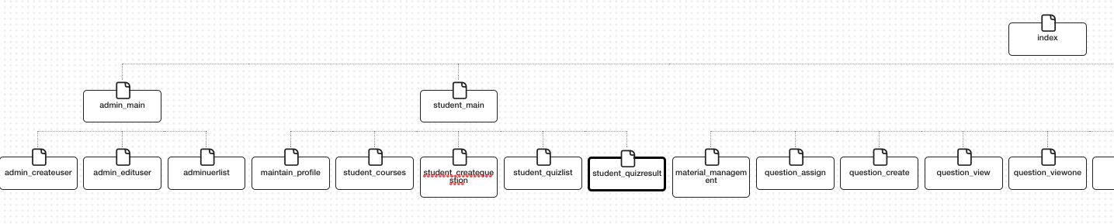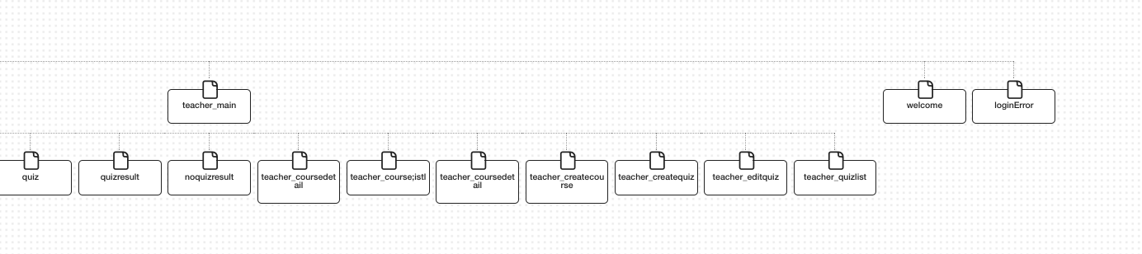

# System structure

In this section, we will illustrate how MVC Model is applied in the E-Learning system. There have 6 servlet controllers in this system. They are used in Course, Login, Material, Question, Quiz and User Management. There also have 6 model in this system.



In this report, An example is shown how the MVC applied in our system.

Login flow on MVC models

1. The browser sends the Login request data to the Container.
2. The Container finds the correct servlet based on the URL, and passes the request to the servlet.
3. The servlet calls the UserINfro for help
4. The expert class returns an answer, which the servlet adds to the request object   
   The servlet forwards the request to the JSP
5. The JSP gets the answer from the request object
6. The JSP generates a page for the Container
7. The Container returns the Home page to the user

# Database Structure

## Entity Relationship Diagram(ERD)

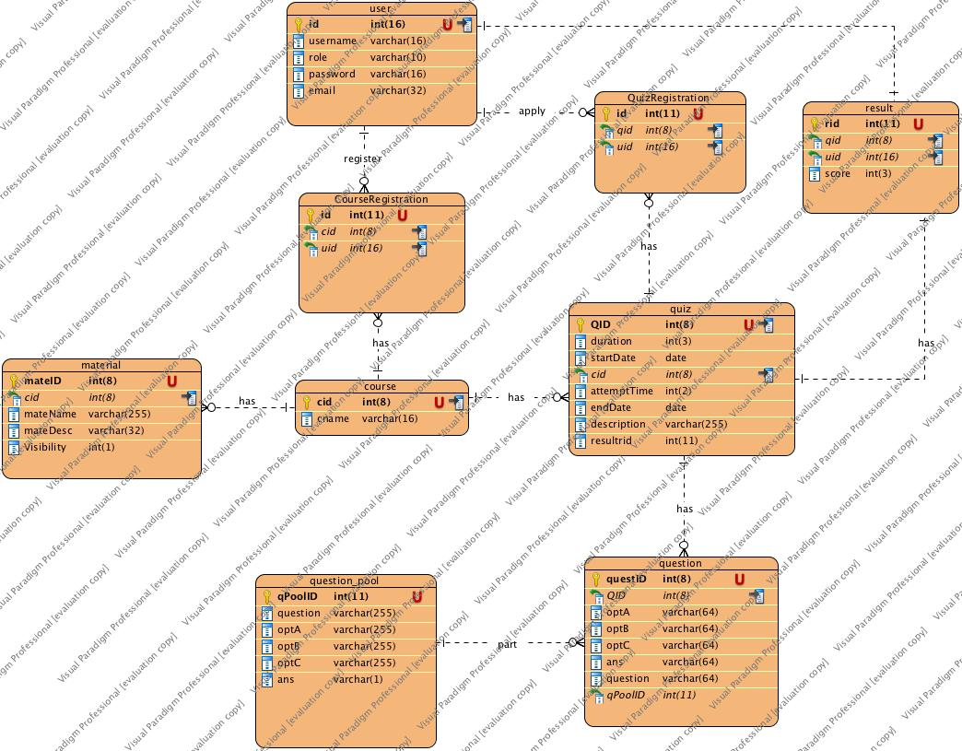

## Entity Table List

|  |  |
| --- | --- |
| No. | Entity Table |
| 1 | Course |
| 2 | CourseRegistration |
| 3 | Material |
| 4 | Question |
| 5 | Question_pool |
| 6 | Quiz |
| 7 | QuizRegistration |
| 8 | Result |
| 9 | User |

## Data Dictionary

1. Entity Course

|  |  |  |  |  |
| --- | --- | --- | --- | --- |
| Firld Name | Type | Size | Description | Require |
| cid | int | 8 | A number for identification of the course | Yes |
| cname | varchar | 16 | A number of the course | Yes |

1. Entity CourseRegistration

|  |  |  |  |  |
| --- | --- | --- | --- | --- |
| Firld Name | Type | Size | Description | Require |
| id | int | 11 | A number for identification of the course registration | Yes |
| cid | int | 8 | A number for identification of the course | Yes |
| uid | int | 11 | A number for identification of the user | Yes |

1. Entity Material

|  |  |  |  |  |
| --- | --- | --- | --- | --- |
| Firld Name | Type | Size | Description | Require |
| cid | int | 8 | A number for identification of the course registration | Yes |
| materID | int | 8 | A number for identification of the material | Yes |
| mateName | varchar | 255 | The Name of the material | Yes |
| mateDesc | varchar | 32 | The Description of material | Yes |
| Visibility | int | 1 | A number for the view privilege | Yes |

1. Entity Question

|  |  |  |  |  |
| --- | --- | --- | --- | --- |
| Firld Name | Type | Size | Description | Require |
| questID | int | 8 | A number for identification of the question | Yes |
| QID | int | 8 | A number for identification of the qiuz | Yes |
| optA | varchar | 64 | The option A of question | Yes |
| optB | varchar | 64 | The option B of question | Yes |
| optC | varchar | 64 | The option C of question | Yes |
| ans | varchar | 64 | The answer of this question | Yes |
| question | varchar | 64 | The detail of question | Yes |

1. Entity Question_pool

|  |  |  |  |  |
| --- | --- | --- | --- | --- |
| Firld Name | Type | Size | Description | Require |
| qPoolID | int | 11 | A number for identification of the question pool | Yes |
| questID | int | 8 | A number for identification of the question | Yes |
| QID | int | 8 | A number for identification of the qiuz | Yes |
| optA | varchar | 64 | The option A of question | Yes |
| optB | varchar | 64 | The option B of question | Yes |
| optC | varchar | 64 | The option C of question | Yes |
| ans | varchar | 64 | The answer of this question | Yes |

1. Entity Quiz

|  |  |  |  |  |
| --- | --- | --- | --- | --- |
| Firld Name | Type | Size | Description | Require |
| QID | int | 8 | A number for identification of the quiz | Yes |
| duration | int | 3 | The duration per quiz | Yes |
| startDate | date |  | The start date of quiz | Yes |
| cid | int | 8 | A number for identification of the corresponding course | Yes |
| attemptTime | int | 2 | the attempt of the quiz | Yes |
| endDate | date |  | The end date of quiz | Yes |
| description | varchar | 255 | the description of quiz | Yes |

1. Entity QuizRegistration

|  |  |  |  |  |
| --- | --- | --- | --- | --- |
| Firld Name | Type | Size | Description | Require |
| id | int | 11 | A number for identification of the course registration | Yes |
| qid | int | 11 | A number for identification of the quiz | Yes |
| uid | int | 11 | A number for identification of the user | Yes |

1. Entity Result

|  |  |  |  |  |
| --- | --- | --- | --- | --- |
| Firld Name | Type | Size | Description | Require |
| id | int | 11 | A number for identification of the course registration | Yes |
| qid | int | 11 | A number for identification of the quiz | Yes |
| uid | int | 11 | A number for identification of the user | Yes |
| score | int | 3 | A score of the corresponding quiz | Yes |

1. Entity User

|  |  |  |  |  |
| --- | --- | --- | --- | --- |
| Firld Name | Type | Size | Description | Require |
| id | int | 16 | A number for identification of the user | Yes |
| userame | varchar | 16 | The name of user | Yes |
| role | varchar | 10 | The role of user | Yes |
| password | varchar | 16 | the password of the user account | Yes |
| email | varchar | 32 | the email of user | Yes |

# Brief description of application

In this section of report, the characteristics or the design of E-Leaning Application will be briefly descripted.

This application has 3 roles. They are students, teachers and administrator. They can login the system. After they login the system the corresponding homepage will be showed.

Students can practice exercises and submit their work through the system. In addition to the student learning and assessment functionality, the system provides account management and assessment reporting for administrative purposes.

the system automatically collects academic results and statistical data. It enables teacher to understand and analyse student learning.

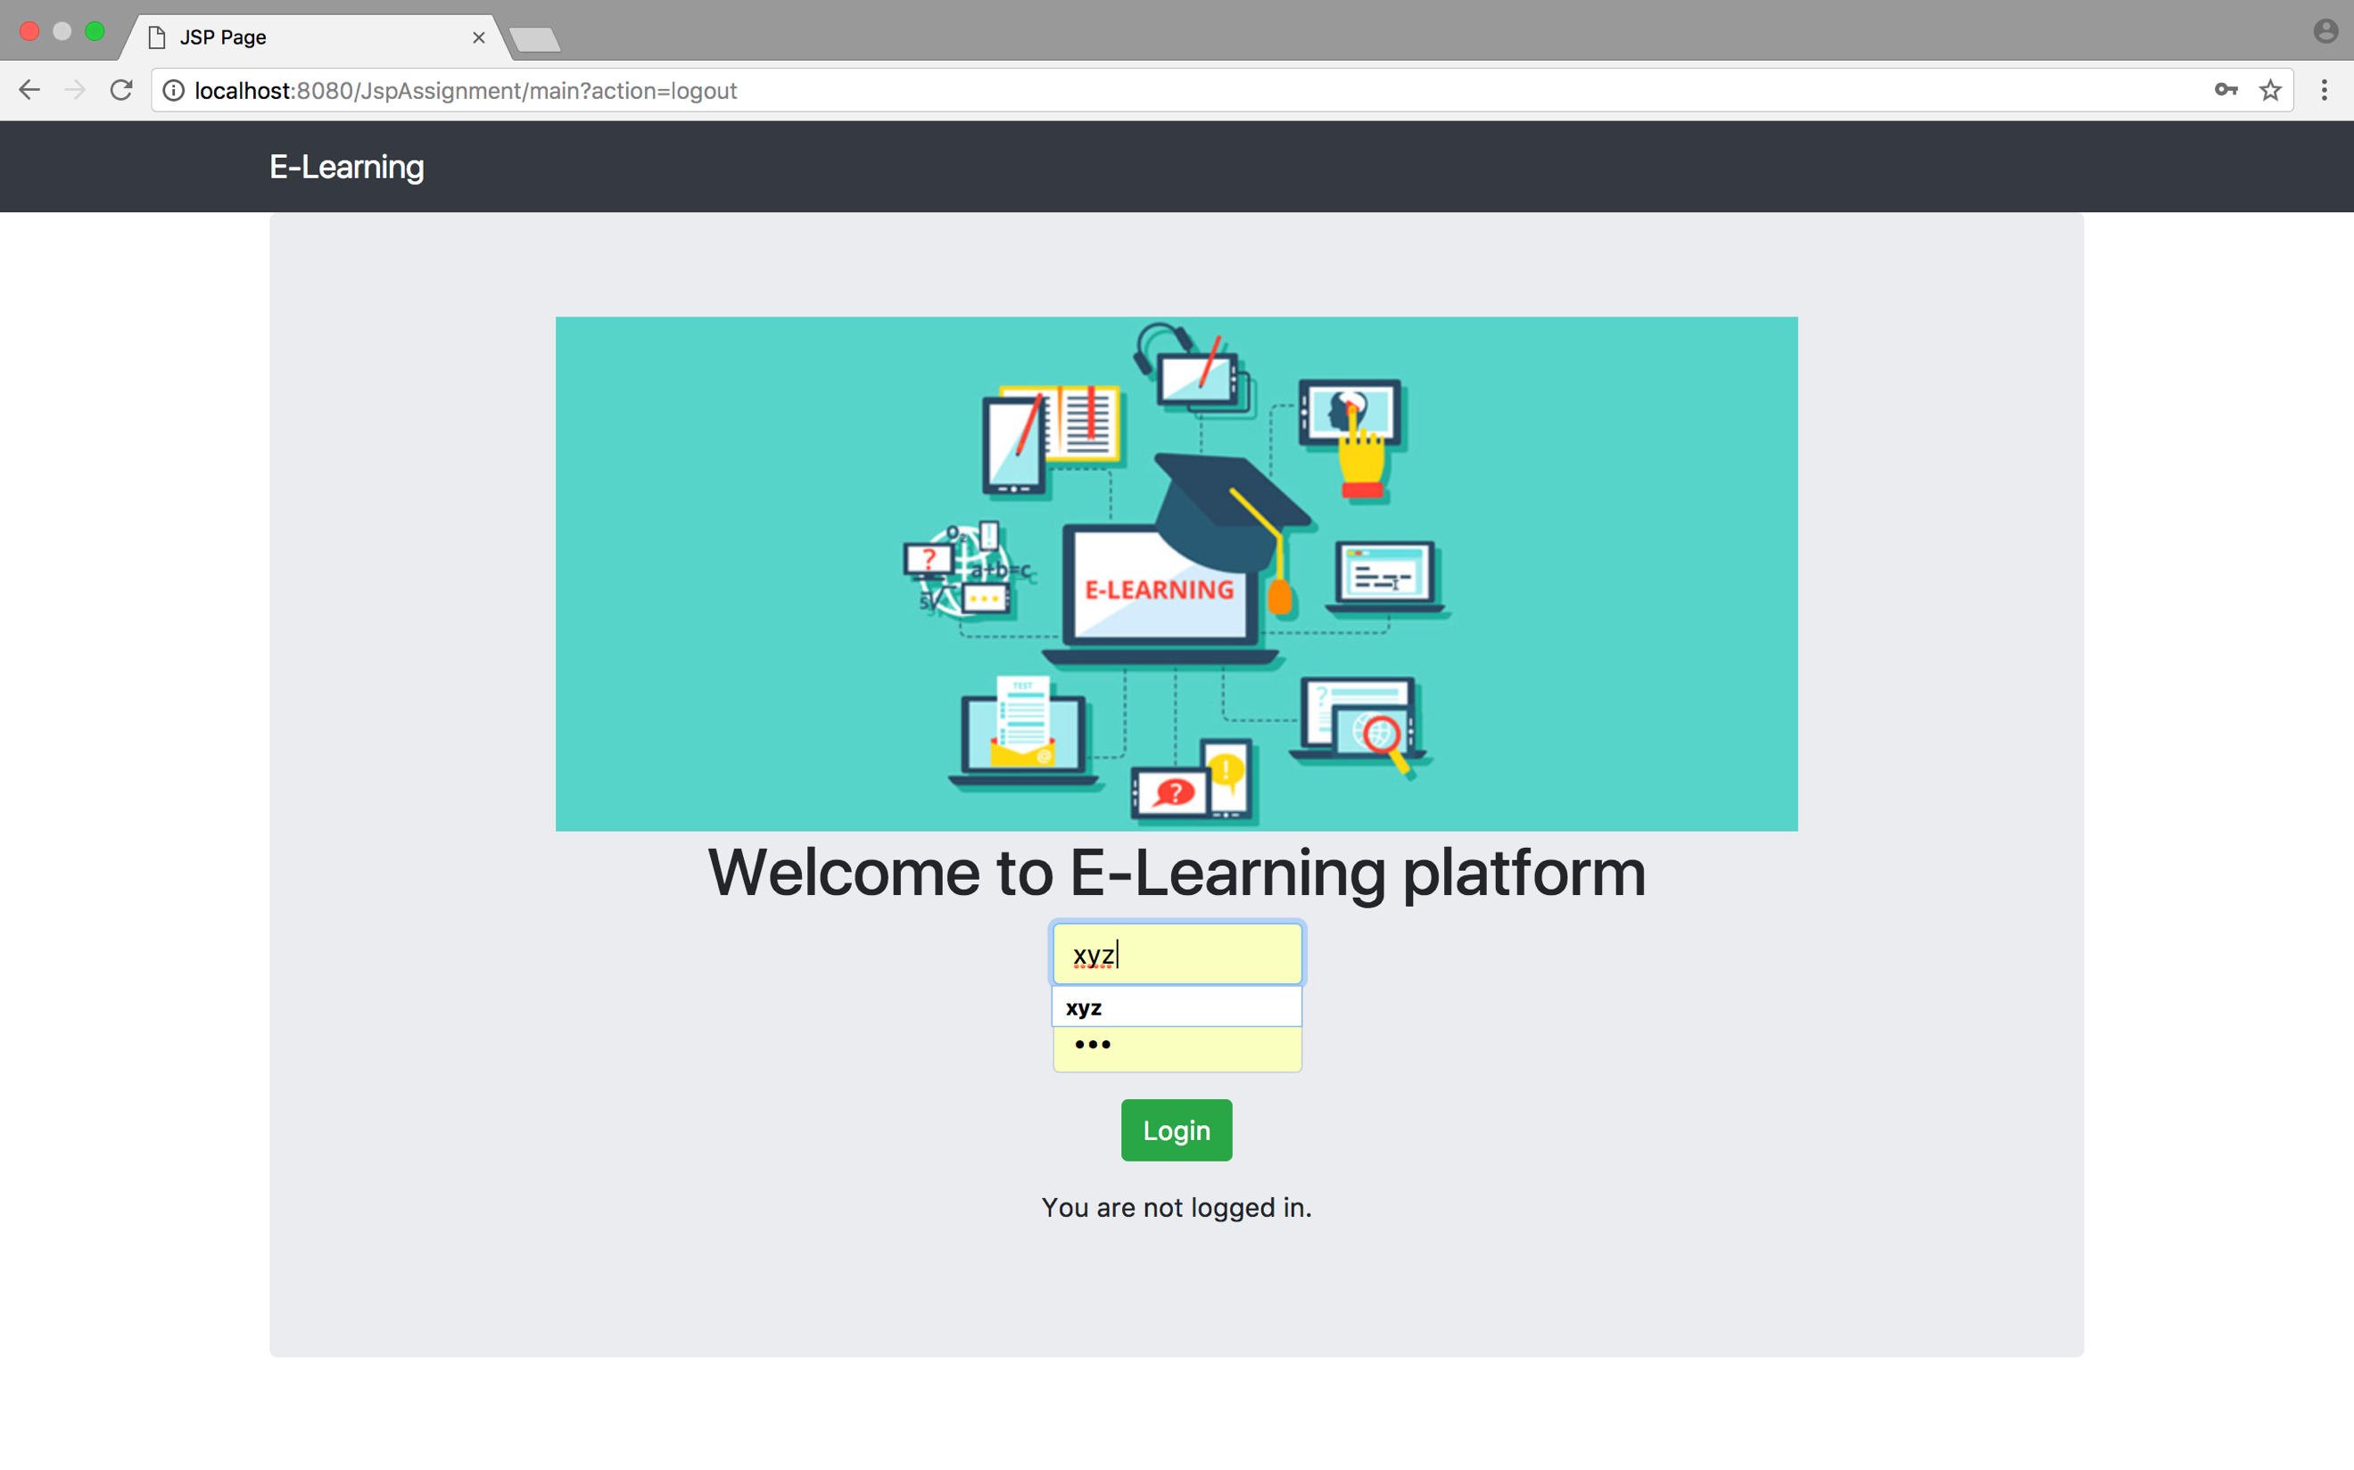

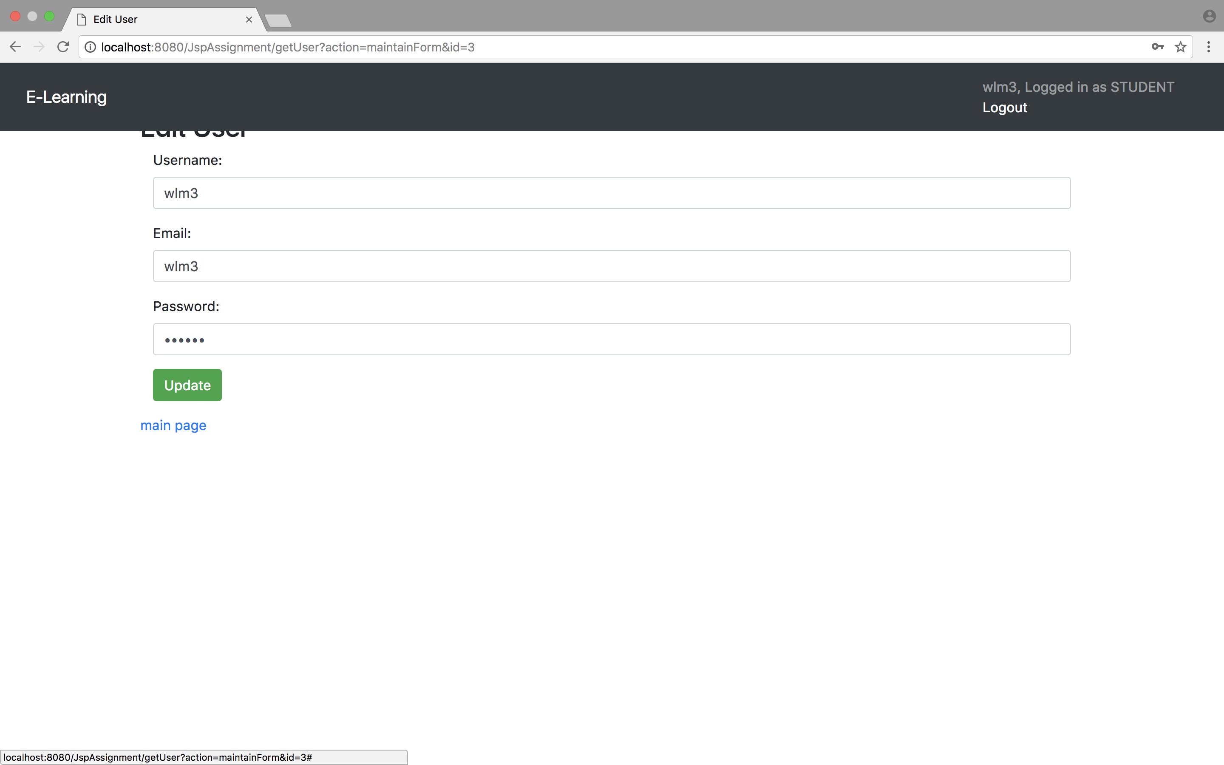

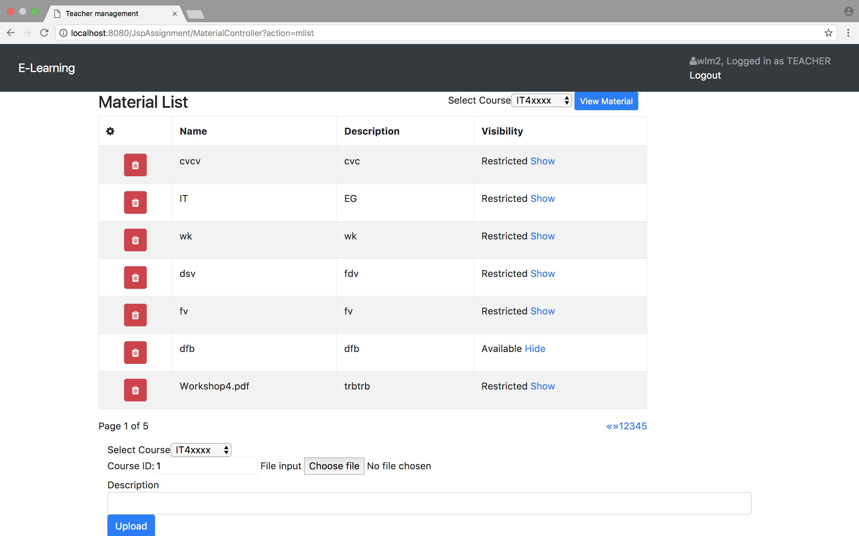

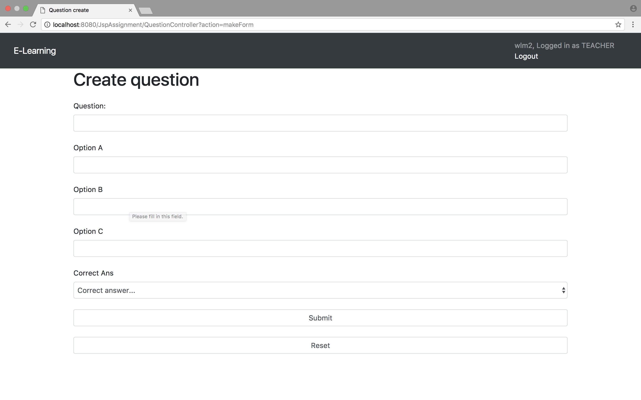

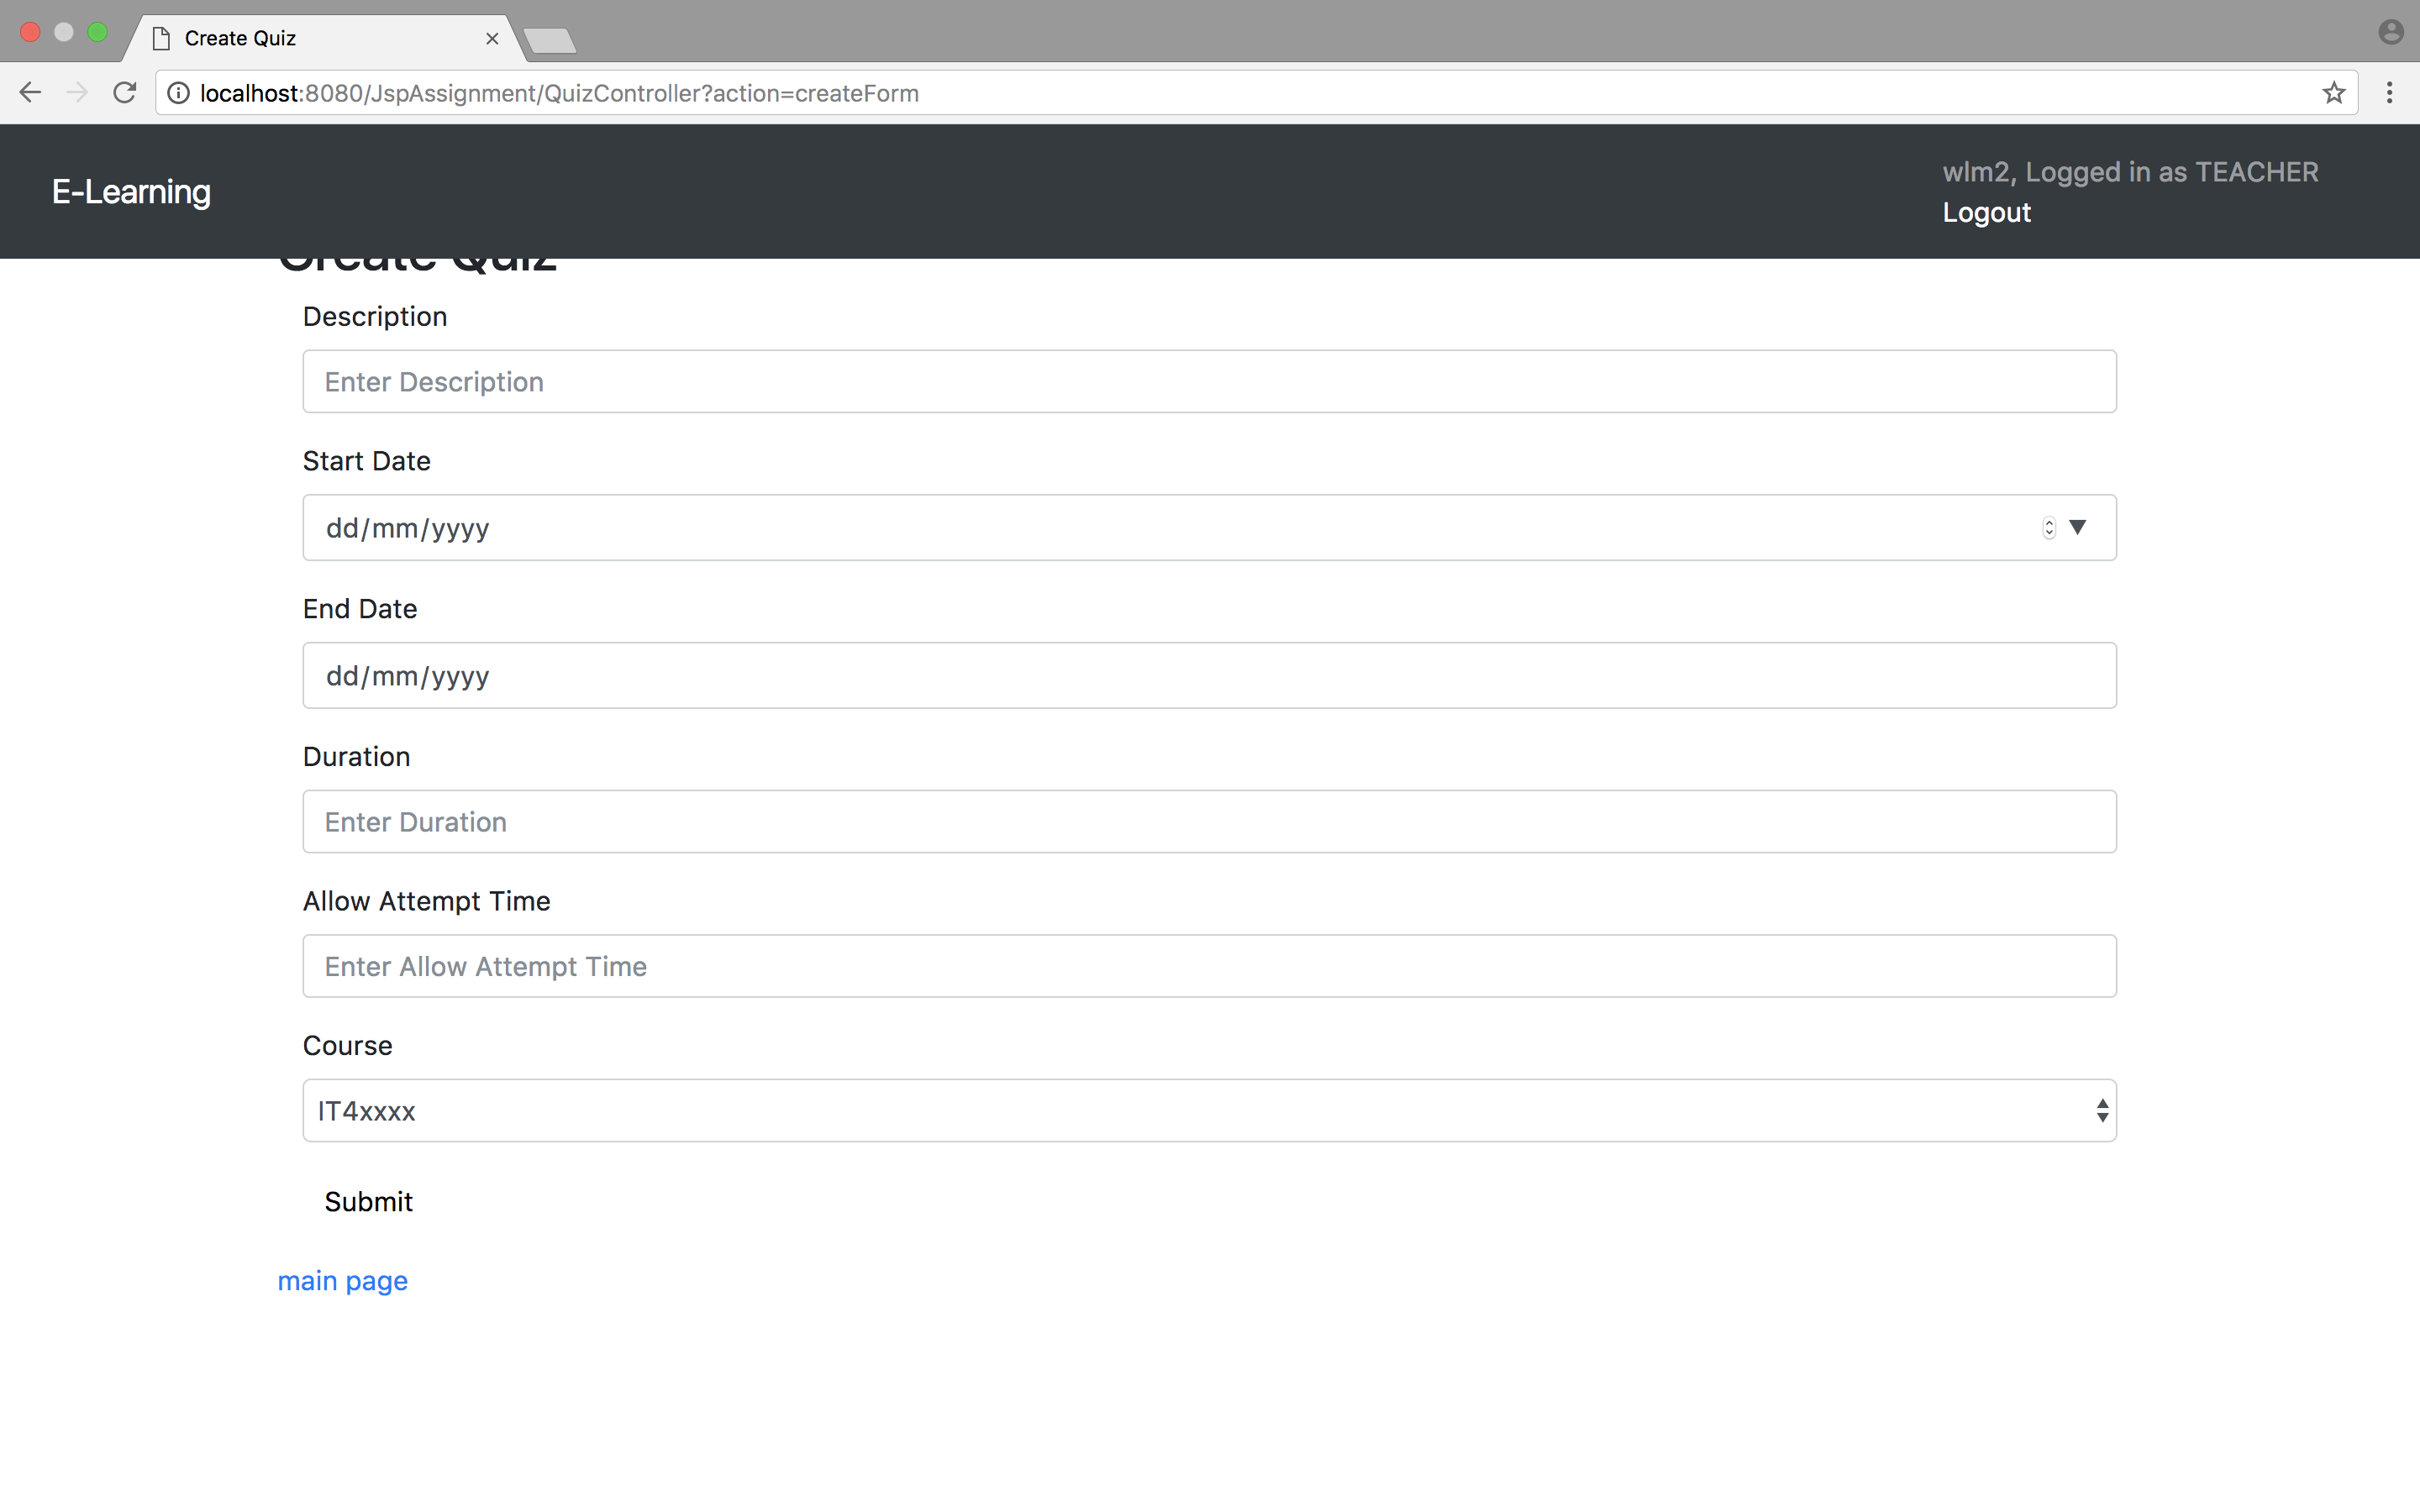

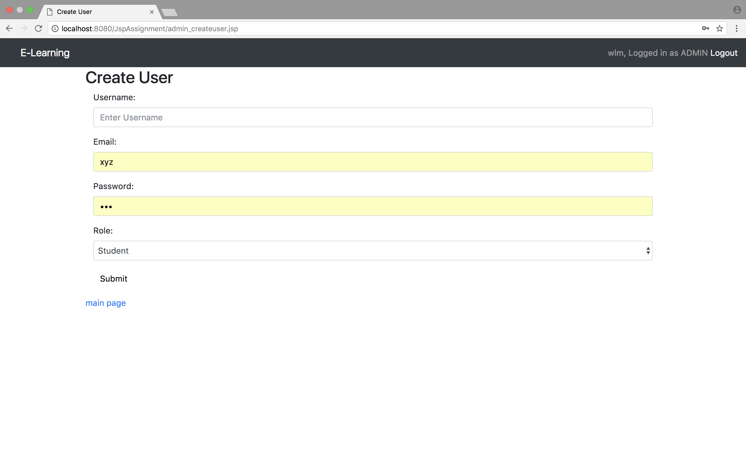

# Conclusion

In this project, The E-Learning system is built. It can achieve the objective of promoting IT in education. It can improve the quality of learning. E-Learning platform enable an open and flexible learning mode. It facilitates the students’ learning process by allowing interacting with learning material, as well as collaborating with their peers. It provides an interesting and effective learning experiences.

# Skill checklist

|  |  |
| --- | --- |
| Skill | Check |
| Use Jsp/Servlets to dynamically generate HTML pages | checked |
| Use Jsp/Servlets to accept user inputs from brower | checked |
| Use Jsp Action | checked |
| Use Custom Tag | checked |
| Use JavaBean | checked |
| Use JDBC for database connection | checked |
| Use session checking | checked |
| Use login control | checked |
| Apply MVC model | checked |