Insert news:

1st

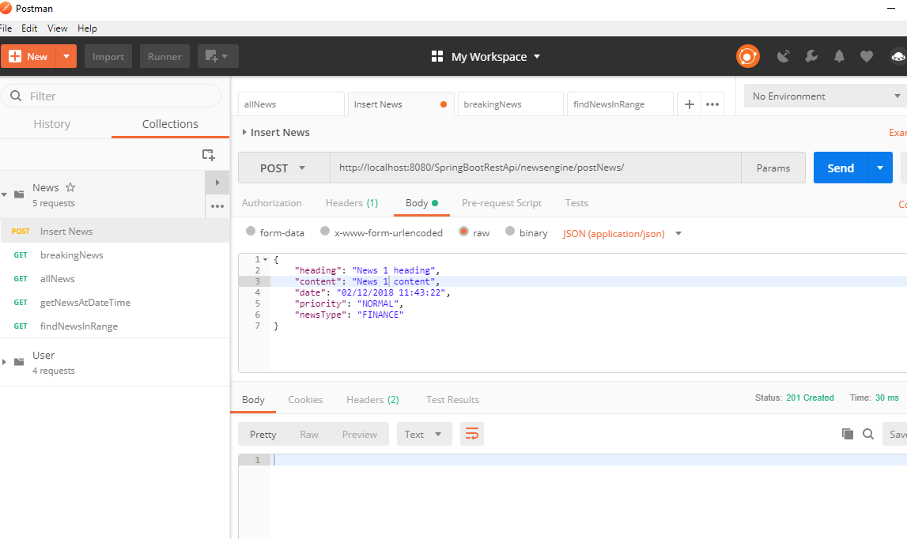

2nd

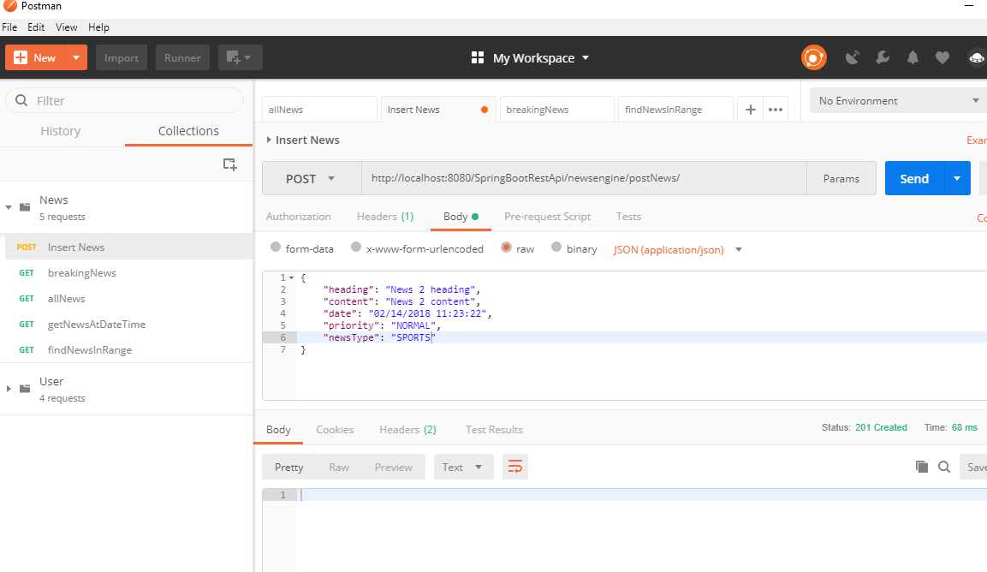

3rd

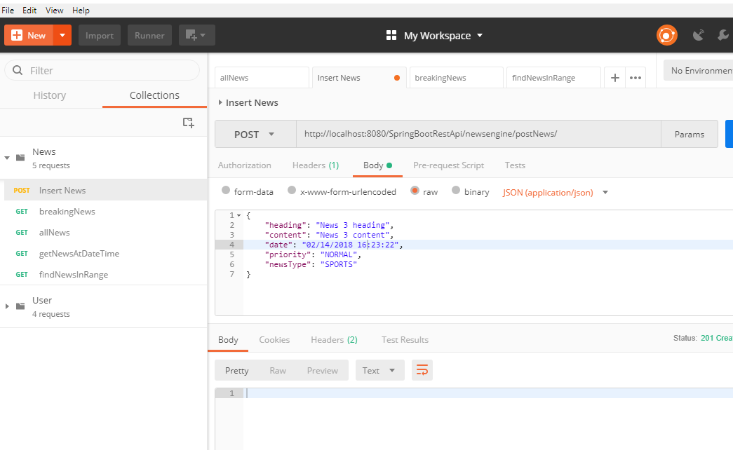

4th

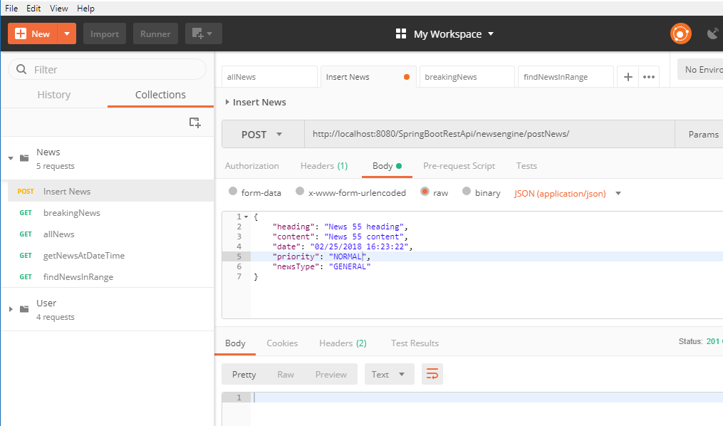

Adding Breaking News

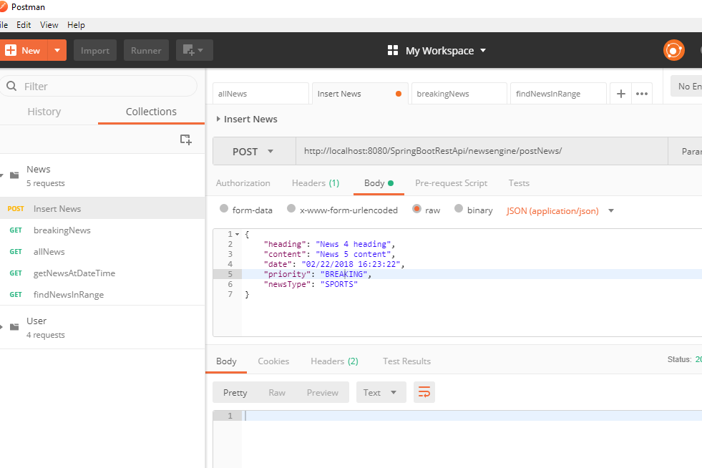

Addedd 2nd breaking news:

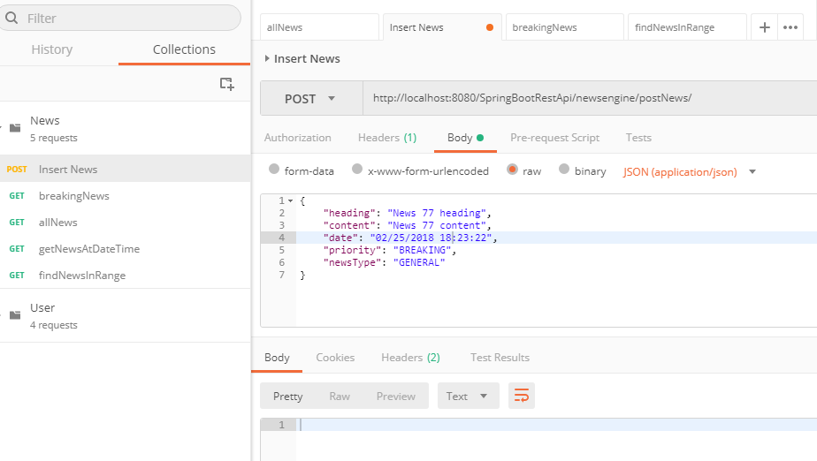

3rd Breaking news:

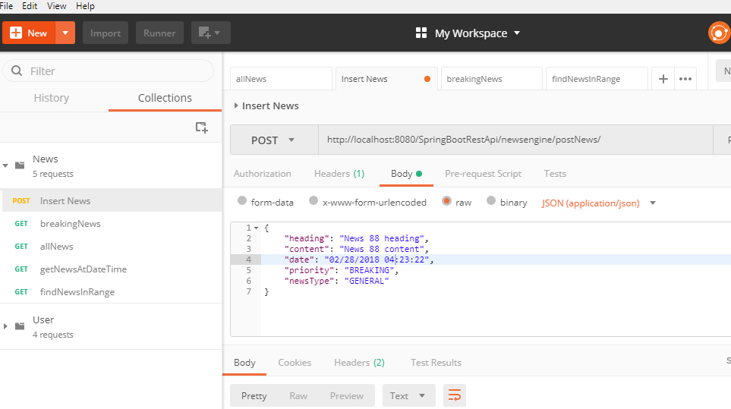

Get all News(brings only non-BREAKING news):

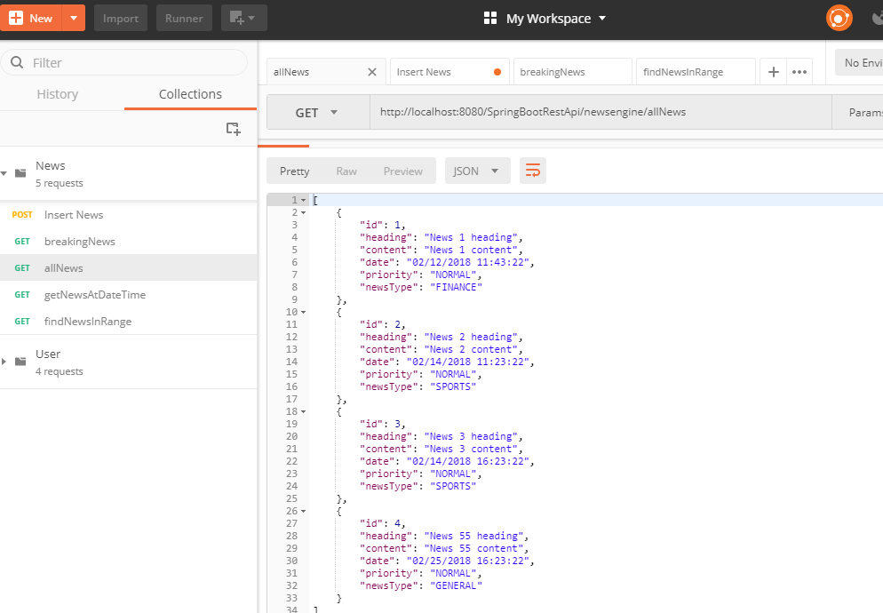

Using same API “allNews” with parameter “&priority=BREAKING” brings only breaking news. This brings only last 2 breaking news. I have kept max breaking nes count 2 in stead of 100 to make testing easy.

