Dextrus v2.0 Robotich Hand – Getting Started Guide

# Introduction

This guide is for the Dextrus v2.0 robotic hand released under the Open Hand Project with the [Creative Commons Attribution-ShareAlike 4.0 International License](http://creativecommons.org/licenses/by-sa/4.0/). The Dextrus v2.0 is a 5 degree of freedom robotic hand.

**Before plugging in the robot hand, please read this guide.**

# Components

You should have the following components:

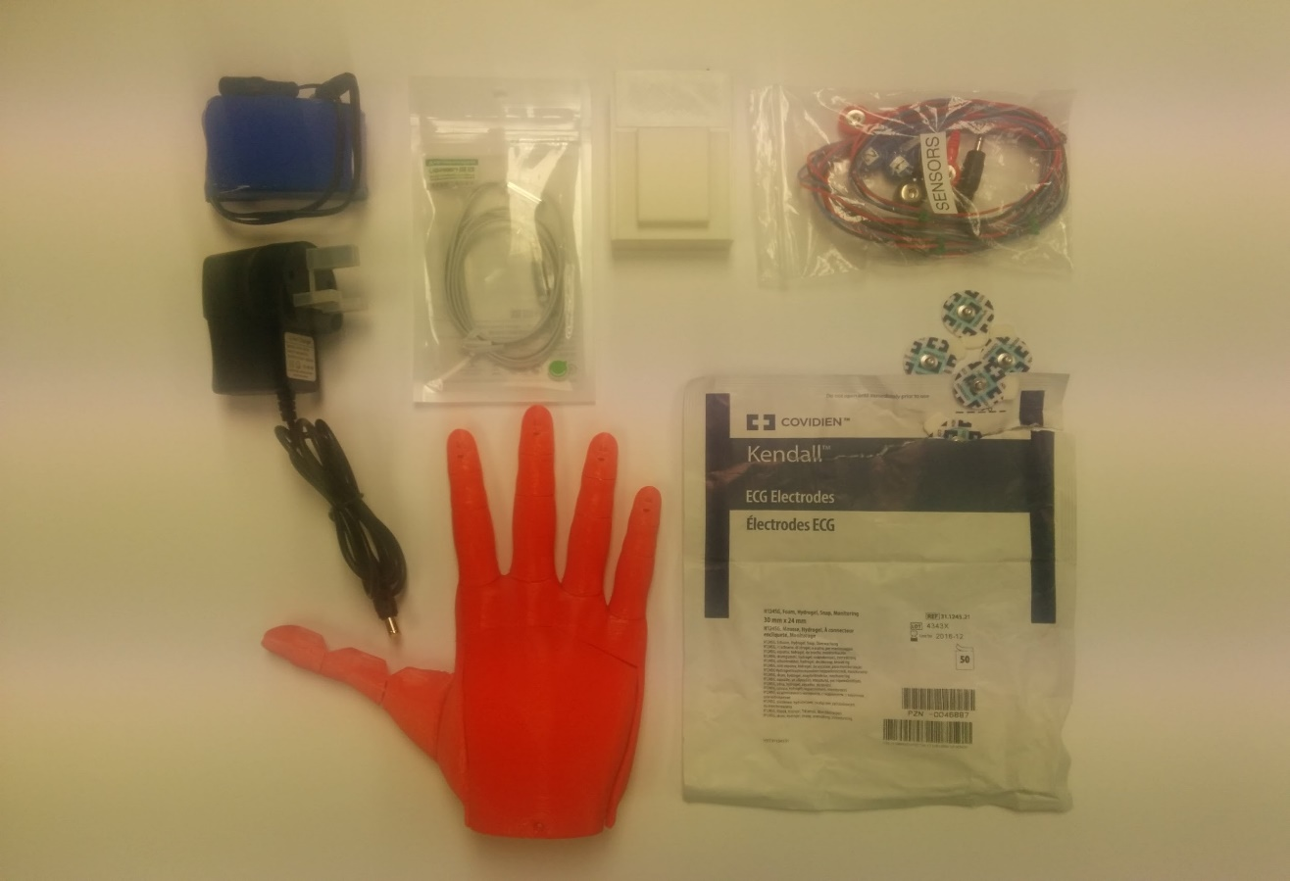

1. Battery
2. Charger
3. Headphone Cable (white)
4. EMG Box
5. EMG Cables
6. EMG Electrodes
7. Dextrus v2.0

# 

# Muscle Control

Electromyography (EMG) electrodes are used to measure muscle signals, which are then used by the robot hand to perform a movement (open/close) or to change grip pattern (fist grip/thumbs up etc.).

Electrode Placement

There are two channels of EMG signals that read signals from two muscles. Each channel has two electrodes and there is a ground electrode so there are 5 electrodes in total. The image below shows the cables that connect the electrodes to the EMG box.

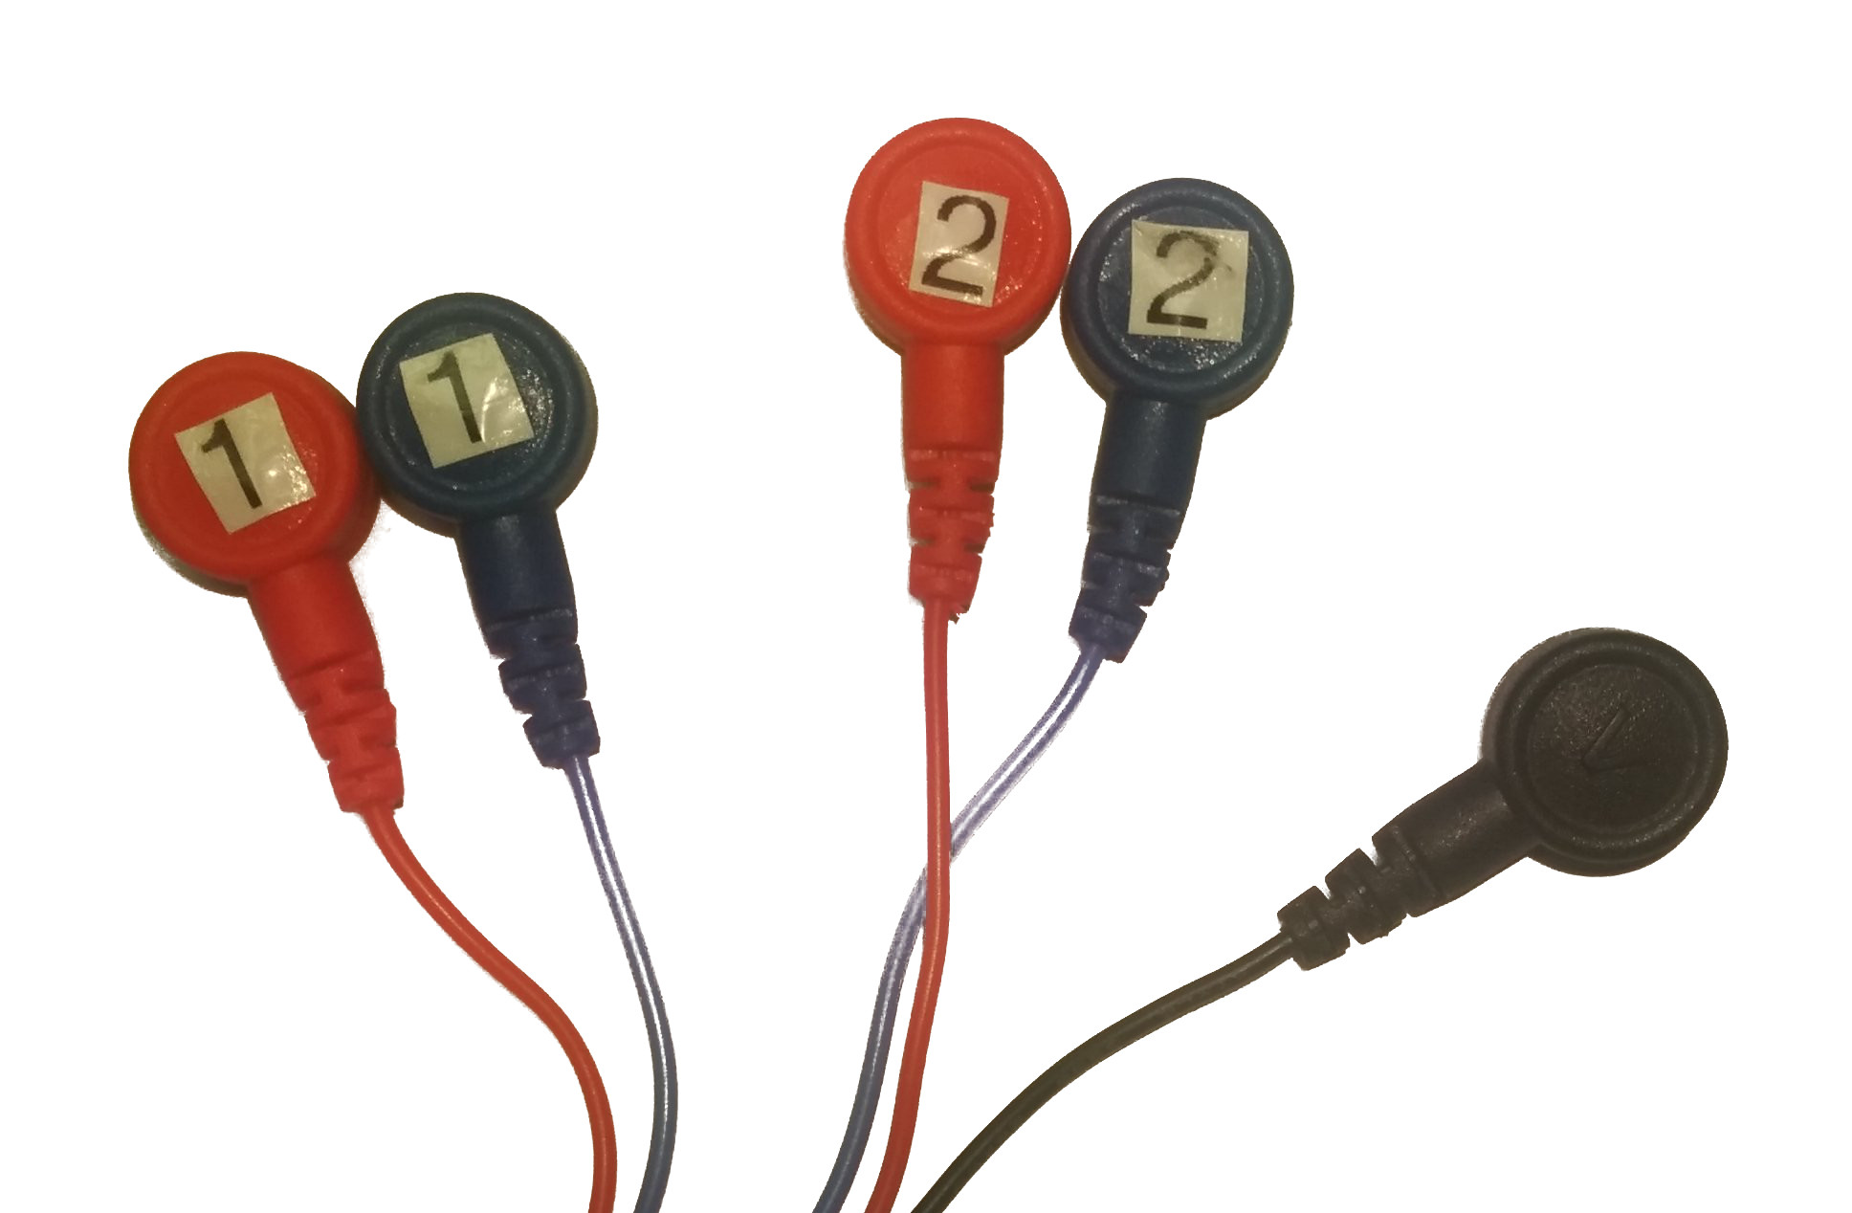

Ground

Channel 1

Channel 2

The electrodes are circular stick-on pads, which need to be placed where there is the most muscle activity. The electrodes can be placed anywhere on the body, but we recommend placing them on the inside and outside of the forearm. *An alternative to this is to place the sensors on the back of the shoulder and on the pectoral muscle.* The images below (figure 1 and figure 2) show the recommended muscle placement.

Channel 1

Channel 2

Ground

Outside Forearm

Inside Forearm

Elbow

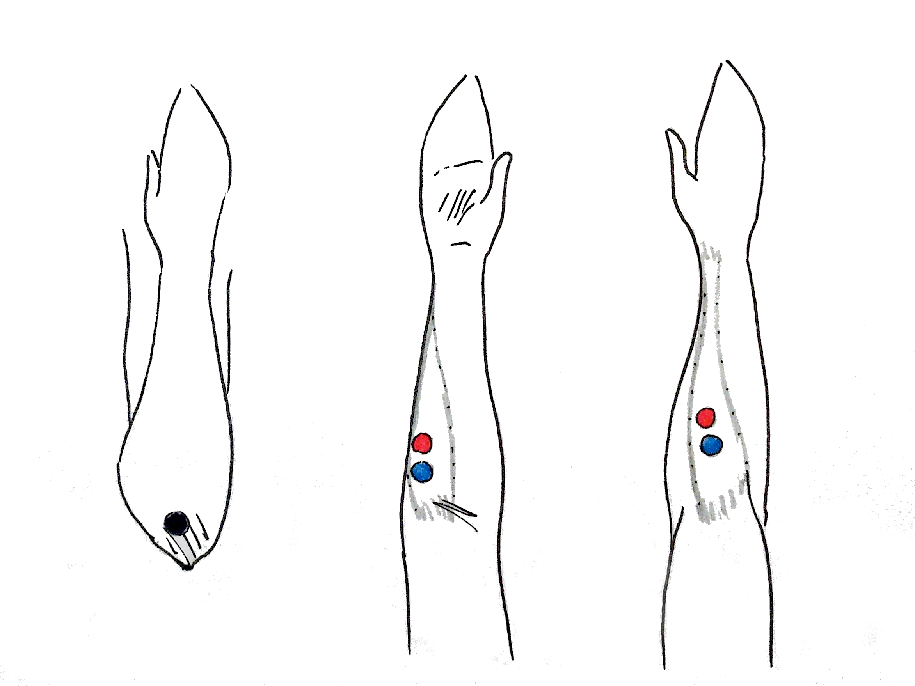

Figure – Electrode placement on forearm

Pectoral

Shoulder

Ground

Channel 1

Channel 2

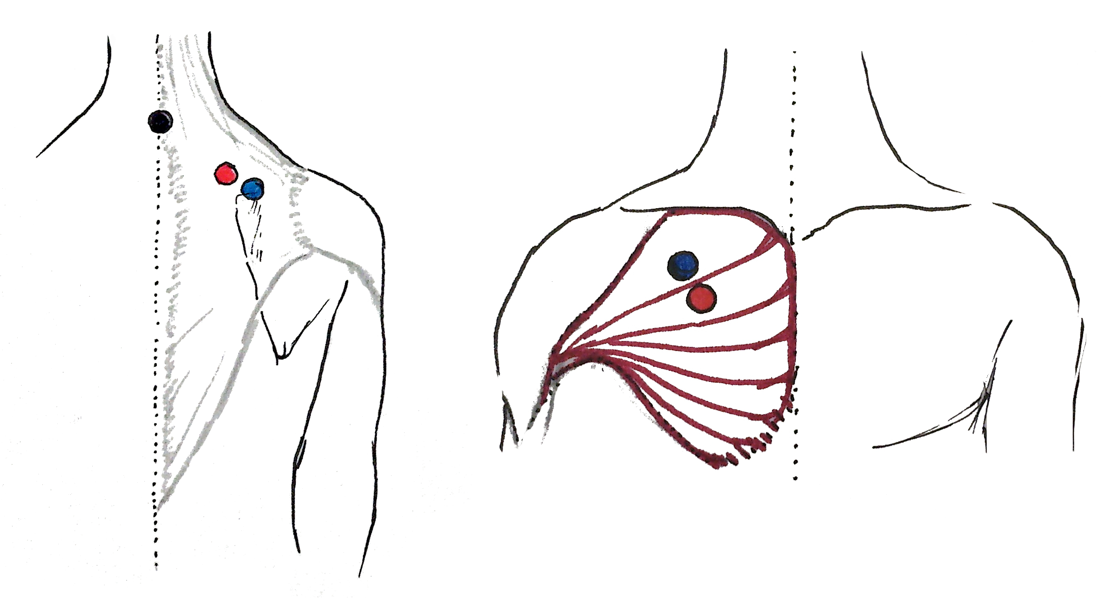

Figure - Electrode placement on pectoral and shoulder

To determine the correct positioning of the sensors on the inside of the forearm, imagine bending your wrist so that all of your fingers are pointing towards your elbow (as seen in the ‘Close’ movement of figure 3). Then touch the inside of your forearm to feel the location where the forearm muscle flexes. Stick two electrode pads to this muscle, leaving a 1cm gap between them, then attach the blue and red EMG wires of ‘channel 1’ to these electrode pads (see the ‘Inside forearm’ diagram in Figure 1).

Open

Close

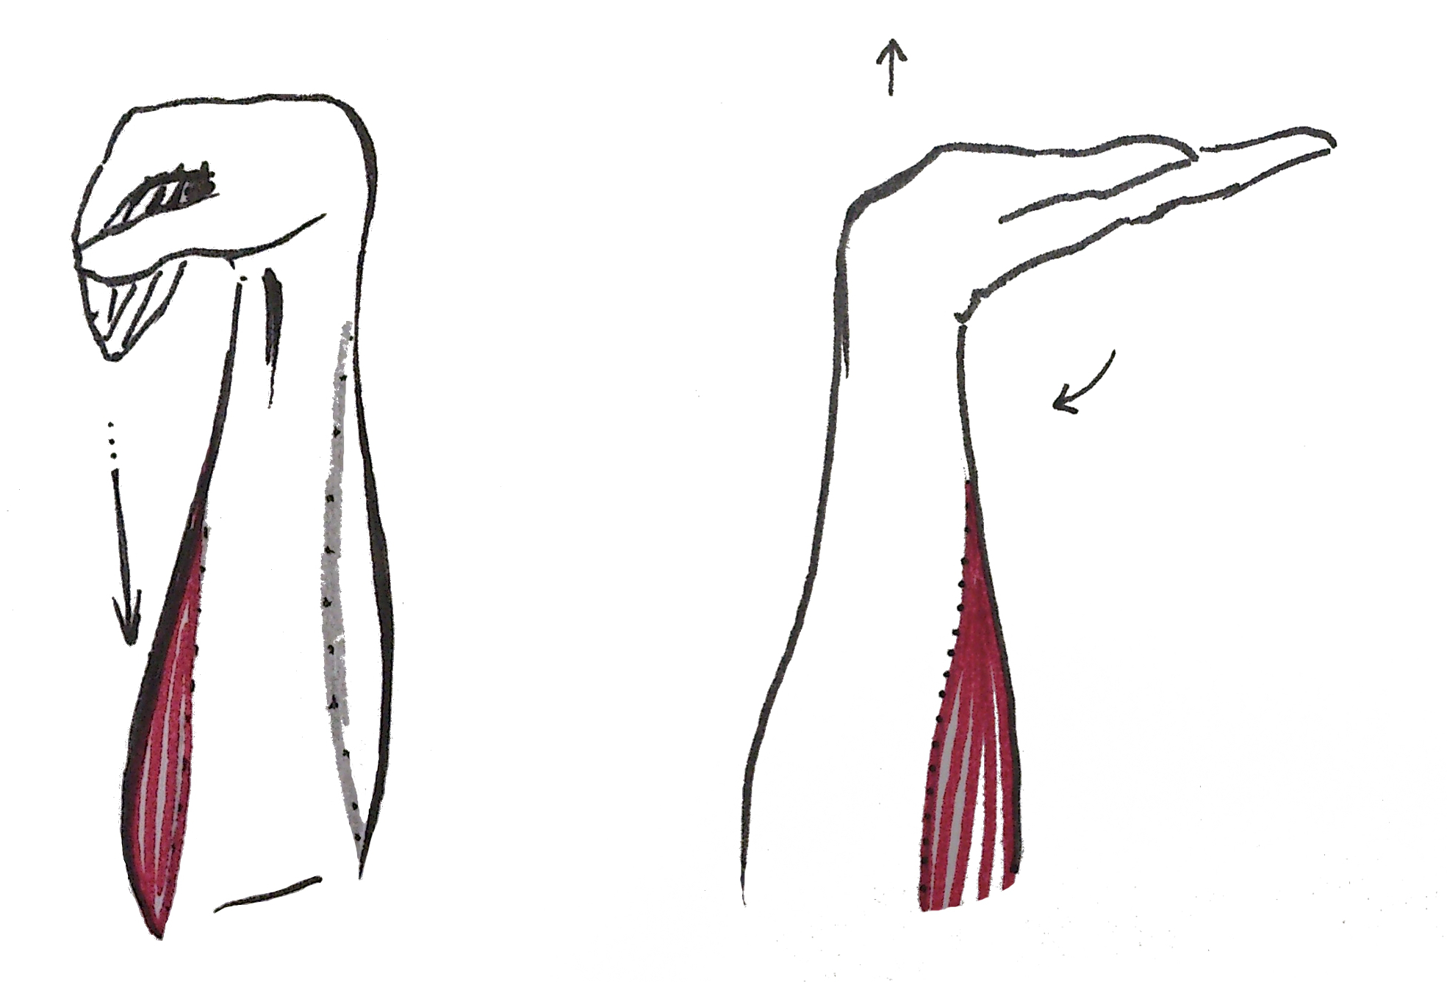

Figure - Closing and opening movements

Now imagine bending the wrist backwards (the ‘Open’ movement in figure 3) touching your outside forearm to feel where the muscle flexes. Stick two electrode pads to this muscle, leaving a 1cm gap between them, then attach the blue and red EMG wires of ‘channel 2’ to these electrode pads (the ‘Outside forearm’ section of figure 1). The black ‘ground’ electrode should be stuck on an area where there is little muscle activity, such as the elbow (‘elbow’ from figure 1).

*Alternatively attach ‘channel 1’ to an area of the pectoral muscle that you have the most control over when tensing, then attach ‘channel 2’ to your shoulder muscle and the ‘ground’ to the top of your spine (figure 2).*

Connecting the Wires

Pop the EMG cables into the electrodes as described above and shown below.

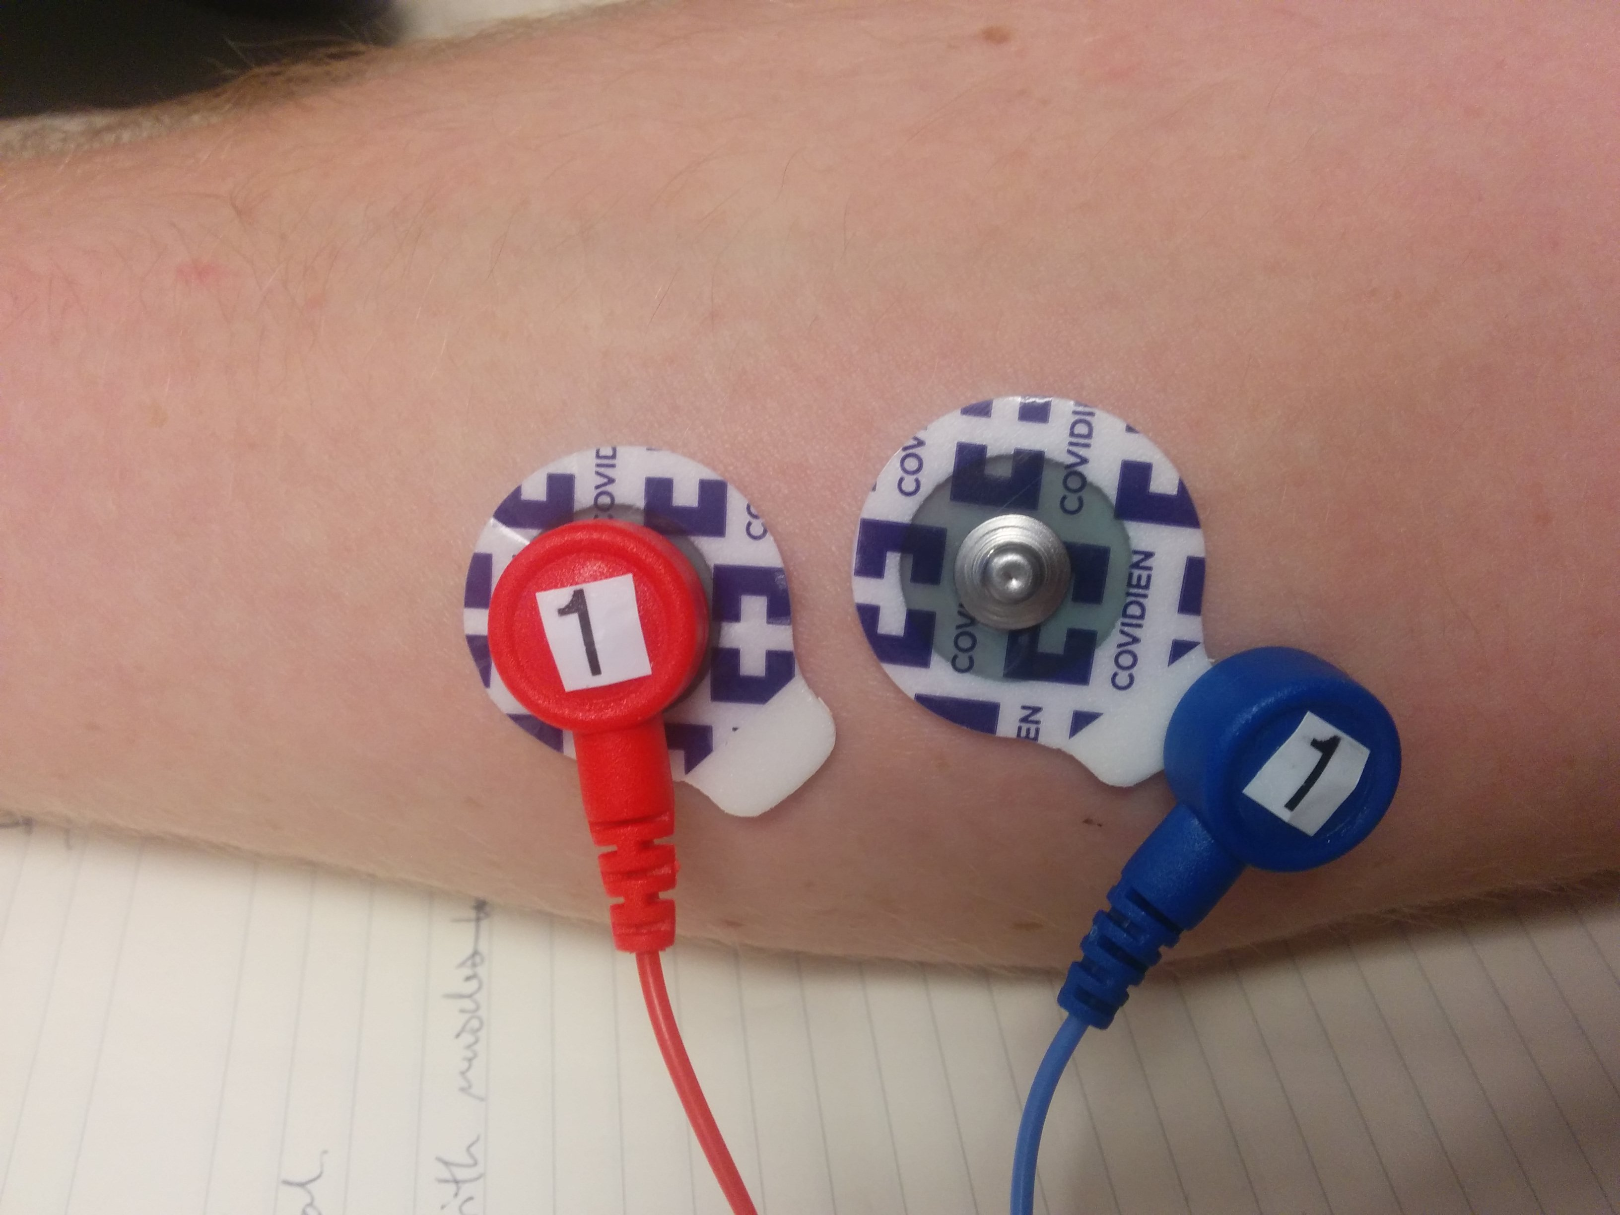

Once you’ve stuck on all of the electrodes and popped all of the EMG cables onto them the next step is to plug the cables into the EMG box. Plug the EMG cables into the EMG box (they should both plug into the black holes on the same side as the belt clip). Then take the white headphone cable and plug the straight end into the remaining sliver hole on the EMG box (figure 4). Finally plug the other end of the white headphone cable into the middle connection of the robot hand (the 90° connector should be plugged into the hand) (figure 5).

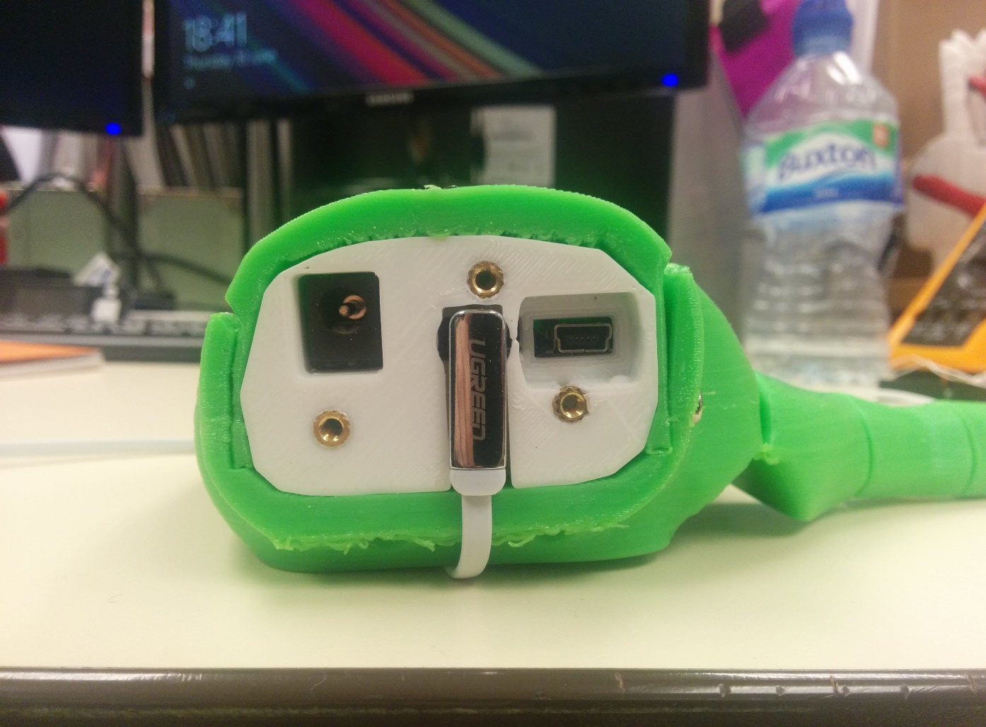

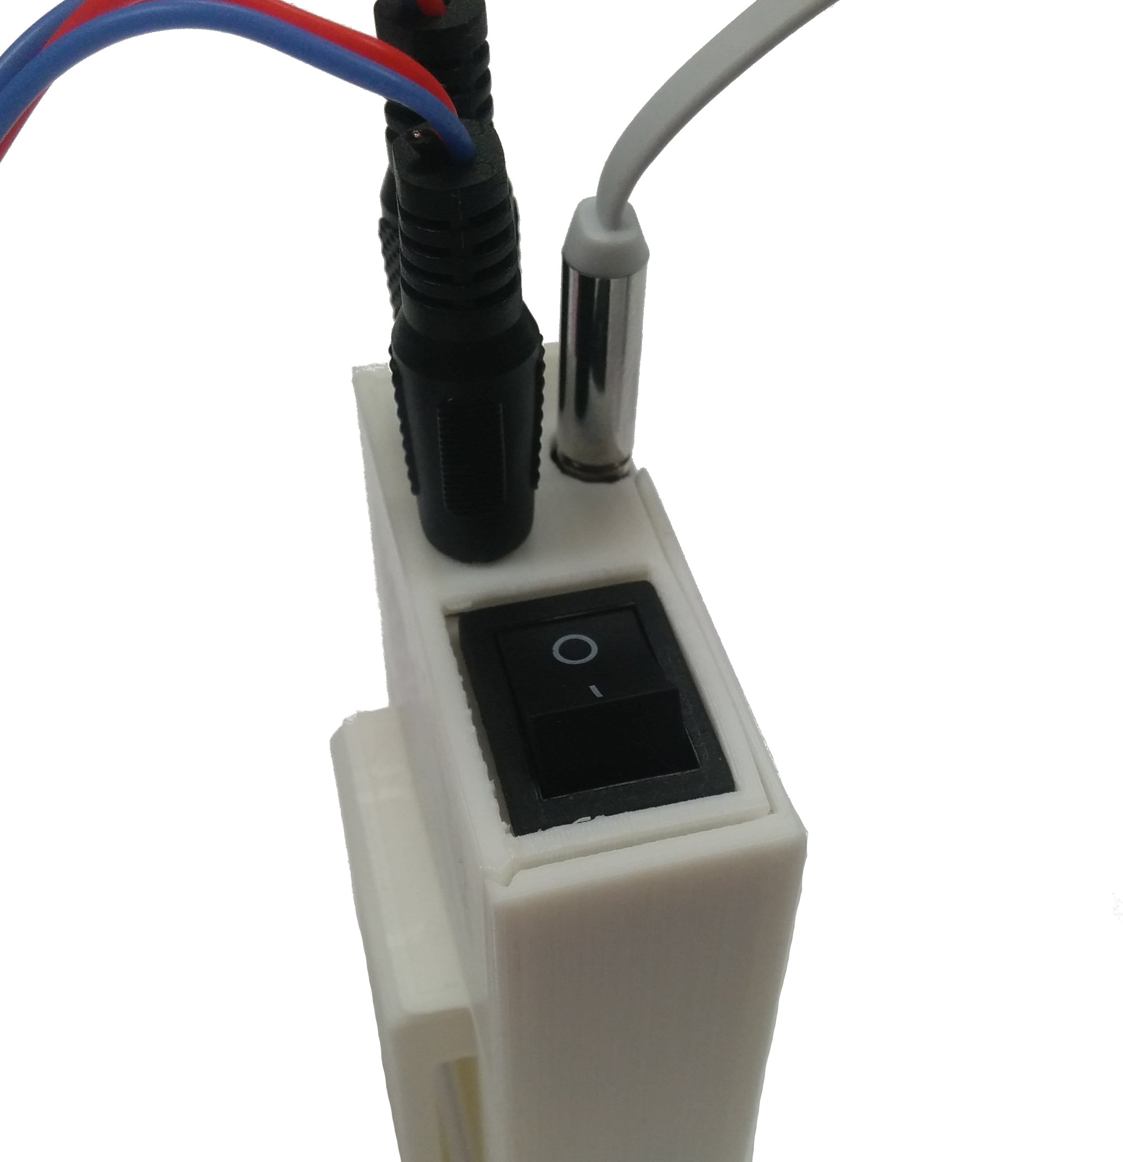

Figure - EMG cables and headphone cable Figure - Headphone jack connection to hand

## Controlling the robot hand with your muscles

The hand is controlled with the open and close movements shown in figure 3, practise these muscle flexes before turning anything on.

Make sure all of the connections are wired up correctly and switch the EMG box on. The EMG box runs off two replaceable 9V batteries which should last for at least a weeks use, these should be switched off when not in use.

The hand has no on/off switch so simply plug the battery in to turn it on.

After plugging the battery into the robot hand, the system needs to learn your muscle characteristics. Don’t worry if it is moving when you first turn it on. First keep your muscles relaxed for a duration of around 10 seconds, then perform a series of open and close movements. An ‘Open’ movement is where you tense the forearm muscle on the outside/back of your arm, which can be achieved by imagining the action of bending your hand backwards at the wrist. A ‘Close’ movement is where you tense the inside forearm muscle, which can be achieved by imagining that you are bending your hand forwards at the wrist (figure 3). With practice, the forearm muscles can be tensed by performing the actions of spreading and clenching your hand (Figure 6).

Open

Close

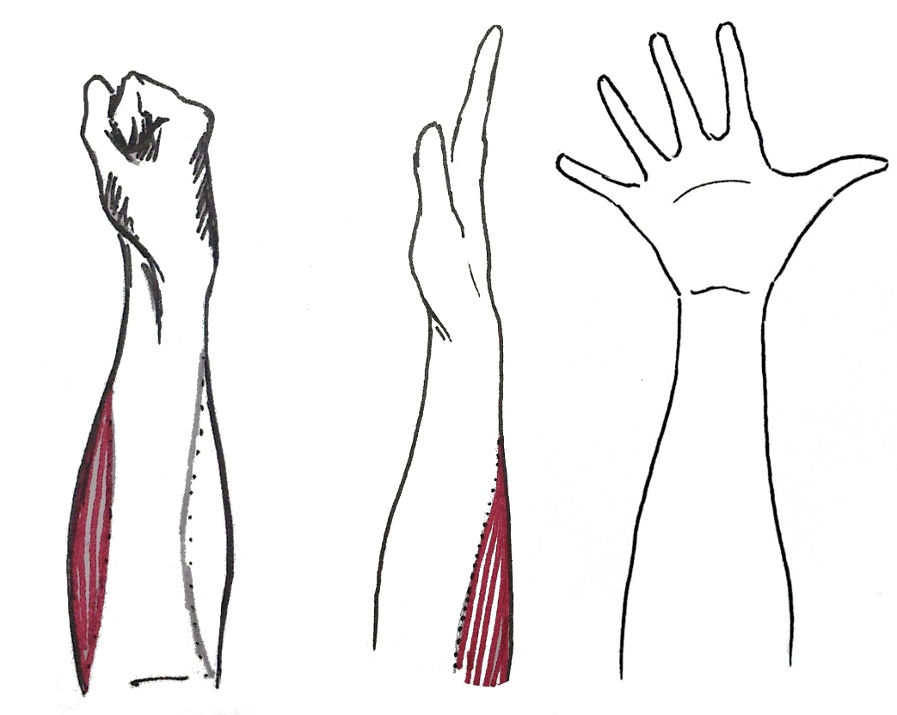

Figure 6 - Alternative open/close movements

If you find yourself having to tense your muscles quite hard, try tensing with less force a few times, the robot hand dynamically adjusts threshold values to suit the muscle strength. The hand may seem unreliable at recognising muscle movements after initial turn on, however performing the ‘relax, open, close, open, close ...’ configuration sequence a few times should allow the hand to adjust to your muscle signals.

If the hand consistently moves in the opposite direction (i.e. you imagine performing an ‘Open’ movement and the hand ‘Closes’), try switching the sensor channels (switch around the 2 connectors plugged into the black holes of the EMG box).

Changing grip pattern

The robot hand will default to the ‘fist grip’ pattern, but this grip pattern can be changed using your muscles. When the robot hand is in the ‘Open’ position, the grip pattern can be changed by holding an ‘Open’ movement for a few seconds (tensing the muscle on the outside of your forearm). This will cycle through the following grip patterns in order.

1. **Fist grip**
   * All fingers move and thumb only opens partially
   * Best suited for picking up bottles or gripping objects firmly
2. **Palm grip**
   * All fingers move and the thumb remains in the open position
   * Best suited for carrying bags or gripping tall thin objects
3. **Thumbs Up**
   * All fingers remain closed and the thumb opens/closes
4. **Point**
   * All fingers remain closed and the index finger opens/closes
   * Best suited for pushing buttons or an alternative to the pinch grip
5. **Pinch**
   * All fingers remain closed and only the thumb and finger open/close
6. **Tripod**
   * Pinky and ring finger remain closed and the other fingers and thumb open/close

**If you have any issues please contact Joel Gibbard** [**joelgibbard@openbionics.com**](mailto:joelgibbard@openbionics.com)**. Please note this device is still a prototype and is not yet a polished product, your feedback will help us improve the design further so get in touch, we’d love to hear from you.**

# Advanced Hand Setup

The Dextrus v2.0 robotic hand can also be controlled using commands from your computer, which involves entering commands into a terminal program, which then sends the commands over the USB cable to the robot hand. The microcontroller within the hand then interprets these commands and performs the required action.

Upon powering up the hand, the hand first opens, it then waits 5 seconds and enters a demo mode, where it cycles through the various predefined grips.

## Installing Termite

If you do not already have a terminal program installed, we recommend using Termite.

### 1. Download Termite

Follow the link to download Termite <http://www.compuphase.com/software/termite-3.1.exe>

### 2. Install Termite

Click the downloaded file ‘termite-3.1.exe’ and follow through the installation assistant using the default settings.

### 3. Configure Termite

Upon running Termite, you should be greeted with the screen below.

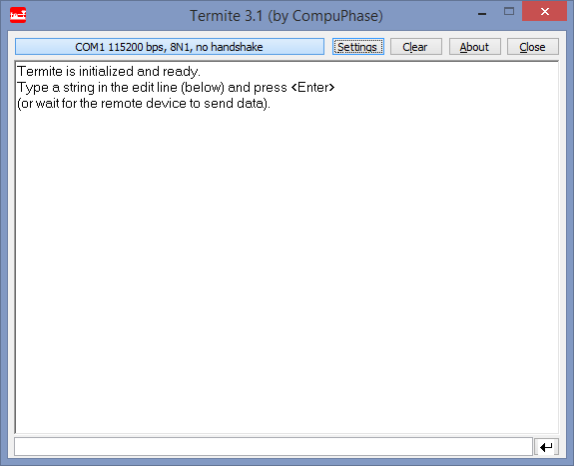

To configure Termite for use with the hand, click the ‘Settings’ button.

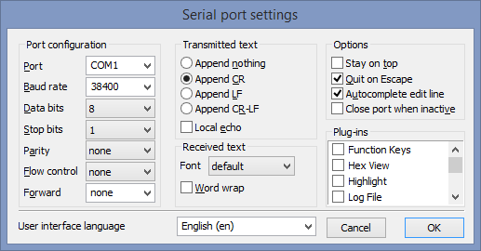

There are a lot of settings here, but the key ones are circled. The ‘Baud rate’ is the speed at which the computer communicates with the hand, and the ‘Append CR’ determines how new lines are indicated.

Once all of the settings have been configured, click ’OK’ to confirm.

## Connecting the Hand

### 1. Power the hand

Connect the USB cable to the hand and to the computer, then plug in the power cable. There is no power switch on the hand, it is always on when plugged into the power socket. Upon powering the hand, the hand will enter demo mode after 5 seconds, this mode cycles through pre-programmed grip patterns and hand movements.

### 2. Determine the COM port

The COM port refers to the communication port which is used to connect to the hand. To determine which COM port is attached to, make sure the hand is plugged into the USB port and is powered, then go to ‘Control Panel -> Devices and Printers’. You should see the hand as a device named ‘Backer Hand ##’ (where ## is a number).

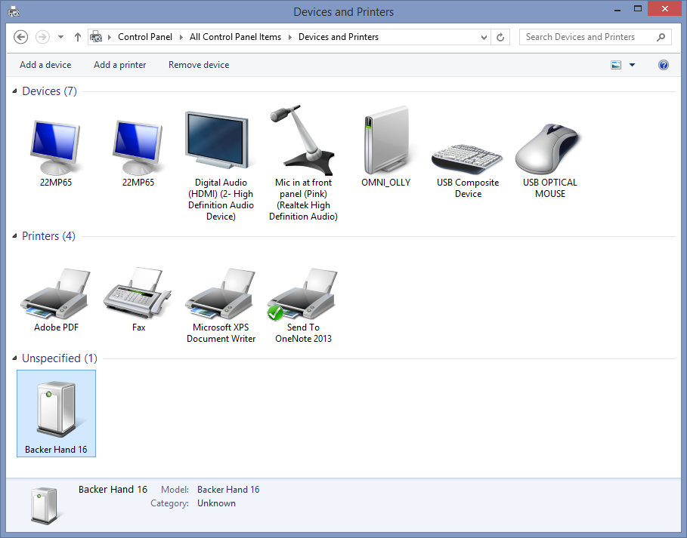

Double click on this device to open the ‘Device Properties’, then click on the ‘Hardware’ tab at the top of this window.

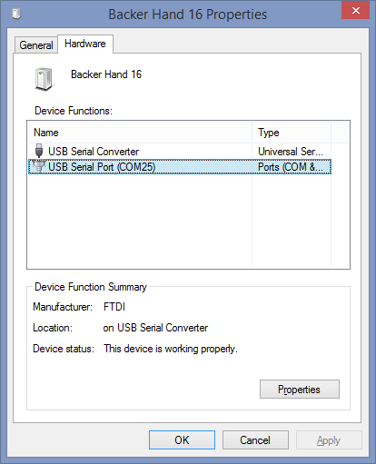

You will then see the COM port number (in this case the hand is connected to COM 25).

### 3. Connect to the Hand

With the hand plugged in, open Termite and click the ‘Settings’ button (as seen in the first image). Click the drop down menu next to ‘Port’ to display the COM ports connected to your computer.

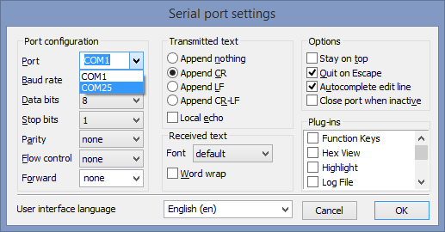

Then select the COM port of the hand and click OK. If the hand is connected and all the settings are correct, Termite should connect to the hand, to verify this connection enter a ? in the edit line (circled) and press enter. This send the ‘?’ command to the hand, which then returns a list of all the serial commands, along with a few examples as seen below.

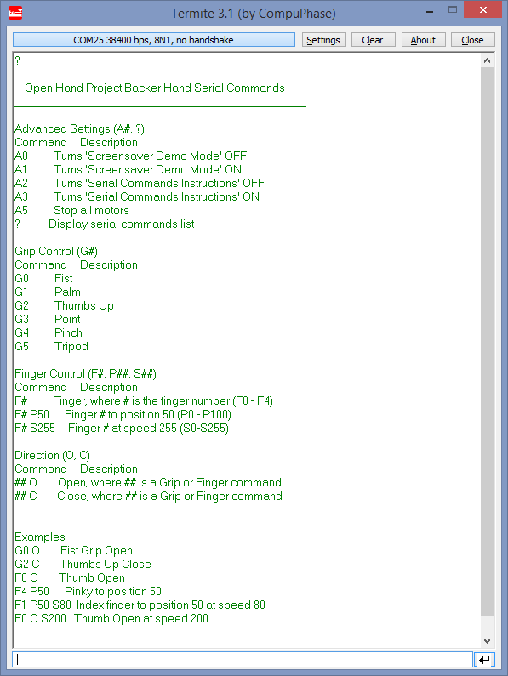

If the Termite does not connect to the hand, double check the settings and COM port are correct. If your window looks like the image below, simply click the button to connect.

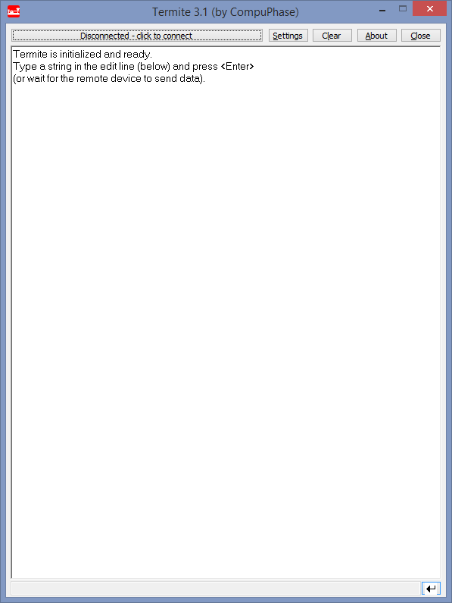

## Hand settings

### 1. Disable demo mode

Upon powering the hand, the ‘serial commands instructions’ are displayed. The hand will then enter demo mode after 5 seconds, this mode cycles through pre-programmed grip patterns and hand movements, the current grip and grip direction are displayed in Termite. To disable this ‘automatic demo mode’, send the command ‘A0’ to the hand.

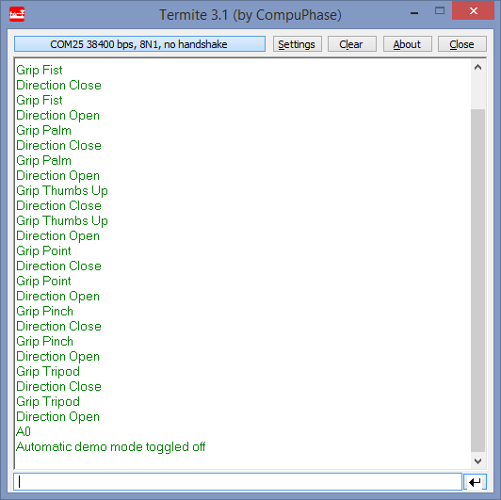

The hand repeats back the received command (A0) and also displays that the ‘Automatic demo mode’ is toggled OFF, meaning that the demo mode will now no longer run on startup. To manually run the demo mode, send the command ‘D’.

### 2. Disable Serial Commands Instructions

Upon startup the ‘serial commands instructions’ are displayed, to disable this function enter the command ‘A2’. This disables the instructions on startup. To view the instructions at any time just enter a ‘?’.

# Hand Controls

The hand has multiple control modes, from the simplest control of opening and closing the hand in various grip patterns, to controlling the positions and speeds of individual fingers.

## Predefined Grips

By entering the command G# (where # is a number from 0-5) the hand will open/close in different grip patterns. To specify whether to open or close, follow the grip command ‘G#’ by either a ‘O’ or ‘C’ to open or close respectively. If you wish to just toggle the direction of the hand, the direction does not need to be entered, you just enter the grip command ‘G#’.

|  |  |  |
| --- | --- | --- |
| Command | Function | Description |
| G0 | Fist grip | All fingers and thumb move |
| G1 | Palm grip | Fingers move, thumb stays open |
| G2 | Thumbs up | Fingers remain closed, thumb moves |
| G3 | Point | All fingers closed, index finger moves |
| G4 | Pinch grip | All fingers closed, thumb and index finger move |
| G5 | Tripod grip | All fingers closed, thumb, index and middle finger move |
|  |  |  |
| G# O | Open grip | Open grip (# is a grip number) |
| G# C | Close grip | Close grip (# is a grip number) |

### Examples

#### ‘G0’ is written in the ‘edit line’ of Termite and enter is pressed.

The first line in the terminal window is the command entered (G0), the second command is the function that relating to the serial command (Fist grip), and then the third line is the direction of movement. No direction is entered so the direction is opposite to the ‘current direction’ of the hand (the hand was open, so it now closes).

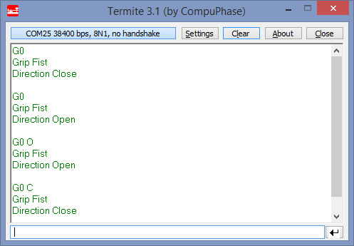

#### ‘G0’ is then entered again.

The hand now moves in the opposite direction (open) using the fist grip.

#### ‘G0 O’

The third command entered opens the hand using the fist grip pattern, however the hand was already in the open position so nothing happens.

#### ‘G0 C’

The final command closes the hand using the fist grip pattern.

## Finger Control

Another method to control the hand is to control the position and speed of the fingers individually. Similarly to the grip control, the fingers toggle direction when entered without a direction component (F#), and will open or close when a direction component is entered (F# O or F# C).

|  |  |  |
| --- | --- | --- |
| Command | Function | Description |
| F0 | Thumb |  |
| F1 | Index finger |  |
| F2 | Middle finger |  |
| F3 | Ring finger |  |
| F4 | Pinky finger |  |
|  |  |  |
| F# O | Open finger | Open finger (# is a finger number) |
| F# C | Close finger | Close finger (# is a finger number) |
|  |  |  |
| P# | Position | Position of the finger (# is 0 - 100) |
| S# | Speed | Speed of the finger (# is 0 – 255) |

To apply an open/close, position or speed function to a finger, the command must start with a finger number command (F#). The other command can then be entered in any order, as long as they are separated by a space.

Note, if no speed is entered (S#), the finger moves at the default speed of 255, also note that the position command (P#) has priority over the direction command (O/C).

### Examples

#### ‘F0 C’

Thumb closes at default speed.

#### ‘F0 O S255’

Thumb opens at a full speed.

#### ‘F3 P50’

Move ring finger to the mid position.

#### ‘F1 P80 S128’

Move index finger to position 80 at half speed.

## Standard muscle control ‘M1’

The hand has two muscle control modes, standard muscle control (M1) and muscle position control mode (M2), which can be enabled/disabled by entering their respective serial commands.

By entering the ‘standard muscle control’ serial command (M1), the robot hand uses the muscle signals from the sensors to determine whether to open, close or change grip (by turning on this mode, the hand will default to standard muscle control mode at startup, to disable this mode enter ‘M0’). When the hand is in the fully ‘Open’ position, the grip can be changed by holding an open movement for a few seconds, in the same manner as in the standard muscle control mode.

|  |  |  |
| --- | --- | --- |
| Command | Function | Description |
| M0 | Muscle control OFF | turn muscle control OFF |
| M1 | Standard muscle control | Fully open to fully closed |
| M2 | Muscle position control | Only moves when tensing muscle |
| M3 | Toggle muscle readings | Toggles whether display muscle readings |
| M4 | Toggle grip change | Toggles whether the grip can be changed by muscles |

## Muscle position control ‘M2’

This muscle control mode opens or closes the hand only when your muscle is tensing, which allows for finer control of grip strengths and picking up objects. To enter this mode, enter ‘M2’, and to exit this mode enter ‘M0’.

When the hand is in the open position, the grip can be changed by holding an open movement for a few seconds, in the same manner as in the standard muscle control mode.

## Muscle control settings ‘M3’ and ‘M4’

The the EMG box outputs 2 analogue signals from the muscles (2 channels), which are fed into the robot hand via the white headphone cable. These values are then fed into an Analogue-Digital Converter (ADC) which converts each of the analogue signals to a number from 0-1024. These values represent the muscle readings, and are used to analyse the state of each of the muscles.

M0 = 96 T0 = 367 M1 = 96 T1 = 178

M0 = 98 T0 = 367 M1 = 98 T1 = 178

M0 = 96 T0 = 367 M1 = 96 T1 = 178

M0 = 98 T0 = 367 M1 = 97 T1 = 178

M0 = 96 T0 = 367 M1 = 96 T1 = 178

M0 = 97 T0 = 367 M1 = 97 T1 = 178

M0 = 97 T0 = 367 M1 = 99 T1 = 178

M0 = 96 T0 = 367 M1 = 96 T1 = 178

Figure 4. Serial dump of raw muscle readings

By entering ‘M3’ when in one of the muscle control modes, the hand will enable/disable the feature that displays the muscle readings (M0 and M1 in Figure 4) and the dynamic threshold values (T0 and T1 in Figure 4). Simply put, if the muscle ADC value (M#) is greater than the threshold value for that muscle (T#) then the hand detects a movement in a particular direction.

(Note, when displaying the raw muscle readings, the grip change mode may be less responsive).

When the robot hand is in the ‘Open’ position, the grip can be changed by performing an ‘Open’ movement for a few seconds, this then cycles through the grips (as detailed in the ‘changing grip patterns’ section). To disable/re-enable this feature, enter the serial command ‘M4’ (note this setting can only be changed when in one of the muscle control modes).

## Advanced settings

These commands are used to toggle various settings, such as whether the demo mode or serial command instructions run on startup.

|  |  |  |
| --- | --- | --- |
| Command | Function | Description |
| A0 | Demo mode OFF | Toggles whether demo mode runs on startup |
| A1 | Demo mode ON | Toggles whether demo mode runs on startup |
|  |  |  |
| A2 | Serial commands OFF | Toggles whether the serial commands display at startup |
| A3 | Serial commands ON | Toggles whether the serial commands display at startup |
|  |  |  |
| A5 | Stop motors | Stops all of the motors |
|  |  |  |
| ? | Serial commands | Display serial commands |
|  |  |  |
| D | Demo mode | Run demo mode once |

The command ‘Stop motors’ command (A5) is used if the finger motors are buzzing.

## Notes

Both the grip and finger controls can be used in conjunction. For example, to pick up a water bottle the thumb can first be moved to position 50, then the fist grip can be closed.

#### ‘F0 P50’

#### ‘G0 C’