Component: Three-phase Load

**Notes:**

* **The variable names for DiTTo in the first column are exactly copied from DiTTo in order to get the parameters in DiTTo easily.**
* **For ePHASORSIM, the symbols in the third column are put exactly same as the ePHASORSIM user guide and the demo examples.**
* **The DiTTo parameters which match the ePHASORSIM’s parameters are put in the same rows.**
* **If one or more parameters which are available in ePHASORSIM but not in DiTTo, in that case the corresponding columns of the Ditto are left empty or necessary suggestions are provided.**
* **The parameters which are available only in DiTTo but not in ePHASORSIM, in that case the corresponding columns of the ePHASORSIM are left empty.**

|  |  |  |  |  |  |  |
| --- | --- | --- | --- | --- | --- | --- |
| Ditto | | ePHASORSIM | | | |  |
| Name of the variable | Description | | Symbol | Description | Unit | Default value |
| name | Name of the load object | | ID | Load name | Name must be unique |  |
| phase_loads or  num_phases | This parameter is a list of positional points describing the line | | Bus A | Name of phase A of the connected bus | Name must be unique |  |
| Bus B | Name of phase B of the connected bus | Name must be unique |  |
| Bus C | Name of phase C of the connected bus | Name must be unique |  |
| nominal_voltage | This is the base voltage of the load | | V(kV) | Nominal voltage of the connected bus (phase to phase (RMS)) | Unit: kV |  |
| connection_type | This is the type of connection that the load connects to | | Conn. type | Connection type | ‘wye’ and ‘delta’ |  |
| This parameter is unavailable in DiTTo; here ZIP means constant impedance, constant current, and constant power load. |  | | Type | Load type | ZIP | ZIP |
| P for phase a comes from phase_loads of ditto | This is the active power in Watt | | P_a (kW) | Active power phase A | Unit: kW |  |
| Q for phase a comes from phase_loads of ditto | This is the reactive power in Watts | | Q_a (kVAr) | Reactive power phase A | Unit: kVAr |  |
| P for phase b comes from phase_loads of ditto | Active power | | P_b (kW) | Active power phase B | Unit: kW |  |
| Q for phase b comes from phase_loads of ditto | Reactive power | | Q_b (kVAr) | Reactive power phase B | Unit: kVAr |  |
| P for phase c comes from phase_loads | Active power | | P_c (kW) | Active power phase C | Unit: kW |  |
| Q for phase c comes from phase_loads of ditto | Reactive power | | Q_c (kVAr) | Reactive power phase C | Unit: kVAr |  |
| This parameter is unavailable in DiTTo; you can please use the same value in DiTTo |  | | Bandwidth (pu) | Cut-off voltage to convert to Z load by defau | p.u. | 0.2 |
| ppercentimpedance | This is the portion of active power load modeled as constant impedance | | K_z | Constant impedance percentage | p.u. | If the load is constant impedance load, the K_z = 1 and K_i = 0, K_p = 0 |
| ppercentcurrent | This is the portion of active power load modeled as constant current | | K_i | Constant current percentage | p.u. | If the load is constant current load, the K_z = 0 and K_i = 1, K_p = 0 |
| ppercentpower | This is the portion of active power load modeled as constant power | | K_p | Constant power percentage | p.u. | If the load is constant power load, the K_z = 0 and K_i = 0, K_p = 1 |
| qpercentcurrent | This is the portion of reactive power load modeled as constant current | |  |  |  |  |
| qpercentimpedance | This is the portion of reactive power load modeled as constant impedance | |  |  |  |  |
| qpercentpower | This is the portion of reactive power load modeled as constant power | |  |  |  |  |
|  |  | | Comments for ePHASORSIM: | The values of K_z, K_i and K_p must fit in the following equation:  K_z + K_i + K_p = 1 |  |  |
| This parameter is unavailable in DiTTo; Please assume in DiTTo: always connected, status: 1. |  | | Status | Identify whether in-service/out-of-service status | 1: in-service  0: out-of-service | Always connected, status: 1 |
| This parameter is unavailable in DiTTo; Please use value = 0 in DiTTo to use nominal voltage instead of initial voltage |  | | Use initial voltage? | Determines if the assigned power is based on nominal or initial voltage (from page Bus) | 1: initial voltage  0: nominal voltage | 0: if you want to use nominal voltage for the all components. |
| Loadmin | The low cut-off voltage in p.u. of base KV. The load is 0 below this | |  |  |  |  |
| Loadmax | The high cut-off voltage in p.u. of base KV. The load is 0 above this | |  |  |  |  |
| positions | This parameter is a list of positional points describing the load (typically just one) | |  |  |  |  |

Example: in ePHASORSIM

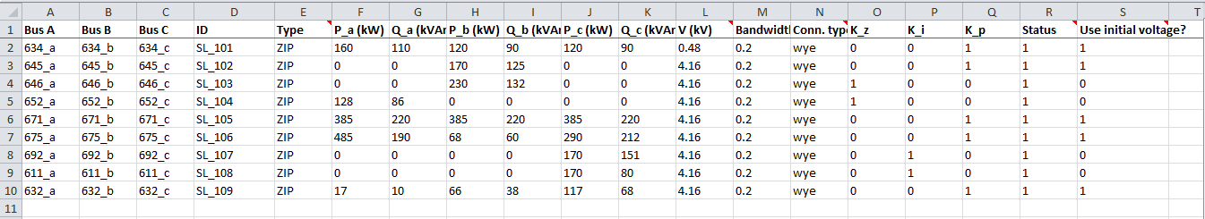

**Component: Single-phase Load**

Note: For single phase, the representation of three-phase load is followed. All the information of the spreadsheet will be provided for single phase load like three-phase load except the parameters (P_a (kW), Q_a (kVAr), P_b (kW), Q_b (kVAr), P_c (kW), Q_c (kVAr),) will be provided for the specific load. For example, if a single phase load (170kW and 125kVAr) is connected at phase-B and neutral, the load parameters would be (P_a (kW) = 0, Q_a (kVAr) = 0, P_b (kW) = 170, Q_b (kVAr) =125, P_c (kW) =0, Q_c (kVAr) =0.



Notes:

* **The above information for single phase load is provided according to the ePHASORSIM user guide (version- 1.2) but it is different from the ePHASORSIM user guide (version 1.4).**