Superstore Sales and Profit Analysis
Exploratory Data Analysis using Python, Pandas and Plotly
Project Report
Submitted by: Piyush Chawla
AICTE Internship / Project Submission
Date: 23 September 2026

1. Introduction
Retail businesses generate large volumes of transactional data every day. Understanding how sales translate into profit — and where that relationship breaks down — is essential for making informed decisions about pricing, discounting, and inventory. This project analyzes the widely used "Sample Superstore" dataset to explore patterns in sales and profit across time, product categories, and customer segments, using Python's data analysis and visualization ecosystem.

2. Objectives
The objective of this project is to perform an end-to-end exploratory data analysis of retail sales data in order to:
- Understand the overall structure and quality of the dataset.
- Engineer useful date-based features from raw order dates.
- Analyze monthly trends in sales and profit.
- Compare sales and profit performance across product categories and sub-categories.
- Compare sales and profit performance across customer segments.
- Compute and interpret the sales-to-profit ratio to identify the most and least profit-efficient segments.

3. Dataset Description
The analysis uses the "Sample - Superstore" dataset, a widely used retail transactions dataset available on Kaggle (https://www.kaggle.com/datasets/vivek468/superstore-dataset-final). The dataset contains 9,994 rows and 21 columns covering order details, shipping information, customer information, geography, product information, and financial metrics.

3.1 Key Columns
Column | Description
Order ID / Row ID | Unique identifiers for each order line and row
Order Date / Ship Date | Date the order was placed and shipped
Ship Mode | Shipping method used (e.g., Second Class, Standard Class)
Customer ID / Name | Identifiers for the customer placing the order
Segment | Customer segment: Consumer, Corporate, or Home Office
Country / City / State / Region | Geographic information for the order
Category / Sub-Category | Product classification
Product Name | Name of the product ordered
Sales | Revenue generated from the order line
Quantity | Number of units ordered
Discount | Discount applied to the order
Profit | Profit earned (or lost) on the order line

4. Tools and Technologies Used
Tool / Library | Purpose
Python 3 | Core programming language
pandas | Data loading, cleaning, aggregation, and feature engineering
Plotly Express | Quick, high-level interactive charts (line, pie, bar)
Plotly Graph Objects | Custom, fine-grained interactive charts (grouped bar charts)
Jupyter Notebook | Interactive development and presentation environment

5. Methodology

5.1 Data Loading and Inspection
The dataset was loaded using pandas' read_csv function with 'latin-1' encoding to correctly handle special characters present in the raw file. Initial inspection was performed using .head(), .describe(), and .info() to understand the shape, data types, and summary statistics of the dataset.

5.2 Date Handling and Feature Engineering
The Order Date and Ship Date columns, originally stored as text, were converted to proper datetime objects using pd.to_datetime(). From the Order Date column, three new features were derived: Order Month, Order Year, and Order Day of Week, enabling time-based aggregation and trend analysis.

5.3 Exploratory Data Analysis
Using pandas groupby operations combined with Plotly visualizations, the following analyses were carried out:
- Monthly Sales Analysis — a line chart of total sales aggregated by order month.
- Sales Analysis by Category — a donut chart showing the share of total sales contributed by each product category.
- Sales Analysis by Sub-Category — a bar chart comparing total sales across sub-categories.
- Monthly Profit Analysis — a line chart of total profit aggregated by order month.
- Profit Analysis by Category — a donut chart showing the share of total profit contributed by each product category.
- Profit Analysis by Sub-Category — a bar chart comparing total profit across sub-categories.
- Sales and Profit Analysis by Customer Segment — a grouped bar chart comparing sales and profit across the Consumer, Corporate, and Home Office segments.

5.4 Sales-to-Profit Ratio Analysis
To evaluate profit efficiency rather than just raw totals, a Sales-to-Profit Ratio was computed for each customer segment as total sales divided by total profit. A lower ratio indicates that a segment converts sales into profit more efficiently, while a higher ratio indicates weaker profit efficiency relative to revenue generated.

6. Results and Insights
Segment | Sales-to-Profit Ratio (approx.)
Consumer | 8.66
Corporate | 7.68
Home Office | 7.13

- Sales and profit both show clear month-to-month fluctuation, suggesting seasonal buying patterns rather than steady, uniform demand.
- A small number of product categories and sub-categories account for a disproportionately large share of total sales.
- Certain sub-categories with high sales volumes do not generate proportionally high profit, indicating discounting or cost pressures worth investigating further.

Monthly Sales Analysis:
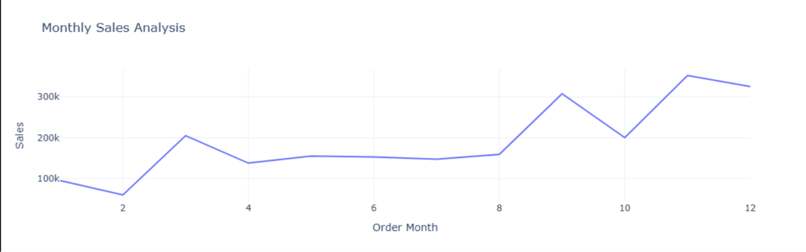

Sales Analysis by Category:

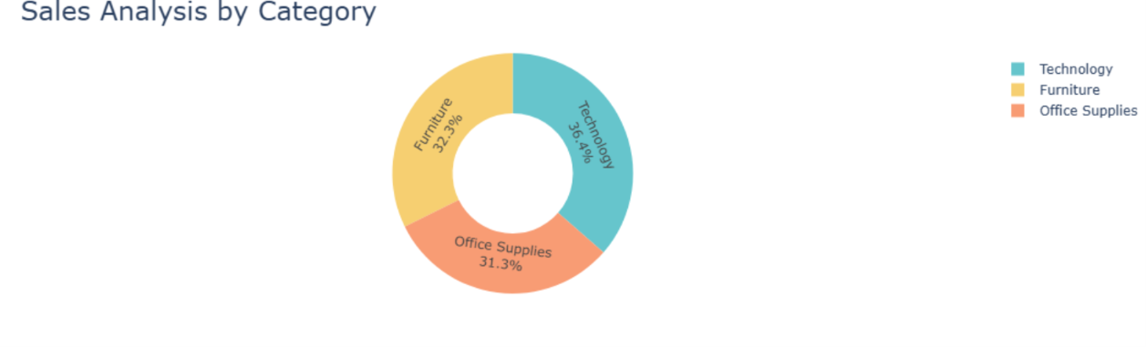

Sales Analysis by Sub-Category:

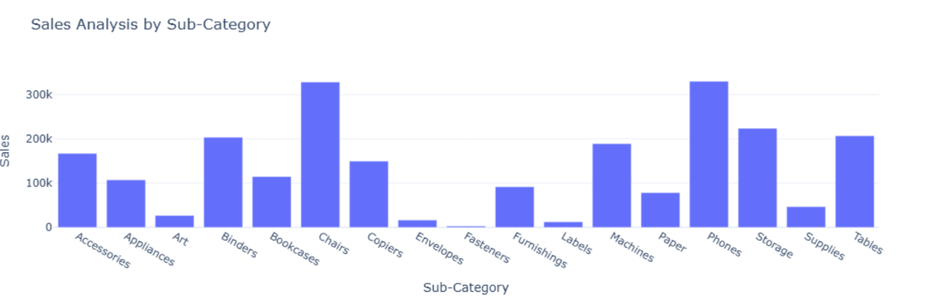

Monthly Profit Analysis:

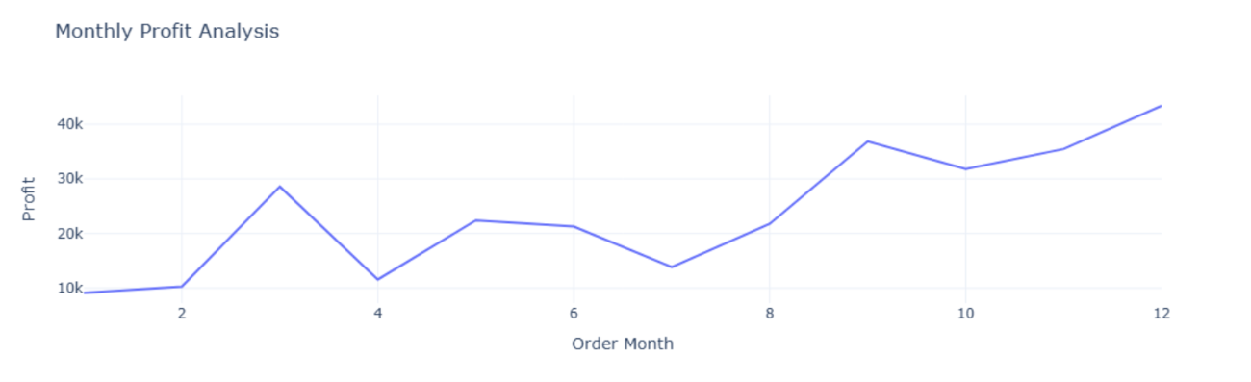
Profit Analysis by Category:

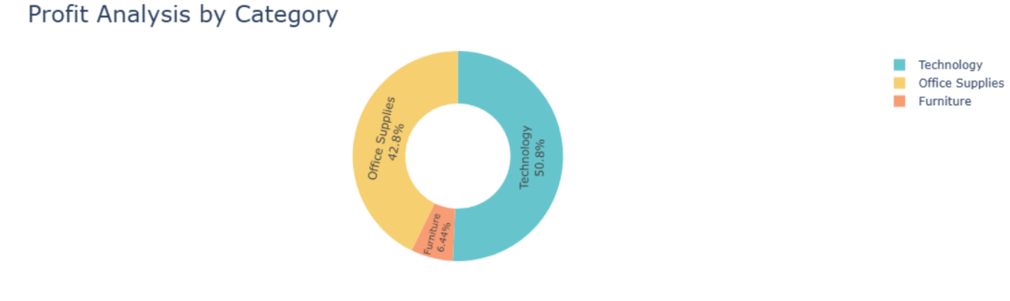

Profit Analysis by Sub-Category:

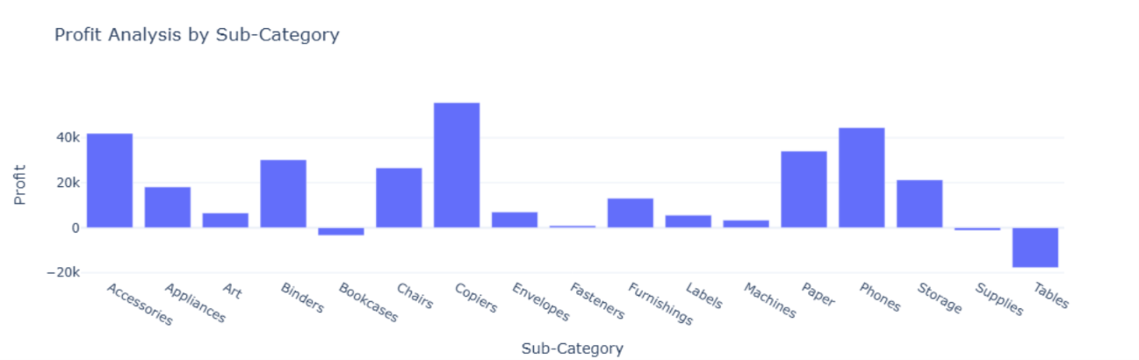

Sales and Profit Analysis by Customer Segment:
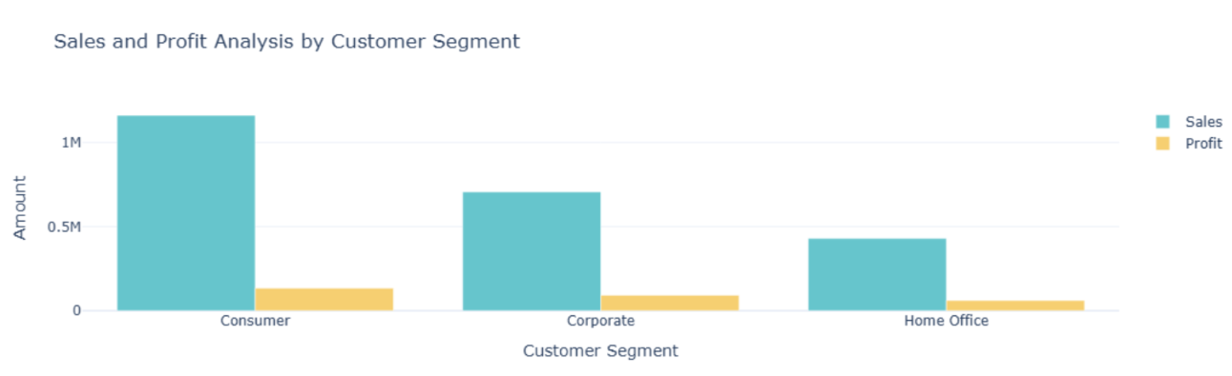

- Among customer segments, Home Office has the lowest sales-to-profit ratio (~7.13), making it the most profit-efficient segment, while Consumer has the highest ratio (~8.66), making it the least profit-efficient despite likely contributing significant revenue.

7. Conclusion
This project demonstrates a complete, practical exploratory data analysis workflow — from raw data ingestion and cleaning to feature engineering, aggregation, visualization, and interpretation. The analysis reveals that raw sales figures alone can be misleading; examining profit and profit-efficiency metrics such as the sales-to-profit ratio provides a more accurate picture of where a retail business is truly performing well. These insights can guide decisions around discounting strategy, inventory focus, and segment-specific marketing efforts.

8. Future Scope
- Incorporate the Discount column to directly quantify the impact of discounting on profit margins.
- Extend the analysis to regional and state-level breakdowns to identify geographic hotspots and problem areas.
- Build a predictive model to forecast future sales or profit based on historical trends.
- Deploy the analysis as an interactive dashboard (e.g., using Plotly Dash or Streamlit) for real-time exploration.

9. References
1. Dataset: Sample Superstore Dataset, Kaggle — https://www.kaggle.com/datasets/vivek468/superstore-dataset-final
2. pandas documentation — https://pandas.pydata.org/docs/
3. Plotly Python documentation — https://plotly.com/python/

