A UN Report on the Relationship between GDP and Life Expectancy

Patrick D. Schloss

2023-10-13

## Abstract

This report was prepared to the attention of the UN. It analyzes the relationship between a country’s GDP, its life expectancy, and CO2 emissions. Our goal is to determine to what degree a country’s economic strength or weakness is related to its public health status and impact on climate pollution. We hypothesize that both life expectancy and CO2 emissions increase with the country’s GDP.

## Plotting GDP by Life Expectancy

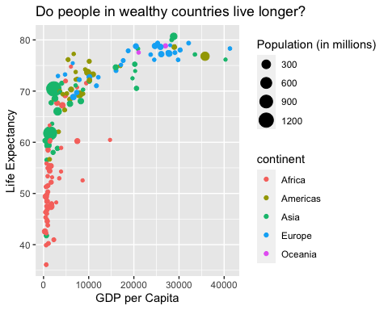

## Summary statistics

The above plot shows the relationship between GDP per capita and life expectancy for a total of 142 countries. For this set of countries, economic wealth ranged from a minimum of $312.2 to a maximum of $41283.2 per capita. $n=2+2$

| Summary of data |  |
| --- | --- |
| Number of countries | 142 |
| Minimum GDP per capita | 312.2 |
| Maximum GDP per capita | 41283.2 |

| country | pop | continent | lifeExp | gdpPercap |
| --- | --- | --- | --- | --- |
| Australia | 18565243 | Oceania | 78.83 | 26997.94 |
| New Zealand | 3676187 | Oceania | 77.55 | 21050.41 |

## Exercises

#### Exercise 1:

Try googling how to create sections by using headers and sub-headers using Markdown. What do you find?

### Exercise 2:

Go ahead and do some online searches on how to do the following:

* Create a bullet point list with three items
* As the first item, write the name of your currently favorite programming language in bold
* As the second item, write the name of a function you have so far found most useful in italics
* As the third item, write one thing you want to learn next on your programming journey in bold and italics
* Turn your bullet point list into a numbered list
* Create a fourth list item and find an online guide and/or cheat sheet for basic Markdown syntax, write its name down here and hyperlink its URL

My bulleted list

* My favorite programming language is **R**
* The most useful function has been *group_by*
* The next thing I want to learn is ***RNAseq analysis***

My numbered list

1. My favorite programming language is **R**
2. The next thing I want to learn is ***RNAseq analysis***
3. The most useful function has been *group_by*
4. This is my [favorite markdown cheatsheet](https://rstudio.github.io/cheatsheets/html/rmarkdown.html?_gl=1*l8arwq*_ga*ODA0MTA1NDY2LjE2OTcyMjQwNTk.*_ga_2C0WZ1JHG0*MTY5NzIyNDA1OS4xLjAuMTY5NzIyNDA1OS4wLjAuMA..)