**HW 12 Central Limit Theorem**

**Codes**

**Output**

*Output of sample size 5, 10, 30, 80, 120, respectively (up -> down)*

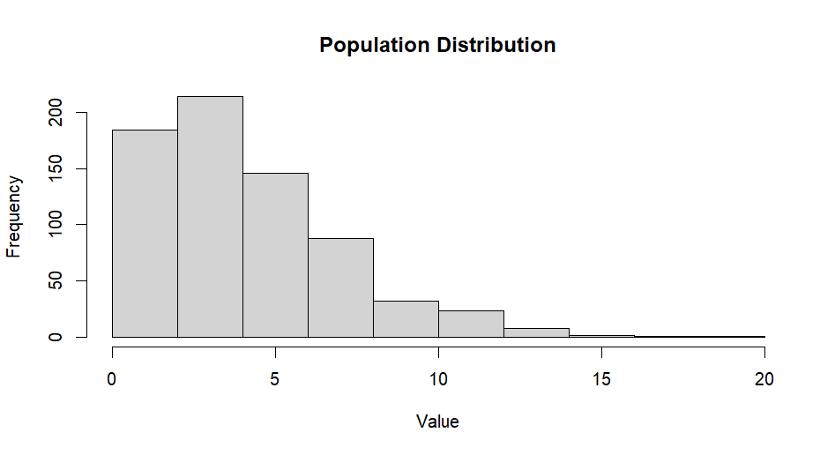

*Population Distribution*

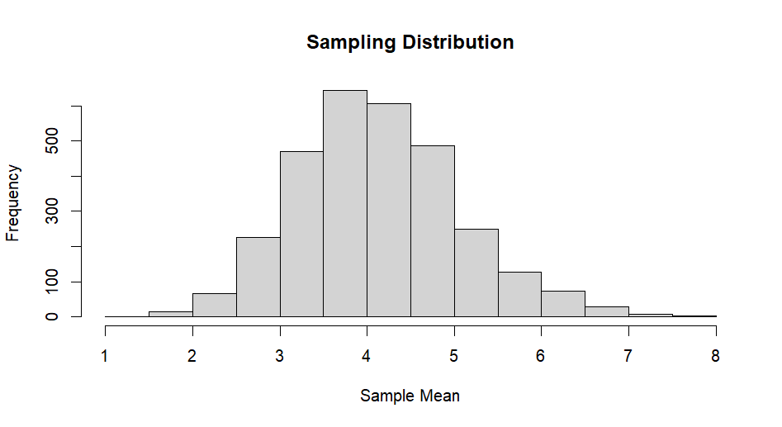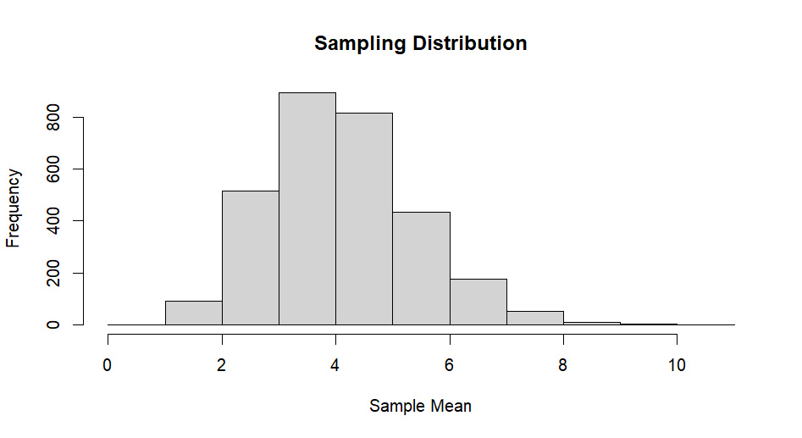

*Sample size = 5 Sample size = 10*

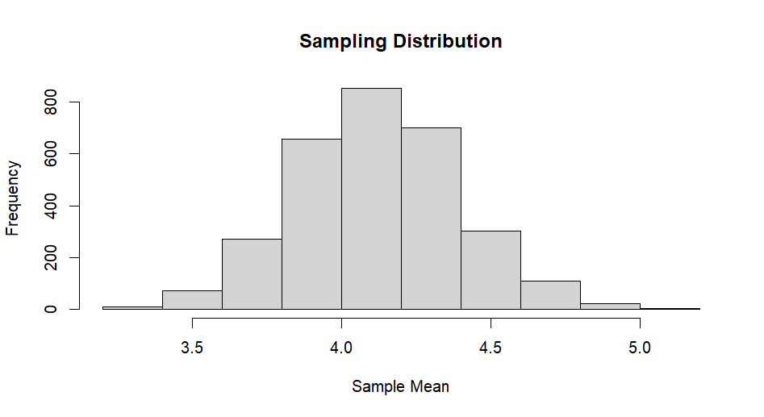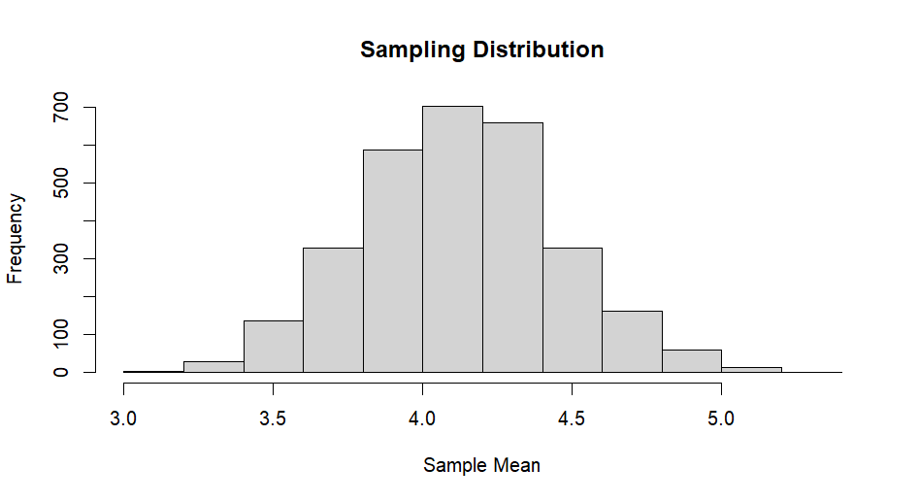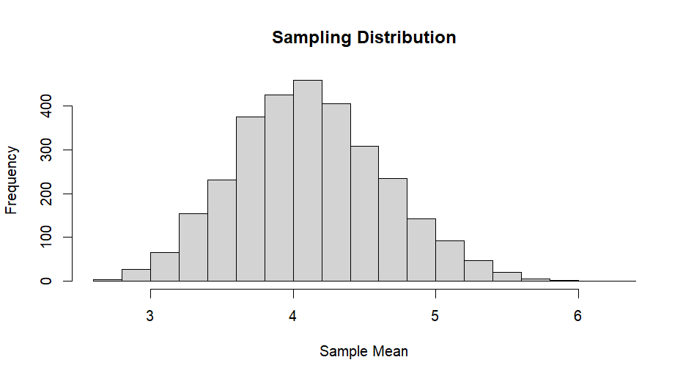

*Sample size = 120*

*Sample size = 30 Sample size = 80*

**Conclusion**

In conclusion, the outcomes of the code strongly support the Central Limit Theorem (CLT). As the sample size increases, the shape of the sampling distribution for the sample mean approaches a normal distribution, consistent with one of the principles of the CLT. Furthermore, the decreasing differences between sample statistics (mean and standard deviation) and their population counterparts as the sample size increases means that the CLT's prediction that larger sample sizes lead to more reliable and consistent estimations. These results provide empirical evidence for the practical applicability of the CLT in statistical analysis.