Windows Live ID, CustomerSource and PartnerSource Signup and Login Instructions

This document will explain to you how to sign up for a Windows Live ID (if you do not already have one) and use it to sign into the Microsoft Dynamics extranet, including CustomerSource and PartnerSource.

Microsoft Windows Live ID is an online service that makes it possible for you to use a single email address and password to sign in to a Windows Live ID -Participating web site or service.

CustomerSource and PartnerSource are authorized web portals for Microsoft Dynamics customers on a service plan and Microsoft Dynamics partners, respectively.

- To learn more about Windows Live ID, visit http://www.passport.net/.
- To learn more about CustomerSource, visit http://www.microsoft.com/dynamics/en/us/customersource.aspx.
- To learn more about PartnerSource, visit http://www.microsoft.com/dynamics/en/us/partner-login.aspx.

To sign into Microsoft Dynamics PartnerSource or CustomerSource, follow these steps:

Step 1 - Get a Windows Live ID If You Don’t Have One Already.
If you do not already have a Windows Live ID, go to https://accountservices.passport.net/reg.srf?id=486&ru=http%3A%2F%2Fwww%2Epassport%2Enet%2FConsumer%2Fdefault%2Easp%3Flc%3D1033&vv=30&sl=1&lc=1033.
Any email address can be used to get your Windows Live ID. Complete the creation of a Windows Live ID, and then close the browser window. This will be the username and password you use to log into PartnerSource or CustomerSource in the future.

- Forgot Your Windows Live ID Password?
If you already have a Windows Live ID (for example, one that you use with a hotmail email account) set up, and you have forgotten your Windows Live ID password, go to https://accountservices.passport.net/uiresetpw.srf?lc=1033 to reset it.

Step 2 - Log into CustomerSource or PartnerSource.
Now that you have a Windows Live ID account set up and you know your Windows Live ID password, you are ready to log in to CustomerSource (customers) or PartnerSource (partners).

To do this, go tohttps://mbs.microsoft.com/customersource or https://mbs.microsoft.com/partnersource, respectively.

Step 3 - Enter Your Windows Live ID Account.
You will be prompted to enter your Windows Live ID account. Enter Windows Live ID username and password. This is the Windows Live ID account that you want to use to log into CustomerSource/PartnerSource.
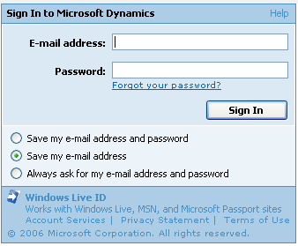

Step 4 - Enter The Email Address Associated with Your Microsoft Dynamics Customer Organization Account.
You will be prompted to enter the email address that you registered within the Microsoft Dynamics system. This may or may not be the same email address as your Windows Live ID account.

If you do not know the email address that is stored in the Microsoft Dynamics system, send an email to ITS MBS Support at itmbssup@microsoft.com, including your name and your organization’s account number.

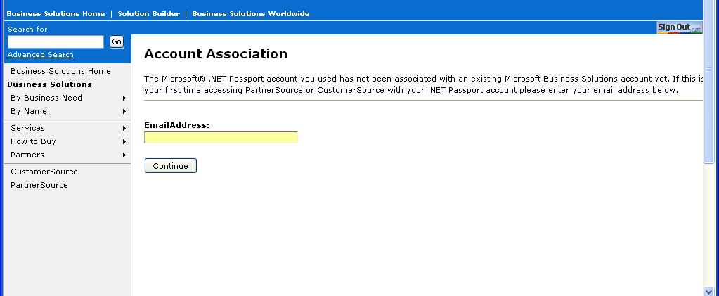

Step 5 - Email Sent Message.
After you enter the email address registered with the Microsoft Dynamics system and click Continue, you will receive the following message:

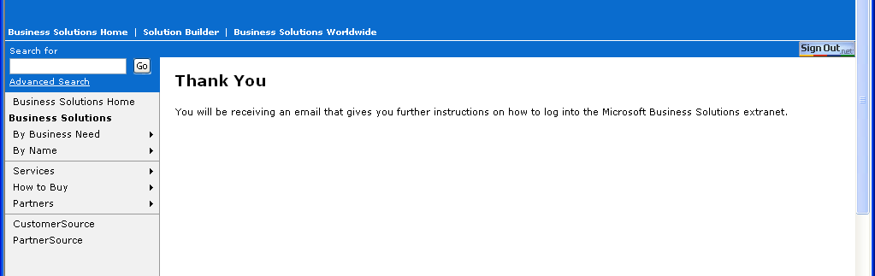

Step 6 - Open Received Email
Microsoft Dynamics has sent you an email that you can now use to associate your Windows Live ID account with your Microsoft Dynamics account in CustomerSource/PartnerSource. Please check the inbox of the email address you entered in Step 5.

NOTE: You will receive a separate email for every profile that you have set up in CustomerSource or PartnerSource. Follow Step 10 for each email you receive.

Step 7 - Click on Association Link in Received Email
Open the email you received from itmbssup@microsoft.com. You will see an email similar to the screenshot below. Click on the long blue URL in the email.

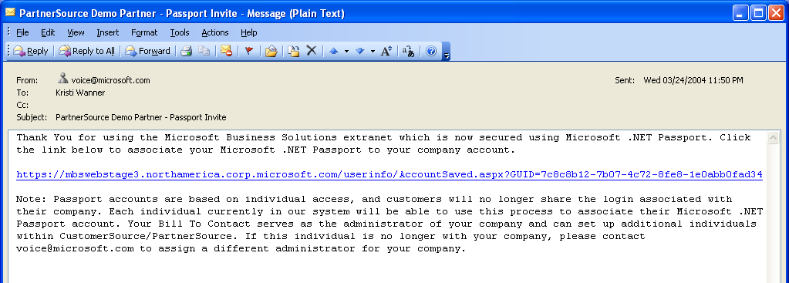

Step 8 - Enter Windows Live ID account
You will be prompted again for your Windows Live ID. Enter the Windows Live ID you entered in Step 3:
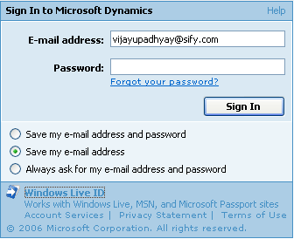

Step 9 - Success Message
You will get a message stating that you have successfully associated your Windows Live ID with your Microsoft Dynamics profile:

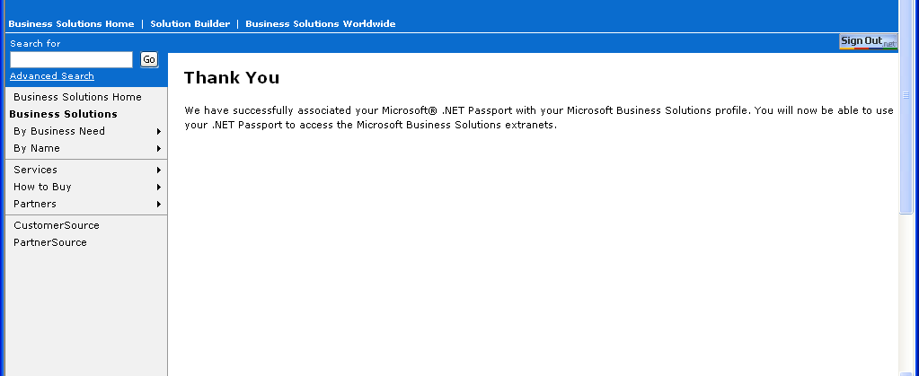

Step 10 - Access CustomerSource or PartnerSource.
You are ready to use PartnerSource! Go to CustomerSource (https://mbs.microsoft.com/customersource) or PartnerSource (https://mbs.microsoft.com/partnersource).

When you use CustomerSource/PartnerSource in the future, use this Windows Live ID username and password to log in.

If you have any trouble with your Windows Live ID account (username/password, etc.), please contact the Windows Live ID support team at http://support.msn.com/eform.aspx?productKey=passport&page=support_home_options_form_byemail&ct=eformts.

Please contact IT MBS Support at itmbssup@microsoft.com if you have any questions regarding this process or have followed all steps and are still having trouble accessing CustomerSource or PartnerSource.

