Peter Schubert
Geoffrey Lynch
Nathan Carey
Nisarg Patel
CIS 435 Project 4 Report: Banking System

Team Member names and Responsibilities:
Name | Responsibility
Geoffrey Lynch | Creating customer profile edit page, creating admin customer search, creating admin customer edit, summary section.
Peter Schubert | Creating the header and footer files, login page, db_include file, designing the main.css, creating the tutorial and the design considerations
Nisarg Patel | Creating Customer / Admin Sign Up pages. Implementing Customer’s Deposit, Withdraw, and Transfer features / pages. Helping out in the User Interface Design section.
Nathan Carey | Creating Historical Data page,create Checking and CD account page, and Bank Metrics page

Design Considerations:
In designing the architecture of the banking application, we wanted to keep the overall layout as simple as possible, allowing the user to move around to various pages at will without making the internal design of the application complicated. Also we designed all the pages using a single main.css so that they would be similar/the same allowing for a uniform and consistent design across the pages. This design further allows each person to work independently, without having to make significant changes to the overall design of the page.
For the login, since there would be multiple types of users using the application, we designed it so that the administrator and customers use the same login. When logging in, the user would just need to specify the type of user they were logging in as so that the application could query the correct database to check the login credentials.
Once logged in, the menu is displayed on all the pages that the user visits. This design allows the user to move back and forth between multiple pages without having to use the “back” button multiple times. The respective menu items for each type of user in the top navigation bar. This functionality of adding and removing certain items from the top navigation bar, allows the respective user (either administrator or customer) to access only what they need and not have to overlap in responsibilities and permissions.

User Interface Design:

Admin View
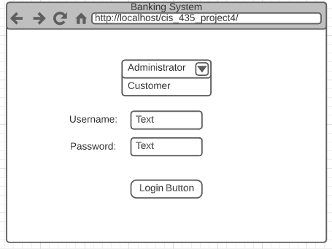 | 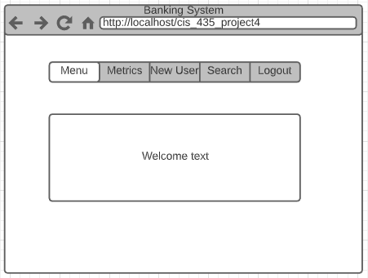
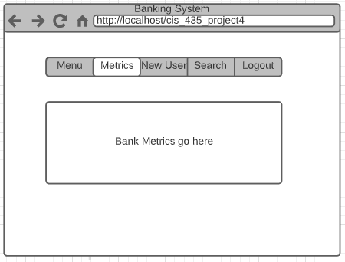 | 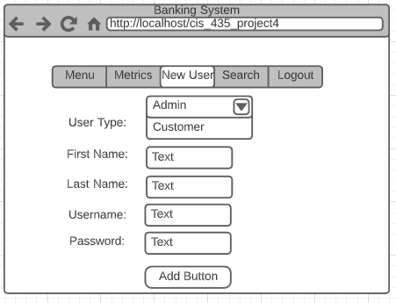
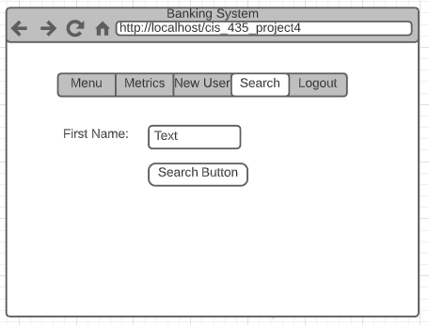

Customer View
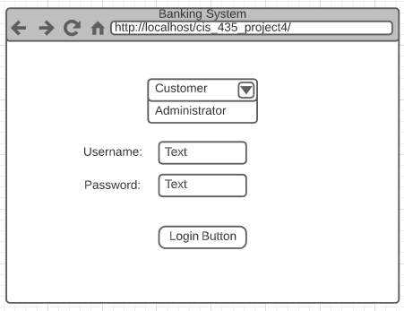 | 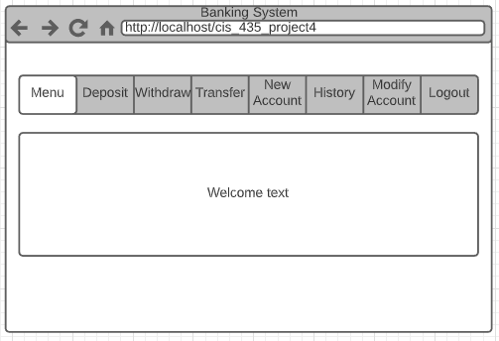
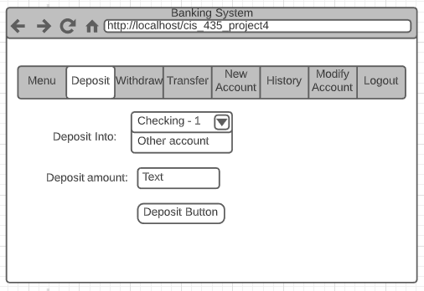 | 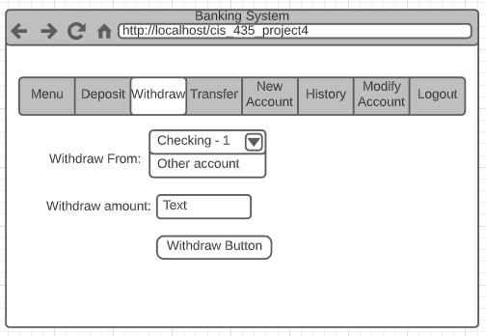
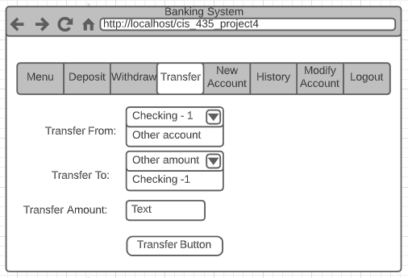 | 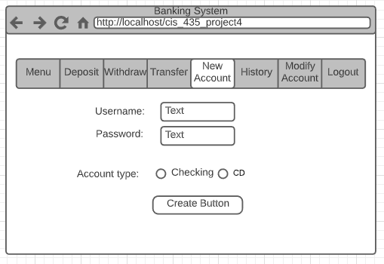
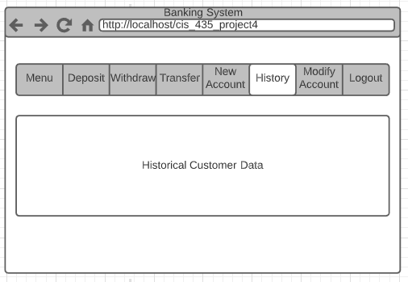 | 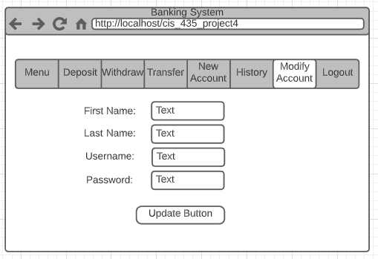

System components and functions (UML):

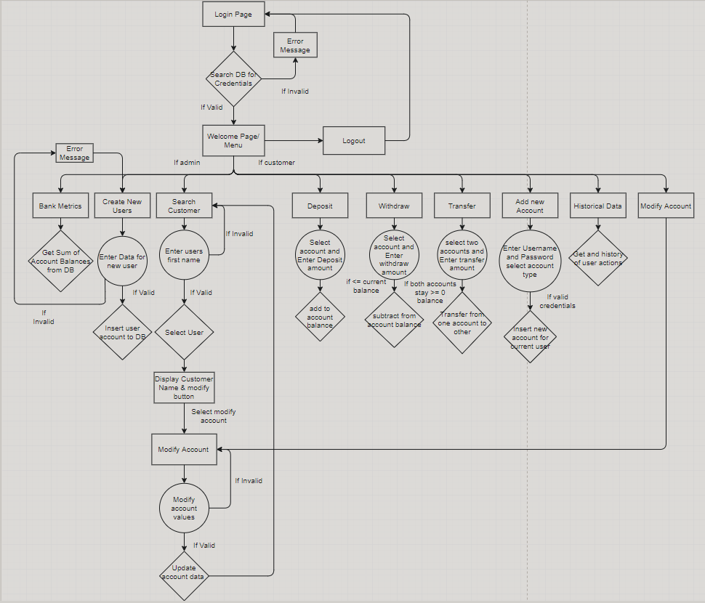
Summary/Conclusion:
Overall the project was successful. We laid out the foundation for the website through documenting all features and a general outline for our plan. This was extremely helpful as we were able to lay out all the requirements before working, and just had to implement them. We also were able to efficiently split up the labor for both documentation and coding of the project. This allowed for everyone to work on separate sections and have it all come together in the end. Through the project, we were able to continue strengthening our skills in PHP and Apache as well as previous concepts like CSS styles, JavaScript, and basic html. This project was a great highlight of everything that we learned throughout the semester. We were also able to work on learning group dynamics and planning for the program, which are very important skills now and in the future. Finally, we used a version control system (Github) for our project. It was good practice and we were able to use some new features.

