Task 3.1P Particle – Sending data to the web

# Student ID: 219011171

# Name: Peter Stacey

## Q1. Provide brief summary (less than two paragraphs) of your understanding of Webhooks and their usage.

Webhooks are essentially, HTTP based callback functions, triggered by a specific event. When triggered they execute and notify any services or other programs that are registered to receive the information. As a callback function, they push data or information to other services when an update it available, rather than requiring those services or programs to poll for data they need.

In the case of Particle.io, the Webhook integrations use HTTP methods (GET, POST, PUT and DELETE being available for the webhook), to forward data to a service when a specific event is triggered.

## Q2: Describe the steps you have taken to create this application similar to an instruction manual. Use bullet points and be concise when possible. Your instructions should be enough for another person reading them to recreate what you have done. (You might as well opt for creating a video)

All steps are outlined in the linked video:

<https://youtu.be/kgnxHha14hI>

## Q3: Submit the graph of your ThinkSpeak chart over a period of 5 minutes (create some artificial change in the reading if you can, e.g. change the luminosity of the room by turning lights on and off) by taking a screenshot of your thing speak similar to the sample below.

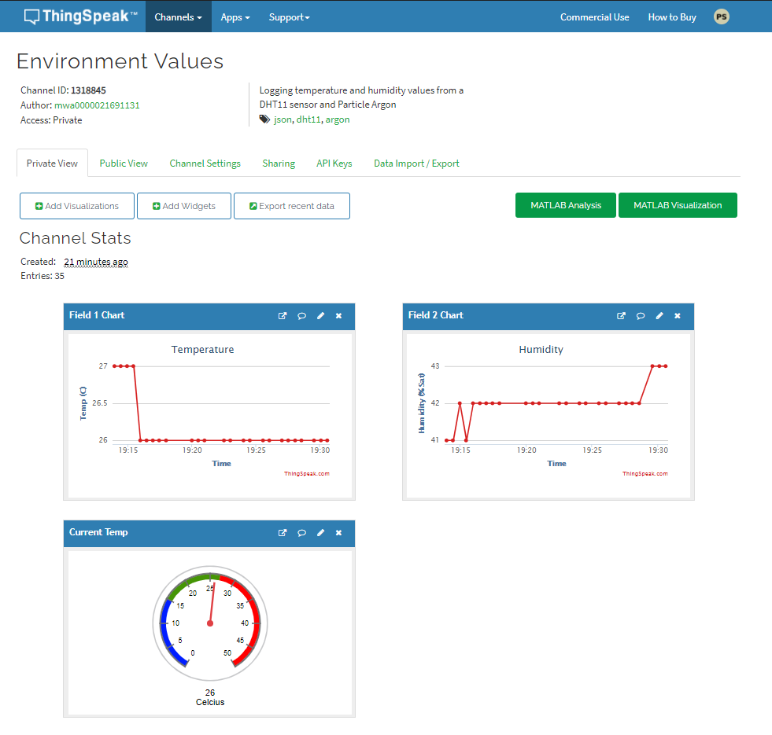

Figure 1: Screen capture from the thingspeak website of DHT11 readings

## Q4: Create a repository named SIT210-Task3.1P-WebHook on Github. Upload your code to the repository. Include the link to your repository here.

<https://github.com/pscompsci/SIT210_Embedded_Programming/tree/main/Task_3_1P/Webhook>

## Q5: Describe a real-life usage scenario for your system (less than one paragraph).

Since my system measures temperature and humidity, one real-life scenario would be in a plant nursery or greenhouse where understanding the current environmental conditions in order to manage plant care.