Task 6.1P RPi – Remote operation

# Student ID: 219011171

# Name: Peter Stacey

## Q1: In no more than three paragraphs, please describe the steps you took to setup remote connection. Using bullet points are much preferred.

The steps to setup SSH access to my RPi 3B+ were:

**Raspberry Pi**

* Confirm the RPi was connected to my local network by running ifconfig in the terminal
  + This confirmed that DHCP had assigned IP 192.168.0.100 to the Pi
* Open Raspberry Pi Configuration from the Preferences menu of Raspian
* Checked ‘Enable’ in the Interfaces tab and selected OK
* At the terminal run:
  + sudo systemctl enable ssh
  + sudo systemctl start ssh
    - running sudo systemctl status ssh confirmed the server was running and active

**Desktop Computer**

* Opened Windows Terminal running WSL2 (Ubuntu 18.04)
* Executed sudo ssh [pi@192.168.0.100](mailto:pi@192.168.0.100)
* Ran ls command to list the content of the home directory
* Ran lscpu to obtain a list of hardware information (see screen capture below)

## Q2: Paste the screen capture here and submit the file as your submission for task 6.1P.

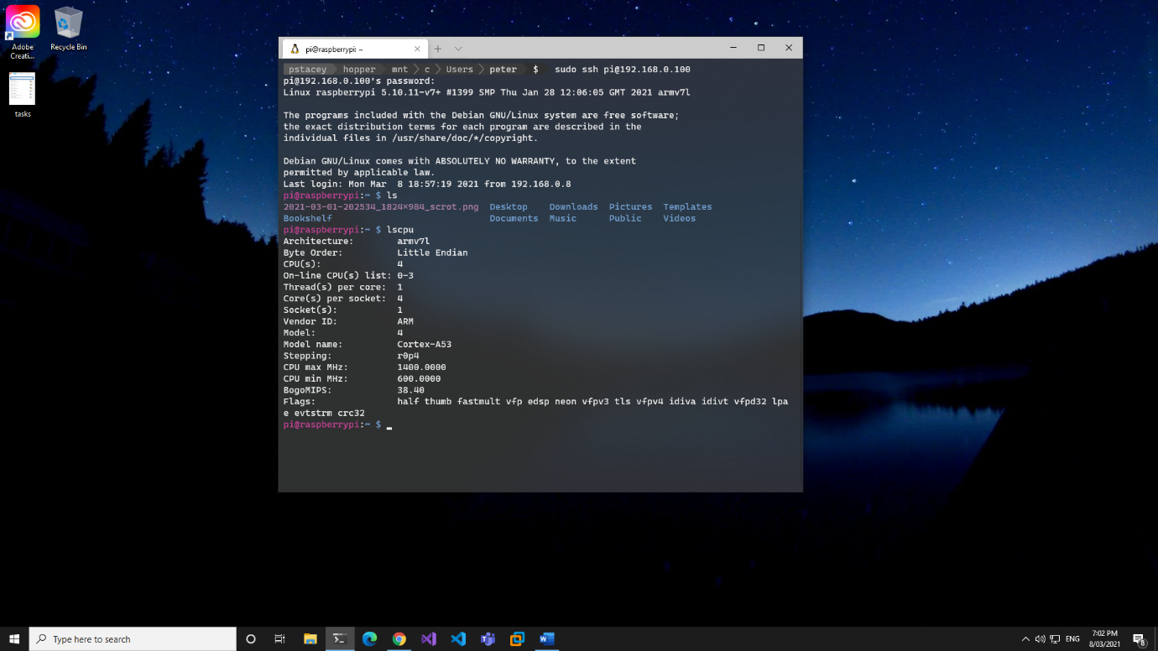

Figure : Screen capture of SSH login to Raspberry Pi from Windows 10 Desktop