Task 8.1D - Raspberry Pi I2C

# Student ID: 219011171

# Name: Peter Stacey

## Q1. Discuss the benefits of I2C serial communication

There are several benefits to I2C Communication in comparison to other communication protocols. These include:

**Low Pin/Signal Ratio (ie. Low pin count)**

As a system that requires only 2 channels for communication, the first benefit of I2C is the small number of pins required in a system. This is evidenced in the attached video where I use an LCD screen, which would normally involve 16 pin connections to a controller, but instead when attached to an I2C Bridge Adaptor, reduces the number of pins down to 4 (refer Figure 1).

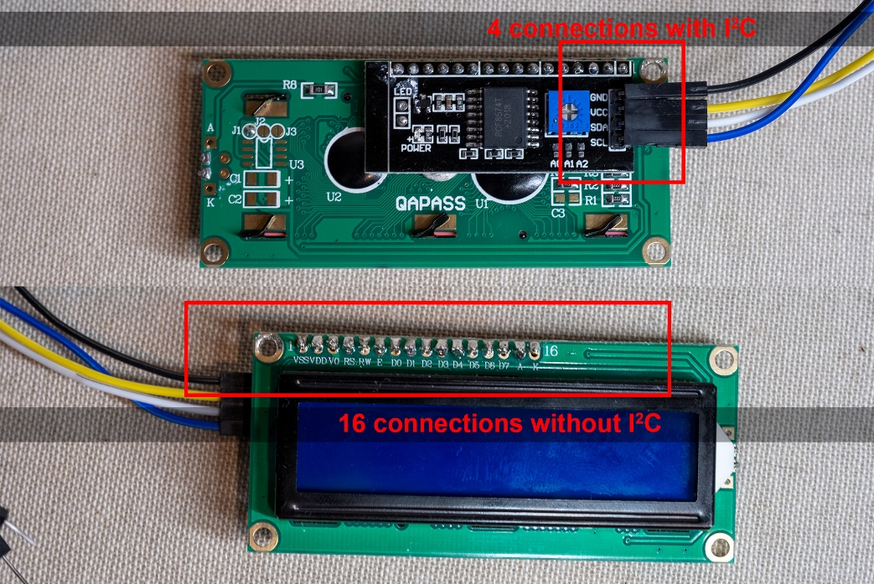

Figure : Pin/Signal Ratio for I2C

**Multiple Master and Slave Devices**

With I2C, following the start signal, the next 7 or 10 bit segment contains the address of the device being communicated with (refer Figure 2).

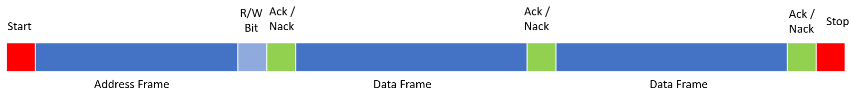

Figure : I2C Message Structure

Since each device in the system has a different address, multiple master devices and multiple slave devices can exist in the one system.

Initially, all devices receive the address signal, however only the device with that same address will send the acknowledge signal, allowing the next segment to then be sent and as many data frame sent as needed, before finally the stop signal.

**Error handling is aided by Acknowledge/No Acknowledge Serial Communication**

Since I2C is a half-duplex communication system (ie. Both devices can send, but only one at a time), the structure of the I2C message includes positive acknowledge signals. When an acknowledge (or a not acknowledge) signal is received, the controlling program has an opportunity to then handle any error conditions gracefully.

**Flexible data transmission rates**

Since the I2C message includes the positive acknowledgement, any change in network speed, or lag in the environment, is naturally compensated for, as the next frame of data won’t be sent until the Ack/No Ack message is received.

## Q2. : Create a repository named SIT210_Task8.1D_RPi_I2C on GitHub. Upload your code to the repository. Include the link to your repository here.

<https://github.com/pscompsci/SIT210_Embedded_Programming/tree/main/Task_8_1D>

## Q3. Put a video demonstrating your system working on YouTube. Your video should include a brief description of how your system works and how you have programmed it.

<https://youtu.be/8gJHcyawuNs>